Trident Tooth: Created in Autodesk®Inventor® 2017

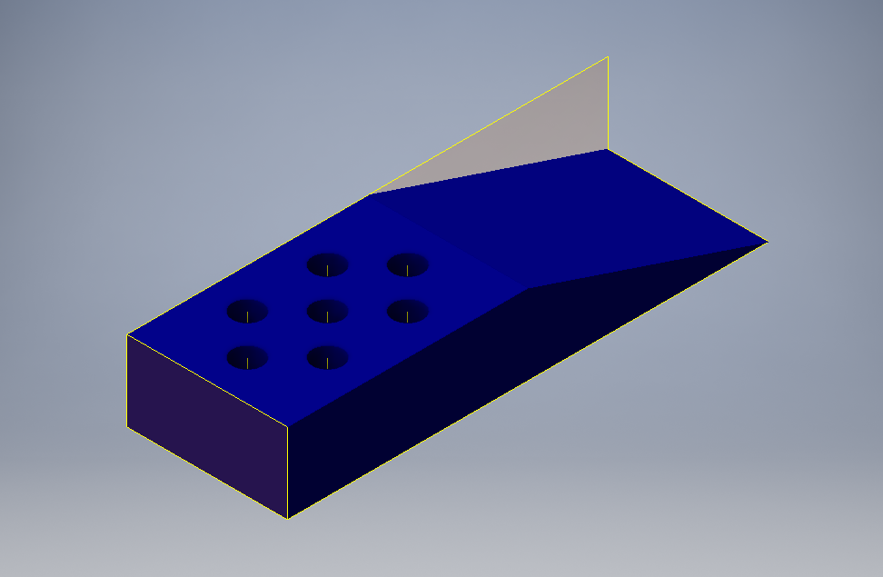
Figure 1:Angle view of the trident tooth

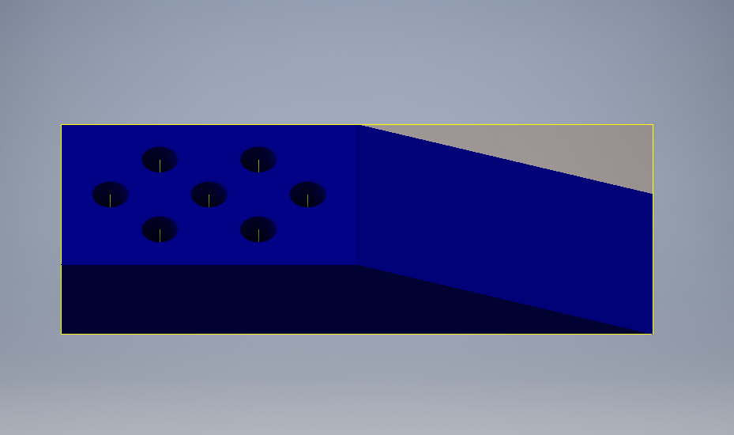
Figure 2: Top-angle side
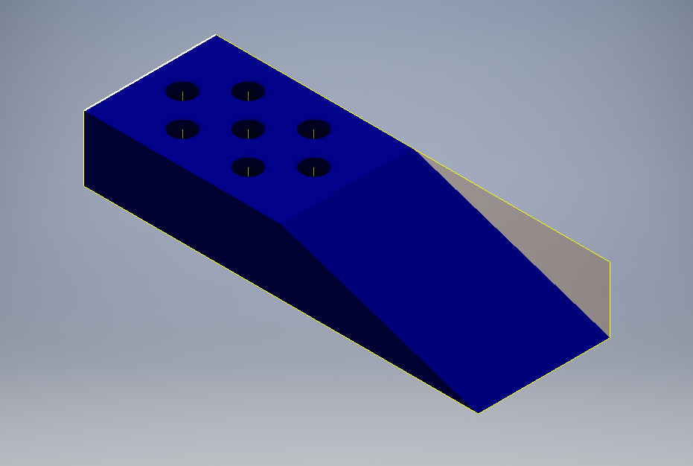
Figure 3: Front-angle

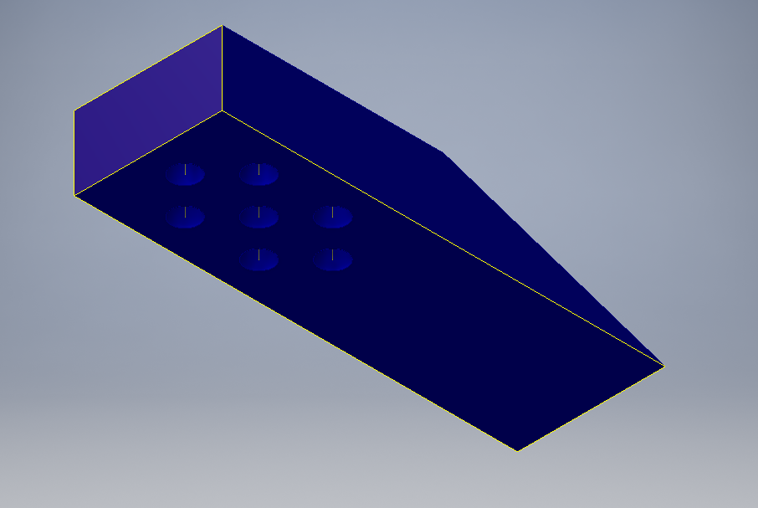
Figure 4:Bottom-angle

