Computers have several devices of input, from the original keyboard to the revolutionary touchscreen, however there is another classic: the mouse. The computer mouse was originally commercialized in the early 1980s by Xerox, Apple, and Microsoft, and throughout the decades it has evolved drastically. This device was chosen for the challenge for many reasons, including a surplus of mice and its pertinent role in PC usability. The specific mouse is a generic Dell mouse, which was bundled with desktop computers several years ago. The mouse of subject was basic, only containing the essential laser system and buttons.
At the heart of the mouse functionality is its laser, which allows the pointer onscreen to move. Older mice utilized a ball surrounded by rollers on several axes; as the ball spun, the rollers spun, and this would calculate how much the pointer moved. However, this design was unreliable, as dust would get inside the mouse and clog the ball, immobilizing it. Today’s mice, including the one disassembled, use light to track pointer movement. When powered, a small LED activates, and its light is channeled by a small piece of plastic to the desk. The light is tracked by a sensor within the mouse that magnifies light, allowing it to see precise changes in the photons caused by movement of the mouse. The sensor reads the movement, and calculates the change in distance. The distance is then applied to the pointer. The LED and light sensor on the mouse were unmarked, so it is assumed they were manufactured by Dell. Like almost any mouse, there are touch keys on the front.
Along with the laser, the mouse also has three small buttons. These buttons are the left click on the left, right click on the top right, and middle click on the bottom right. The function of these three buttons is simple; when the button is pushed, it creates a signal that is sent to the computer. When the left button is clicked, a signal is sent from the mouse to the computer communicating that the left button was pushed in. The signal creates a “click” that acts as a button press where the pointer is located. The right button usually opens up a micro menu that displays several options specific to the program being used, allowing for simpler functionality. The middle press is activated when the scroll wheel is pushed in, and on most programs this created a mode where the screen is moved by moving the mouse, instead of the scroll wheel. The buttons were an interesting part to examine.
The mouse disassembled had little parts within it, but it did contain a laser and several buttons. The disassembly process taught how the laser system worked in greater detail, as well as how the buttons worked. The buttons were expected to be embedded into the motherboard, but instead they were entirely separate modules. If another mouse were to be examined, it would be a modern mouse for its advanced technology.

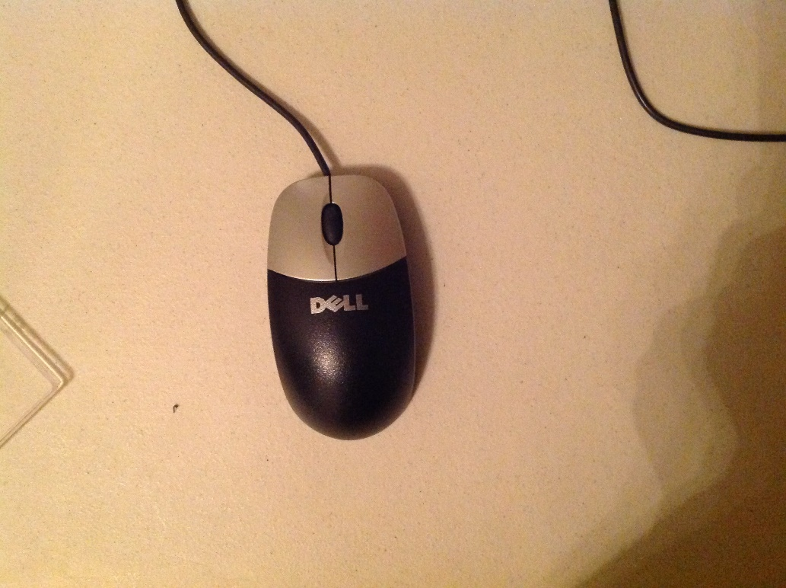

The mouse before disassembly

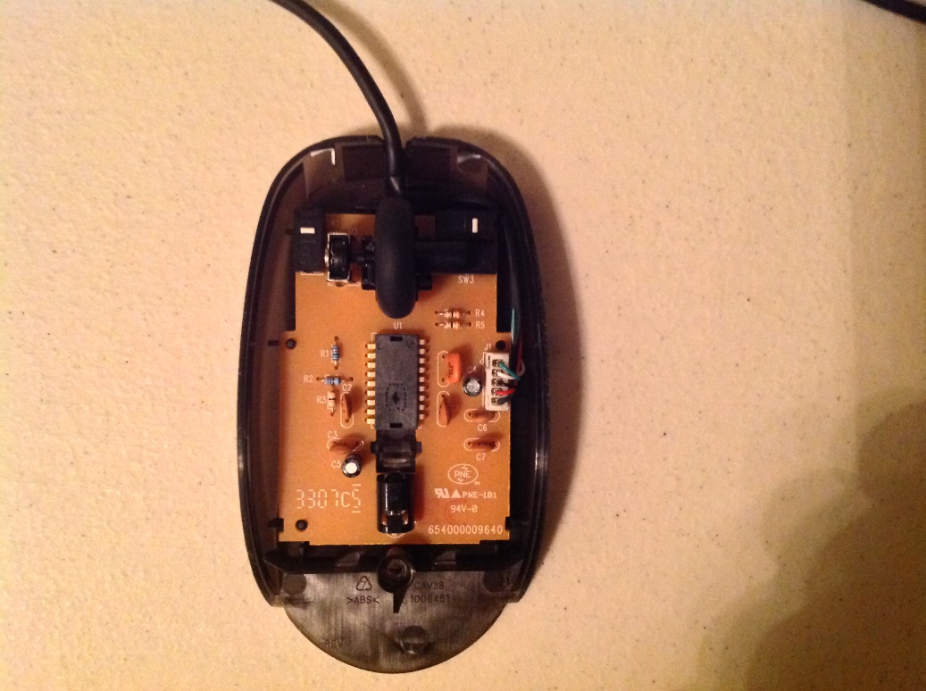
The top part of the mouse taken off, with the motherboard still intact
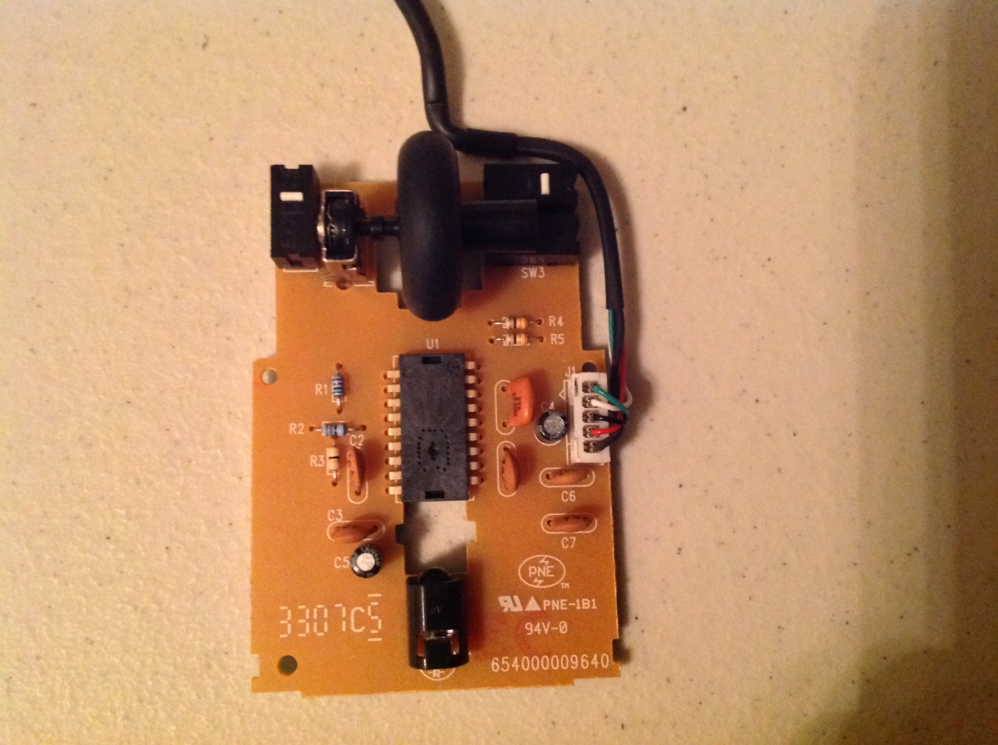
Green Circle- Buttons
The motherboard taken out of the case

Blue Circle- Light Sensor for pointer movement

Red Circle- LED
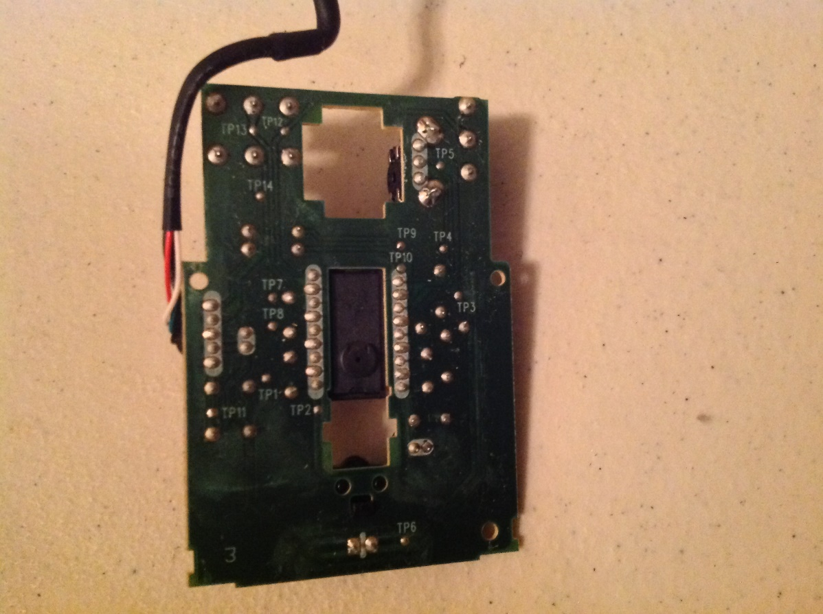
Back of the motherboard
Purple Circle-
Scroll wheel

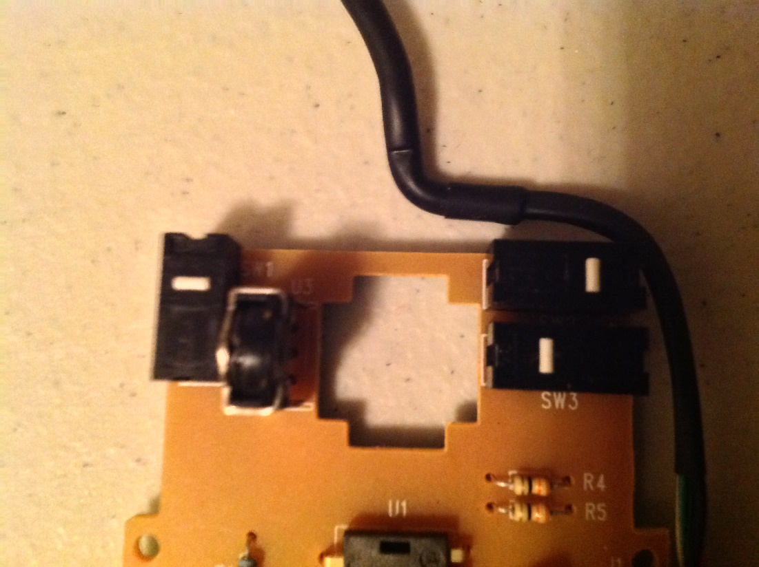
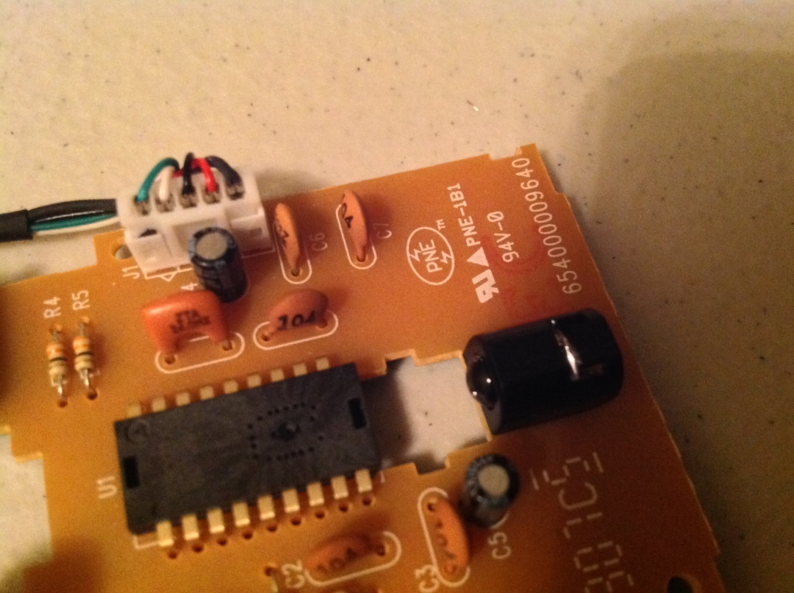
The light sensor and LED. The LED is facing parallel to the motherboard, so a plastic module directs the emitted light to the workspace
Green Circle- Middle Button
Blue Circle- Right Button
Red Circle- Left Button
Close up of the buttons;
The scroll wheel is removed
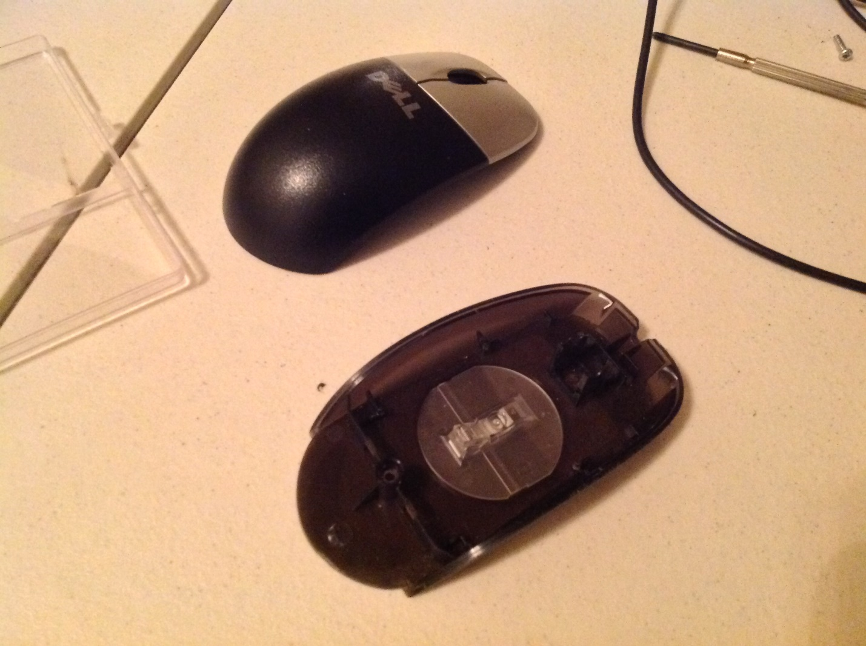
The two pieces of the mouse case which contain the light filter that directs the light from the LED to the surface

