**Take Apart Calculator**

We are the I.J Holton, team 8440B.

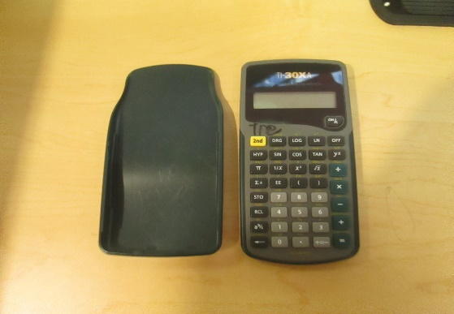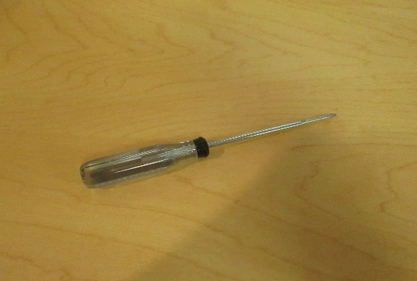In this online challenge, you must take apart a Texas Institute object. We chose a TI-30XA calculator. Before we started this online challenge, we decided that we only wanted to use one (1) or two (2) objects or tool to take apart the calculator. So, we chose a screwdriver and are hands.

We starter of by just taking the screws out of the calculator. That was the easy part. Then we opened it up, took a picture, and we found the batteries, the calculators "smart" panel or mother board, and black and red cords.

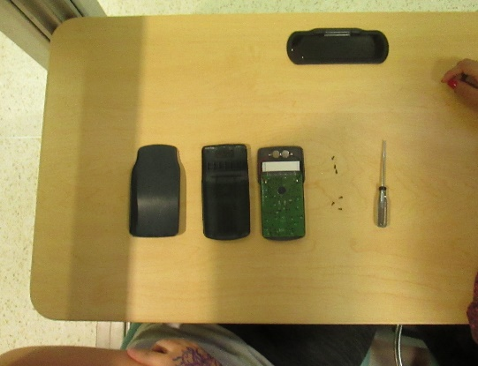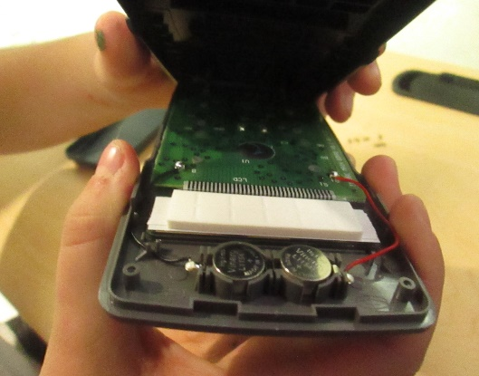

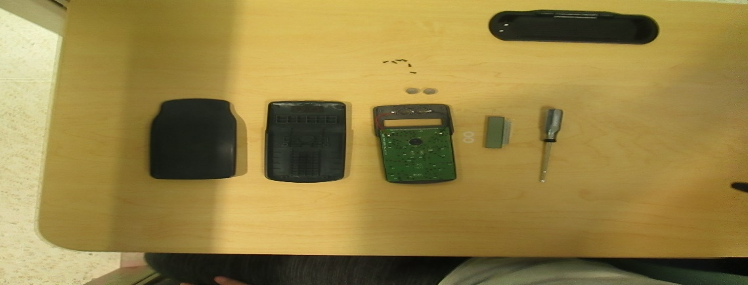Next, we took out the batteries and the screen for the calculator and had to disconnect it from the black and red cords, so that it wouldn’t stay connected to the mother board. From there we just tried to get out the panel (mother board) out without breaking it.

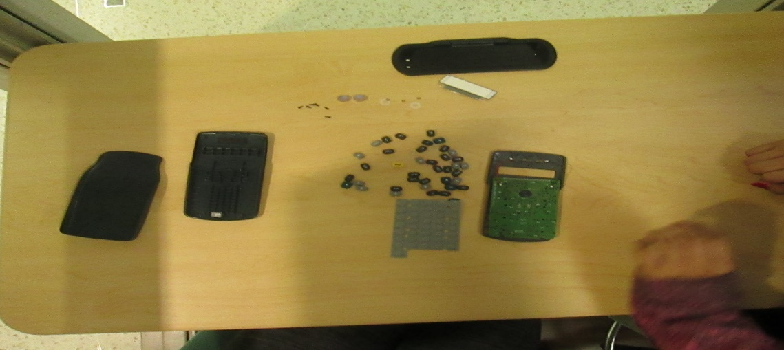As soon as we got the panel (mother board) out, we noticed that the panel (mother board) was the piece of the calculator that held on the keys. As soon as we got the panel (mother board) off, all the keys either fell of or flung a couple feet.

Then we challenged ourselves to see if we could put it back together. It was very challenging but, none of us could do it. Finally, we cleaned up and put the calculator in a plastic bag and labeled it with a post it notes.