Kailey Kolesar
Team 4073A

Texas Instruments Online Challenge

Introduction:
Texas Instruments is a vital part of the electronic community. Texas Instruments are found in so many devices that they have more than 40,000 patents throughout the world. As an essential part of the electronic community, for my Texas Instruments Online Challenge the device I chose to deconstruct was a Samsung Galaxy Avant, model SM-G386T. My reasoning for choosing this device, over the other vast majority of options I had to choose from, comes from my curiousity about the inner-workings of this phone, that I and many others have used on a daily basis.

Simplified Parts List:
-Motherboard
-Rear-facing camera
-Vibration motor
-Audio Jack
-Ear speaker audio flex cable

Before Disassembly:
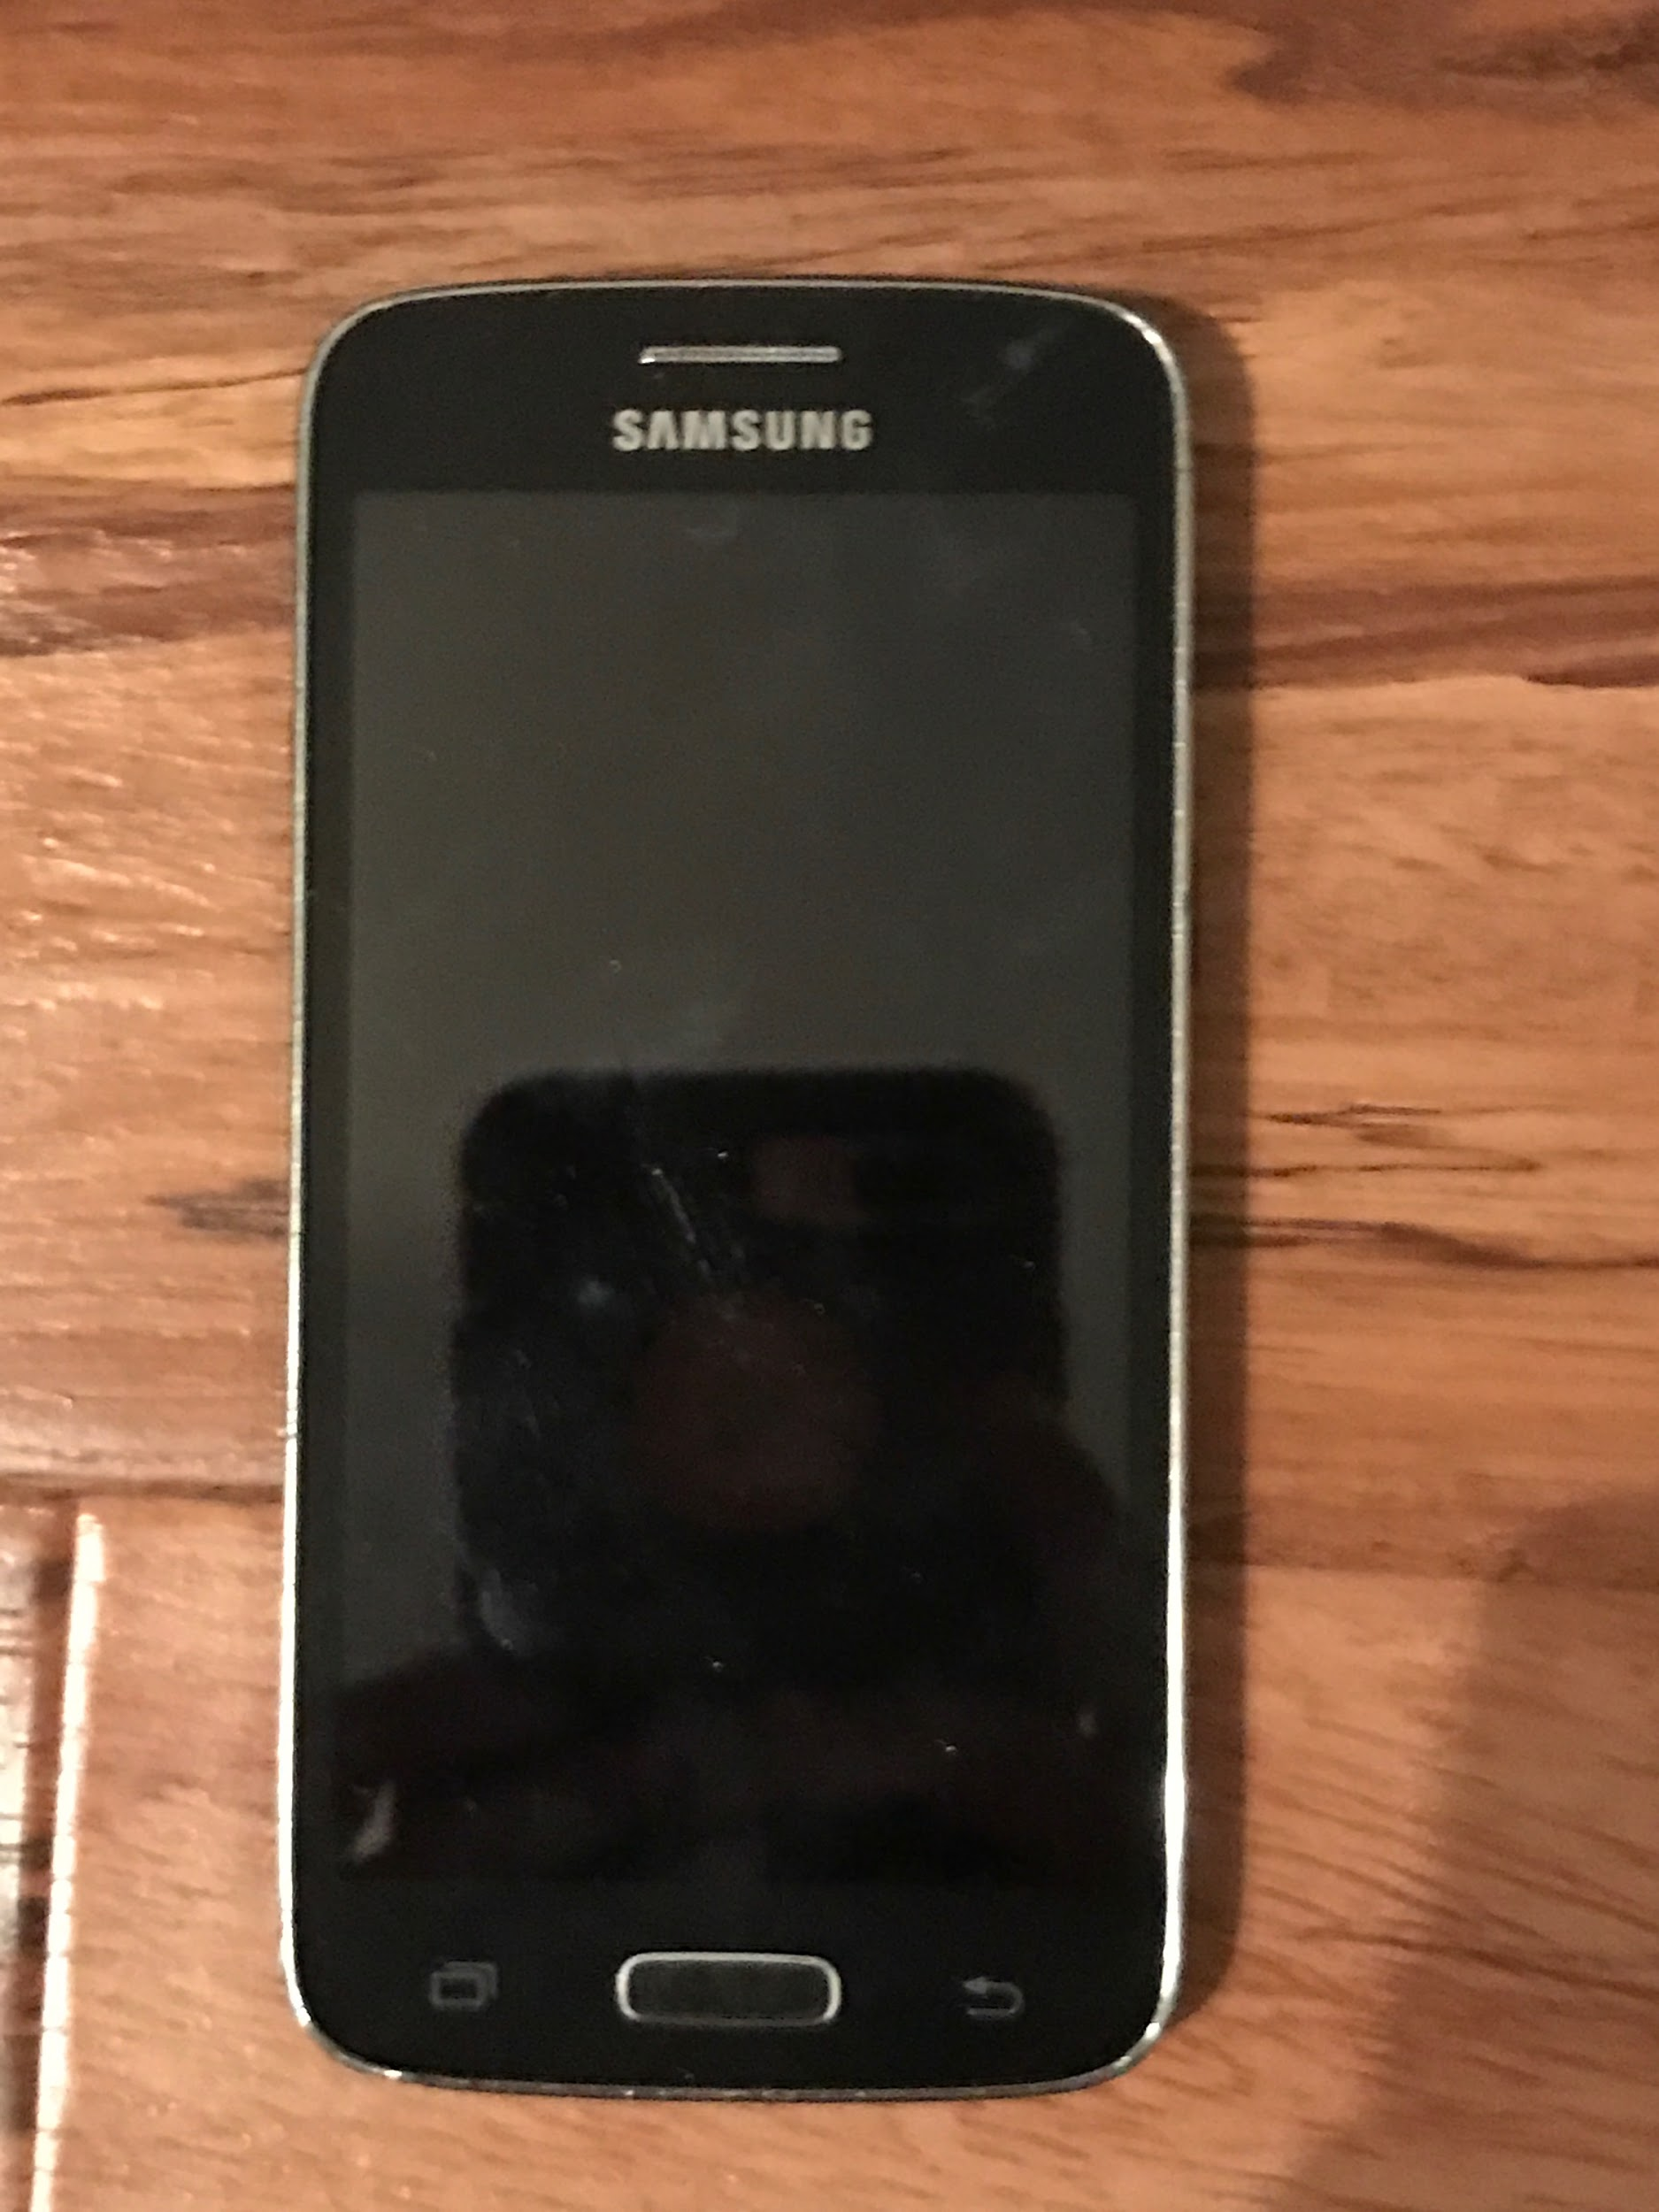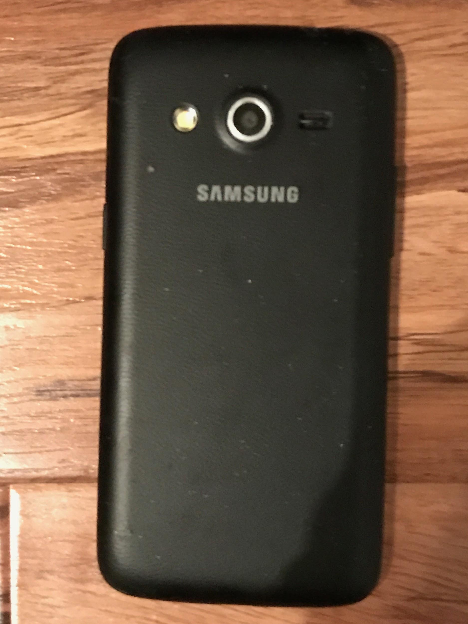
The original phone, a Samsung Galaxy Avant (Model: SM-G386T) before disassembly
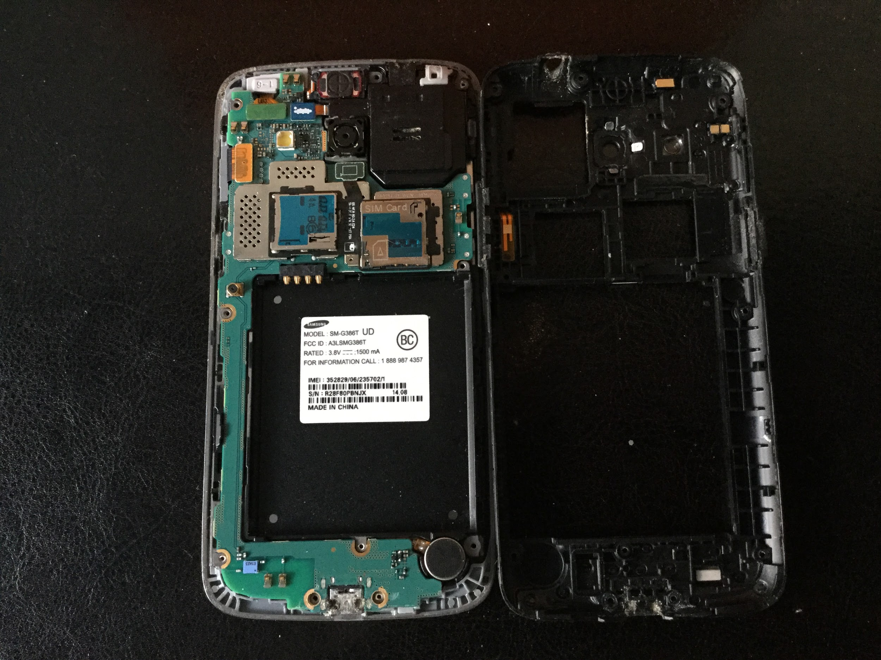
Inside view of the phone after the internal cover was removed

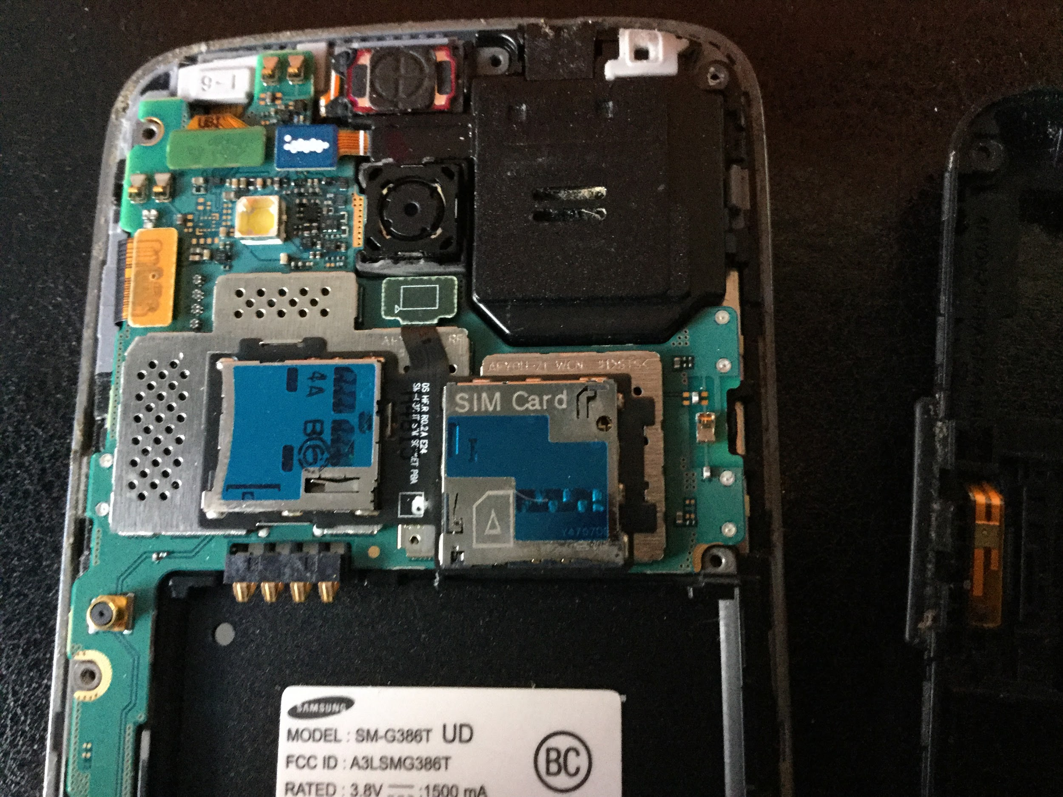
Close up of some of the inner components in the phone before disassembly

After Disassembly:
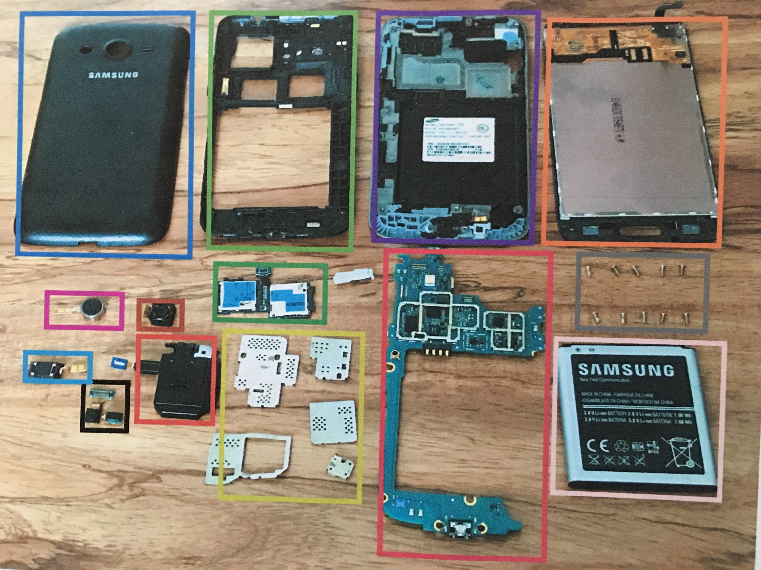
Layout of the phone and it’s inner components after teardown
1. Back Plate 2. Internal Cover
3. Middle Housing 4. LCD Screen + Touch Screen Controller
5. Vibration Motor 6. Rear-Facing Camera
7. Ear Speaker Audio Flex Cable 8. Audio Jack Assembly
9. Front-Facing Camera + Proximity Sensor 10. SIM Card + Micro SD Card Slots
11. Metal Shields 12. Motherboard
13. Screws 14. 2100 MAH Battery
*No Texas Instruments components were found
Component Identification:

Motherboard Front:
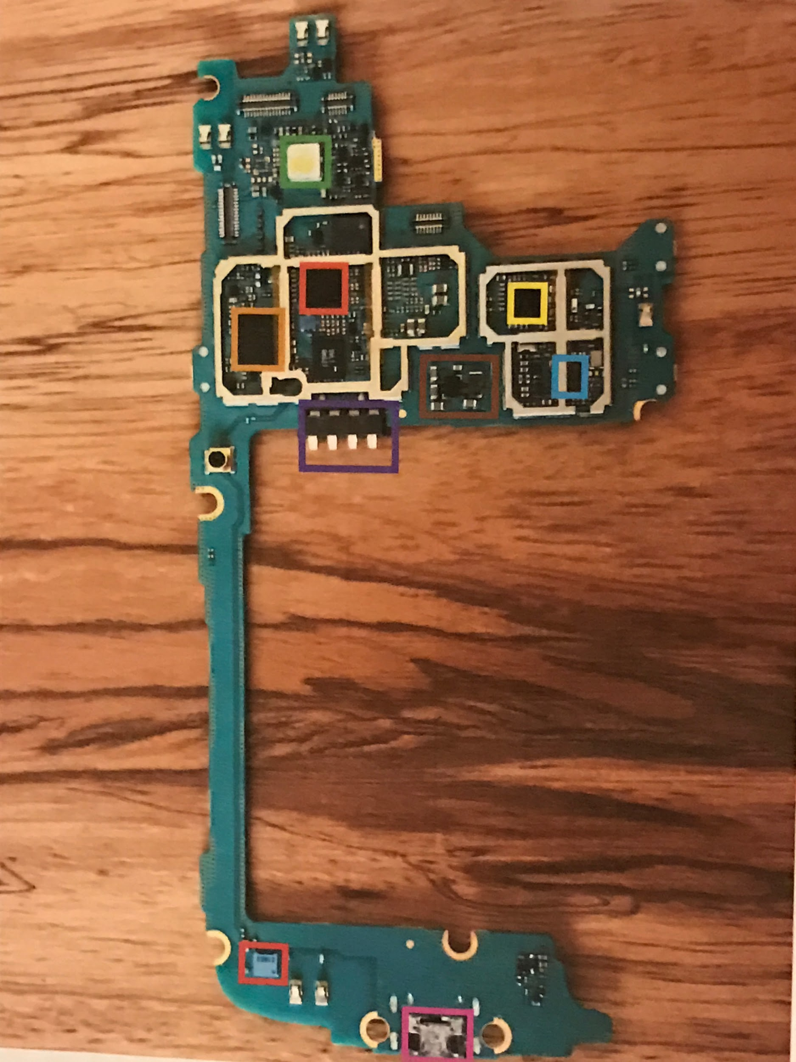
1. Flash- light for the camera mode on the phone
2. Radio Frequency Transceiver- transmits and/or receives radio signals between two devices
3. Multimode Multiband Power Amplifier Module- supports LTE output power
bandwidth bands in 3G and 4G cell phones
4. Wifi Module- allows access to wifi networks
5. Audio Amplifier- boosts the electrical current to amplify the sound
6. Audio Codec- responsible for coding or decoding digital data stream of audio
7. Battery Connector Pin- port between the battery and the motherboard
8. Pressure Sensor- measures the pressure within and transmits that information via
electronic signal
9. USB Charging Port- connector between to battery and the charger

Motherboard Back: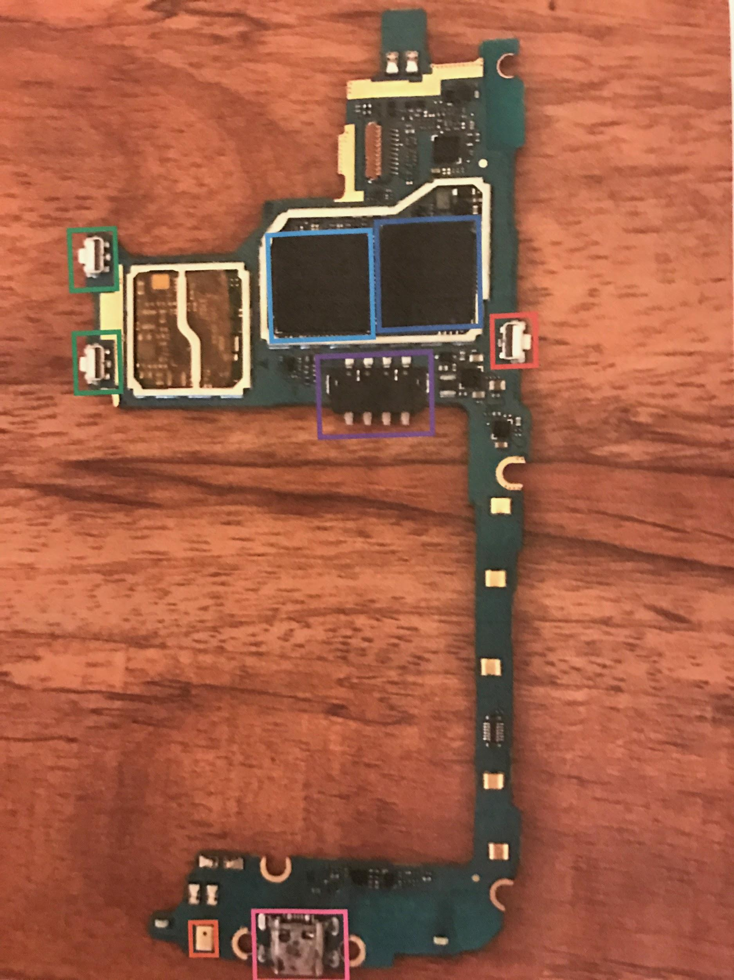
1. Up/Down Volume Buttons- allows you to turn the volume up and/or down
2. Samsung 16GB Memory- storage for the system
3. Toshiba Processor- the central processing unit (CPU) in the cell phone. Responsible for the speed of the CPU. The computer of the cell phone
4. On/Off Button- allows you to turn the phone on and/or off
5. Battery Connector Pin- port between the battery and the motherboard
6. Pressure Sensor- measures the pressure within the system and transmits that information via electronic signal
7. USB Charging Port- connector between the battery and the charger

Back Camera:
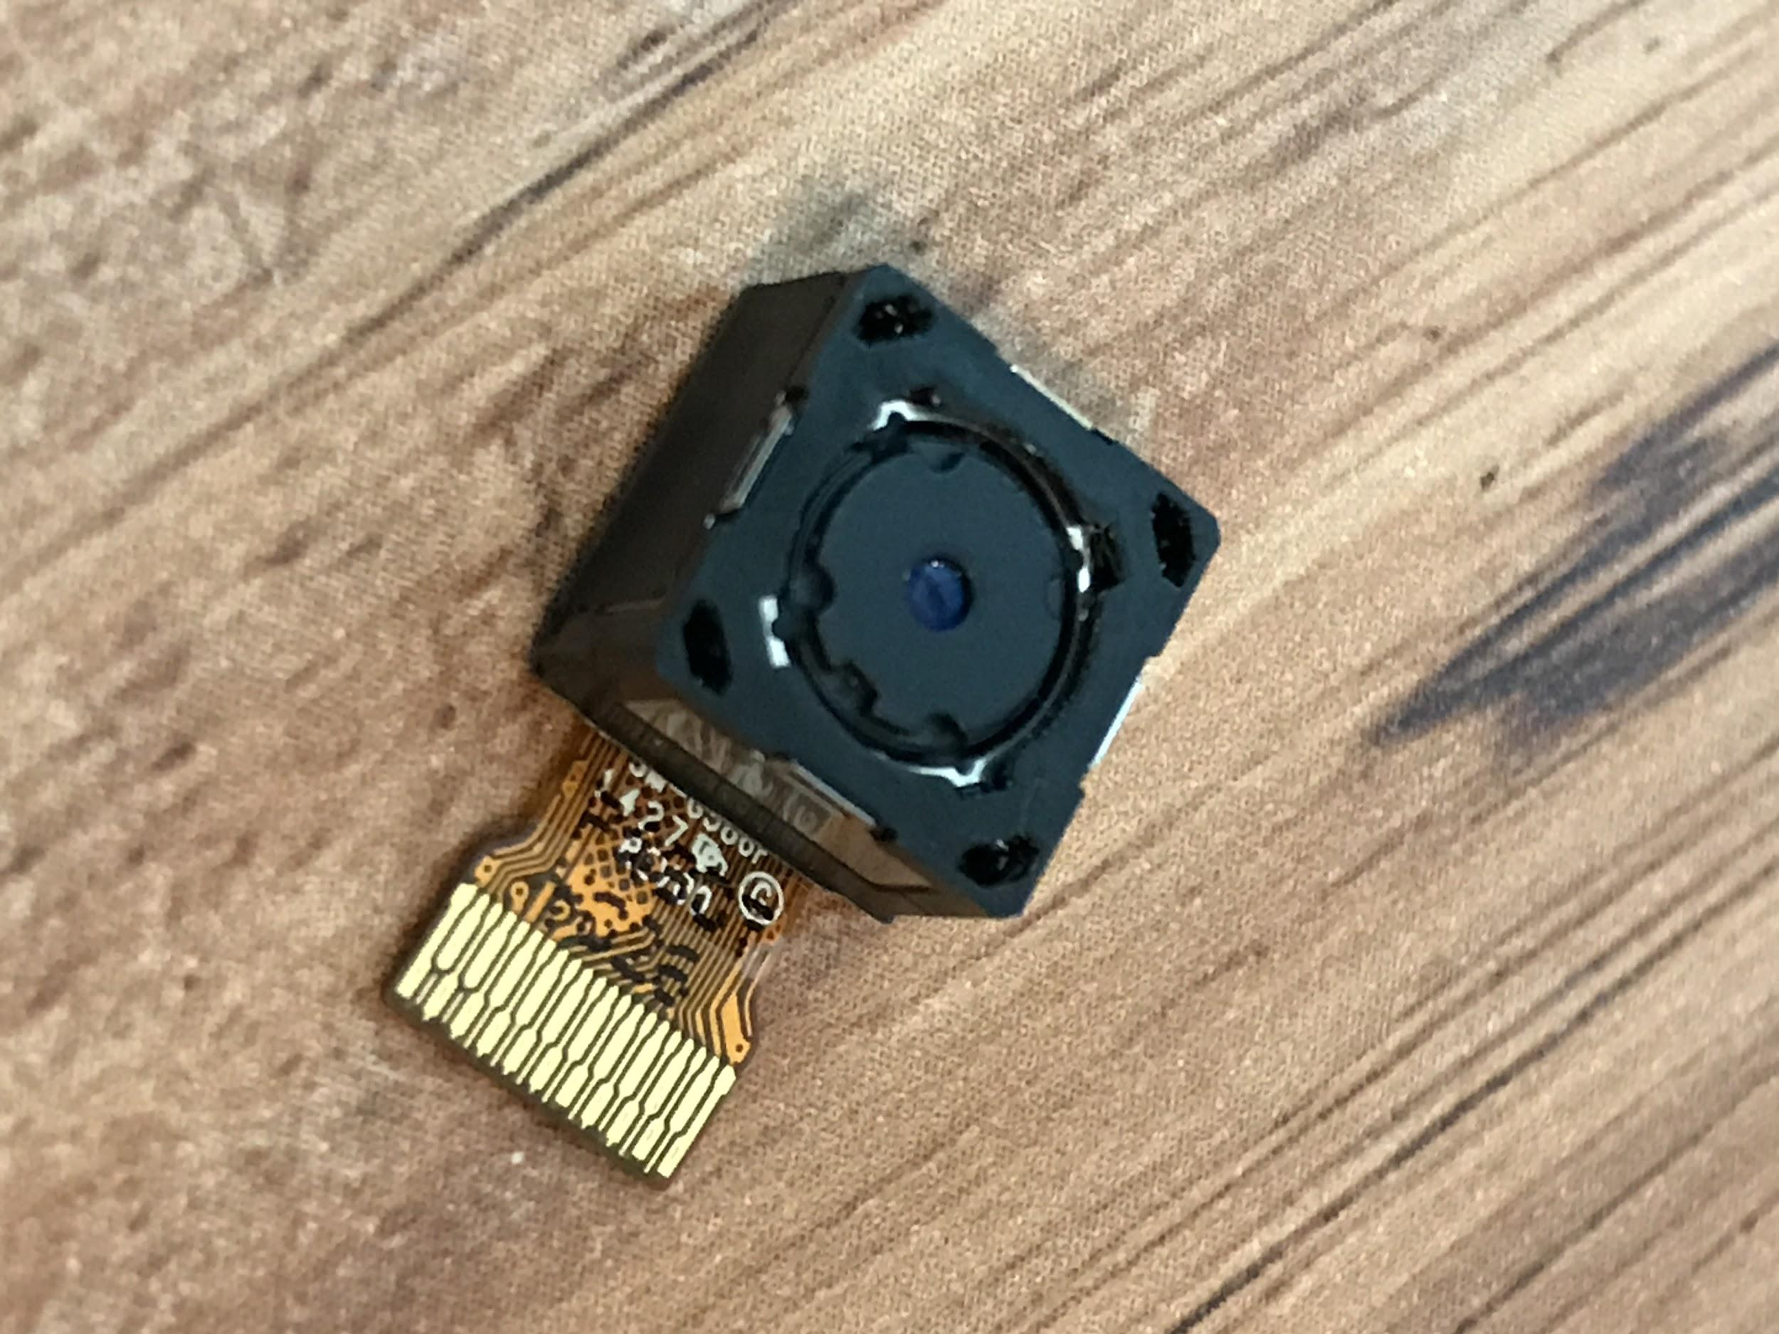
5MP Back Camera: Allows the user to use the cellphone as a typical camera.

Vibration Motor:
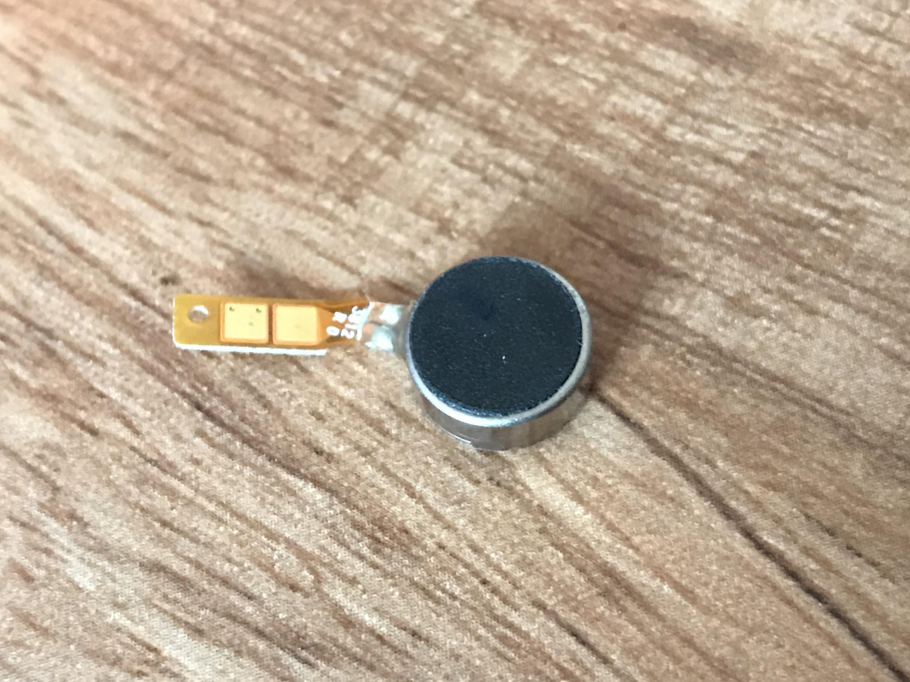
T-Mobile Vibrator: The vibration motor is responsible for the phone vibration mode on the phone.

Audio Jack: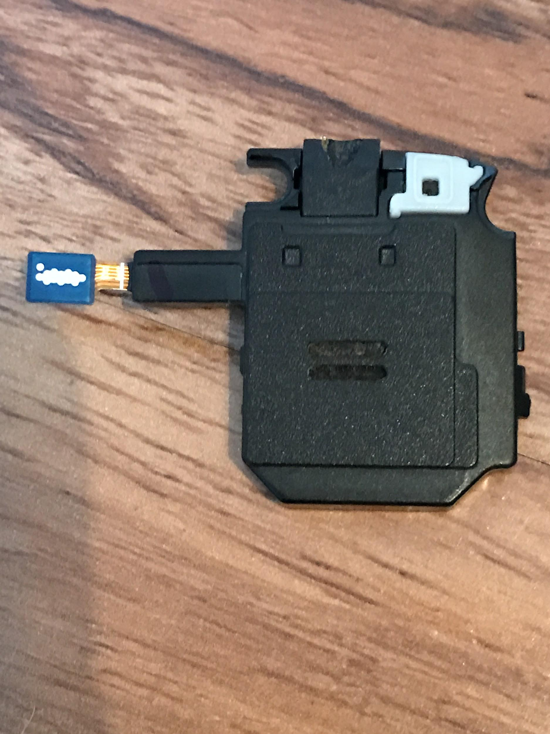Audio Jack component allows for the use of a typical 2.5 mm audio jack device such as headphones and detached speakers.

Ear Speaker Audio Flex Cable:
Front: Back:
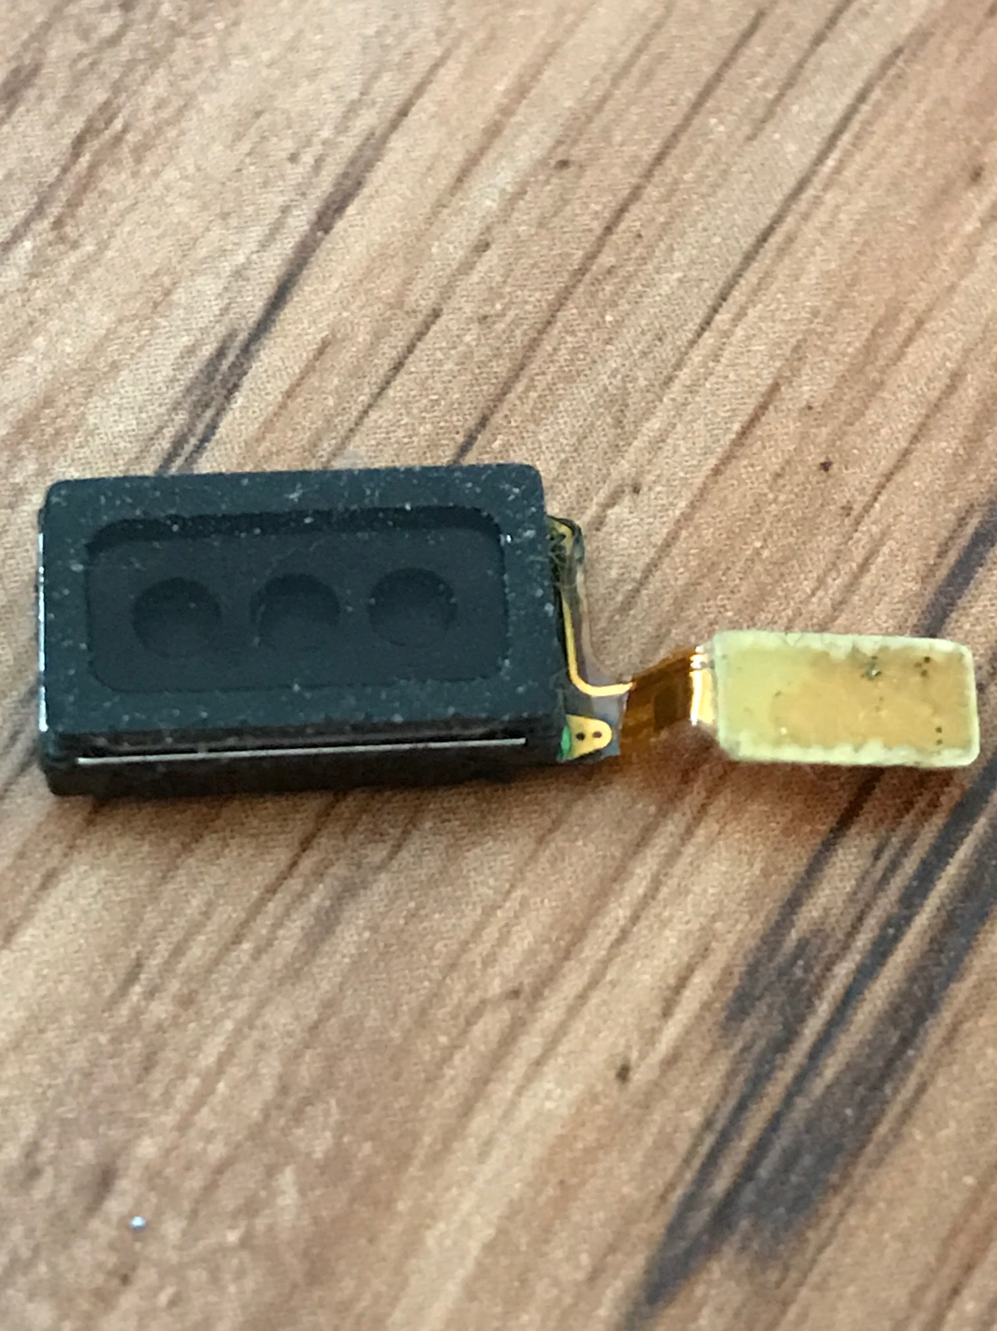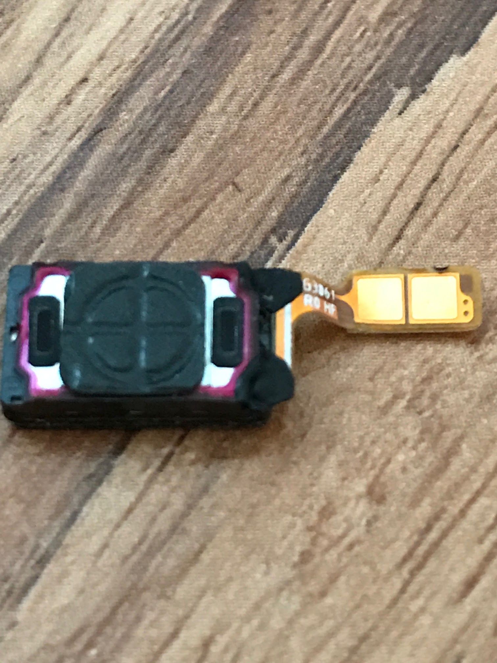
Ear speaker: responsible for the speaker that is heard when the phone is placed on the ear. This is also responsible for the speakerphone option.

Conclusion:
In locating and identifying the components of a mechanism, I learned many valuable lessons. For starters I learned the importance of attention to detail because each component has a specific location and role in the operation of the mechanism. I also learned that different devices, usually depending on the sale prices of the phone have different companies that produce the components of that device. For example the Samsung Galaxy Avant is a cheaper version of the popular Samsung Galaxy, therefore does not contain many of the name brand electronic components such as Texas Instruments. The last thing I learned was that many cell phones have the same components, but different manufactures. Overall, there is a great deal to be learned from disassembling an electronic device.

Sources:

Research on the Texas Instruments company:
https://en.wikipedia.org/wiki/Texas_Instruments

Research on the components within a cell phone:
http://www.kids-online.net/learn/click/details/motherb.html

https://forum.xda-developers.com/galaxy-s4/help/wipe-internal-storage-dead-phone-t2901499

http://www.techrepublic.com/pictures/cracking-open-the-samsung-galaxy-note-4/32/

https://www.ifixit.com/Teardown/Samsung+Galaxy+Nexus+Teardown/7182

https://www.ifixit.com/Teardown/Samsung+Galaxy+S6+Teardown/39174

https://en.wikipedia.org/wiki/RF_module

https://www.sparkfun.com/products/13678

http://www.explainthatstuff.com/amplifiers.html

https://www.ia.omron.com/support/guide/35/introduction.html

https://en.wikipedia.org/wiki/Audio_codec

Research specifically on the Samsung Galaxy Avant:
http://www.samsung.com/us/mobile/phones/all-other-phones/samsung-galaxy-avant-t-mobile-black-sm-g386tzkatmb/

Research on how to disassemble a cell phone:
http://www.sonymobilephones.com/samsung-galaxy-avant/disassembly/videos

Research on the electronic component manufacturer logos:
http://elcrost.com/symbols-of-electronic-components/logos-for-electronic-component-manufact
urers-electronics-forums-circuit-symbols-of-components-manufacturer-2015-01-06-00/

https://www.electronicspoint.com/resources/logos-for-electronic-component-manufacturers.47/

