***The Keyboard***

In computing, a computer keyboard is a typewriter-style device which uses an arrangement of buttons or keys to act as a mechanical lever or electronic switch.

Software keyboards or on-screen keyboards often take the form of computer programs that display an image of a keyboard on the screen.

A computer keyboard is an input device that allows a person to enter symbols like letters and numbers into a computer. It is the main input device for most computers.

Keyboards allow you to input letters, numbers, and other symbols into a computer that can serve as commands or be used to type text.

***Computer’s contents:***

***Mouse***: Used for making selections.

***Keyboard:*** for entering data, generating commands.

***Monitor:*** The monitor is the visual component of the computer.

***Speakers***: The speakers are the audio component of the computer.

***Computer System Unit .***

***Printer.***

***Compact Disk (CD)***

***Thumb Drive.***

***Input Devices (keyboard, mouse etc.)***

***Output Devices (monitor, speakers etc.)***

***Secondary Storage Devices (hard disk drive, CD/DVD drive etc.)***

***Processor and Primary Storage Devices (c p u, RAM)***

***What are the parts of the computer?***

***Typing (alphanumeric) keys****:* These keys include the same letter, number, punctuation, and symbol keys found on a traditional type writer.

Letter Key – include letters, number’s symbols and special key.

***Numeric Key*** – numbers from 0 to 9 and symbols like +, ‐, ? And \*

Belong to this part of the keyboard Function Key (Top Row) – these keys are

Called function keys because they perform special functions.

***Cursor Key or Arrow Keys (Navigation Key)***  these key’s include left (←), right (→), up (  ),down (  ) directions.

***Control Keys***: these keys are used alone or in combination with other keys to perform certain actions. The most frequently used control keys are CTRL, ALT, the Windows logo key, and ESC.

***Function of the Other Keys:***

***CAPS LOCK Key:*** when you press this key, all the letters that you type will be in capital letters.

***SHIFT Key*** : this key is used to capitalize a letter you want to change. To do this press the letter you want while holding down the shift key.

***Escape Key*** : This key is used to exit programs quickly.

***Enter Key*** : Pressing this key allows the computer to do the command you had given.

***Backspace Key***: This key will erase any characters on the left side of the cursor

***CTRL and ALT Keys:*** these key are called combination keys because they only work together with other Key.

***Status Lights***: these are the lights found on the upper right part of the keyboard. Each light has a name from a particular key. If the lights are on, it means the key is activated the keyboard is one of the main ways to communicate with a computer. There are many different types of keyboards, but most are very similar and allow you to accomplish the same basic tasks.

A keyboard is a lot like a miniature computer. It has its own processor and circuitry that carries information to and from that processor.

A large part of this circuitry makes up the key matrix. When the processor finds a circuit that is closed, it compares the location of that circuit on the key matrix to the character map in its read-only memory (ROM). A character map is basically a comparison chart or lookup table. It tells the processor the position of each key in the matrix and what each keystroke or combination of keystrokes represents. For example, the character map lets the processor know that pressing the a key by itself corresponds to a small letter "a," but the Shift and a keys pressed together correspond to a capital "A."

***Home***

***End***

***Insert***

***Delete***

***Page Up***

***Page Down***

***Control (Ctrl)***

***Alternate (Alt)***

***Escape (Esc)***

As you type, the processor in the keyboard analyzes the key matrix and determines what characters to send to the computer.

***1-What's under the keys?***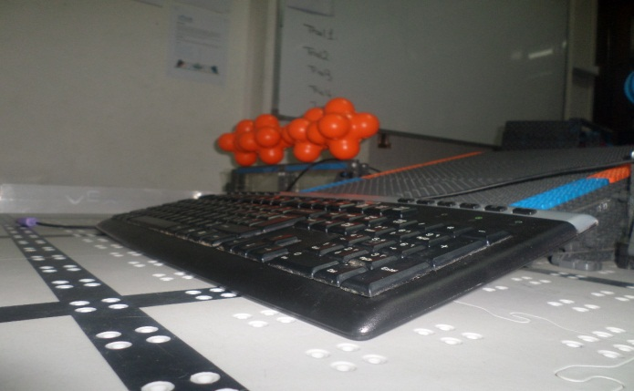

Pull a key off the keyboard and you can see roughly how it works. There's a little hole in the plastic base and the keyboard has a long round bar the same shape. When you press the key, the bar pushes down through the hole to touch the contact layers below. Inside the hole, there's a little tiny piece of rubber (you can't see it in this photo) that stops the key moving down and pushes it back up when you release it. This is what gives the spring to the keys.

***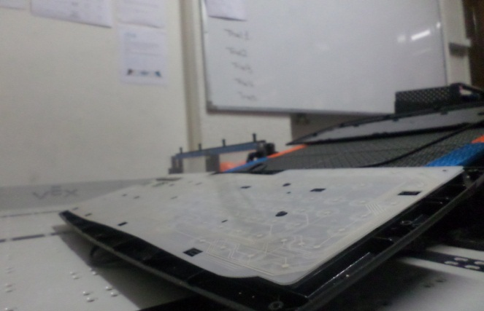2. What's under the keyboard?***

Take off the keyboard's bottom panel and you can see how it all works from beneath. You can see the transparent plastic contact layers that detect key presses and (through those layers) you can see the round bars poking the keys down from above. The green rectangle at the top contains three small LEDs that activate the indicator lights for "Num lock", "Caps lock", and "Scroll lock". Notice also the cable running along the inside of the case atthe top of the keyboard, which carries electrical signals from the keyboard to your computer's USB port (or PS/2 port on older machines).

## *3. How do the keys press down?C:\Users\user\Documents\Bluetooth Folder\heba\SAM_1969.JPG*

Peel back the electrical contact layers and you can see the bottom of the keys and where they press down. Balancing on my fingertip, you can see one of the little rubber pieces that makes the keys bounce up and down. Notice the pattern of electrical tracks on the contact layers. In this photo, we are looking down through the bottom of the keyboard (so the keys are underneath).

## *4. How do the contacts layers work?C:\Users\user\Documents\Bluetooth Folder\heba\SAM_1975.JPG*

This is the magic part of a keyboard. There are three separate layers of plastic that work together to detect your key presses. Two of them are covered in electrically conducting metal tracks and there's an insulating layer between them with holes in it. The dots you can see are places where the keys press the two conducting layers together. The lines are electrical connections that allow tiny electric currents to flow when the layers are pressed tight to one another by a key moving down from above.

In the photo below, you can see a close up of the underside of one key—and, if you look closely, just about see how it works. There's one set of electrical connections on the lower sheet of plastic, printed in light gray. The other set is on the upper sheet of plastic and printed in dark gray. The two sheets are kept apart by a clear plastic layer except at the holes, which is where the keys push down to make the two sheets touch.

## C:\Users\user\Documents\Bluetooth Folder\heba\SAM_1978.JPG *5-How does it all work together?*

## When you press a key, the top and bottom contact layers come together and the keyboard sends a signal to your computer—just like this...

## Animation showing what happens inside the keyboard when you press a key

## *6-How do keypads work?*

TV [remote controls](http://www.explainthatstuff.com/remotecontrol.html), [cellphones](http://www.explainthatstuff.com/cellphones.html), push-button [telephones](http://www.explainthatstuff.com/telephone.html), and all kinds of other little gadgets use a different kind of key-switch mechanism that's simpler, more compact, and cheaper to make: it's called a rubber-membrane keypad. Instead of plastic keys and contact layers, there are just two parts. On top, there's the keypad part with all the keys molded from a single piece of flexible (rubbery) plastic. The **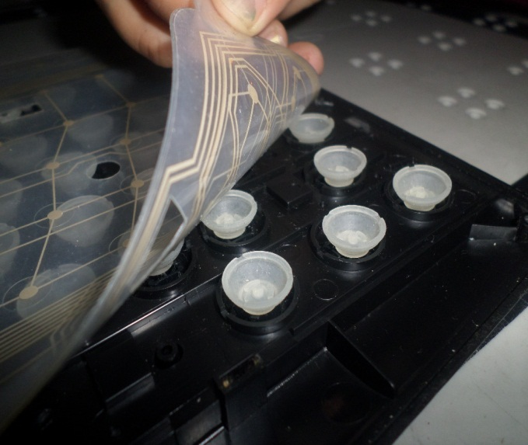**underside of each key is coated with a small patch of electrically conducting material. The second part of the keypad is a layer of electrical contacts formed directly onto a circuit board. When you press down on a key, the conducting material bridges the contacts, completes a switch, and triggers the specific circuit for that key. The problem with keypads like this is that you get oily films or dirt building up between the two layers, which can stop one or more keys from working. They also feel very "squidgy" to the touch, which makes them unsuitable for ordinary computer keyboards.

Photo: A typical TV remote control is made from two layers. In this photo, I've taken them apart and placed them side by side. Left: The main circuit board (green) has patterns of electrical contacts on its surface that sit directly underneath the rubber keys. Right: The rubber membrane keypad (white) is made from a very flexible plastic. When you squash a key down with your finger, you push the electrically conducting contact on the base of the key onto the tracks on the circuit board underneath, closing a switch and activating that key.

## *Resources:*

<https://en.wikipedia.org/wiki/Computer_keyboard>

<http://www.computerhope.com/jargon/k/keyboard.htm>

<http://study.com/academy/lesson/what-is-a-computer-keyboard-parts-layout-functions.html>

ecs-imus.weebly.com/uploads/1/1/3/7/11375967/the\_keyboard\_and\_its\_parts.pd

<http://computer.howstuffworks.com/keyboard2.htm>

## *Conclusion*

In summary, computer keyboard is an input device that can’t be escaped. When you buy keyboards go for the known and best brand types, otherwise it will soon fail to operate.