Texas Instruments Electronics Online Challenge

**2886A**



**Final Report**

Our team, 2886A, decided to use a Sony remote for our project. Although this contains no actual TI parts, there are some similar and are listed below.

* T5.00GT
  + Capacitor
  + TI: TPS
* H801 (M)
  + Capacitor
  + 6.3V
  + TI: TPS

* LED 1
* RM – V210 / RG – 117
  + PCB
  + TI: TSC2000
* Casing

It was interesting to see how these components actually work together and go hand in hand. TI uses many parts similar to the ones found in our remote.

**Visual Documentation**

### Appendix A: Sony RM- VL600 Universal Remote

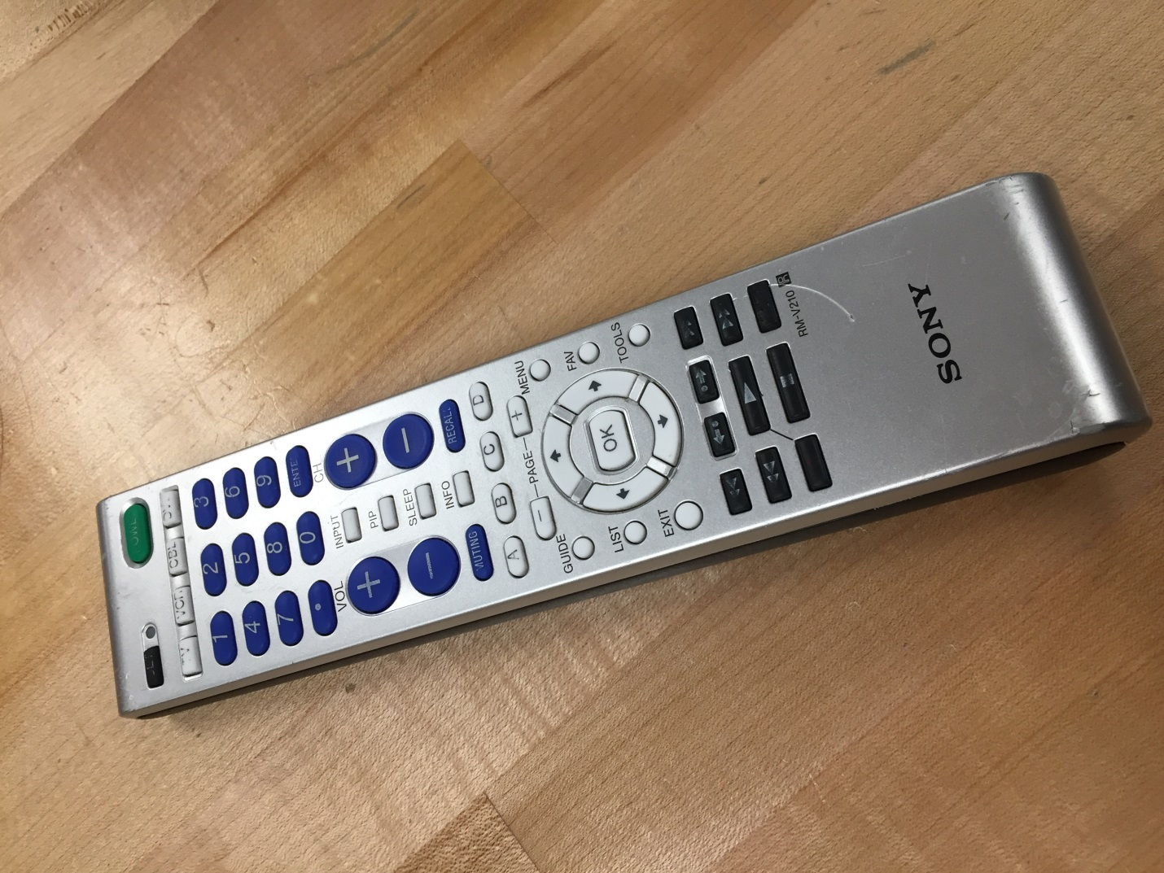

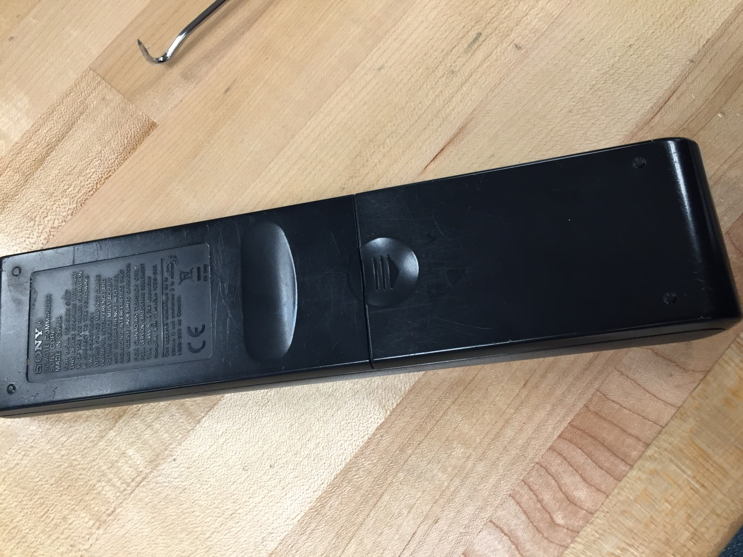

Appendix B: Component Close-ups

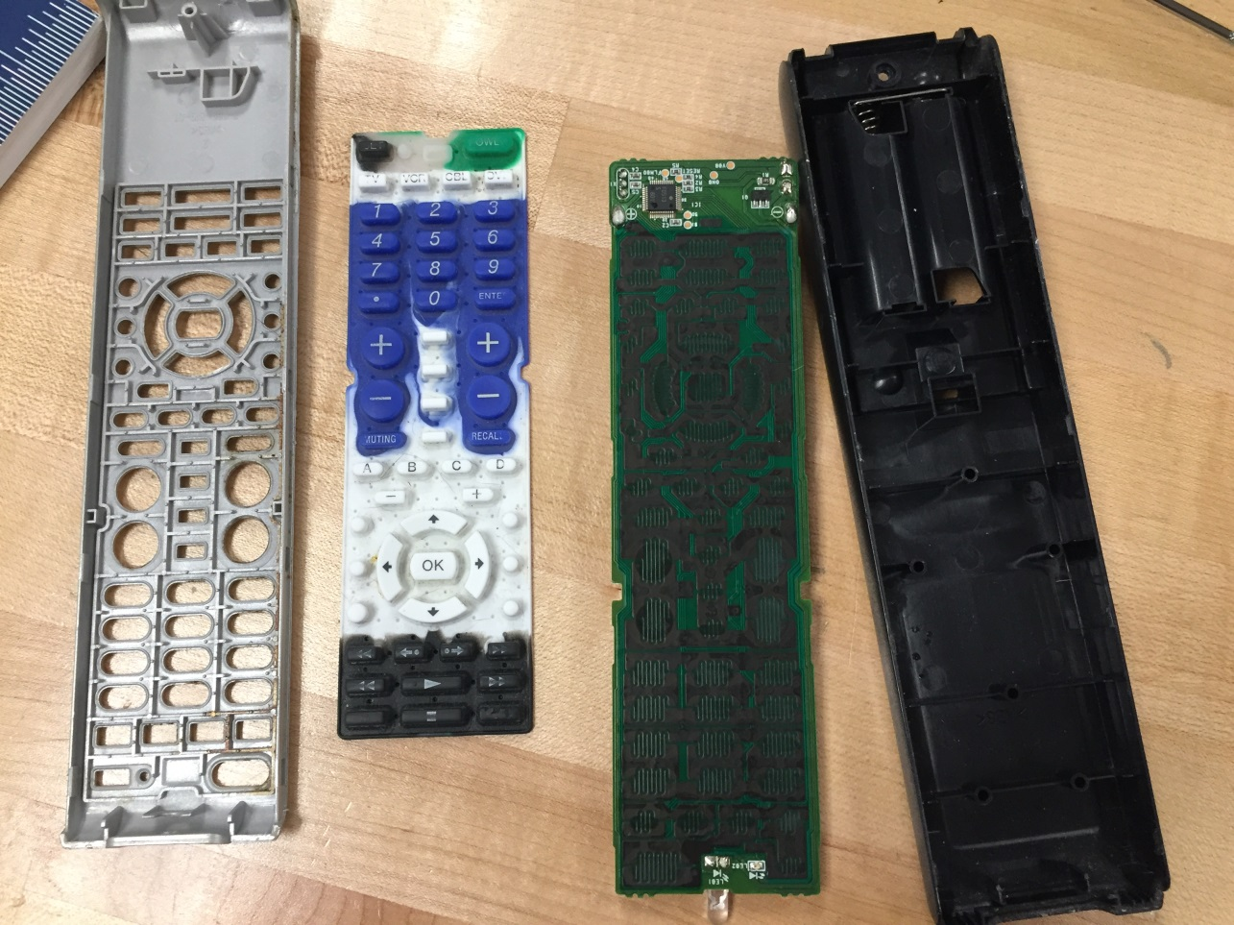

This is a picture of the inside of the remote.

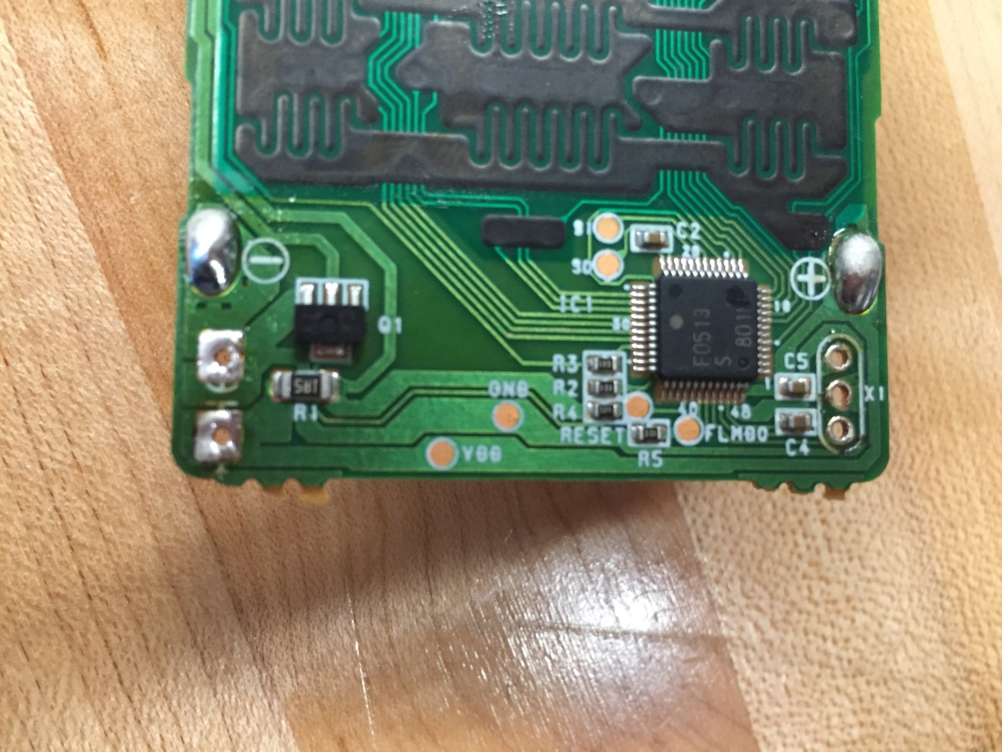

This is a picture of the motherboard.

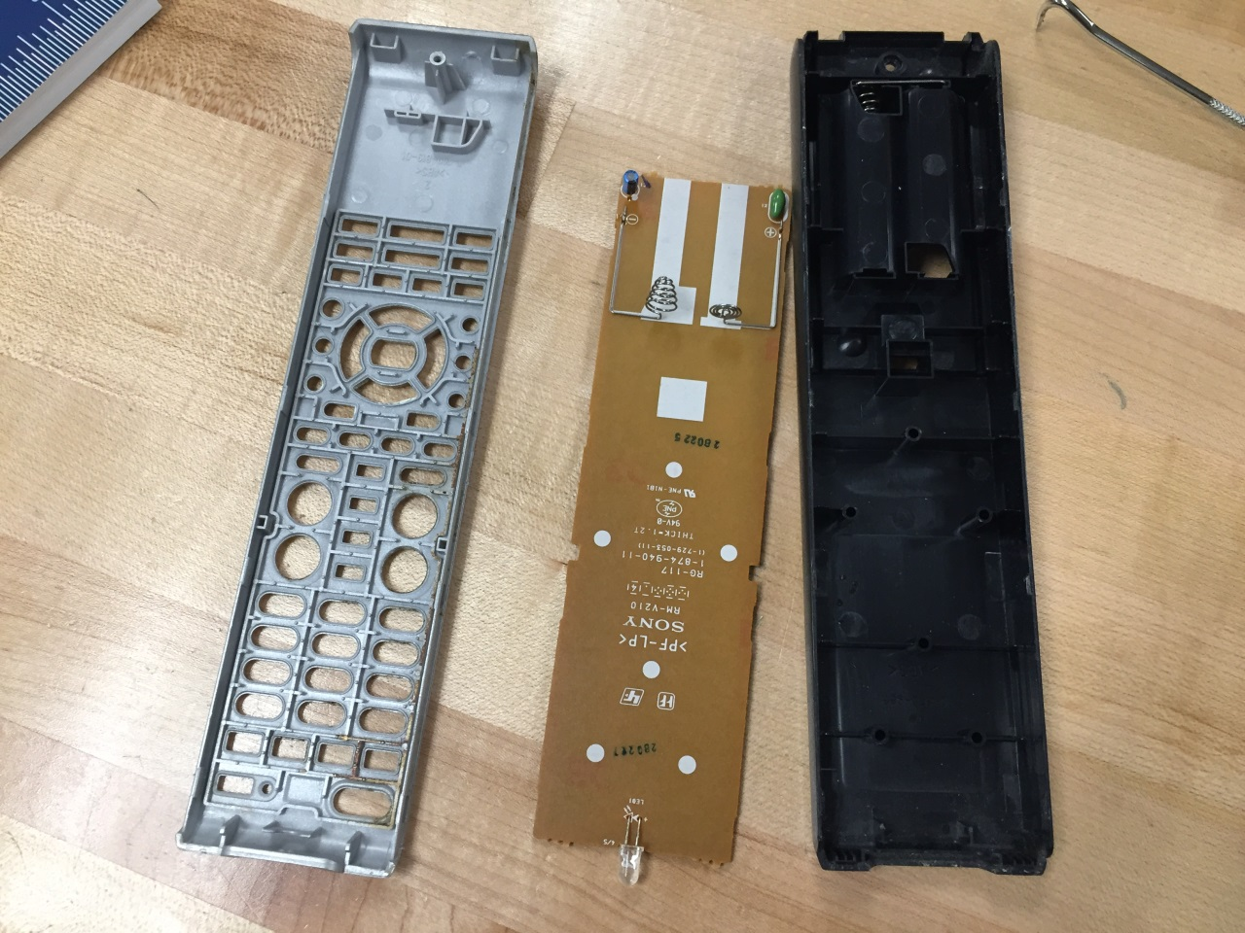

This is also a picture of the inside

Appendix C: Disassembly

We used screwdrivers to pry apart the casing and then there was only one component left. We de-soldered two capacitors from it. There really wasn’t much to it, simple interior.

Work Cited

Tonks, D. (n.d.). RC: Sony RM-VL600 Remote Control Review (1). Retrieved September 27, 2016, from <http://www.remotecentral.com/Vl600>

Sony Universal Remote RM-VL600 User Guide | ManualsOnline.com. (n.d.). Retrieved from <http://tv.manualsonline.com/manuals/mfg/sony/rmvl600.html>

Sony eSupport - RM-VL600 - Support. (n.d.). Retrieved from <https://esupport.sony.com/US/p/model-home.pl?mdl=RMVL600&LOC=3#/howtoTab>