VexIQ Online Challenge

Over the years the iPod touch has evolved into new ways to do all of the possible things it can to this day. Inside the iPod touch we know there will be many complex parts that aid the iPod, but we will be able to list all the parts of the item to make the iPod touch what it is today. There are many different types of the iPod touch but the one I am going to be cracking open and observing the third generation iPod touch. We chose

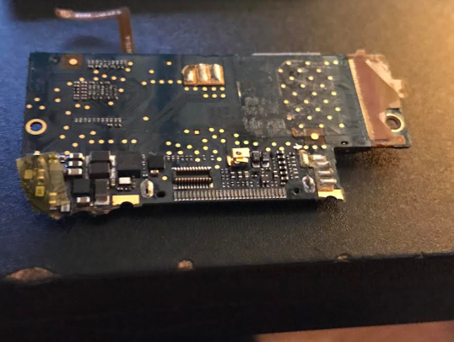 What's inside? Well, inside the iPod touch there are many pieces that all work together to cause the iPod to function properly; here are all the parts we found:

* Screen Protector (Protects from physical damage)
* The battery (Makes the device itself function)
* LCD Display (Screen)
* LCD Metal Backplate
* Touch Wheel Cable
* A bunch of screws (To hold the iPod in place)
* A front panel
* The plastics of the front panel
* 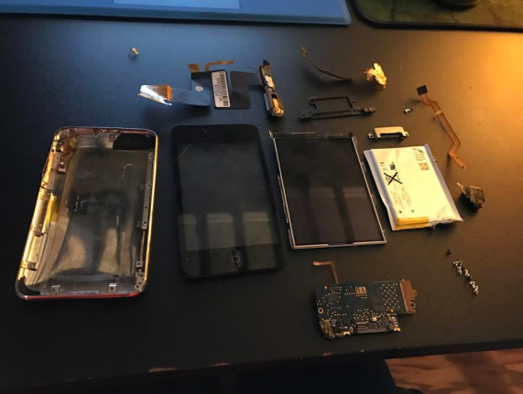Hard drive cable
* Logic Board (Mother Board which is the main circuit board)

Please note that the iPod itself is made from recycled stainless steel and aluminum and a tiny bit of gold.

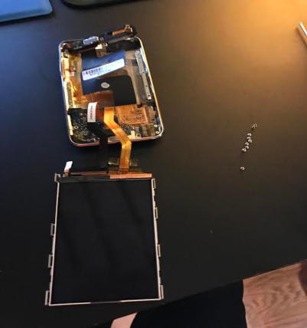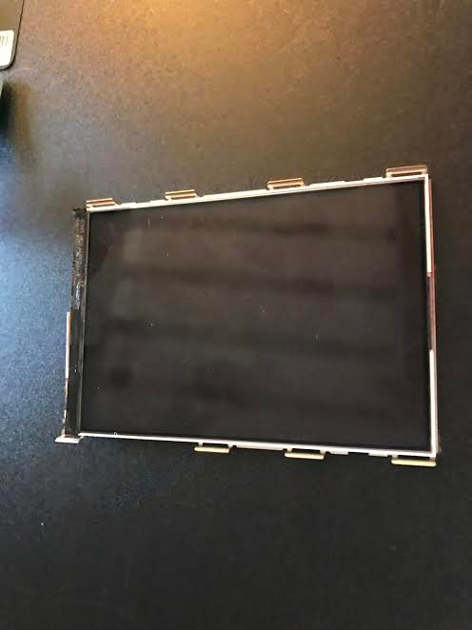

Final Summary Report

In conclusion to the deconstruction of this 3rd Gen. iPod, we found the screen protector, the battery, LCD display, LCD metal backplate, a touch wheel cable, a load of screws, a front panel and the plastics from it, a hard drive cable, and the mother board. Sadly, we could not find any TI Components because Apple does not assemble iPods with Texas Instruments. The main reason we chose the iPod 3rd Gen was because it was the only device it in my VEX group that was useless, but it showed how one of the earliest iPods Apple has made. It gives us a true idea how iPods have significantly changed in price and quality. Although it is an model, it is still quite complex. Although the use of iPods have decreased, it is still the number one popular MP3 on this planet to this day. The main age group that has one are very young children. Some reasons are because it has a search engine and YouTube, as well as games and a wide variety of music. The main lesson we learned about in this tearing apart of this iPod was that it was not as hard as we thought it was, but the parts were not so easy to understand. We have found out that there are many parts that help keep the iPod to function. Our group had to be very delicate of taking out and dismantling the iPod, so it won’t break. The parts that we didn’t know, we asked our VEX IQ ROBOTICS teacher, our peers, or searched it up online with key factors. The iPod gives us a very open understanding of how engineers assembled important parts. This deconstruction also helped us on knowing where a part goes, how it get gets put, and what the part is. Now we can officially compare this old iPod to the newer ones!