Winnetka Wildbots 224X

We first chose a LG phone but after some research we only found 1 Texas Instrument component on the device so we were looking for another device until we found a LG 50 inch LCD TV .We first took the back plastic that covers the inside of the TV off so we can be able to see the parts.

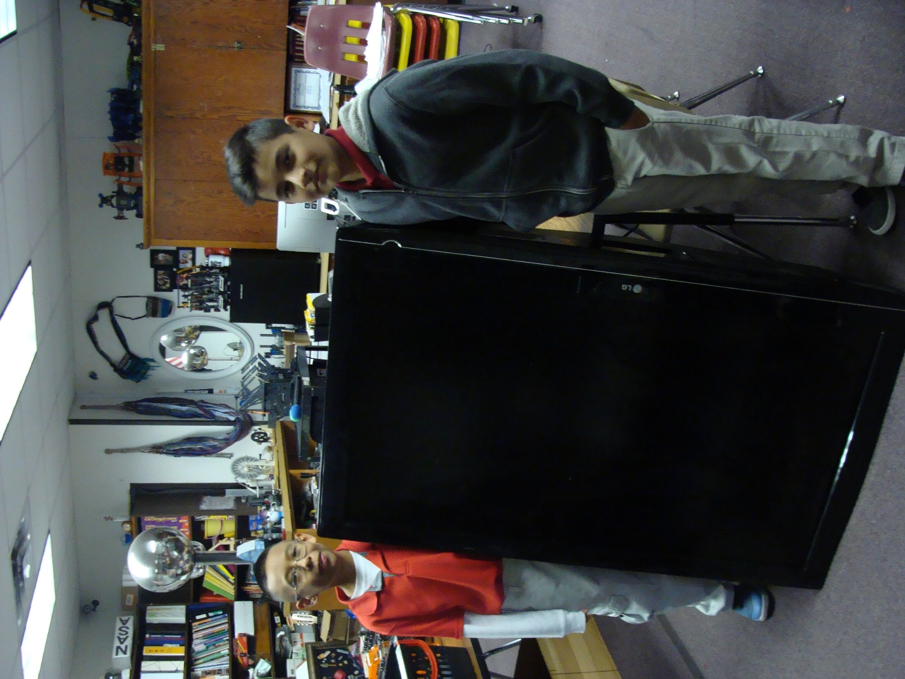

The parts of the screen, the area where the circuit boards are arranged in the back and that’s called the chassis. A LCD display made out of TFT glass. It also has polarizers and diffusers these help focus and balance the light across the screen. Cold cathode fluorescent lamps go horizontal across the LCD TV. Reflector intensifies the light hitting the polarizers and diffusers made of white-clear plastic.

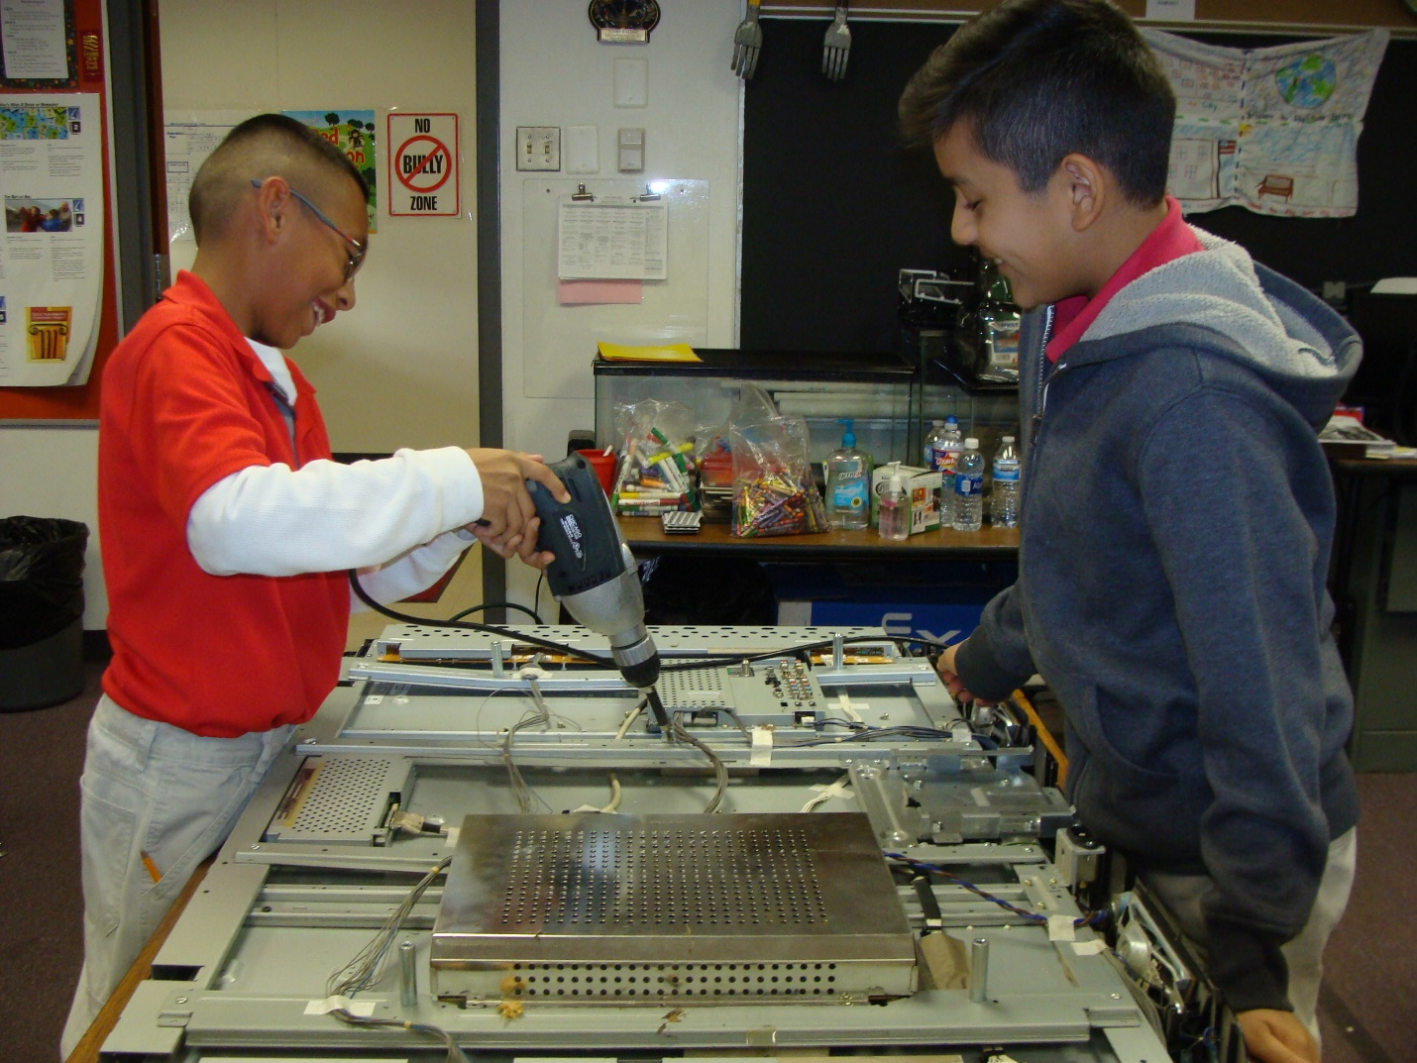

We found two semiconductor that had the Texas Instrument logo on it. It was on the Main board. There were many more semiconductors on the Main board, Control Board, and Power Board. What does a semiconductor do is the conductivity of a semiconductor is somewhere between that of an insulator, which has almost full conductivity.

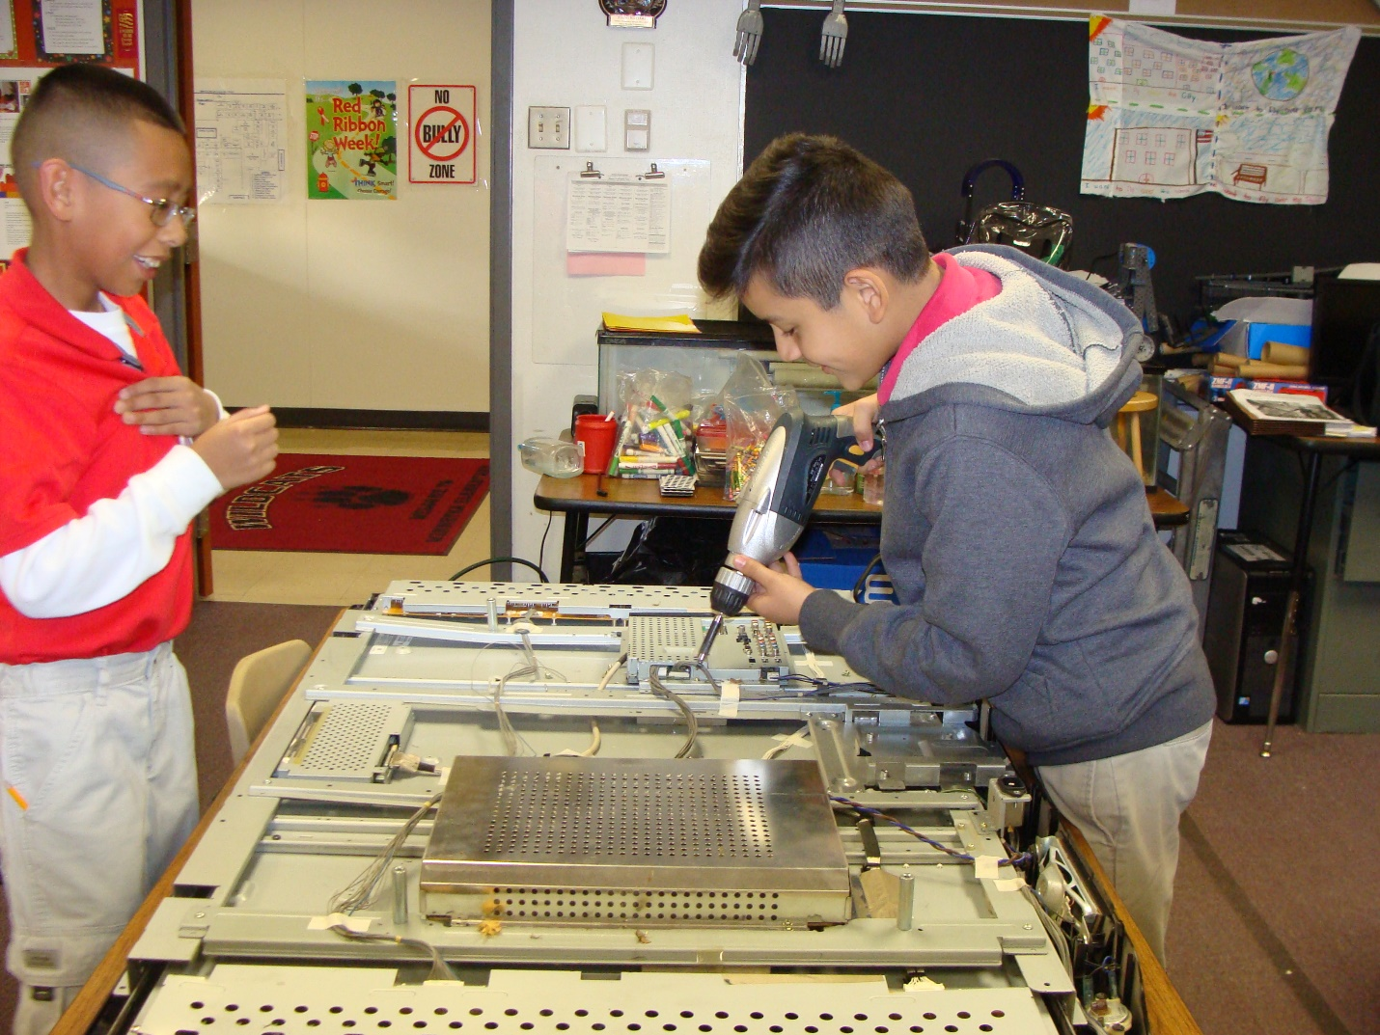

Most semiconductors are crystals made of certain materials, most commonly silicon. Most conductors have just one electron in the valence shell.

The power supply takes in power and distributes it across the TV and it’s connected to a power court or an AC adapter.It converts the main AC supply into DC voltages that can be used by the circuit within the LCD TV.

The T-Con Board or Control Board is to control logic signal of gate and source for driving TFT LCD. 

The inverter boards are usually found along the edges nearest to the TV Panel and are only found in LCD's. These boards function is to convert the low voltage DC supplied into a high AC voltage to light up the backlights.

The main board or motherboard has 1 USB port, 3 HDMI ports, 1 OPTICAL port and 1 S-Video port. The function is to take in the video and audio signals and convert the analog video signals into digital signals that can be sent by the low voltage differential signaling to the T-con board.

The audio signal is taken to the audio processor and then audio amplifier which then drive the left and right speakers.  On this LG LCD TV the jack pack was attached to the main board.

LCD stands for liquid crystal display and it is a thin, flat electronic visual display that uses the light modulating properties of liquid crystals. LCD do not emit light directly thus backlights are needed to make it where you can see them. The function of backlights is to illuminate the LCD from the back of the display panel.

**Semiconductor**

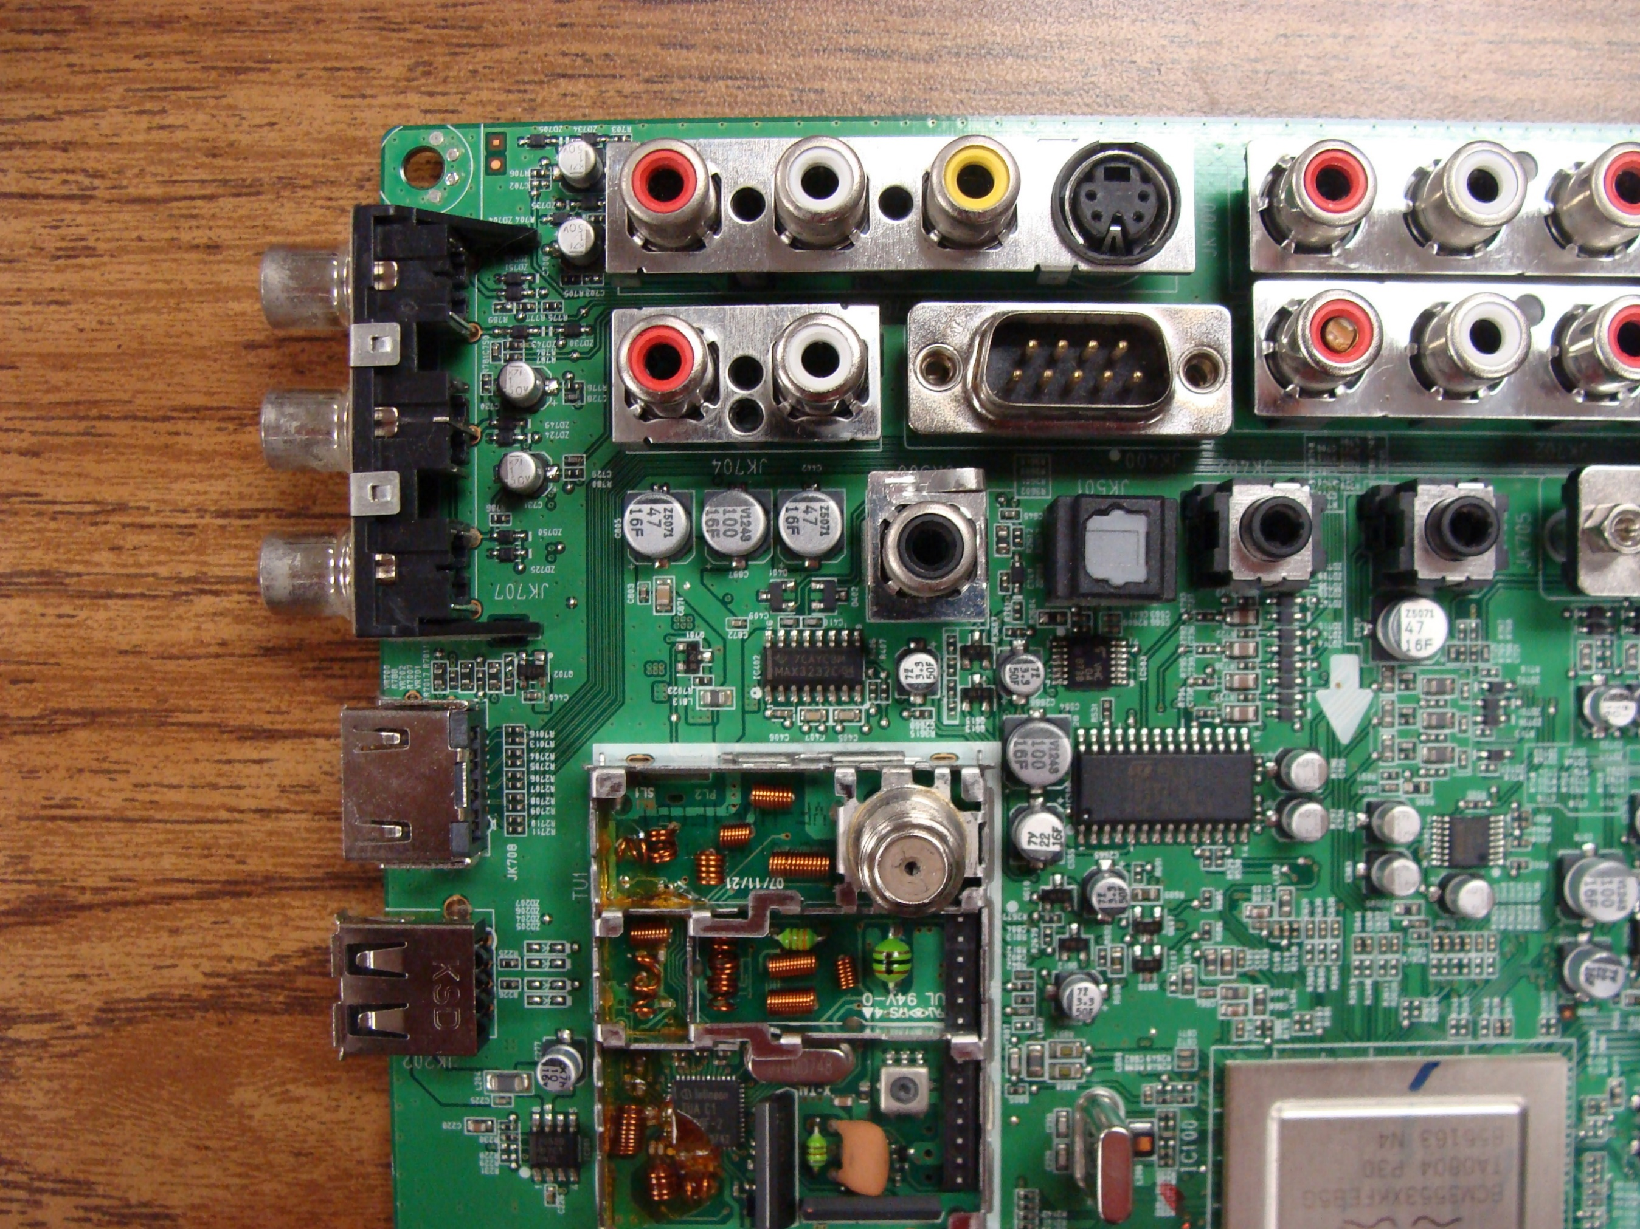



**Side Key Panel board**

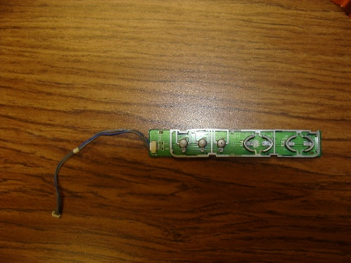

**Power Control/Remote Receiver Unit (IR/LED control) board**

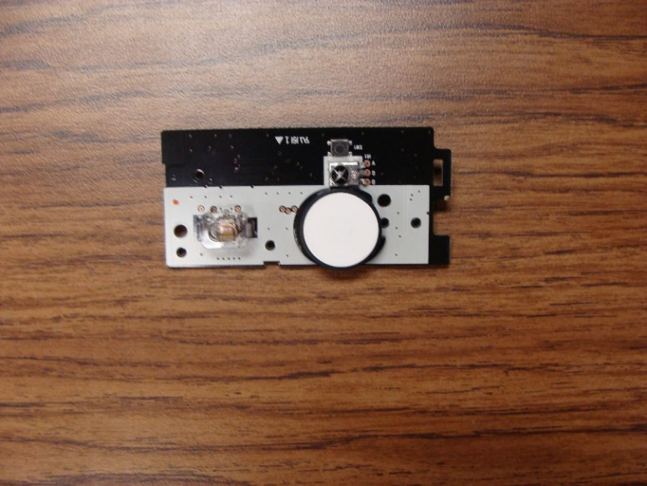

 **Left Speaker & Right Speaker**

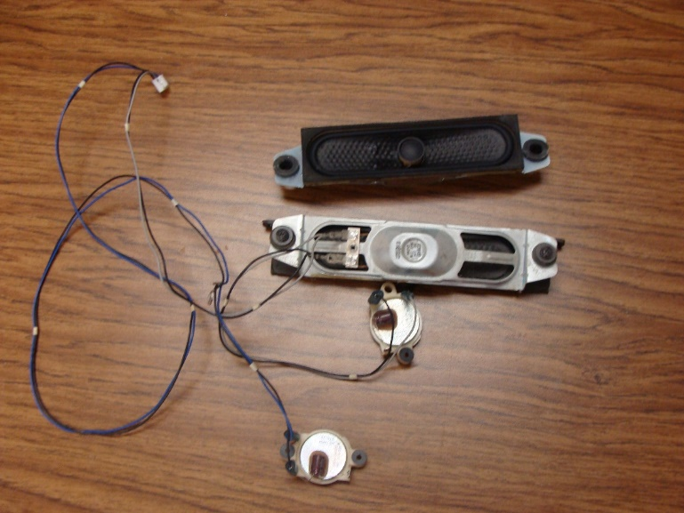

Power Board

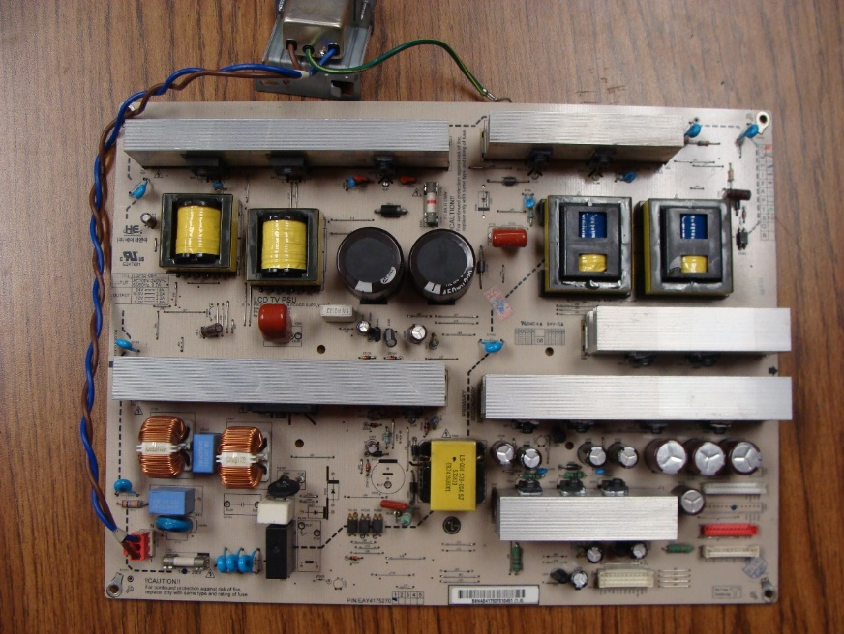

Timing Controller Board (T-con board)

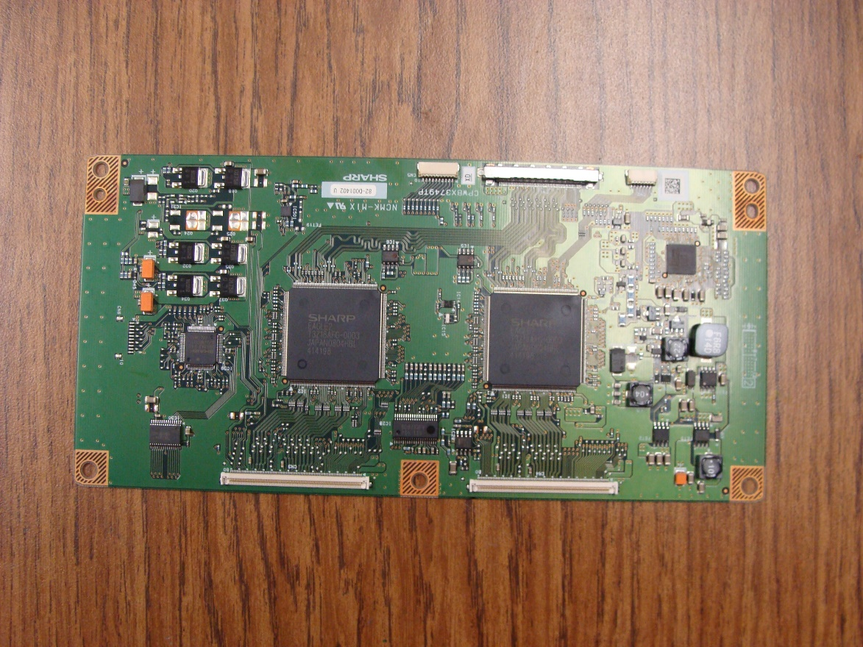

Inverter boards on both sides

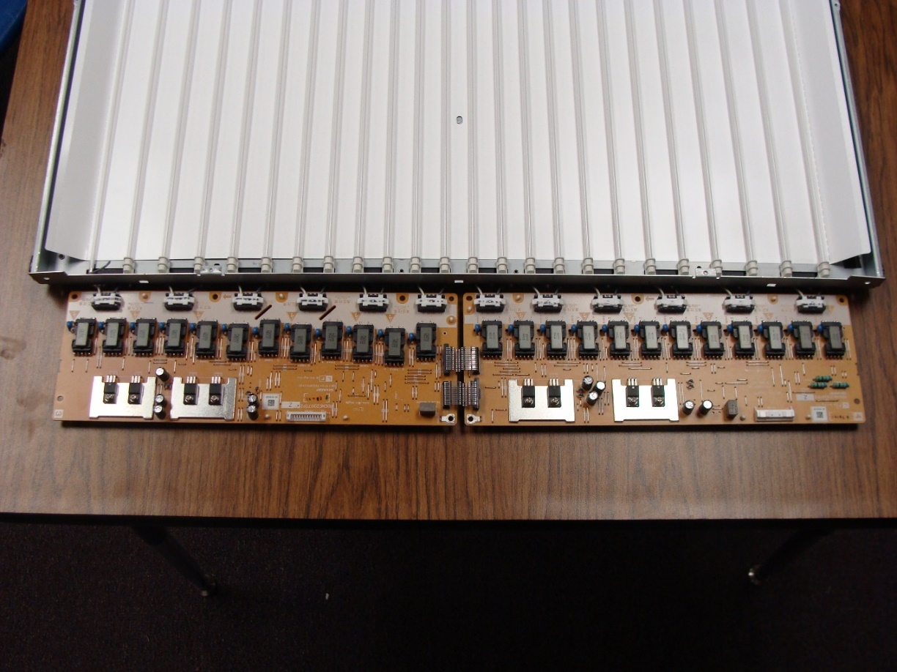



Mainboard

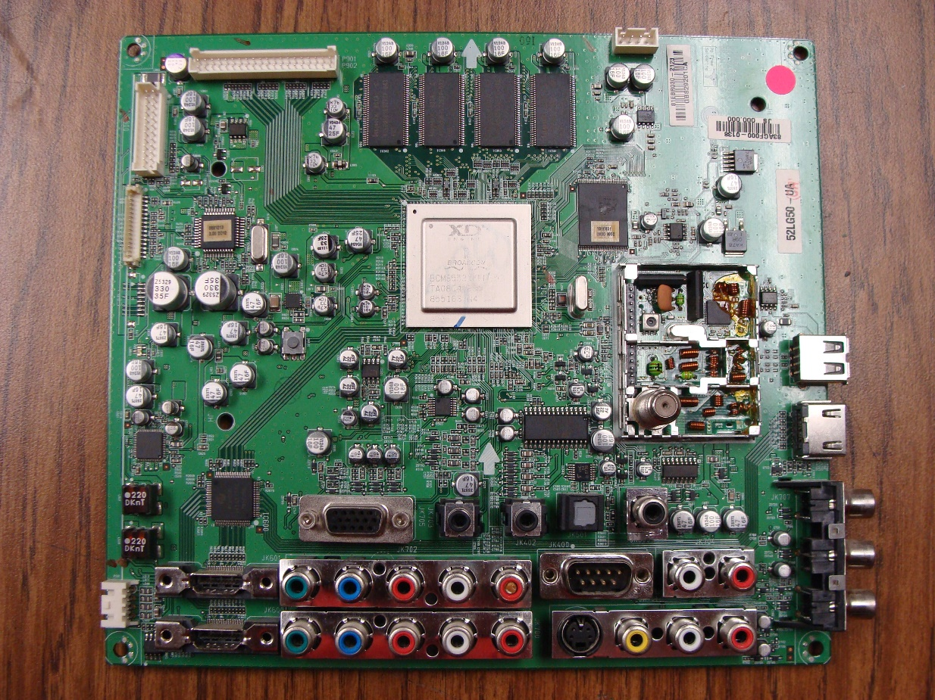

Jack pack Section

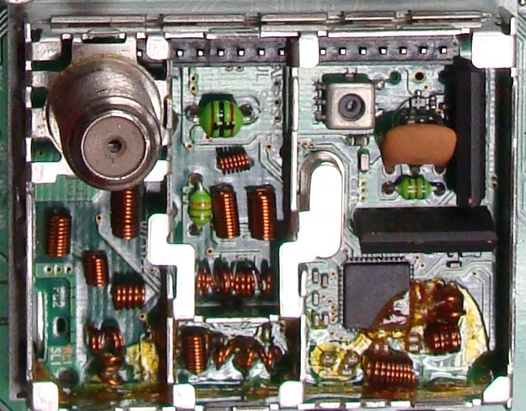

LCD Panel

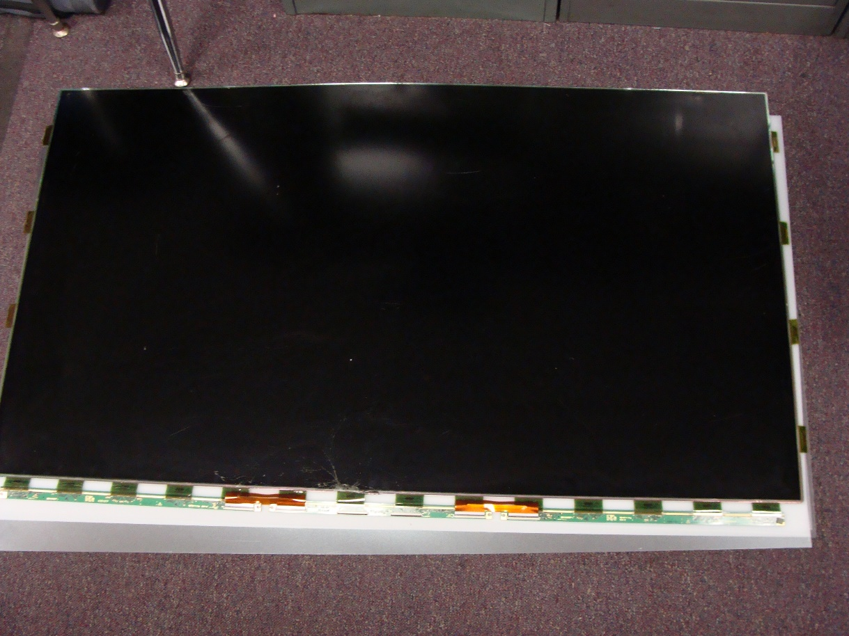

Backlights

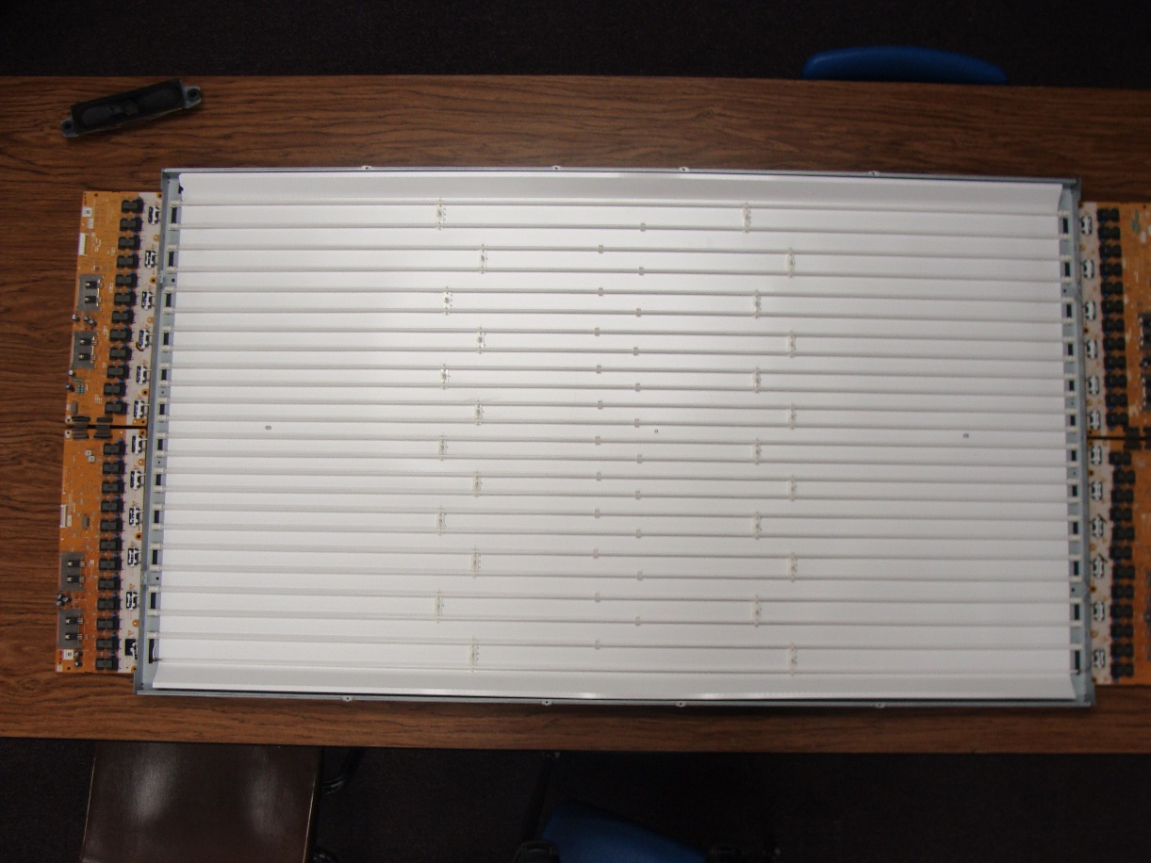

**Polarizers and Diffusers**

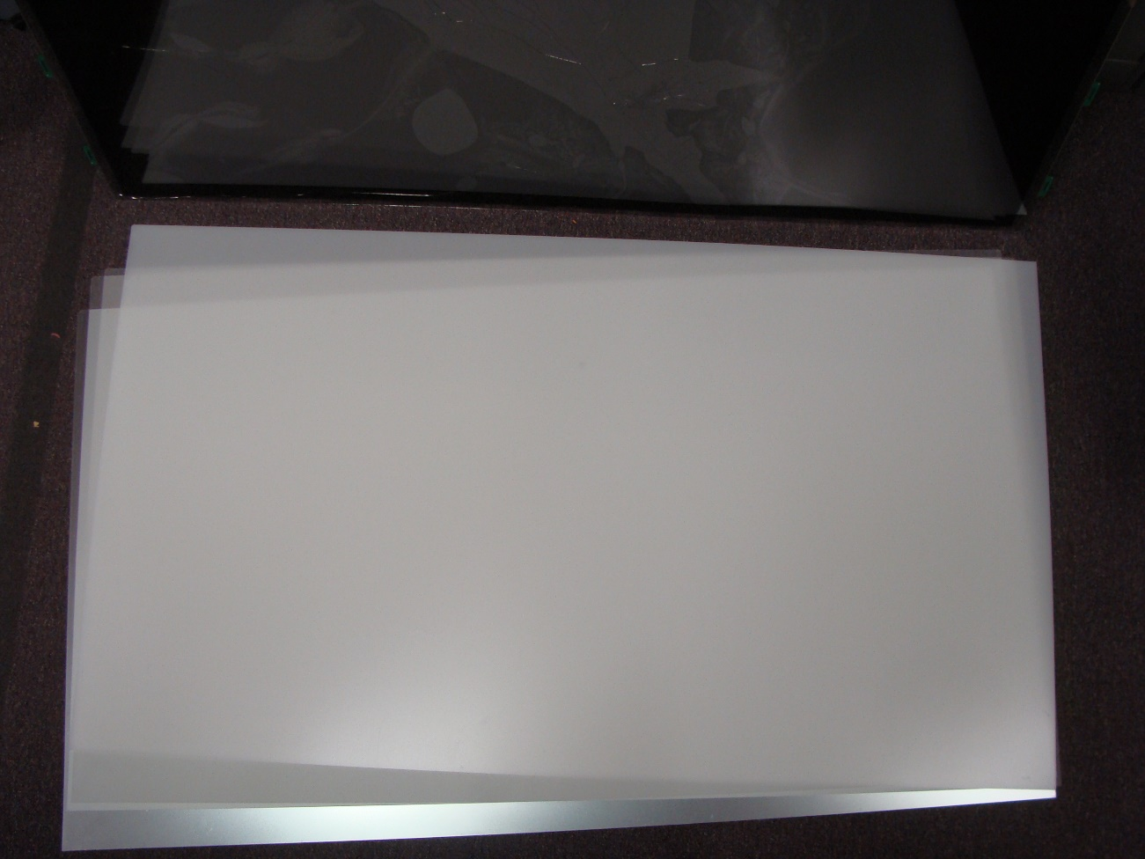

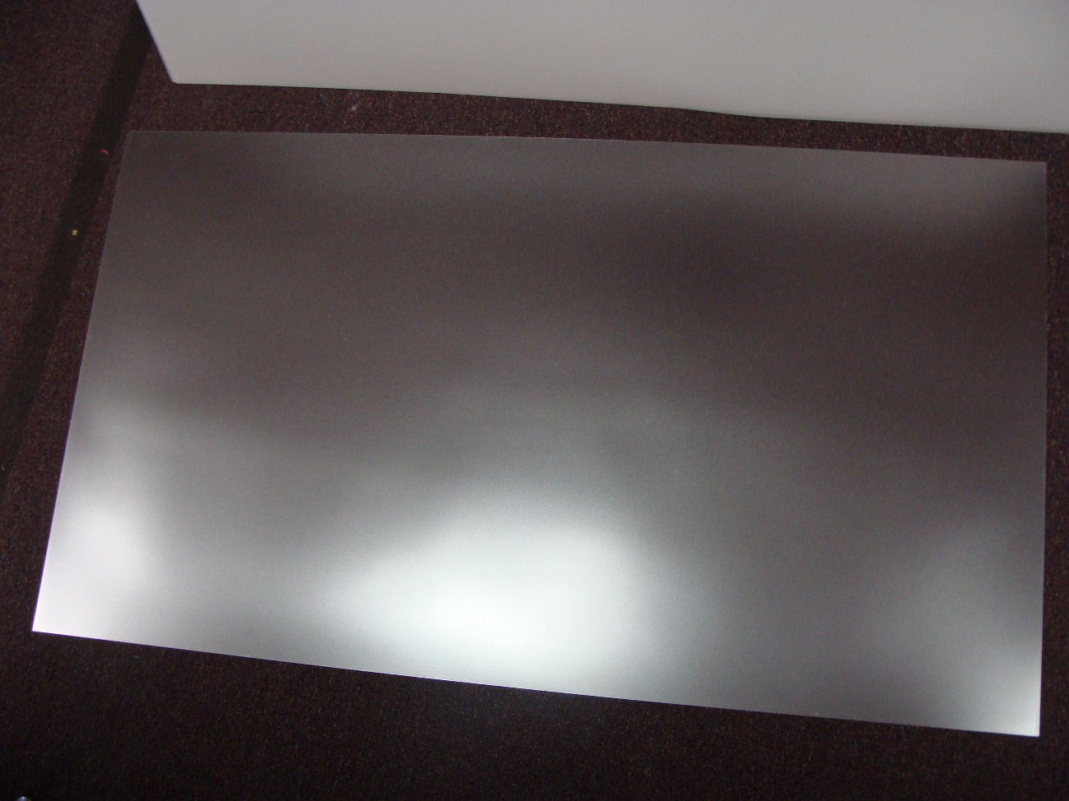

**Cabinet assembly**

