Future Robot Challenge
By: Alex Kirchner, Steven Trinh, Elijah Nierstheimer, Landen Ho, Cristian Franco
Introduction
At first, before we considered the design, we had to consider how many parts were available to us. When we started the construction of our bot, the competition team started their construction. We only have a finite amount of parts, so we had to consider the fact that we could not use most parts that the competition team was using. Lock nuts were off the table for us because lock nuts are scarce and the competition team needed all the lock nuts they needed. 45º gussets were very scarce, so we couldn’t build a holonomic or a X-drive yet we could build our cup holders for our design.
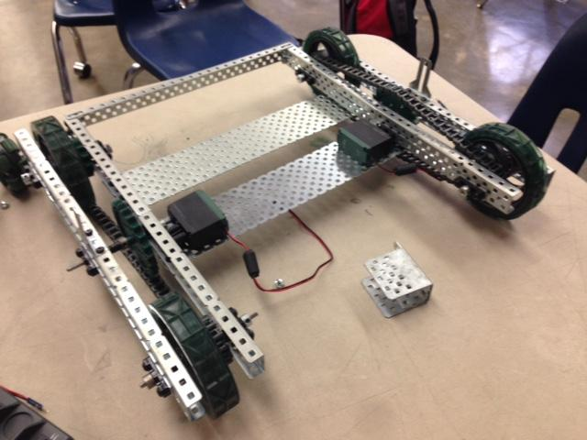
Design Process & Base Construction
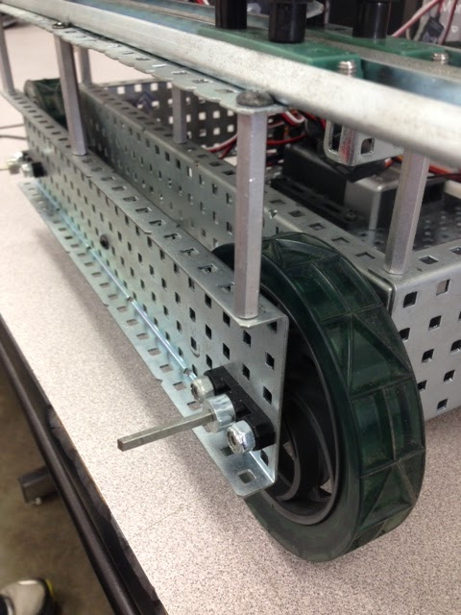
We started out with the idea of a holonomic with a medium sized cylindrical cooler on top that could maneuver its way around any area using ultrasonic sensors, and serve drinks, food, etc. to people. The one problem that made us change our design was the fact that the holonomic would most likely not be able to support the cooler’s weight, or the cooler would bend the metal parts in the holonomic. We changed our design so that we wouldn’t have to worry about weight. Our new idea was to to build a square base using two motors with sprockets and chains, with a scissor lift that lifts a tray of food and drinks, but we kept the idea of using ultrasonics. So we started off building the base, it was a 18½ in. by 19½ in. that used 6 35x5 C-channels and 2 35x5 plates that supported the cortex and kept the base from wobbling. Two wheels on each side are between two 35x5 c-channels. After running our prototype program a couple of times, we observed that the sprockets and chains didn’t line up which caused slipping. The sprockets were then replaced with gears, but the same outcome happened. Our final base design was the simple VEX drive which would allow cooperation between the code and construction.
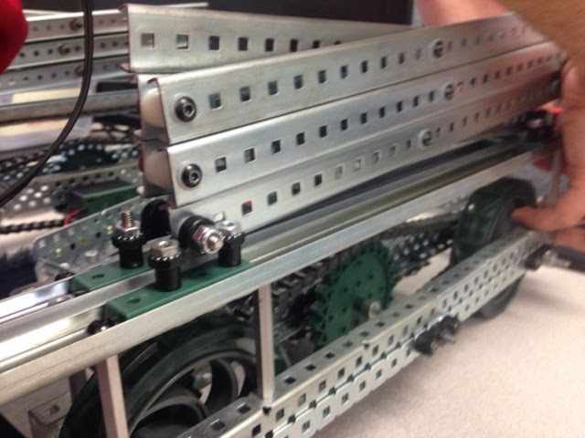
Lift Construction
After building the base prototype, we started on the scissor lift. We decided to use 12 24 holed tracks for the scissor lift, 6 on each side. Each side of the lift is controlled by two motors running two 12 teeth gears (spur gears). Those two gears run one 84 tooth gear so that we have a gear ratio of 1:7. At the bottom, each scissor lift slides on four inside sliders, which slide on two 33 holed tracks. Two of each set of sliders are bolted down so that the lift can move in equilibrium with the opposing lift. Each side of the lift sits on top of each side of the base. When fully extended, the lift is 17 inches tall, when compressed, the lift is 9 inches. In total, the lift is supported by 12 2in. standoffs, 6 on each side. To allow both sides of the lift to work in unison, we connected the two sides of the lift with two bars, one on each side at the top of each side of the lift. Later when we were testing the programming, the motors powering the lift were a bit too weak, so we attached bundles of rubber bands to connect the front and the back of the lift so that the elasticity of the bands would support the motors. It took us a couple of times to get the spacing and functionality correct, but we got it right in the end.
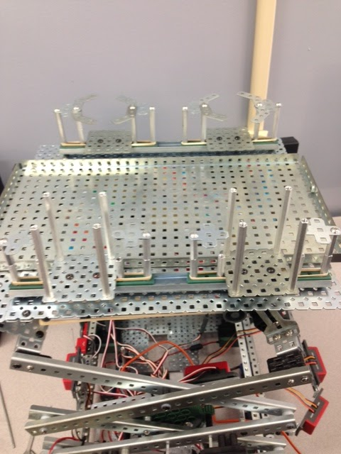
Platform Construction
The last construction element in our design was the platform which held the cupholders and tray. We used one base plate to act as the tray for snacks, and hold two 5x35 plates which are used to hold the sliding cup holders. Our sliding cup holders consist of two inside sliders on a a 23 holed track which have two 1 in. standoffs which are connected on the top by a cross gusset. The gusset has two 45º gussets on top which can swivel to conform to any cup. In total, there are 4 cup holders, therefor there are 8 sliders in total with 2 cup holders on each side. When you add the measurements of the base height, lift height, and platform height, the robot’s total height is 29 inches.
Programming and Maneuverability
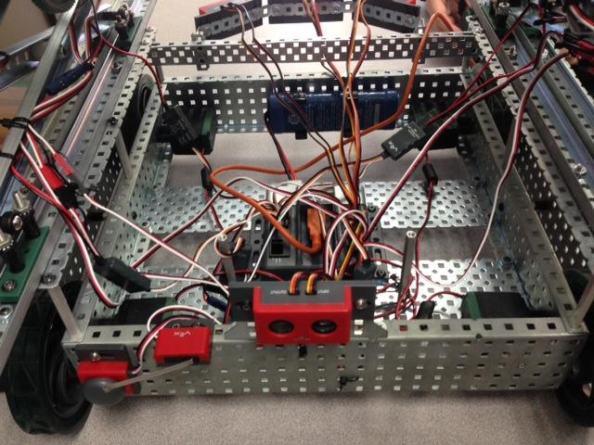
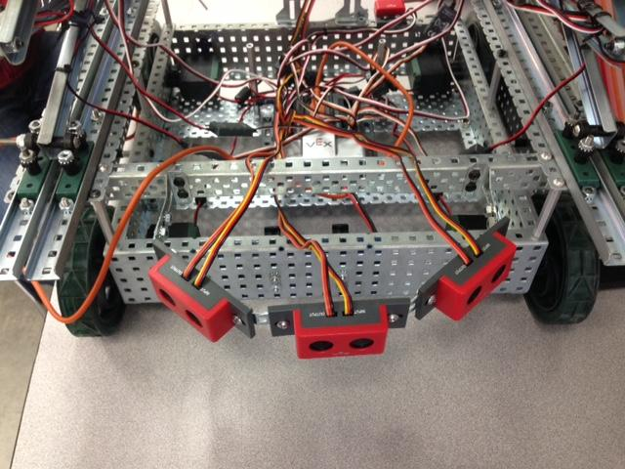
After finishing the body of J33V3S, our last obstacle was to perfect the mind. Our first ultrasonic configuration was to have 4 ultrasonics on each side of the base, so that J33V3S would have a full 360º detection field. The main problem with our first configuration was that the sensors would detect too many objects at one time. We improved our program by decreasing the range of the sensors but even then, the robot would still turn incorrectly. One member of the group suggested that we have a semicircle of three ultrasonics on the front that had an approximate range of 140º. In addition to the array, one ultrasonic was placed in the back so that the robot could turn around for a user. One last problem arose: when the bot detected something, it would continue in that direction and wouldn’t stop. The addition to a stop zone would prevent ankles from being bruised and items being damaged or pushed over.
We set our motors on the base to 80 because this value was the optimal speed our robot could perform on. Any more or any less would result in the robot being unstable when the lift is fully extended while turning, or the robot being too slow to follow anyone. We ran multiple values to find this “sweet spot”.
The four motors that operate the lift are set to operate for 1.7 seconds at a time, this will prevent the gears from slipping and the motors from burning out.

