ROBOT ARM Mk1.1

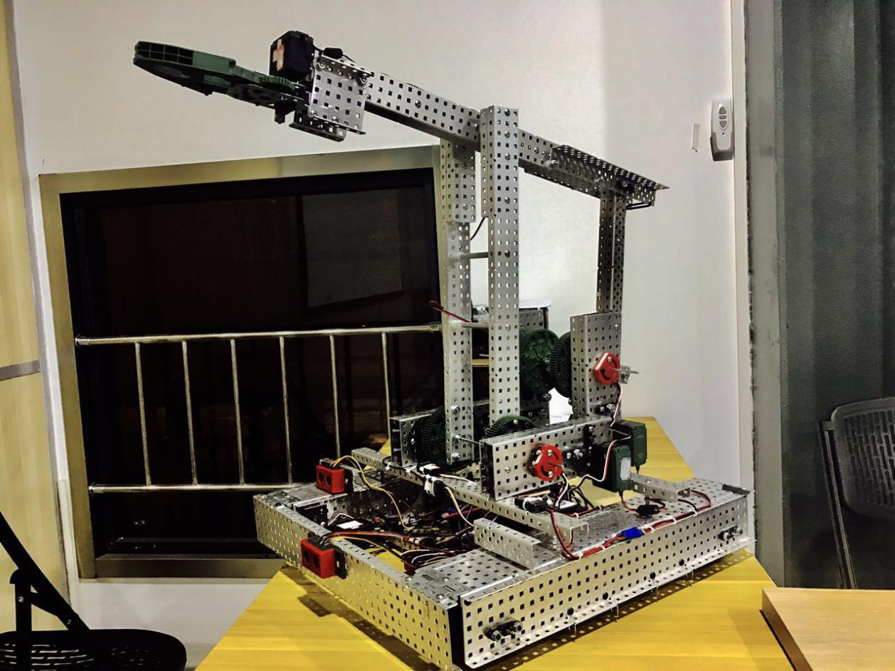

BY XILIN TANG

As you can see, this robot’s code name is robot arm Mk1.1, it means, that is just the beginning for a big plan to set up a robot system. In fact, when I watch some science fiction film, like iron man or star wars, there are lots of robots to help people and to do some interesting things. So I ask, why I can’t to make a robot like that?

1.1 Brainstorming
Rome was not built in a day. As beginning of this,I have two different way to solve this problem. At first，in the one hand，I think I can make a robot very" lovely "like a robot pet whic code name is “ i-BallBot" it is designed by “BB8” from “Star Wars” and “Baymax” from “Big Hero 6”. The "I-BallBot " have two system to transform, system1 is the “quasi-man” form. it is esay to help and communication with people. And system2 is a ball from it is esay to shipping. And I also want to make the ball skin whit and eyes is bule,because this color can make people feel much more comfortable.

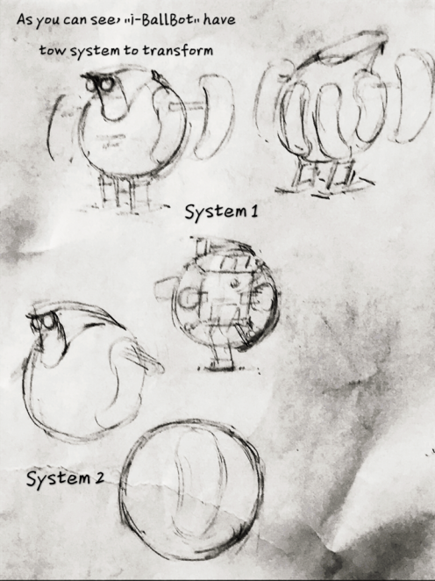
（The "I-BallBot " have two system to transform, system1 is the “quasi-man” form. it is esay to help and communication with people. And system2 is a ball from it is esay to shipping. And I also want to make the ball skin whit and eyes is bule,because this color can make people feel much more comfortable.）
In the other hand, the other way I want to make a robot look more "geek".and I got some idea from“Fallout4” “Interstellar” and “R2-D2”.
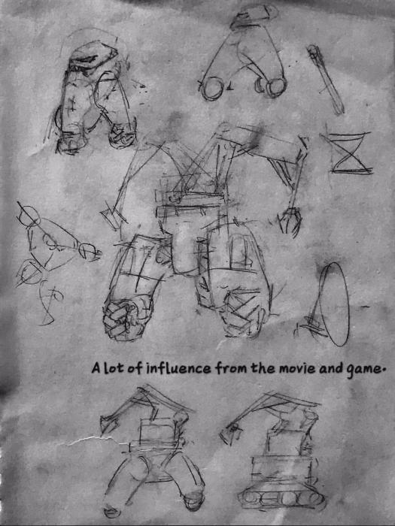
I want make this robot like a helper but not just a pet.so I don’t need it look pretty”cute”,it should

be more useful then the“i-BallBot”.And the program and the automatic control will be more important then the appearance in this stage.

1.2 Think big and do small
After the tough choices, I think the second way is the most realistic choice now I can do. It does not means that the“i-BallBot”is a bad idea to choice.But now the“i-BallBot”for me is too far away.In fact,the second idea is a good Technical reserves for me to study robotics and do more interesting design in future,foe example like“i-BallBot”.So it is good choice for me to begin a big plan.
At the beginning of the second idea,I need a brainstorming again to development. fist, I should to know what I want to show in the video. I think if the program and the automatic control is the important for my robot,I need to make something adequate perform this characteristics.
I think robot arm is best why to show my idea.of course it is little boring.But In the stage 1.1,I said that I want to have a robot helper,but now I can’t make

a human robot like C-3P0,so the arm is the only way I can choice.But the design from the 1.1 is have a problem that which type chassis and arm do you what to choice.Because,you need to compromise in the ideal and reality.
2.1 Make a chassis
Chassis is the important part of my robot arm. Because,it is not just a power system,It must be stable enough to the whole machine system,So I gave up lots of ideal design from 1.1.In fact,delta chassis,up and up the stairs all theses idea I was give up.

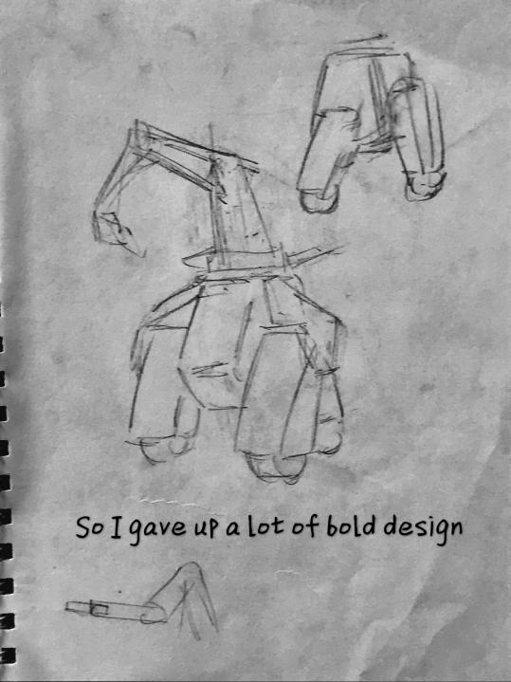
（Delta chassis,up and up the stairs all theses idea I give up）.

Finally,I Choice the 4x4 chassis to be come my Mk1.1
robot arm’s chassis.
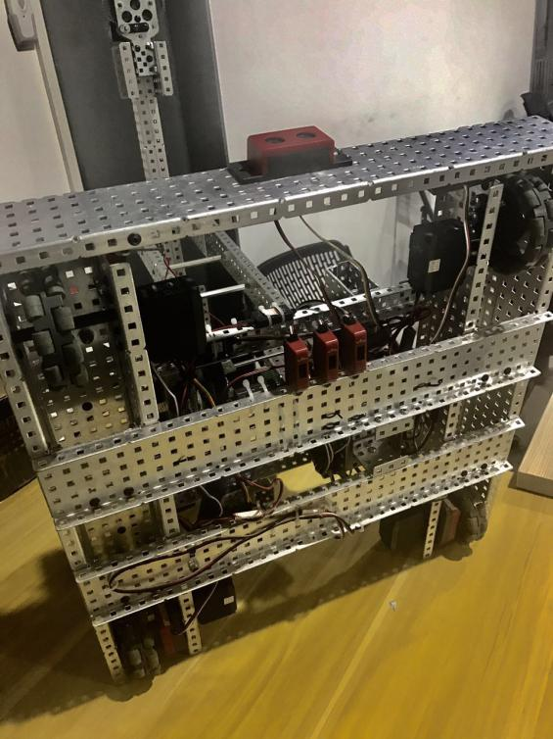
(Finally,I Choice the 4x4 chassis to be come my Mk1.1 robot arm’s chassis .)

2.2 Arm systems
Now is our protagonist’s show time. Robot arm is difficult to make.Because you need to make it in the existing conditions as stable as possible.So I have three idea to compare which one is the best choice.
First one is motor direct driving ram,I design it has six motor to control,and this one can do lots of difficult job then anther one can do.for example like pour water.But the defect is,that one is too heavy.

Second one used the mechanical structure is two parallelogram and one delta with tow motor,it is easy to control but problem is that one have high demands on parts.
Third one is same like second one.that one use mechanical structure too. And power from tow motor unit,it is easy to control,but dose not need high demands on parts.And for this plan, I got some inspiration from a Industrial robot and a toy robot.

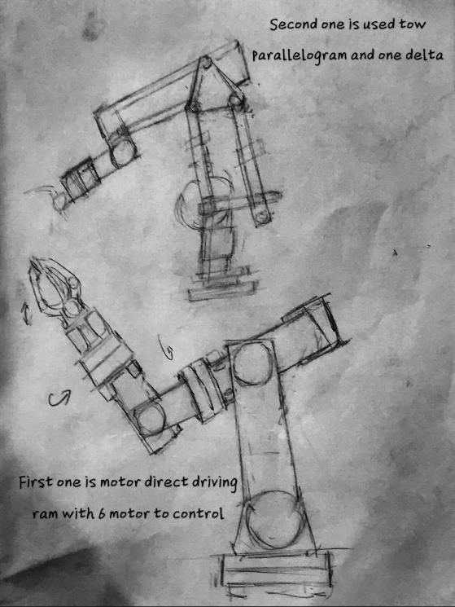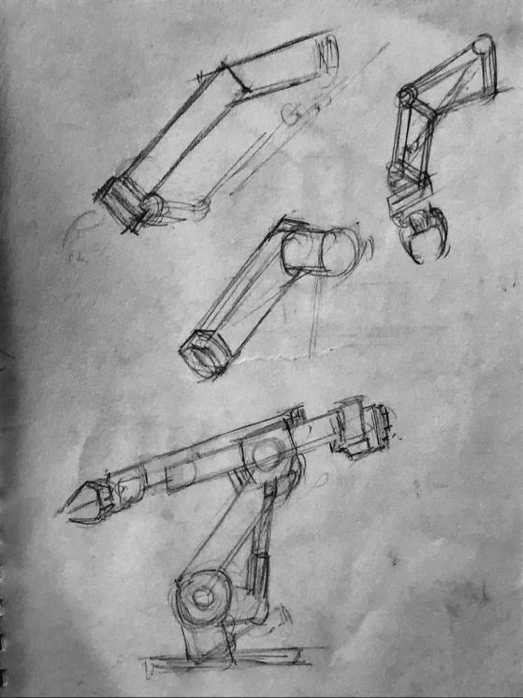

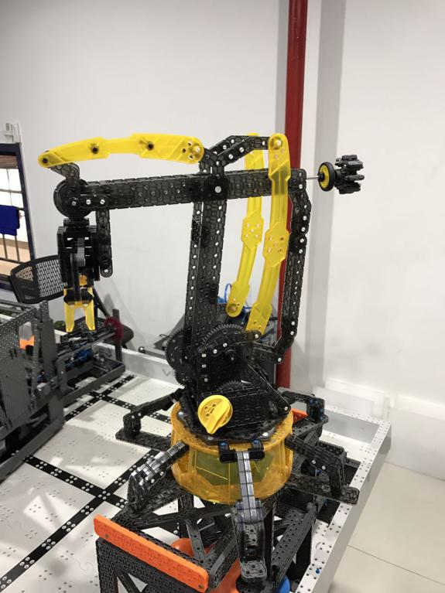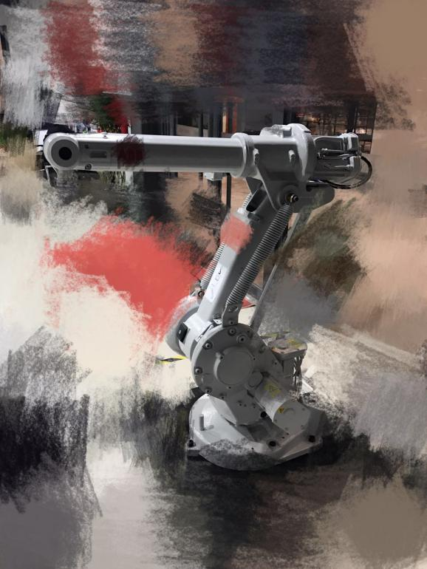
(The inspiration from a Industrial robot and a toy robot.)
In the end,I chose the third plan to make my robot arm.And I use 4 setting of 100RPM motors and tow 1 by 21 gear ratio unit.

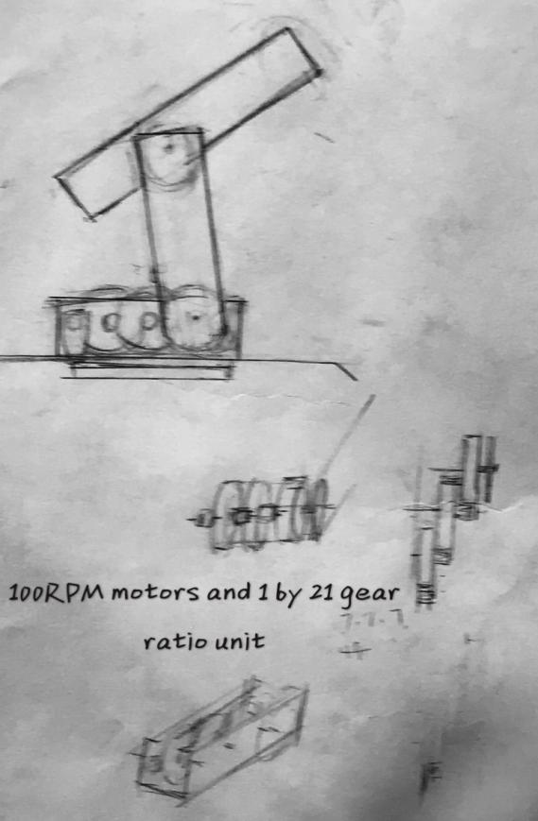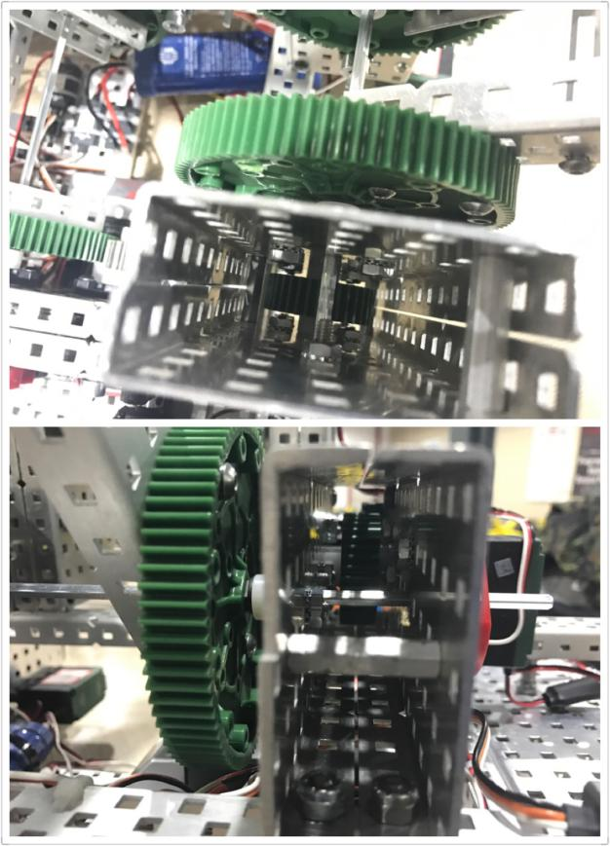

3.1 Sensors and controllers
In the stage 1.1, I said the program and the automatic control is most important for this robot ram,so I use lots of sensor for this robot.And sensors are :

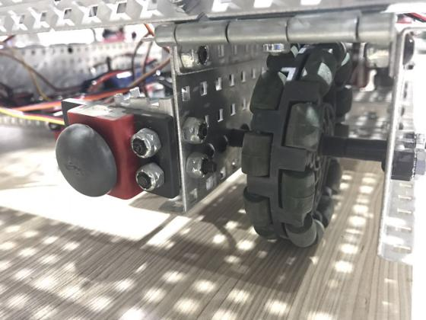bumper switch x1
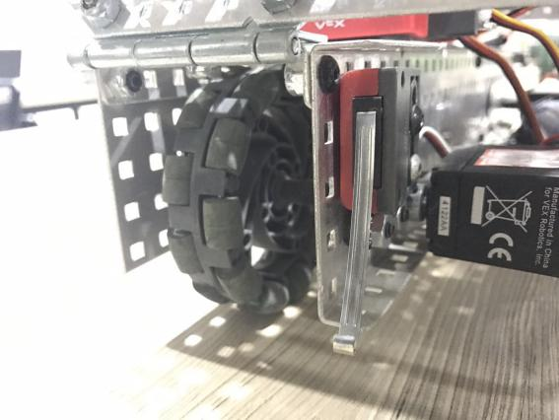touch sensor x1
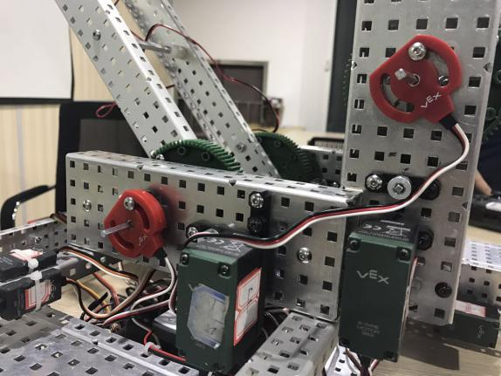potentiometers x2
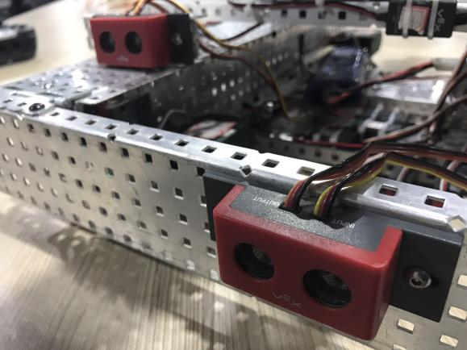sonar sensors x2
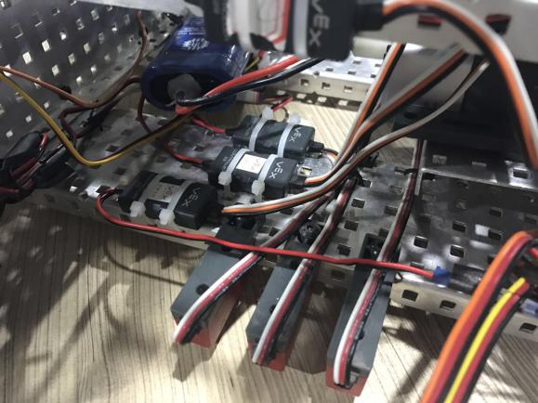line follower sensors x3
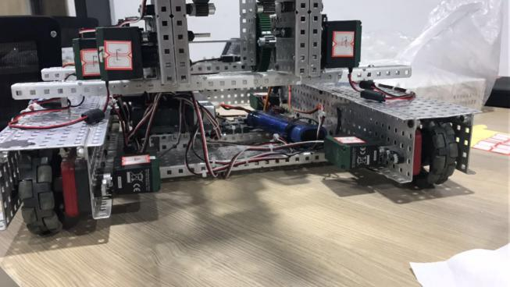encoders x2

The controllers are :
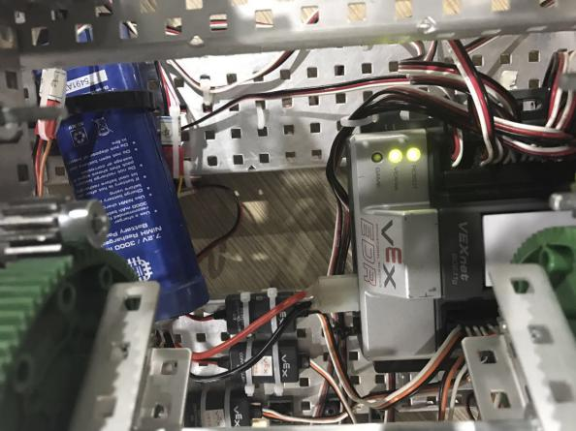VEX cortex brain x1
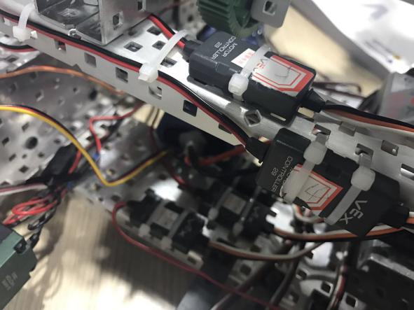motor controllers x9
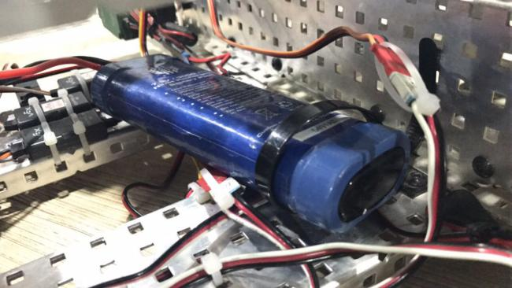main battery x1

And the our VEXnet and how to control:

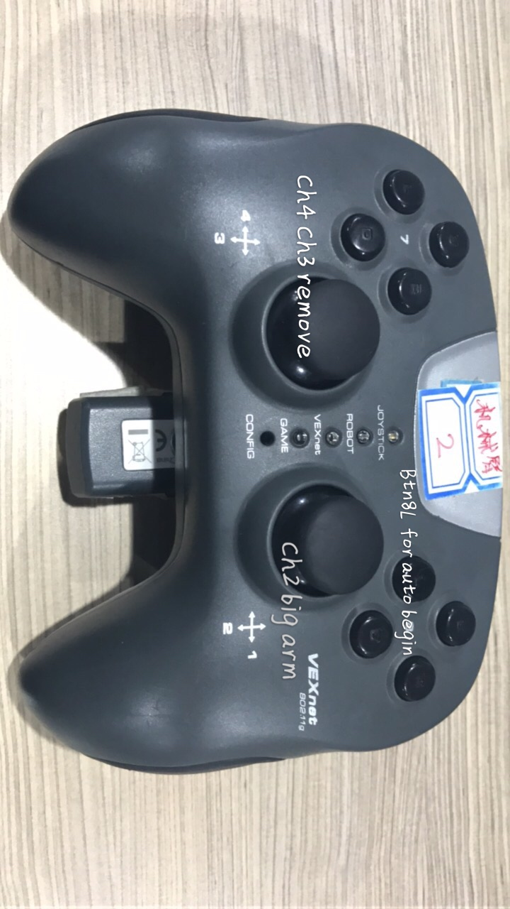

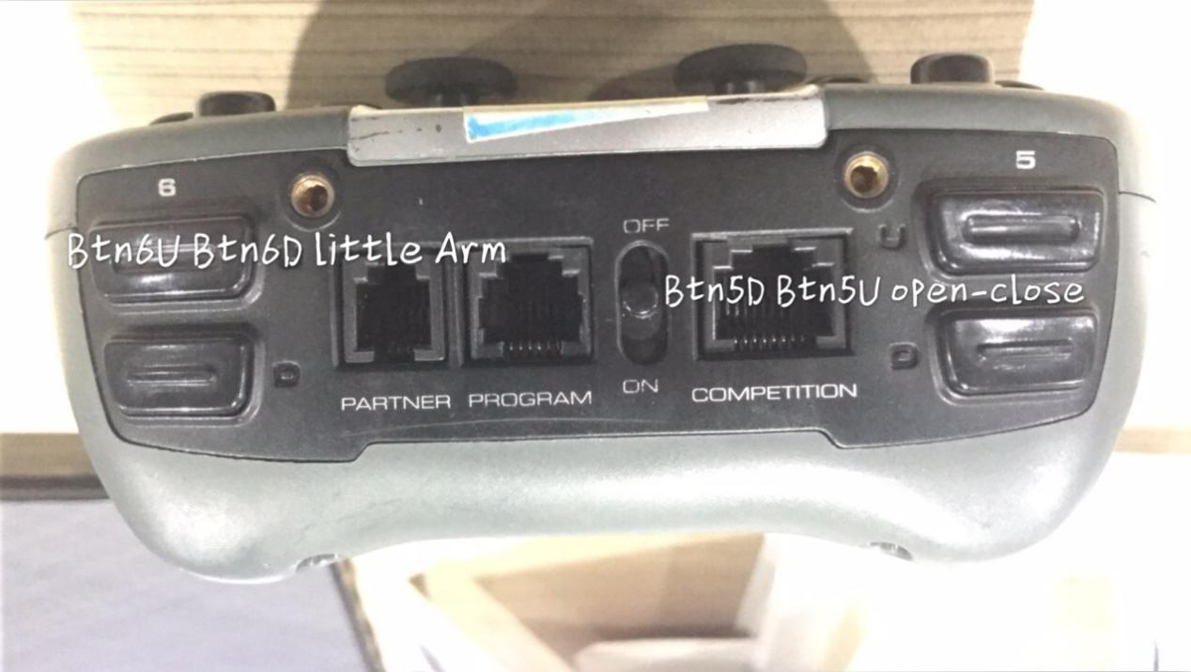

3.2 The program
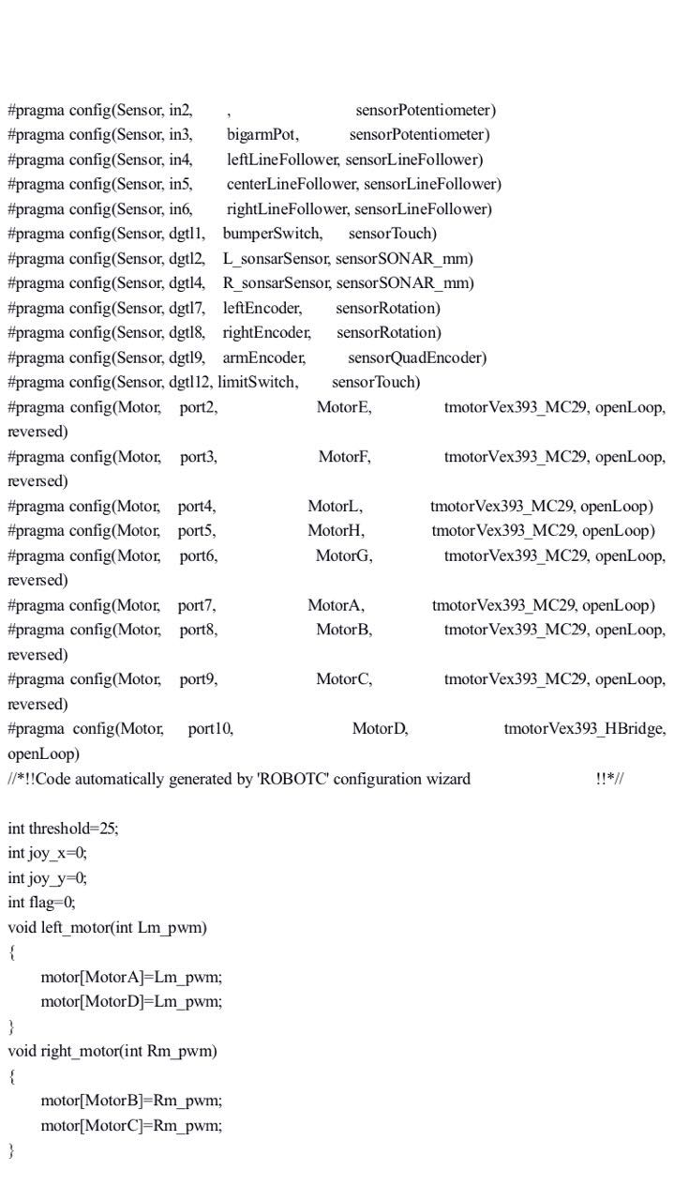

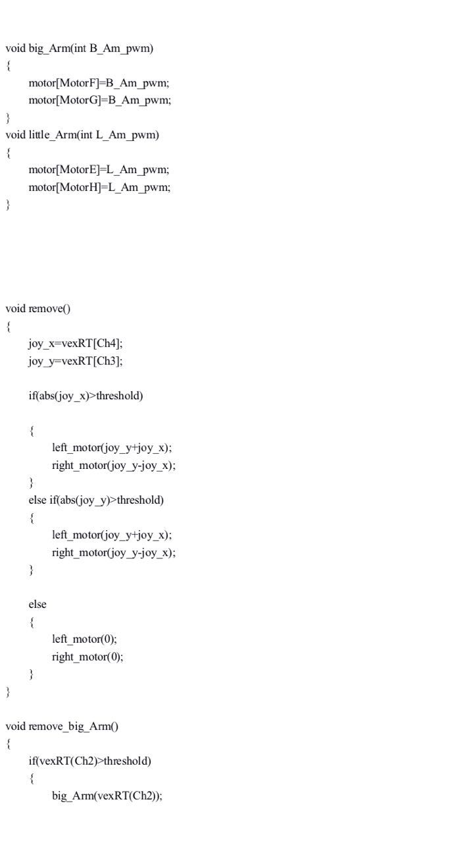

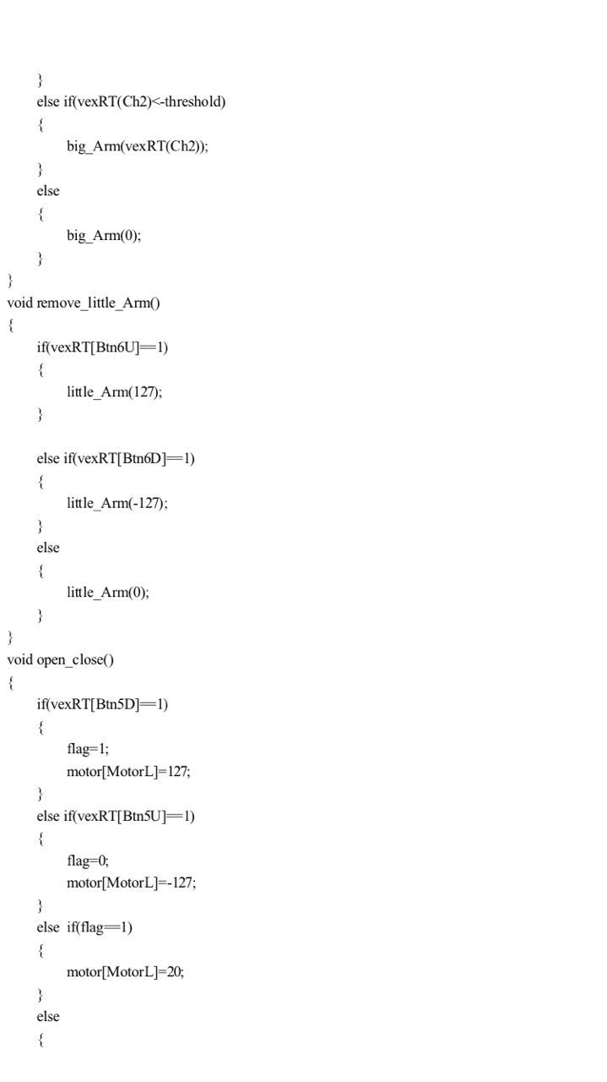
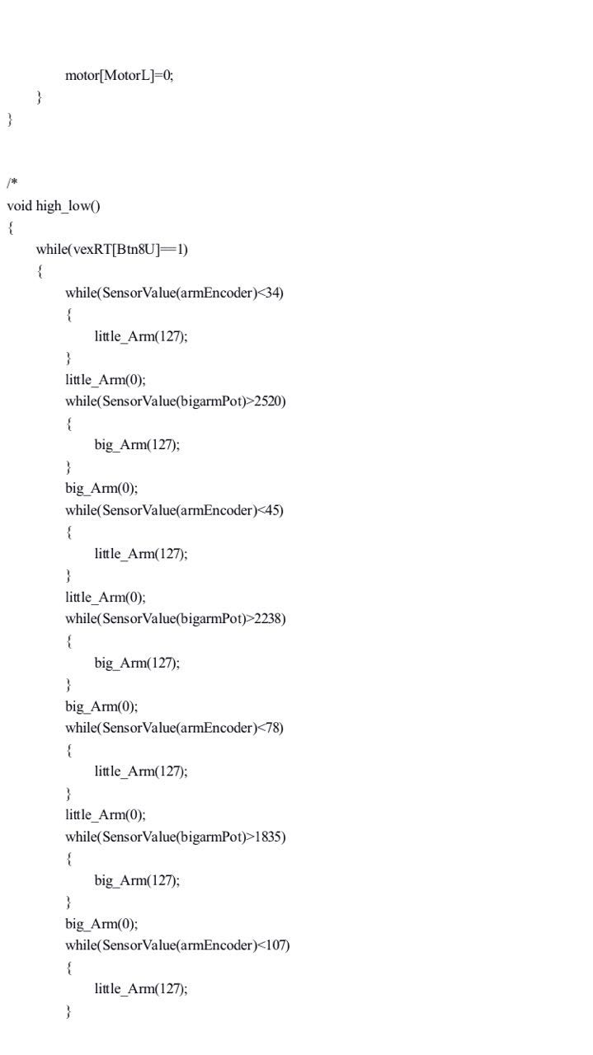
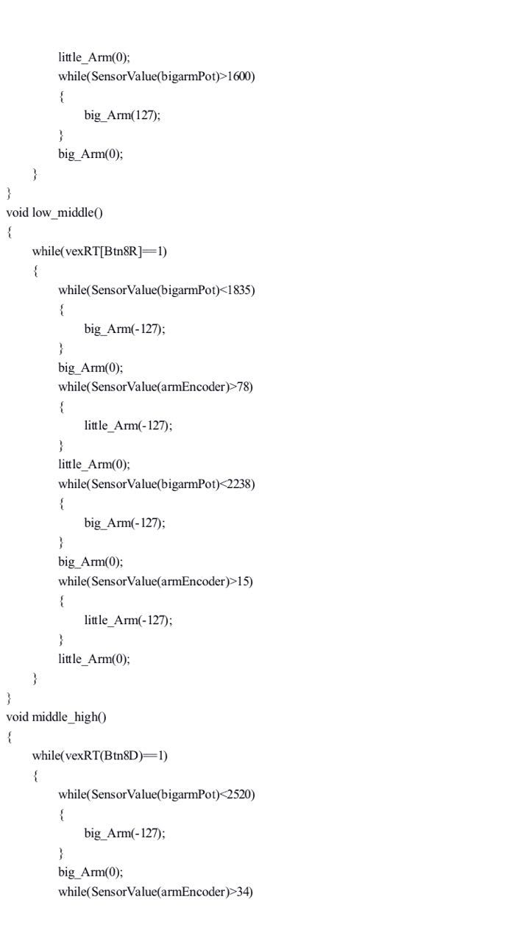
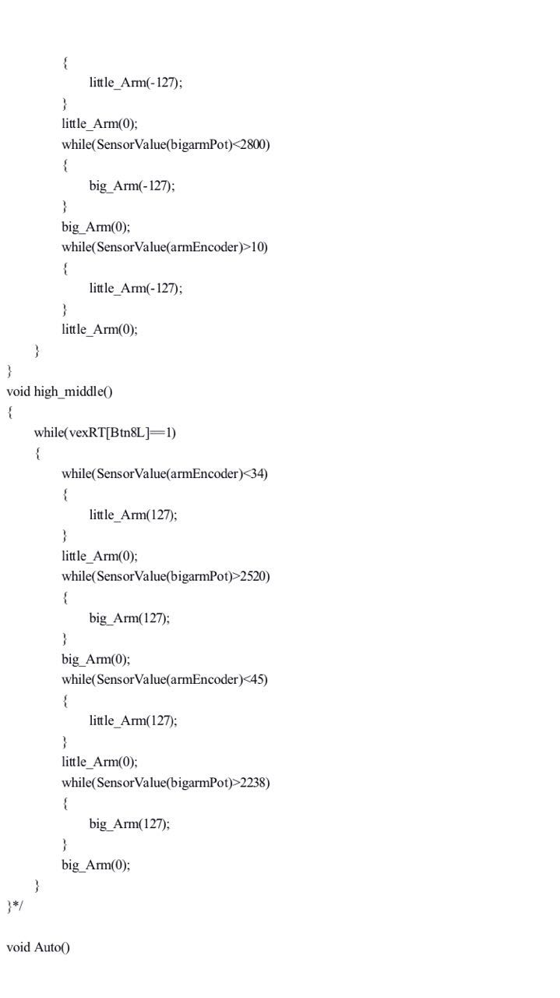
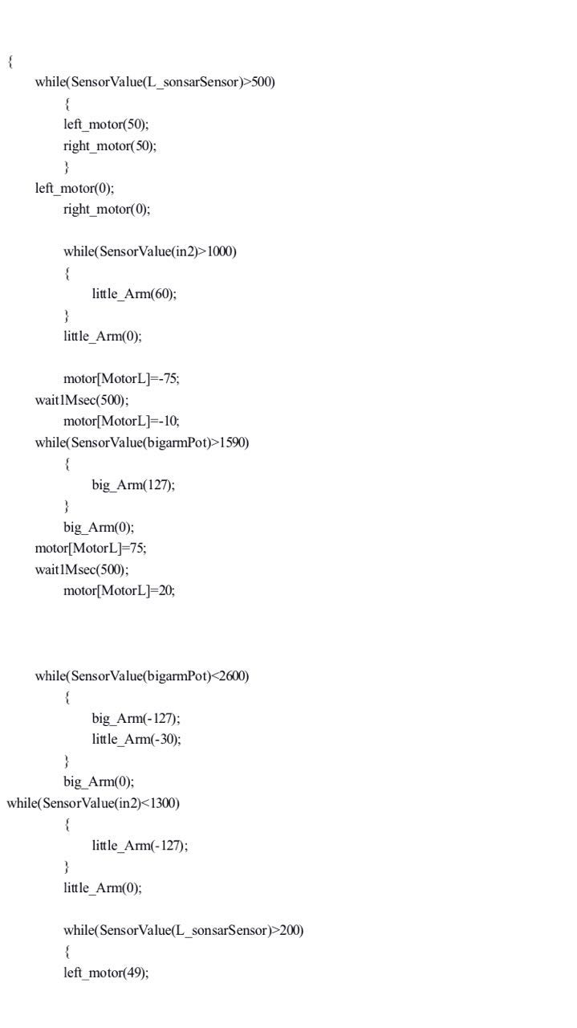
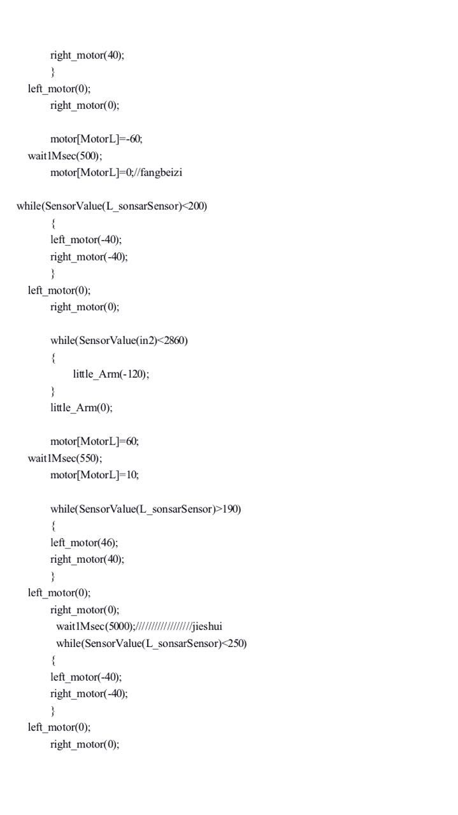
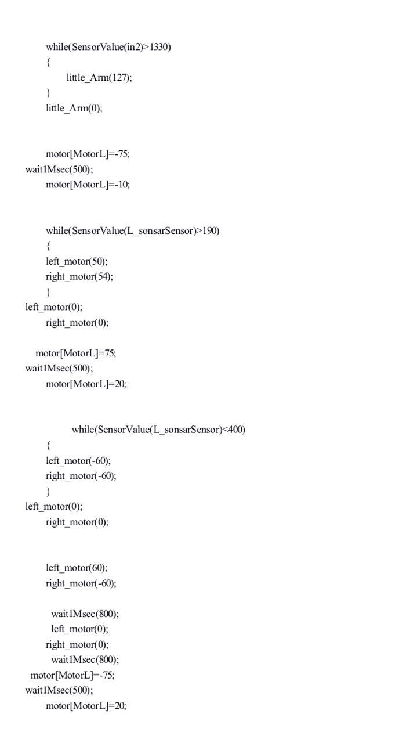
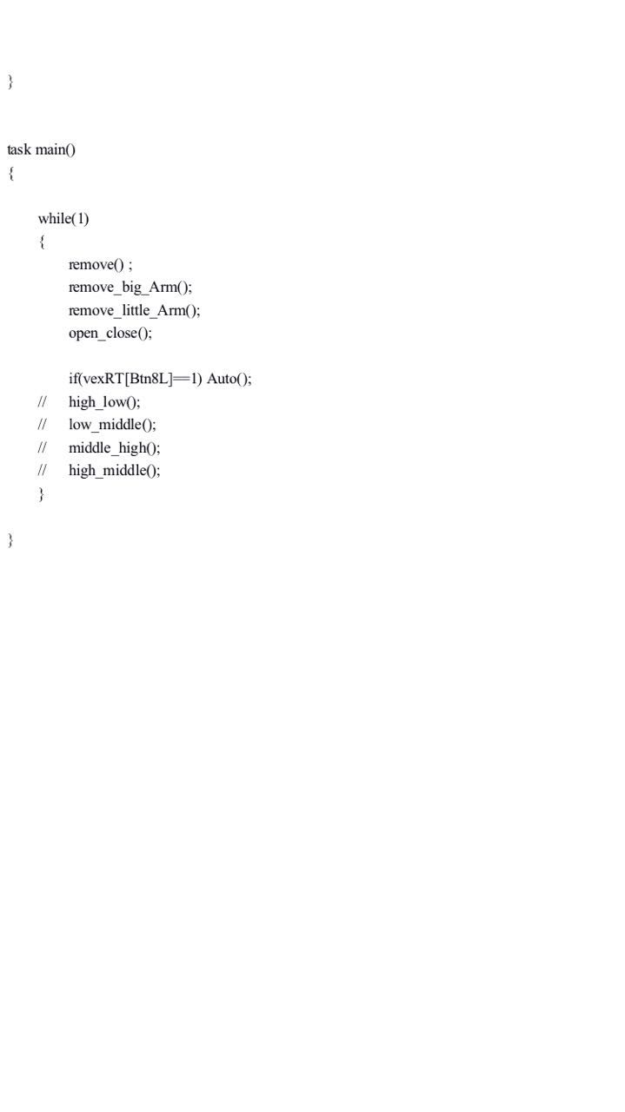
4.1 In the end
It is just a begin for me to explore a robot system and not just for the VEX championship,In this time,I got lots of new experience about how to design and make a robot.I think I will have anther new designs and results soon.Thank you!

