**Texas Instruments Electronics Online Challenge**

Robert Figley

1/05/2017

Annandale High School

**Summary**

I chose to take apart an Apple IPhone 5c. I chose this device because it was my old phone and has started to come apart now. I have always preferred IPhone over androids because of how much stuff I have acquired over the years on my apple account. I also find the IOS operating system easier to use over android’s. I knew I wanted to take apart my old IPhone ever since I saw this project come up.

There are many different components that make up this phone with multiple manufacturers for them but I did not find any Texas Instrument components in the IPhone 5c. To get inside the phone you have to unscrew the 4-inch LCD screen from the rest of the plastic body. Once the screen is removed almost all of the rest of the components are visible. The battery is the next largest component after the screen and takes up the majority of the space inside of the phone. You will find a microphone and two speakers, one for regular ear-to-ear calls and another for speakerphone and music. On the front side of the logic board you’ll find Apple’s A6 application processor, and a Qualcomm LTE modem and receiver. On the back side of the logic board is, a Toshiba NAND flash, Qualcomm power management IC, Broadcom touchscreen controller, and a Murata Wi-Fi module. The camera is found in the upper right corner of the phone.

The LCD screen is for displaying images as well as receiving inputs by the user. It is how the phone displays what it is doing to the user and is about the only thing the user will see while they use their phone. The two speakers are for broadcasting noise so that the user can hear audio. The microphone is what the user speaks into to capture their voice. The processor is like the brain of the phone; it executes all of the functions and codes of the phone. The battery supplies power to the phone. It is a Li-polymer, 3.8v 1510mAh. The modem and receiver are there to receive a signal for phone, text, and data service from a provider. Modems are how phones are connected to the outside world. The cameras are for taking pictures and there are two of them, one on either side of the phone. NAND flash is a type of storage that doesn’t require power. The power management IC controls the power usage throughout the phone. The Wi-Fi module allows the phone to connect to a Wi-Fi server.

I was surprised on how much padding material that I found inside on the phone. I learned about the multiple different companies that supply apple with the components that are used to make an IPhone 5c. The most interesting thing I learned about this phone was that there is a mirror on the backside of the exposed part of the screen. That was something I was not aware of.

**Pictures**

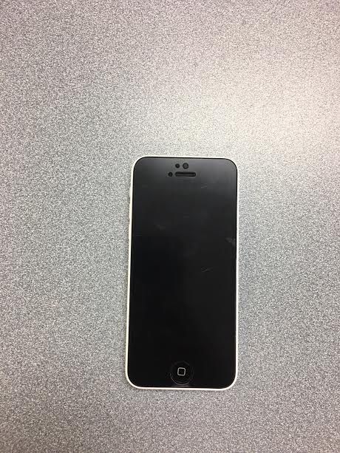

Front side of the IPhone 5c

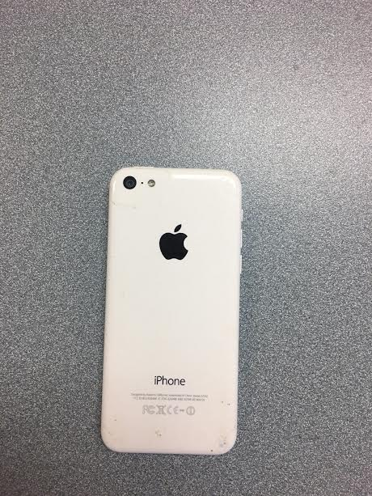Back side of the IPhone 5c

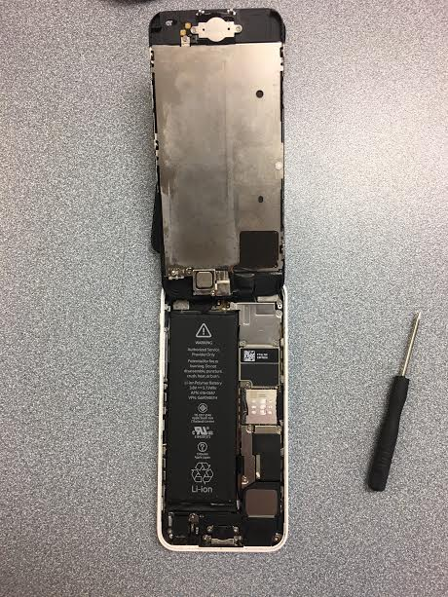I used the screw driver on the right to remove the screws holing the screen down. This is the first thing you see when you lift the screen.

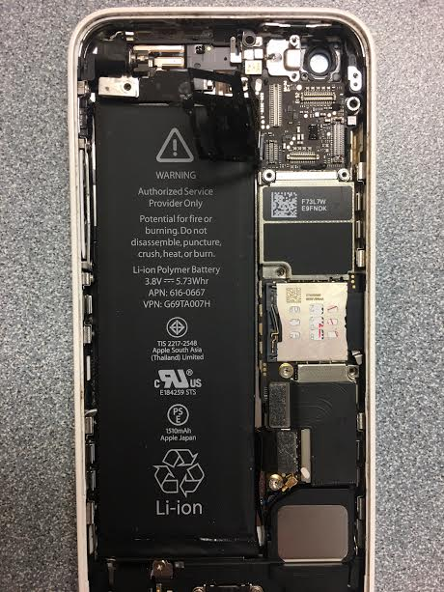After screen is fully taken off.

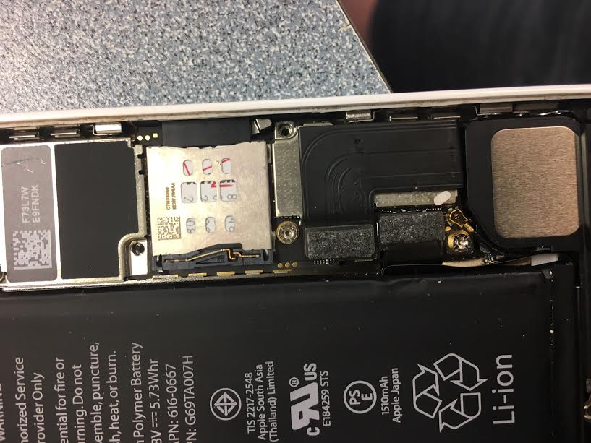Processor and LTE modem and receiver (Verizon is the service provider)

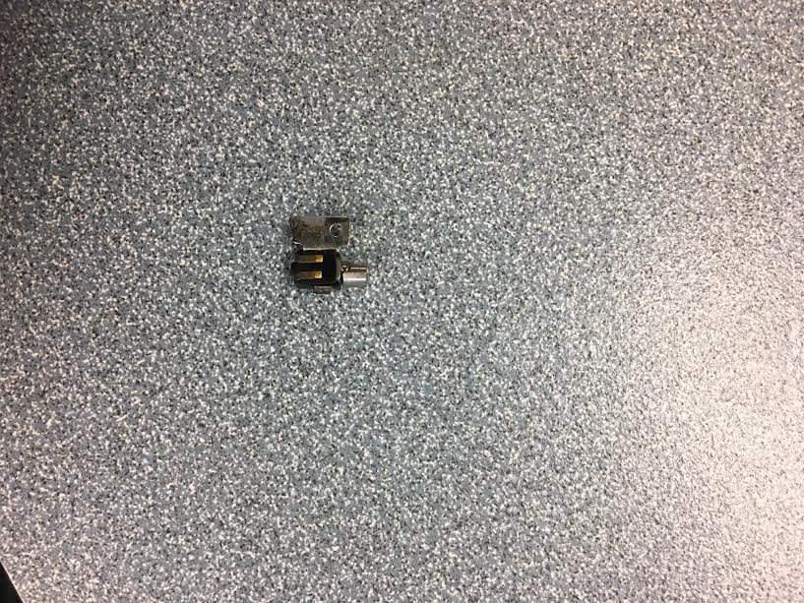This small little piece here was the only moving part I found in the phone. There is a round metal piece on the right side of the component that rotates

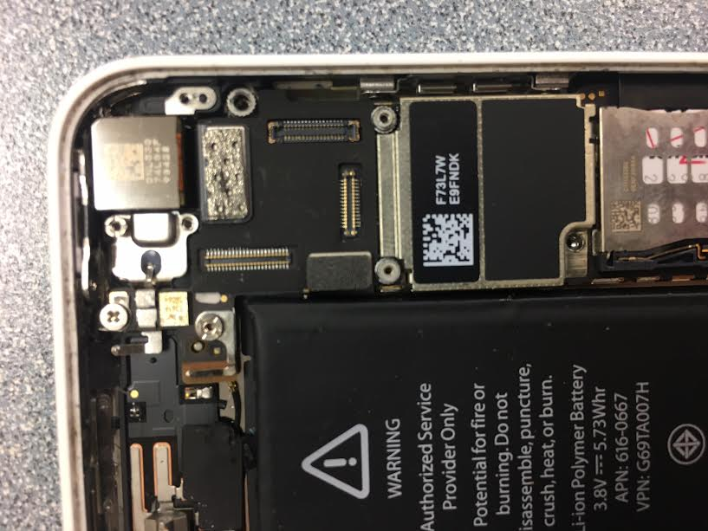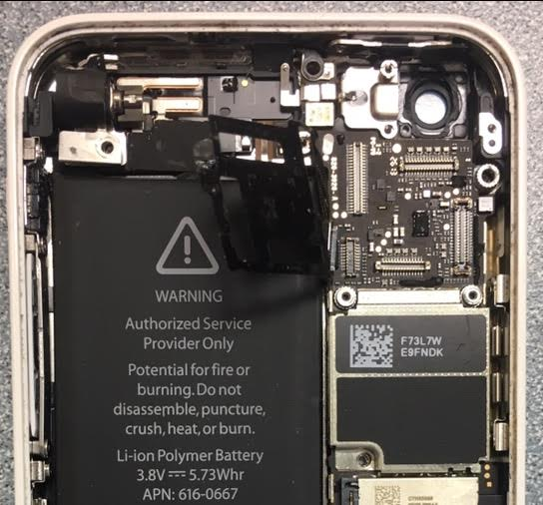Before and after the rear camera was removed

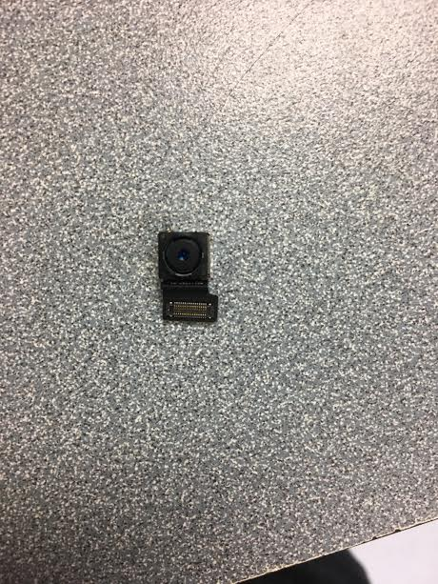Rear facing camera fully removed.

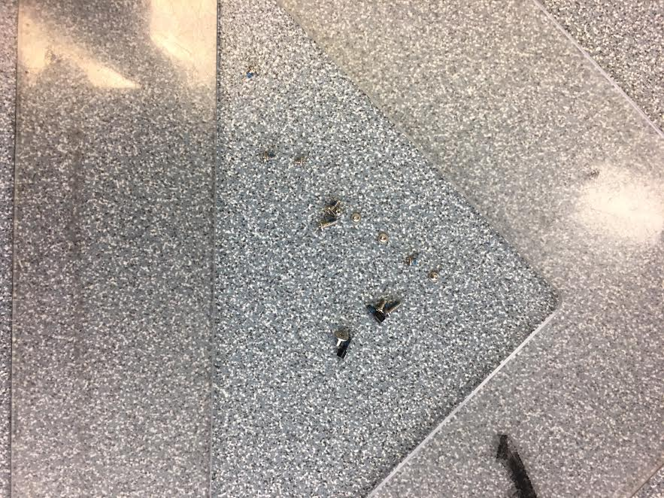All of the screws that I took out of the phone (I lost a few while taking them out of the phone because of how small they are).

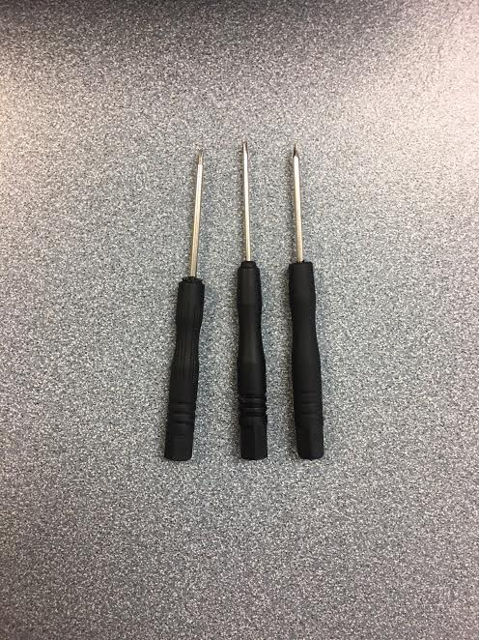I used to 3 different screw drivers to remove all of the screws that were in the phone.