***The She-Engineering Journey***

Chapter 1

Walking into 6th all of us were nervous yet curious but covered all of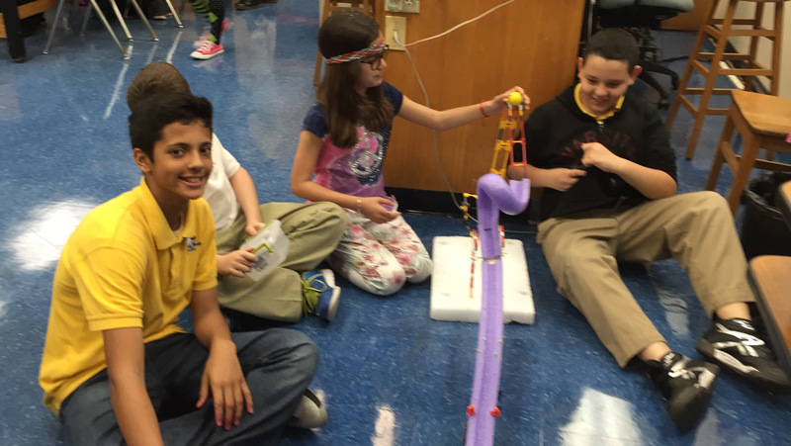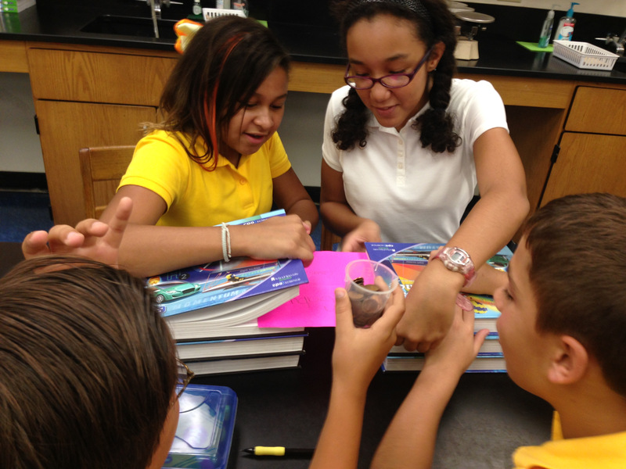

this turmoil of emotions with a tough face and the, “I know what I’m doing…. Just don’t ask”. We first started as individuals, completing classwork on our own but then we entered some groups with other people to work on simple robotics projects. Daniela and Gaby were in the same group. During this period of time, we had an assignment at the start of every class called a Bell Ringer. The Bell Ringer of each day would cause class discussions and each group of people had to state their case to the class and by the end of the 15-20 minutes the side with the most people won. We built a variety of products in the class, a roller coaster made out of recycled products, a fan and our personal favorite was when we had to figure out a way to have a paper carry 100 cents! In the end the majority failed but everyone got a couple of laughs out of it as every group thought theirs to be the best but ultimately was just like everyone else’s. We weren’t together yet as a group but we knew each other and occasionally gave each other help when needed. Lily wasn’t in the school in 6th or 7th grade. Then, came around a time in which we had to assemble new groups for Vex IQ. Daniela, Amy, Laura, And Gaby were in the group together along with two other people. Being in the group in 6th grade for Vex IQ helped us become aware of each other's strengths and weaknesses and how this would be used as an advantage for our group’s success. It is in this grade that we started learning programming using RobotC and the computer language. We began by designing and preparing to build a chassis. We decided to do so because we could use the chassis as a blank slate to build upon when we receive word of the upcoming challenge. We began slowly progressing in the amount of work done per day and finished the chassis at the end of the school year.

Chapter 2

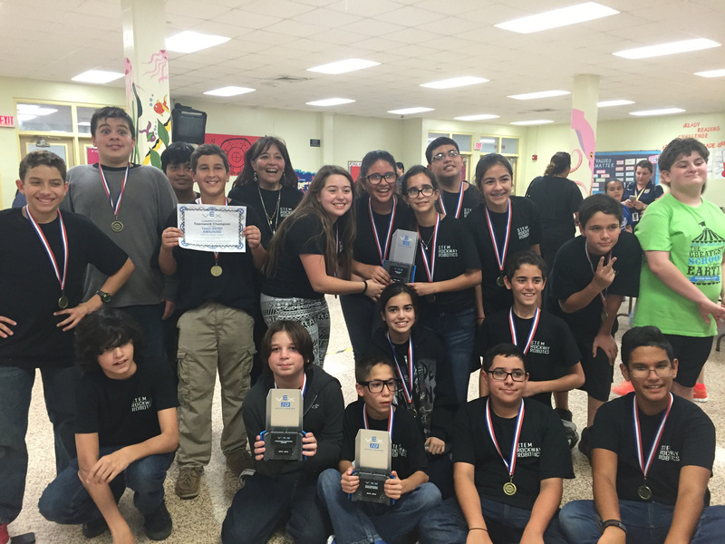At the start of seventh grade, we were put in separate periods because of schedule conflicts. Laura and Daniela were in 6th period while Amy and Gaby were in 2nd period. Although we were separated in robotics for a whole school year, all of us still kept in good touch and contributed our aid and assistance when one was in need of help as us girls have to stick together. In each of our classes our Bell Ringers from 6th grade evolved into a daily mini lesson on gears, different autonomous’, measuring torque and speed and daily questions on definitions of several words everyone thought they need but had their mind blown when the truth settled in. After struggling and constantly competing both groups qualified for the state competition in Tampa winning the excellence award. Daniela and Laura’s robot was a shooter-bot that launched balls by kicking them into the air after gathering maximum speed over a period of a couple of seconds. Their robot’s autonomous was to suck in 3 balls, load the kicker, make it into the goal and park on the ramp while emptying all the cutouts. Amy and Gaby’s robot was a sturdy chassis that had a shovel to pick up and launch the balls to the goal, their autonomous was emptying the cutouts, throwing 6 balls over and parking on the ramp. Forwarding in time to the state’s competition, both present teams were very nervous as it was our first competition and the countless hours spent after and during school were all in preparation for this competition. Unfortunately, neither group qualified for World’s. But, on the bright side, we did not leave empty handed as Laura and Daniela were awarded the Sportsmanship award. This loss did not discourage in any way as we are very resilient girls, prepared for any challenges and obstacles heading our way.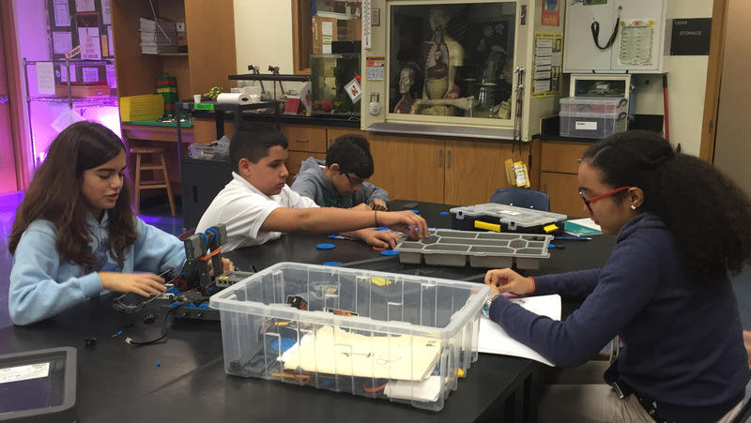

Chapter 3

Starting eighth grade, we all ended up in the same class and we chose to be in the same group and so far, we are an all-girl group that works incredibly as a team now that, as the years have gone by, we each noticed our specialty and focus on it rather than being all over the place and having everyone perform everything. Since all of us are female Hispanics, we belong to a minority group. Not many engineers are female and/or Hispanics and that’s is exactly what inspires us to set a new standard of engineering. Especially during competitions when the time for picking of alliances arrives, and one person per group represents the robot, our group is represented by a girl. Sometimes we feel they underestimate the “girls’ power”, so we have to do our best to be noticed. At the competition in which we qualified for States this year, Laura was the representative and was one of only two girls standing up there, and also the only ones in middle school… it’s so hard to make it in a High-school competition “I was very nervous because nobody was asking questions about our robot even when we were at a pretty good position on the rankings...I told everyone passing by what our robot could do and how many points it could score”. At first, the other teams did not expect us to win or have any chance, but as they saw us competing they got more and more intrigued by us and our abilities. 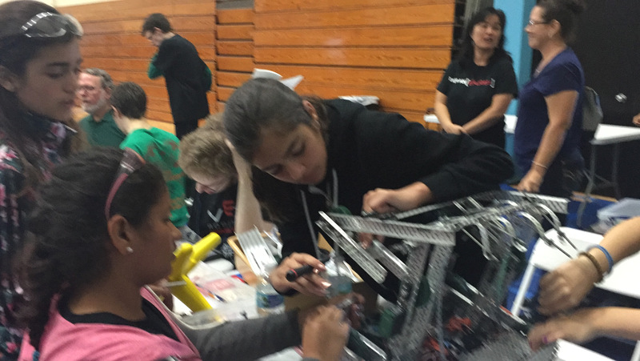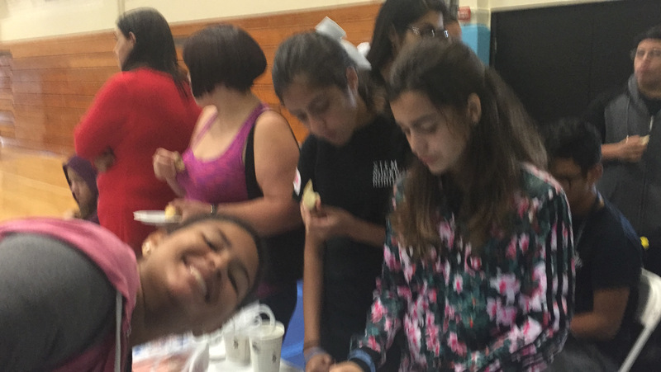

This overall experience of proving we can achieve amazing things if we put our minds to it, has improved our self-esteem and has shown us the true potential we have. We have learned the importance of teamwork and dedication and engineering in our everyday lives.

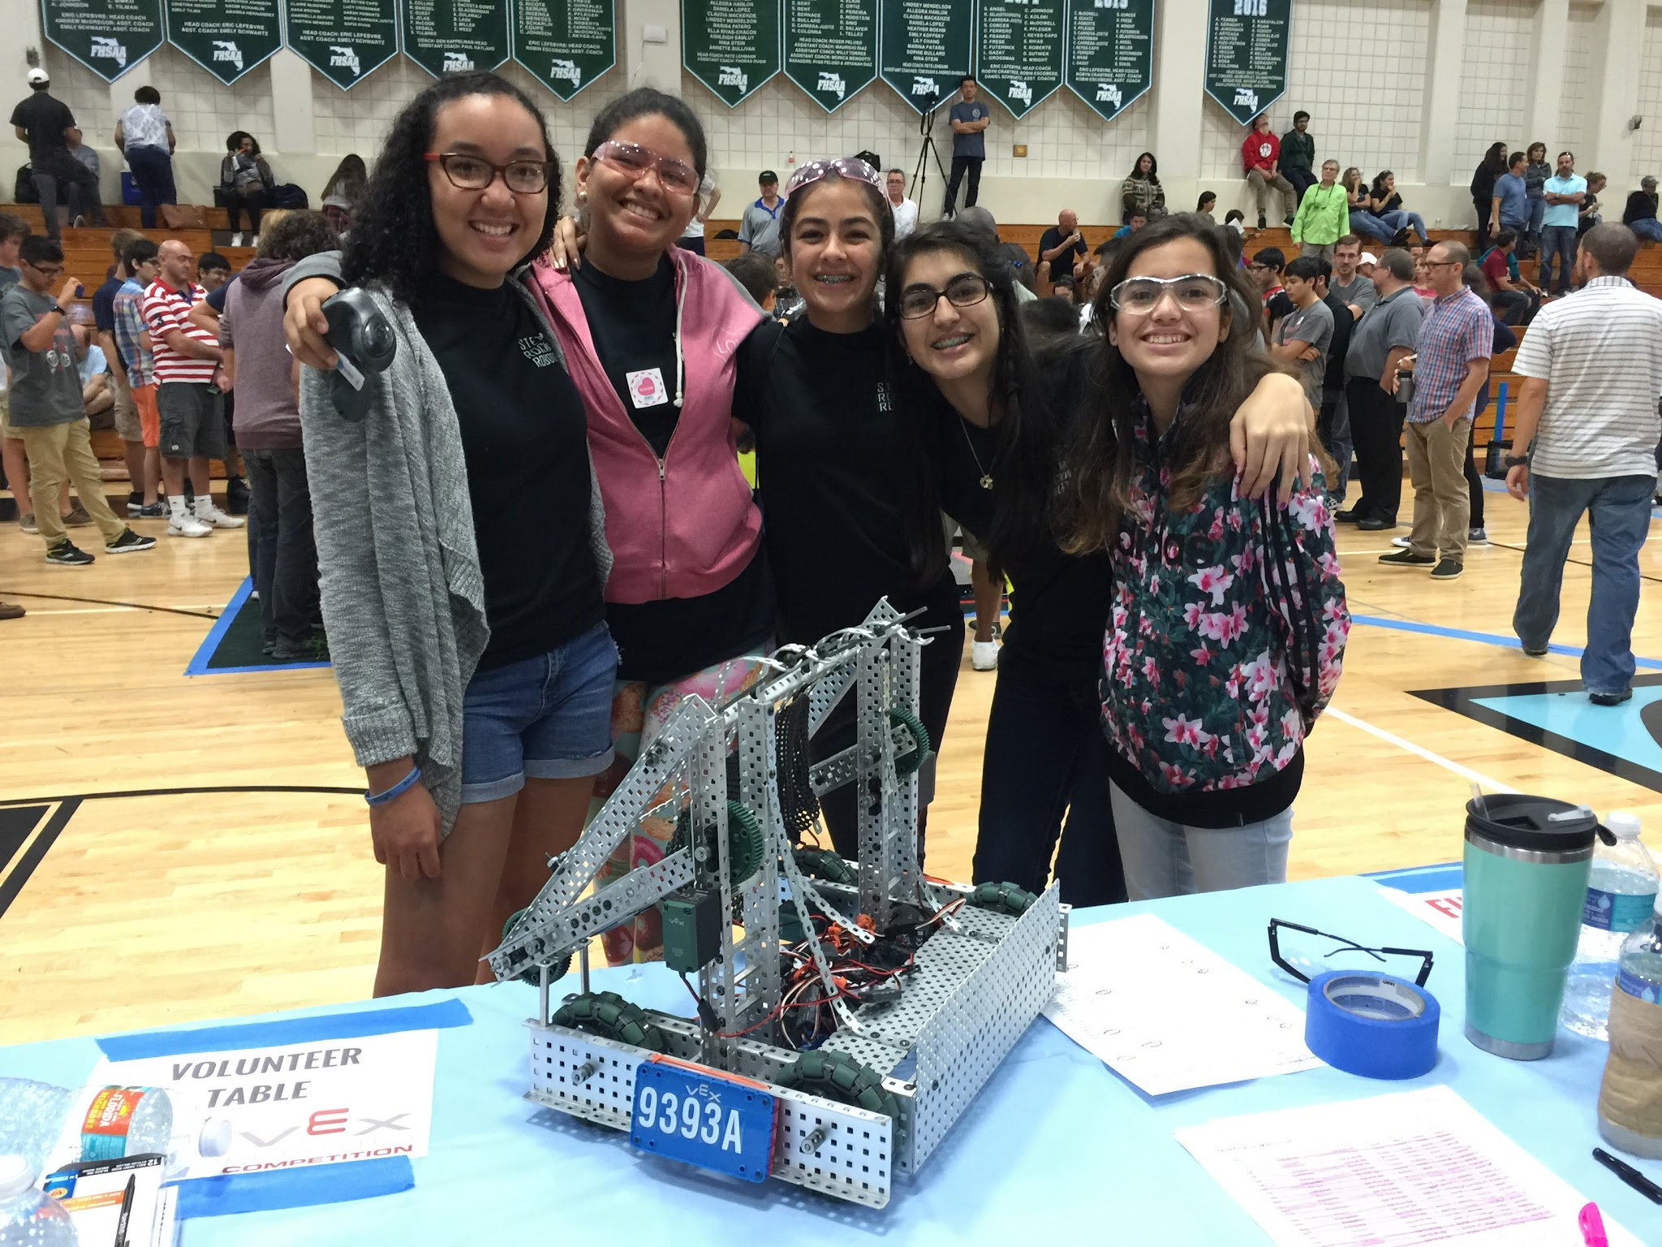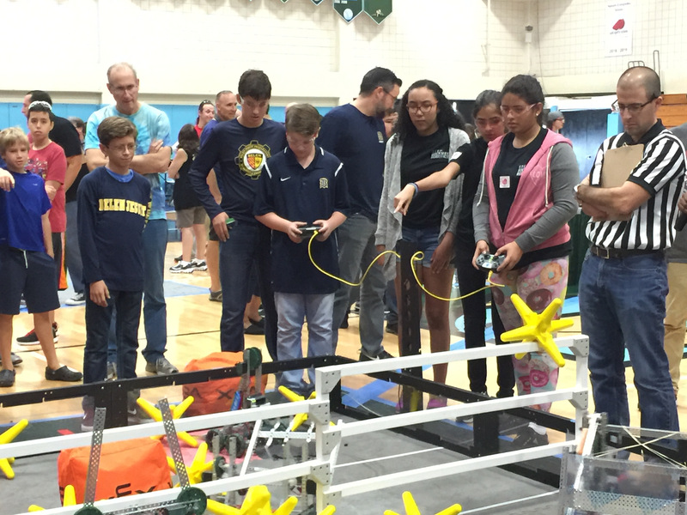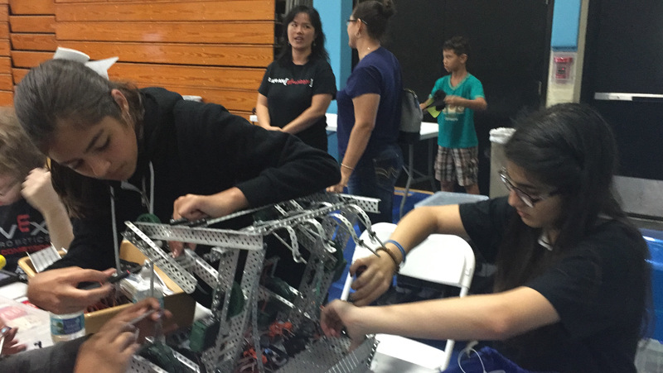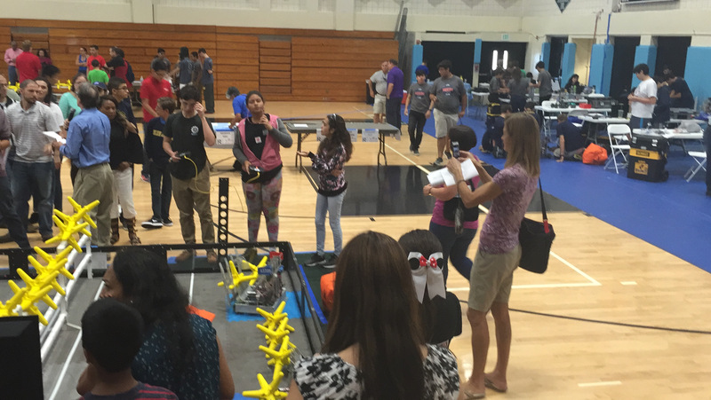Our group from left to right: Gabriela, Laura, Daniela, Lily, and Amy.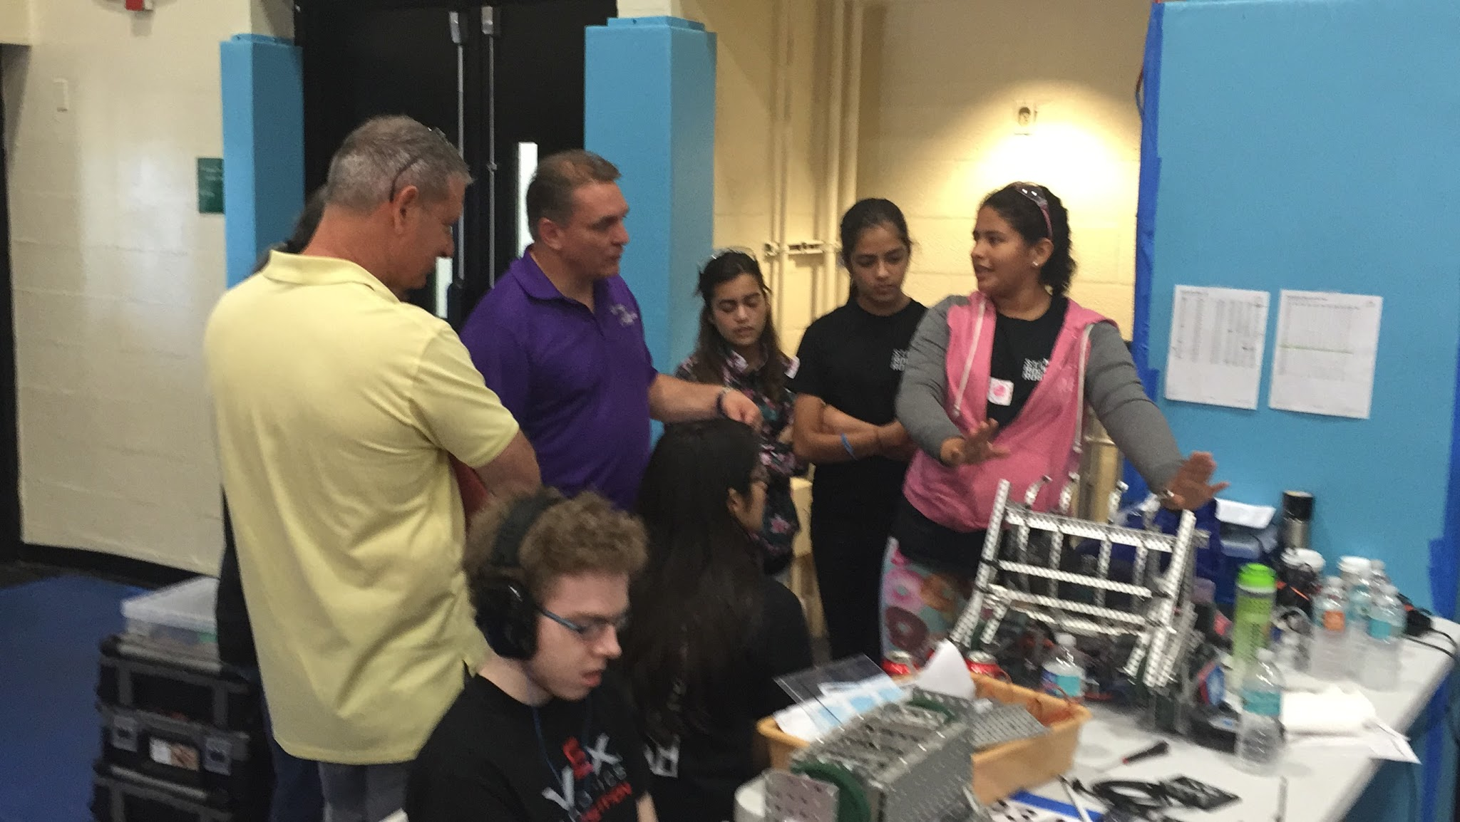

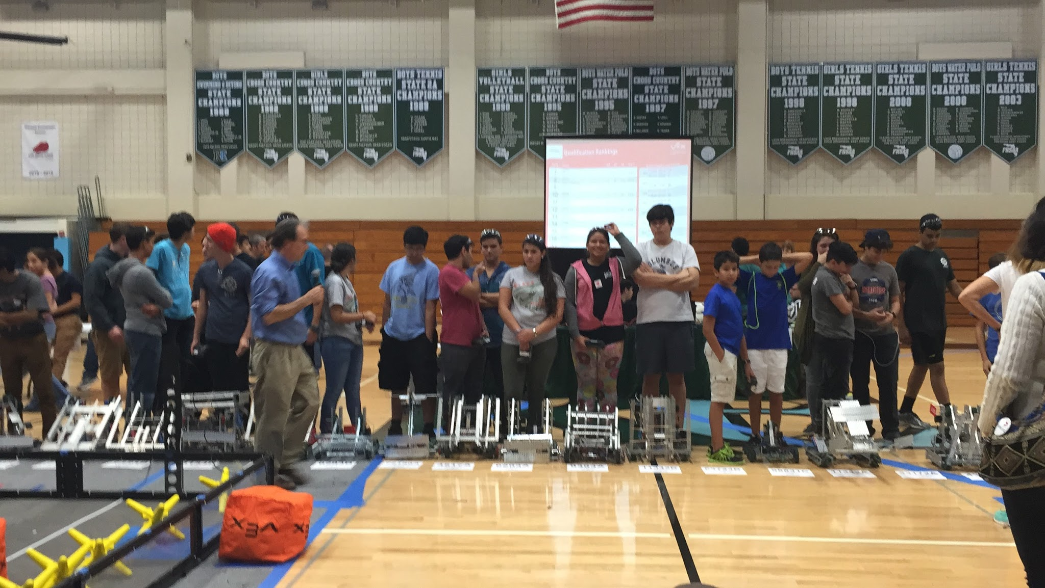Programming with RobotC