For the Texas Instruments Electronics Online Challenge I decided to use a camera for the electronic we took apart. There were many different components in this camera but none were a Texas Instrument in origin. We have labeled the key components down below starting with the SD card reader. The SD card reader is an important component for memory storage and being able to get the pictures off the camera. The next component was the user interface processor. The user interface processor is what allows the user to be able to move from function to function with in the camera. Another key component of the camera is the Timing generator. This assists the camera in running whatever command that the user has input at the speed the user wants it to. This makes it so it doesn’t take 5 seconds for the picture to take when you push the button. The final and arguably the most important part of hardware in the camera is the Digital Camera Processor. This is what separates a digital camera from one that uses film. It has a hand in helping with color detection, Noise reduction and image sharpening. While taking apart this camera I found various parts of it that I have never heard of before and really opened my eyes to how intricate today’s technology has become. It showed me that there are various pathways and areas of engineering I could take with my knowledge of robotics and engineering.

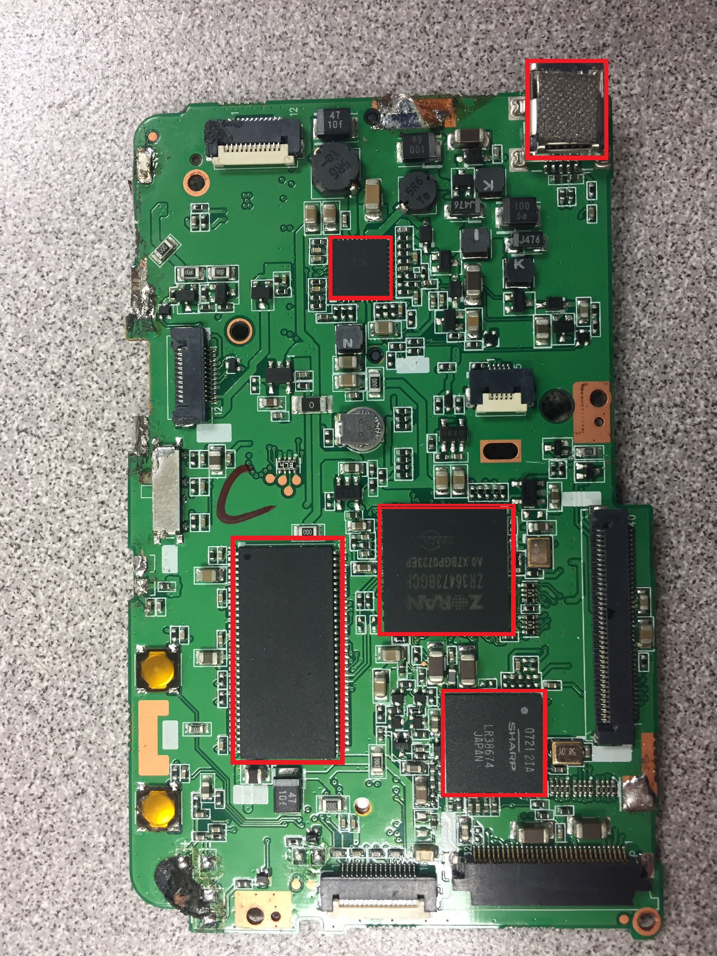
E

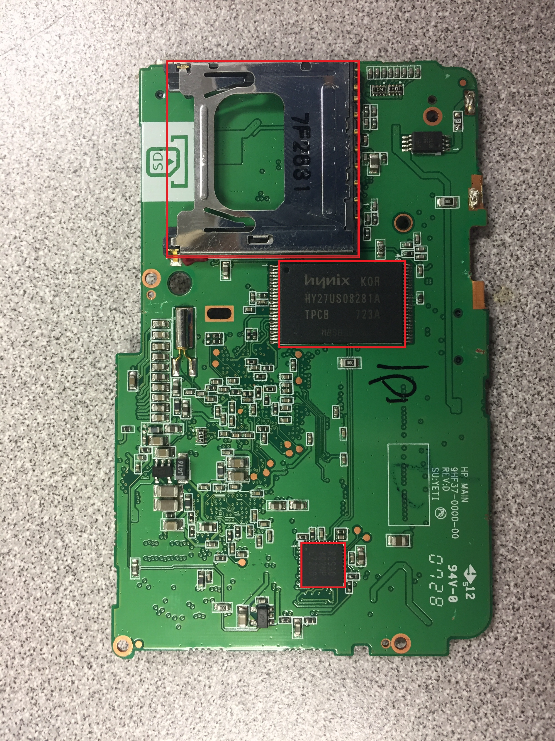
C
- SD Card reader
- User Interface Processor F-Digital Camera Processor
- Timing Generator

B
A

