Texas Instruments Online Challenge Final Summary Report
Grace Brethren Robotics Team E
Challenge Team Lead: Nicholas Barberena
Challenge Team: Shant Thiele
Cooper Ray
Caden Regenstreif
Logan MacNeal
Introduction
For the Texas Instruments Challenge we have elected to disassemble a non-functional DVD player. We picked the DVD player because when it was suggested, I think we were all mutually curious about what’s inside.
Summary
We’ll start off with a simple part; the fuse we found on this circuit board is no different from any other fuse on any other machine. It and others like it protect the machine, or in our case the DVD player, from over current. This is when too much electricity is flowing through the circuit. Unfortunately we weren’t able to find any Texas instruments parts in the DVD player. The majority of the parts were manufactured by Mitsumi Electronics Company.
We also have a micro processor which makes sense of what’s on the disk and relays it to the TV. This is probably by far the most important part of the DVD player. Our next part is the display. This is similar to a digital clock. This can display how far you are into the movie or what time it is. Another part we found is the motor that spins the disk so the player can read the disk. This part was also made by Mitsumi Electronics Company.
Our next part is the two motors used to slide the tray out. It is very similar to the disc spinning motor except this one is larger and can only move about 60 degrees. We managed to find the total voltage which is 5.9 Volts and the size of the pulley is 8.80 mm
Conclusion
We have learned that the inner workings of a DVD player are a lot more complicated than any of us have imagined. We also learned that finding a part is a lot harder than typing the serial number into a search engine. That’s all I have to share. Thank you for reading.

*Thank you to Texas Instruments for the challenge. I really enjoyed it. Thank you also to my mentors for making this possible.

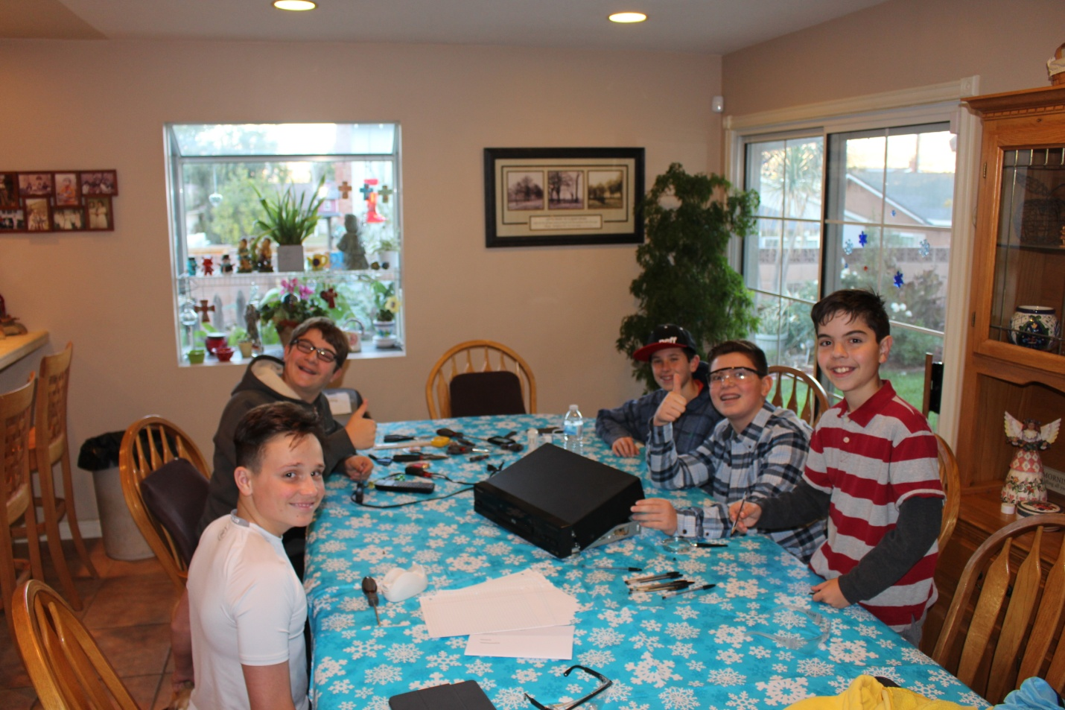

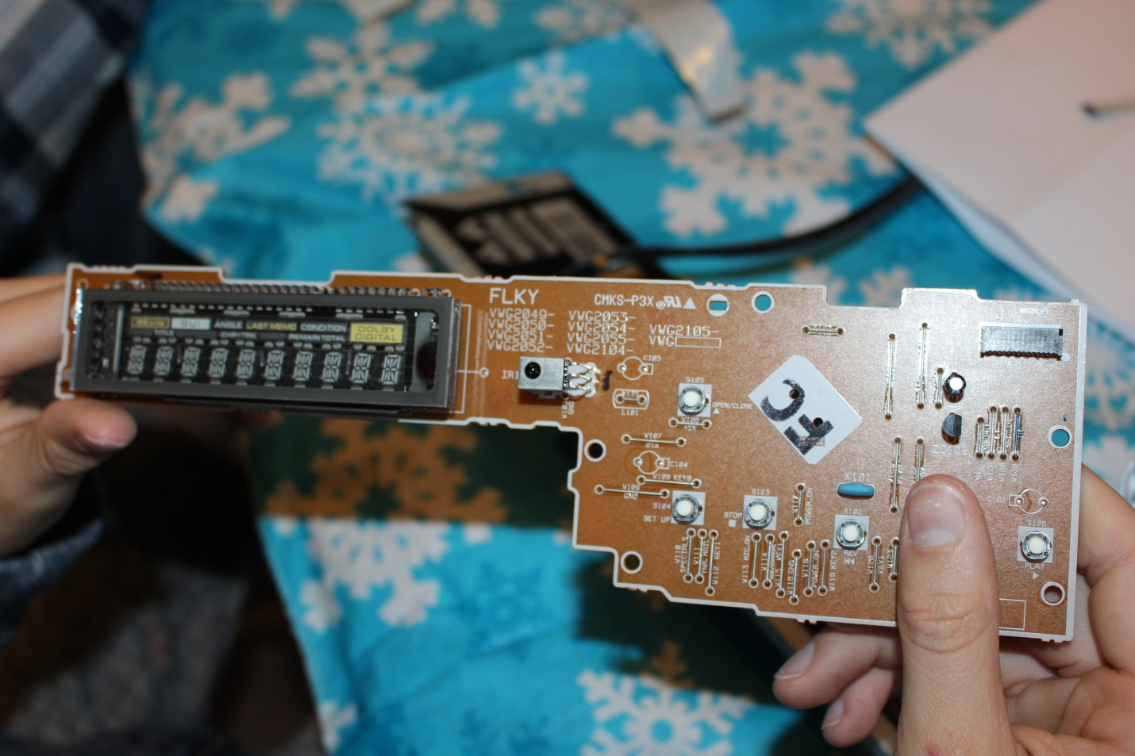
This is the team with the DVD player in the center!

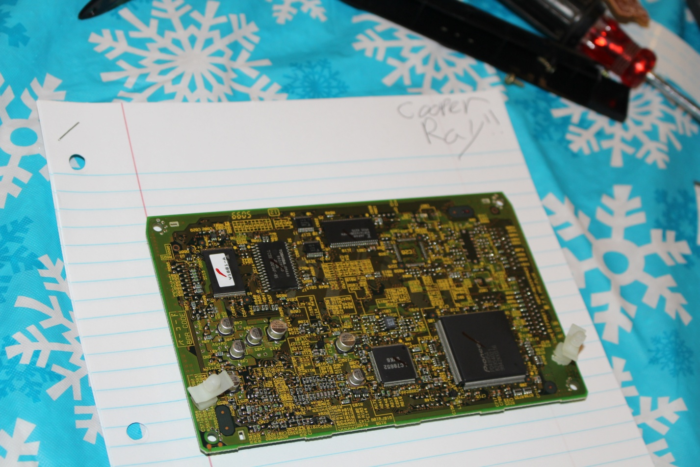
This is the front display which shows the time and how long the movie is.

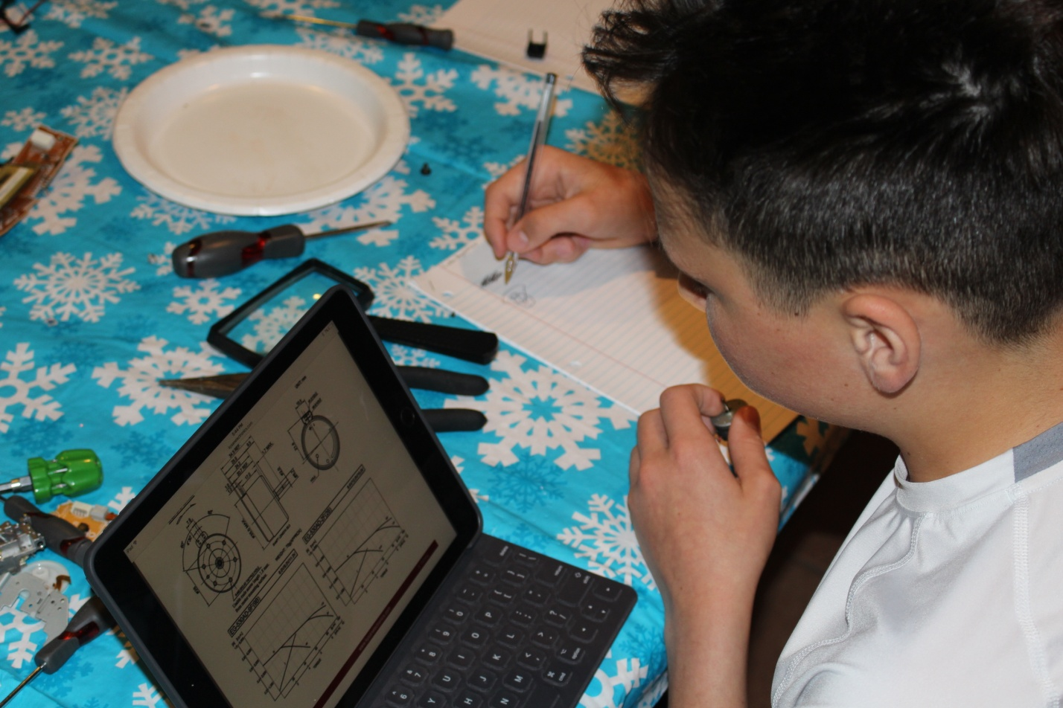
This is the circuit board with the micro processer which I spoke of in the report.

This is Caden researching the motor which I also spoke of in the report.

