What is inside a mouse?

Team name “Team LAZY (11579H) “

### C:\Users\DPALLEN\AppData\Local\Temp\IMG_1207.JPG

*Introduction:*

We choose a Hewlett-Packard (HP) computer mouse because we thought it would be interesting to see what is inside an everyday household product. A mouse is something that we commonly use without thinking about how it works. HP founded on January 1, 1939 and grew into a $7 Billion company in 2015[[1]](#footnote-2).

We were surprised when we found that the device contained no Texas Instruments (TI) labeled parts. As such, we opened a second, non-branded mouse looking for TI parts. Again, we found no components from TI. However, we examined the very different mechanism.

*Summary of Findings:*

We took apart the mouse down to the computer chip. Here is what we found:

* Six and a half feet shielded Cord
  + Ground wire
  + Four wires (yellow, orange, red, black and brown)

Purpose of this wire is to connect the mouse to the computer. Movements to the mouse made by human hand dictate the actions made on the computer screen.

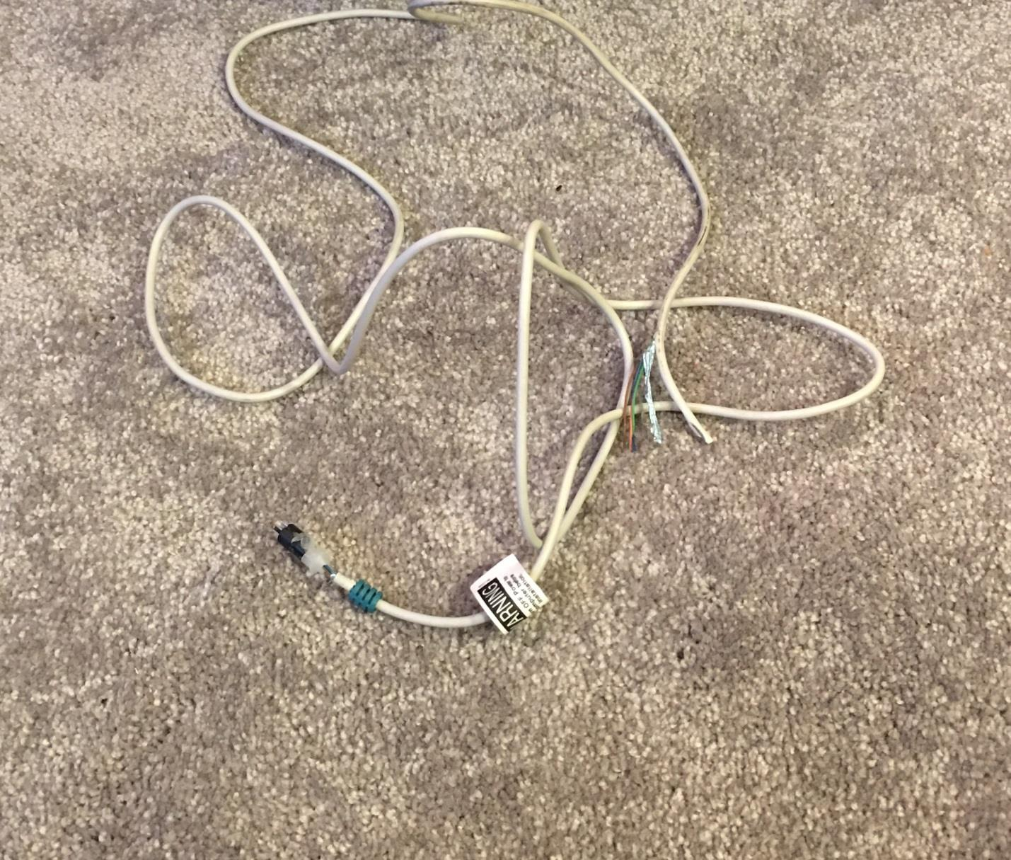

* + Computer Chip
  + PS2 style plugs contains outer shells that have 6 pins
  + Axle/Wheel (Gears?) that moves the tracks ball movements
  + One black guide wheel
  + One black cover
  + Two springs
  + One small, medium and one large screw
  + 1 cm compositor

The purpose of the computer chip is to act as the brain of the mouse. It tells each part what to do and make it run.

* Upper Shell / Lower Shell
* Closer

*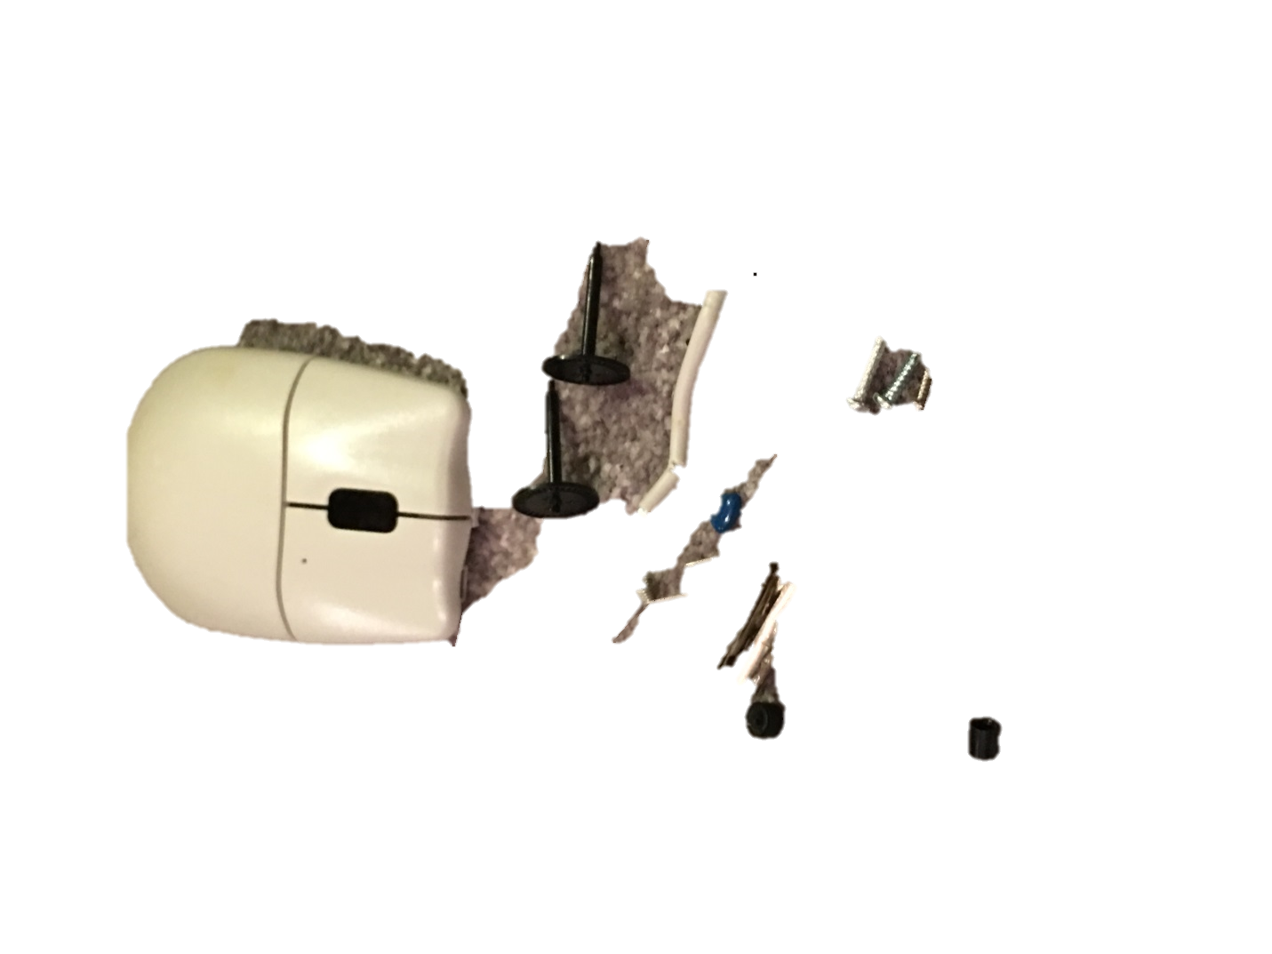*

Internal wheels

Screws x3

PS/2 Connector Shield & Pins

Springs x2

Cable

Wheeled Axles x2

Upper Shell

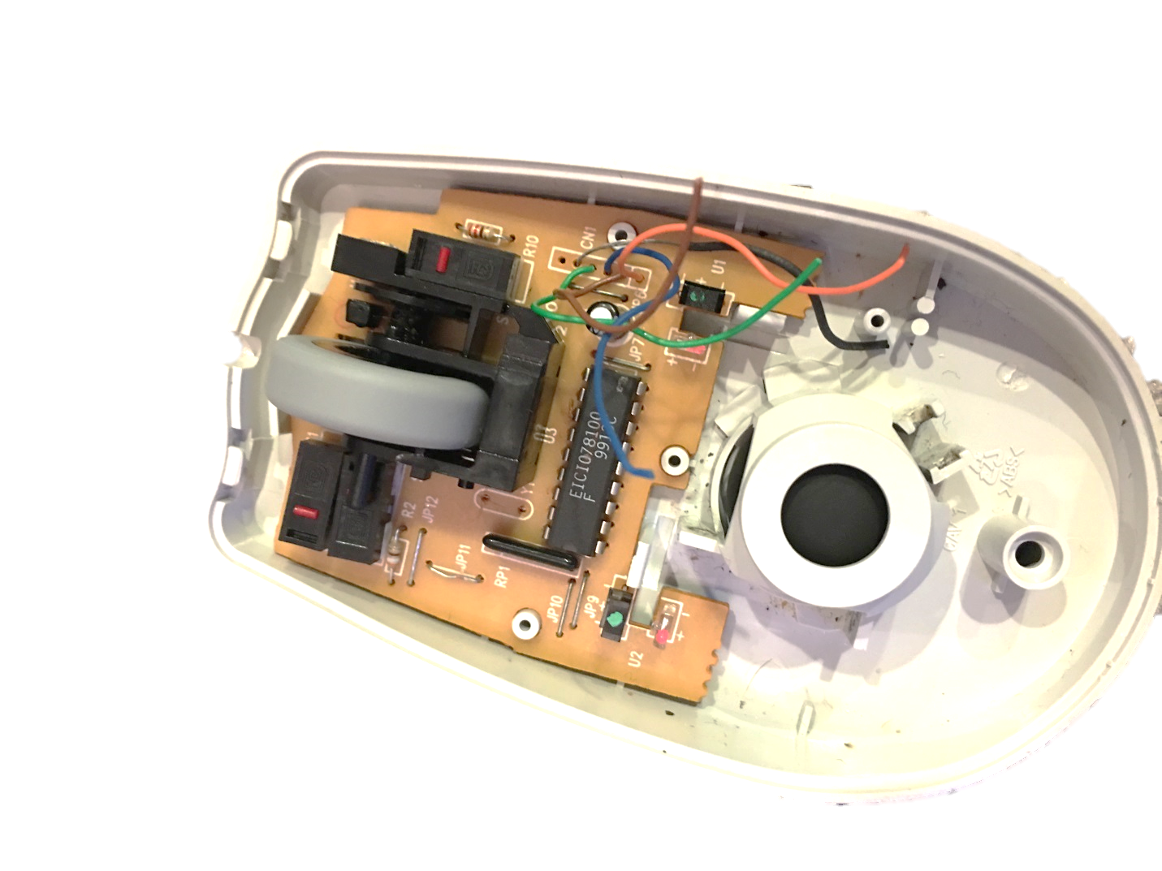

*Conclusion:*

A computer mouse may seem small and simple, but once you open it up, there is a lot of technology involved inside to make it operate. There is an LED light that shines through a gear so every time it sees light, the mouse will move on the screen. Inside the mouse, there is a ball that is under the guide scroll that is connected to a sensor that connects to the commuter. This allows the user to scroll up and down on a page.

1. <https://en.wikipedia.org/wiki/Hewlett-Packard> [↑](#footnote-ref-2)