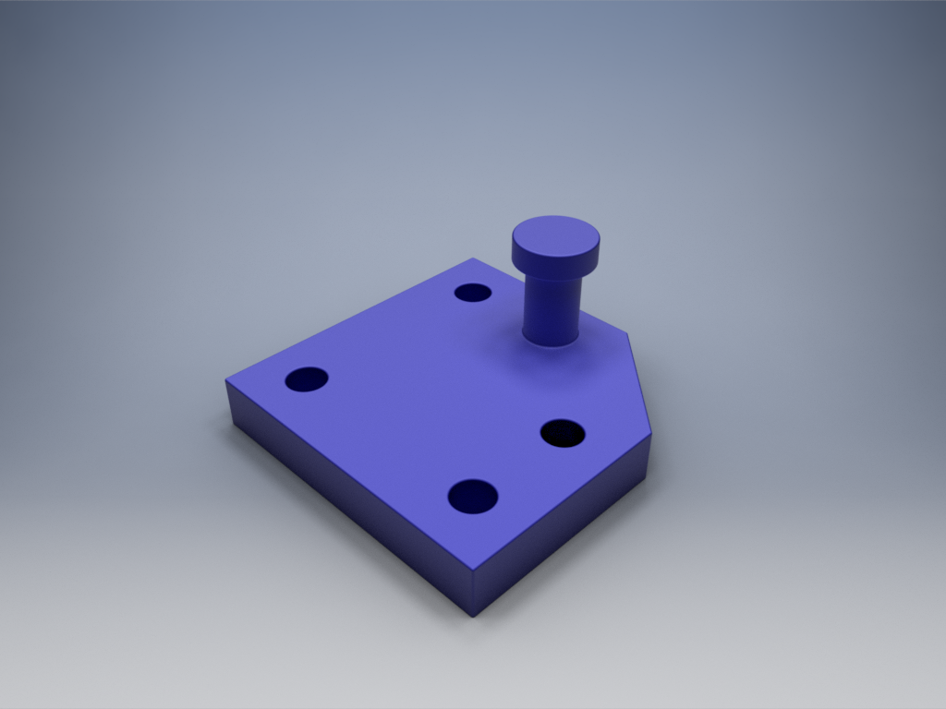
Figure 1
The Problem:
When you decide to try can conserve motors by using a certain set for more than one purpose, you have many options to choose from. One of the more popular options is the double ratchet or rotating ratchet method.
The advantage of the double ratchet method is that it allows for different manipulators to work simply by changing direction rather than using an actuator to change the gearing of the motors. This allows us to use that otherwise wasted actuator in a manipulator or drivetrain.
However creating a rotating ratchet system with VEX parts can be extremely tedious and frustrating (see figure 2). As the amount of spacers must be perfect and custom nuts must be used in place of kelps nuts or nylocks. A custom back plate must be made from vex material at weird angles. The limited holes that vex provides are too constricting and do not allow for easy placement of the ratchet.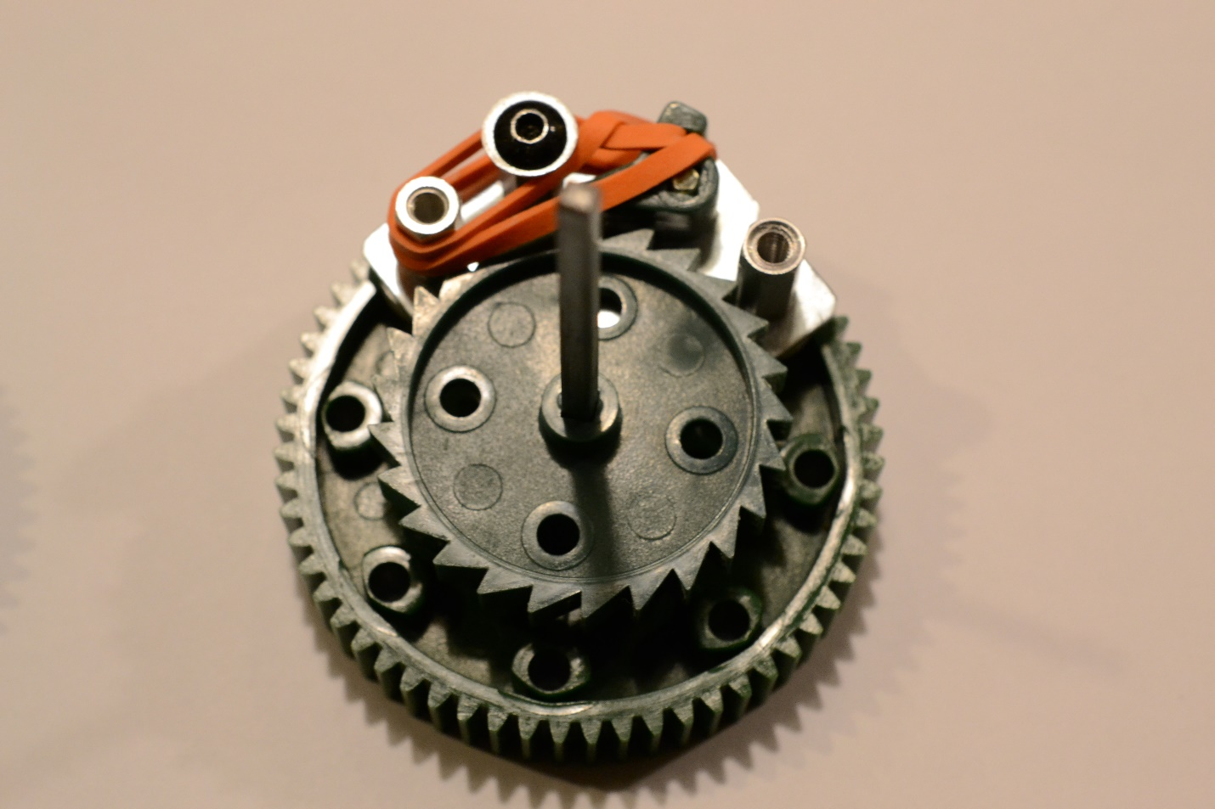
Figure 2
The Solution:
A rotating ratcheting method is easily employable on most VEX StarStruck robots. The 3D printed model is much slimmer and easier to use than our custom prototype, making it even more flexible to use on more robots.
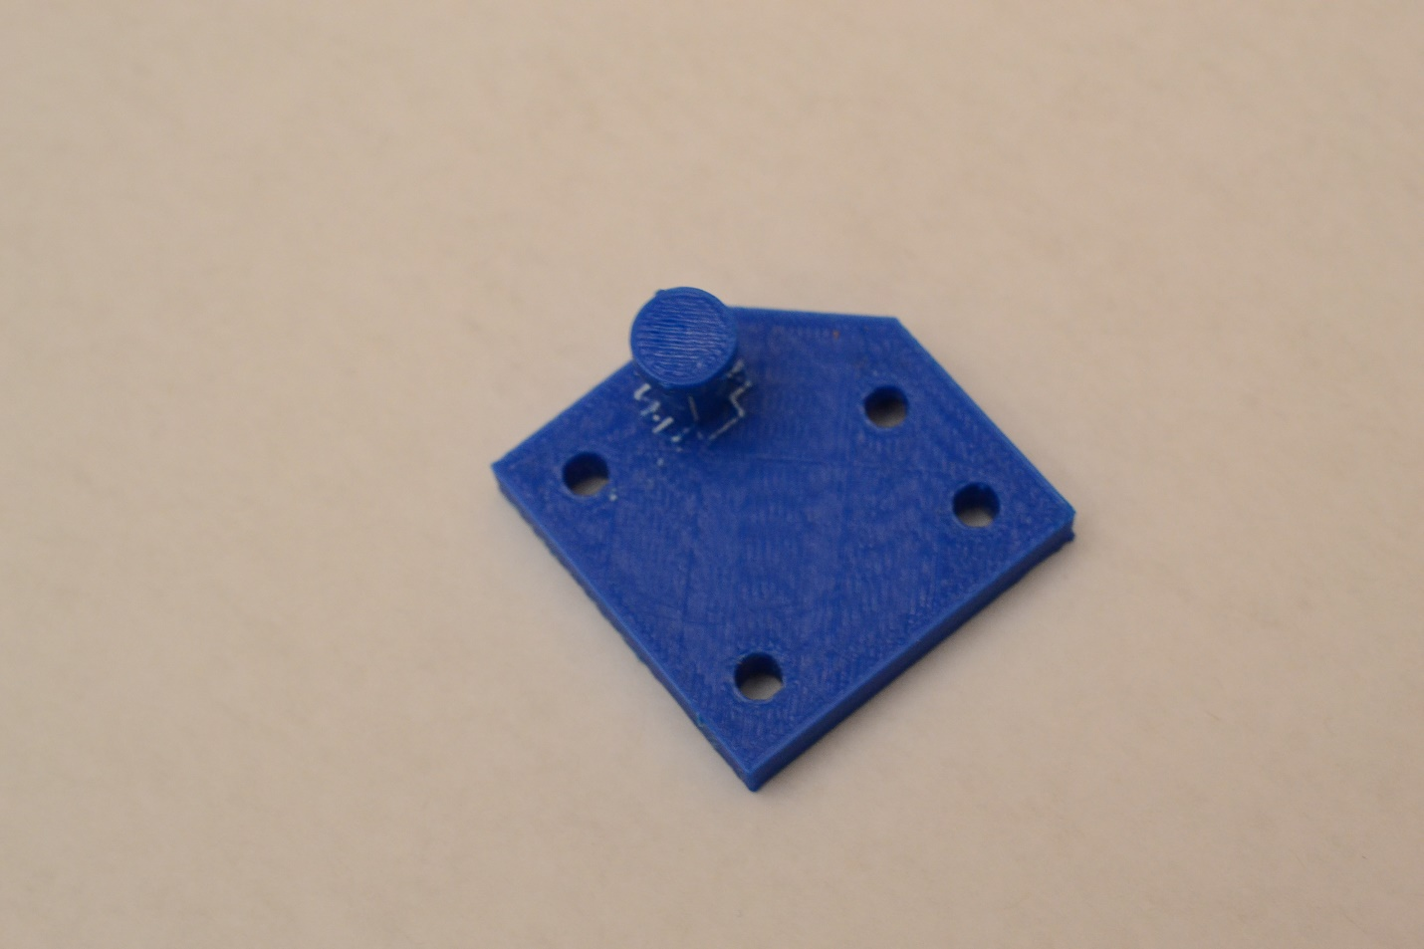
Figure 3.
For example, a robot which employs a slip gear catapult can run a double ratcheting system so that when running clockwise –for example – the bot drives the catapult, but driving counter clockwise, operates the hanging mechanism.
The Process
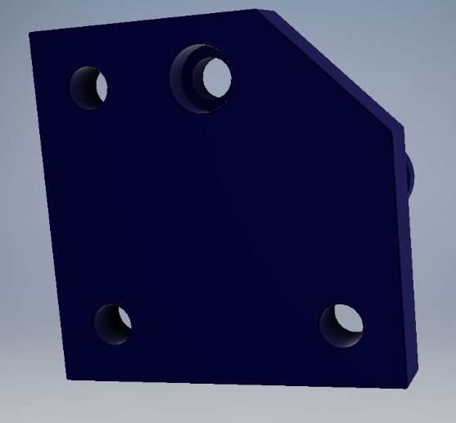
Our CAD file is a simple yet effective model. Using a student version of Autodesk Inventor Professional 2016, we first sketched the base plate of our prototype onto the XZ plane, and we extruded it 0.23 inches. After that we counter extruded 4 bores into the base with a diameter of 0.175in. Then we created a counter bore with a diameter of 0.27in, and a depth of 0.125in. We then created a mount for the rubber band. We created a pole with a height of 0.375in, and gave it a nub (diameter: 0.375in) so that the rubber band would not fall off.
Figure 4
Fabricating the part was surprisingly easy yet difficult as this was the first time many of us had used the 3d printer. However each time we used the printer, there was either a glitch in the calibration or the filament jammed mid print. Our third print, ended with multiple bores and a slightly smaller scale than our previous prints. However we were able to achieve a working model (figure 3).
The Conclusion
Our team had already had previous experience working with CAD files and 3d modeling, but this experience was an eye opener into the surprising amount of glitches, and problems that 3D printing has, and we are still far away from having a perfect easy to use system.
Now that we have gone through this challenge, I believe that we will be more comfortable with 3d printing and modeling, and we will be using this to gain an edge in competitive robotics. Especially because 3D modeling allows us to see the flaws and advantages of a robot without having to build it.
The 3D modeling skills we have learned will likely stay with us forever, and it is easy to see how this could aid us in any career path in the future. CAD files allow use to share images, and designs quickly and efficiently without losing resources such as time, material, or money.

