- Create a drive base: our c-channels, and an additional bar across the front for support. Mechanum wheels are optimal, but preferred because it allows you to move in all four cardinal directions and rotate with ease.
- The next step is to create 2 towers, each with 2 c-channels for support, on the back of the robot to hold the claw. On these attach motor, axles, and gears, that will help generate torque and the strength to lift the cubes.
- Add the c-channels to the axle to create the dual lift. Use screws and lock-nut to attach the arm pieces to the gears
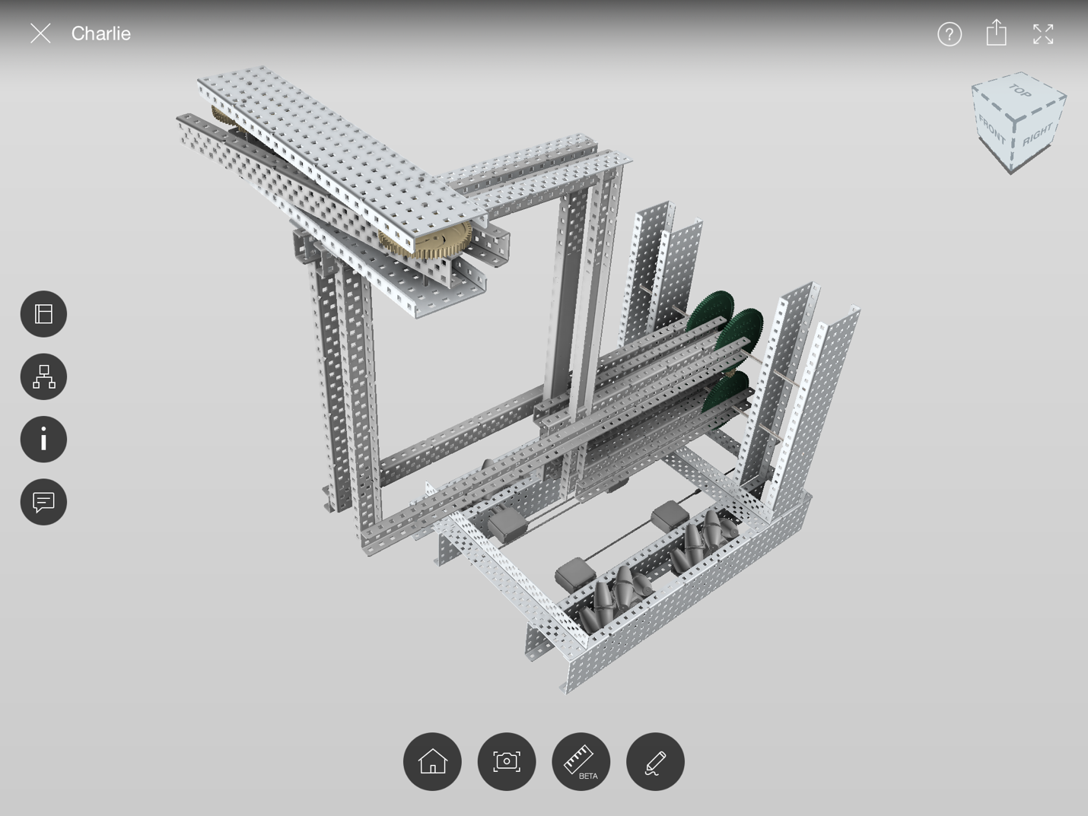
- Follow design to build the claw correctly. And rubber bands or standoffs to increase grip strength. Attach to end of lift securely.

