We joined robotics, because it's interesting to learn the mechanism of the robots and very fun to build them. Also, it is even more exciting to do while making new friends. In our team, we have six people who are Aditri, Chris, Karina, Maanasvi, Pranathi and Siddhi we are Team 10515B.This is our story in robotics.

**Siddhi’s side of the story**

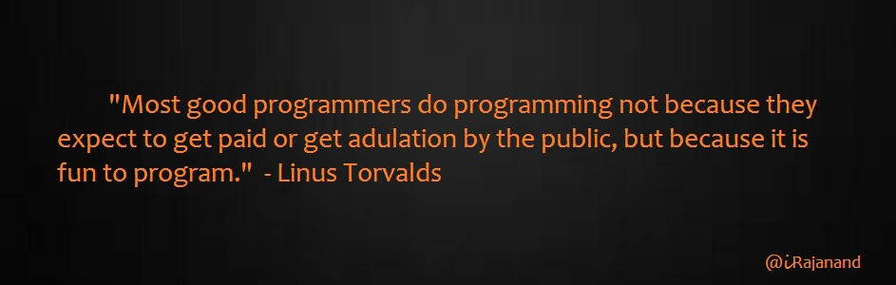

One afternoon, after my last class, we all gathered in Mr. Eddy’s room for announcements. It was the first day in robotics. Mr. Eddy told us to get into teams. I looked at Karina while grabbing Pranathi’s arm. The three of us went into the other room, where everyone works on their robot and where the Vex IQ Crossover field is. Aditri, Chris, and Manasvi joined us and we formed our team, Team 10515B.The “B” stands for Beta pack. I introduced myself to everyone and then everyone took turns introducing themselves. I told them that we had to build a robot that must score points in the Vex IQ Crossover field. I explained the rules to everyone. The whole team had to be its builders. Then we decided who will be programmer. I was programmer last year with another one of my friends, who is now in high school, and we both did an excellent job! In fact, at state we won an award for programming and at Worlds, we got 50th place in programming! So I had a lot of experience in programming already. The language we use is C ++. I said I will be programmer and Karina will be too. Then everyone started coming up with ideas. For some reason, nobody was agreeing with my idea. It took a long time for us to understand each other and cooperate, as a consequence, our robot took a long time to build but eventually we became best friends and finished the robot. Here’s a little more detail on how we worked it out. I was scared at first. When we started building the robot, it did not worry about it because things were not working like claw and motors. Sometimes me and my team had some disagreements, but we worked through them. I think of us as a family, we have fights, yet in the end we always are friends and have lots of fun. After a few weeks we started understanding each other, everyone started getting serious and worked hard by coming in early in the morning, staying in seminar every single day, we finally got the robot working. After the robot was done, I starting the critical programming work. The regional competition is soon. We are working really hard to get the best results we can. No matter what happens, I am happy with the progress we made. Life is short and it’s full of challenges. One of these challenges was making the robot work. Wherever we go in robotics competitions, I am happy with the progress we made and I learned a lot, both about being in a team and robotics. One of the things I learned was that being in a team is not easy, it comes with compromises and disagreements. I learned new things in programming like the sonar sensor, a device that measures the distance to an object. It’s much easier to program using it if I’m doing things that need a lot of long distance. I hope we make it to the next competition, despite the fact that our team has its ups and downs they are still my best friends. I really hope we will succeed and I hope it will be a great year being in robotics.

**Maanasvi’s part of the story**

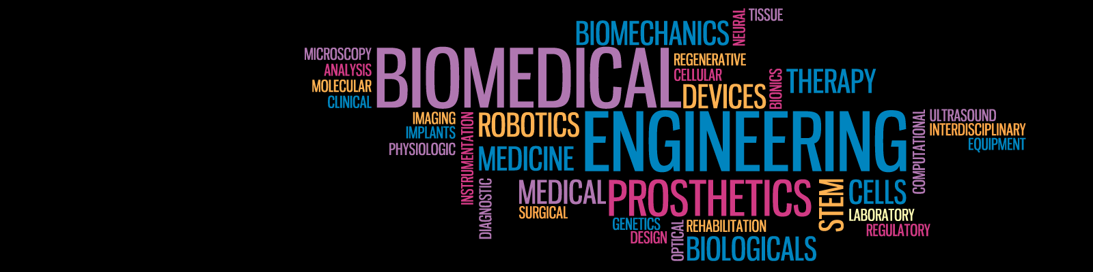

It was the first day of school and I thought it would be the beginning of an awesome new year, but… it ended up being the worst day of my life. Of course moving is always hard, but over the summer I met a friend and I knew as long as she was with me what could go wrong? Right? Unfortunately, I was mistaken everything could go wrong. She told me the best way to make friends was to join clubs. I decided to join robotics club. The reason I picked robotics, because I wanted to be a bioengineer, and I thought it would be good to learn more about technology since I wanted to be a biomedical engineer. Unfortunately, my friend and I didn’t get into the same teams. I knew my teammates, but they weren’t really my closest friends. In the first few weeks, everyone was pretty friendly and we seemed to be making good progress on our robot. I started to get a good feeling about being on this team, maybe it wasn’t as treacherous as I thought it would be. Alas, this happiness didn’t have a long life. After we finished building the robot, it wasn’t working because it wasn’t balanced. Therefore, we had to take the whole thing down and build it all over again. This happened process was repeated five times. I was so stressed out about the robot, so I decided to take action. I was the pit boss and event coordinator of this team and I needed to make sure everyone was on task the competition was coming up soon and we needed the robot so that the drivers could get as much practice as they could. I realized that the main reason why we couldn’t finish the robot is that nobody could agree on one thing, also there were some people who were out of the loop. Basically everyone had different plans for the robot and we didn’t have any proper communication. Pranathi created a WhatsApp group so that we could talk to each other out of school. Eventually, I was able to get everyone to agree with each other and we finished the robot! So far, being on this team has taught me a lot. While building the robot I learned a lot about motors and gear ratios. When we did the stem research project I was surprised to find out how important robots were in medical fields. However, the most important thing I learned was that teamwork was the key to success.

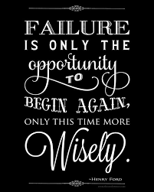

**Pranathi’s part of story**

My first day was really fun and exciting. Some of us were friends and some of us weren’t, but when we decided to be on the same team, we weren’t just teammates, we became best friends. We chose our jobs on our first day. We chose our jobs according to our interests and hobbies, because this way people will not get bored of their job and sit there idly. This step was really important because this is how we all contribute to our team. I am the scribe, team leader, and the main builder. I liked the building. I had prior knowledge and experience about building and scribing from last year when I was on a team with my friends we went to 4 different competitions we won many trophies. It was really fun in Kentucky meeting and competing against other people. Our team is doing their best to win competitions. My friend Siddhi and I are the team leaders because we already had experience in robotics and our teammates did not have any experience and we wanted to help them with our guidance. We are trying many different designs and now we are going with the idea of a claw. I learned through this process of building and rebuilding, that you truly learn from your mistakes. Despite, the fact that it was frustrating, I learned from every time we failed how to improve our robot. I like to write, that is why I am the scribe. Scribing is really helpful because you will know more about the materials in the VEX IQ kits and how will you use it usefully in your robot. According to my experience, the notebook is really organized and you can plan easily. I also like building things with different materials. The building is all about imagining things with extreme concentration. I always wanted to use some creativity in my work. These skills are very important in robotics. I remember my first day in robotics this year I was really excited to build our robot. Our instructor said to pick our teams fortunately, many of my friends were on my team. My friend Siddhi and I became the team leaders. We had a lot of challenges like there was always something wrong with our robot, our motors did not work because they were not updated or we weren’t getting along, but we overcame all of those challenges by just working together and having fun building our robot together. We all are sharing a job of being the builder because it is a big job. This is how we all support each other. It is really fun when we all work together and the product comes out very successfully. I think I had a great time working with my teammates. I think we will be very successful in the future with robotics, but even if we aren’t successful I’m glad I got to spend this year in robotics with these people.

These jobs are the pillars for proper functioning of our team. We have specific parts to play in order to succeed. Our first day was fun and exciting!

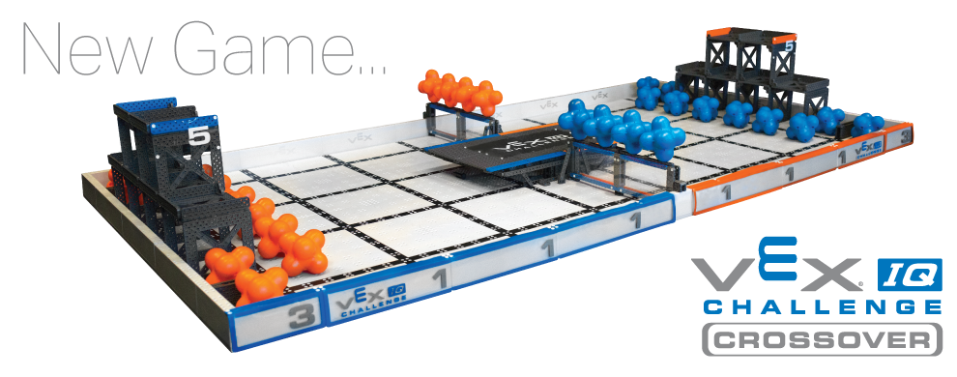

**Karina’s Part**

The first day of school, I knew no one, but myself. I met these people who introduced me to robotics and soon became my teammates. These people are not just my teammates, but they are my true friends. We have been through fights and joyous moments, and I’m glad that I got to spend time with these crazy people who have changed my life. Day 1 of robotics was pretty wild and dramatic, everyone was deciding their teams, and well I picked this one. The people on my team were Siddhi, Muskaan, Chris, Aditri, Pranathi, Maanasvi, and me. We’ve been through ups and downs together, for example when Muskaan dropped out. We were damaged by it, but we have still made it through. These people are my school family and I love them as friends. My job was builder, programmer, and driver. Back to business, we had building and programming to do, and a long road ahead of us. We started out designing an elevator, which soon enough failed. You learn from your mistakes. We then built a conveyor belt, which also failed, time was running out. Finally, we built a claw, in the end, this worked out. The moment we finished the claw was like feeling a rush of adrenaline coursing through my veins. We were finally done! But, we really weren’t done, now we had to improve our idea and only 3 weeks left till regionals. We currently have a long road ahead of us, yet I’m glad to be with these people, who have changed my life, both as friends and as teammates. Even if we don’t make it to worlds I have still enjoyed this experience and will remember it forever. Robotics is not just a club it is a difficult journey, but if you’re with the right people it can be enjoyable and educational.

**Chris’s part**

On my first day of robotics, I had lots of fun making new friends. I learned that being way too shy to try new things is bad because you don’t know if you like it. My friend Aditri is on my team, and when she’s around nothing gets boring. I’ve learned to care for my team like my family. My job on the team is a builder. We built a claw. At times we were confused about what to do and had to start over, but that didn’t stop us from doing our best. We scraped the elevator idea and decided to make a claw. But we had trouble building it. With our robot done our drivers can start practicing. We’re working on our plan now. But the most important thing to remember is that in robotics the fun never ends.

**Aditri’s part:**

My first day of robotics was really fun! When we had to split into teams I chose the team with the most people I know and my best friends, Chris and Karina! Even though I was confused a lot of times, I knew my team would have my back. At first, I didn’t even know half my team and know we’re all besties! My job in our team is the electrical engineer and builder. My job as the electrical engineer is to make sure all the batteries are charged. It may not seem very important, but if the batteries aren't charged during competition then we can’t compete. As a builder, I’m supposed to help build the robot. To me my Robotics team is more than a team to me, to me, they are my best friends.

**A team together!**

Our team came together very fast than I imagined. We are really hard-working and we can face as many challenges as possible. I liked the fact that we have fun while working at the same time.

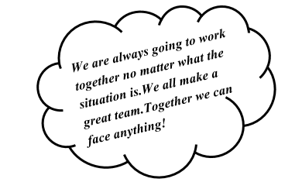

**Stem Jobs in the Future**



Robotics has really changed our team’s way of looking at the world and our future jobs. For example, when Siddhi and Karina joined this club, they had no clue about programming. This club has taught them how to program, and now both of them are interested in programming jobs in their future. Robotics has truly affected their life, because if they didn’t try programming, they wouldn’t realize how much they actually like about programming. Siddhi also really loves to work with robots and she wants a job related to programming and robots. Robotics has really affected Siddhi’s life, because what she wants to do in the future is based on how much this experience has affected her. Maanasvi wasn’t really interested in technology until she joined robotics. She really liked biology though. After realizing how fun working with robots was and there was more than just building, she decided that she wanted to be a profession that involved both technology and biology. She decided to be a biomedical engineer. Biomedical engineers create technology or equipment that helps doctors with their procedures. They also make artificial organs and teach doctors how to use equipment. Some of our other group members also want jobs in the stem field, such as being in the computer science field, the medical field, the robotics field, and the environment field.

**Conclusion: The Sweet Smell of**

**Success!**

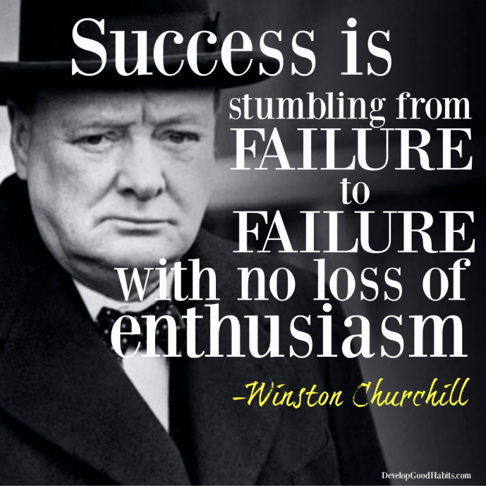

We were so happy when our robot was done. We all put so much effort and dedication into this. We also learned we need to plan ahead of time other ways it is going to be so, hard to get the robot done. If you do not plan ahead of time you may have to redo your robot too many times. If you plan wisely you will have the perfect design that can work for you in the competition and have less stress and more practice for the drivers. You need to put in hardworking order to get the “success”.

We are always going to work together no matter what the situation is. We are so glad that we got to work with each other. Together we can face anything!

