Texas Instruments Electronics Online Challenge

Allie and myself (Tiffany) are 2 proud member of team 1231A, the Astrobotz! We chose to dissect an old, 2008, ThinkPad laptop. The reasons being: they are small and portable (compared to a TV), readily available, and many people use these laptops every day. Also, since this is an older computer, it will be interesting to look at the evolution of ports etc. It is important to understand modern, frequently used technology – especially when you aspire to work in a STEM field.

While the rest of our team (and us) work on other challenges, Allie and I took a special liking to this engaging challenge. Allies motivation for doing this challenge was that she thinks technology is amazing. Taking apart and breaking it down it really makes her wonder what’s inside everything. My personal motivation is my dad’s understanding of at-home technology (he is an HVAC professor at NOVA Community College). He drove me into STEM and robotics, so I would like to have some of his views on the world. Learning really does fulfill.

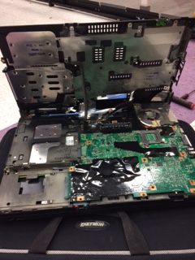 Beginning:

* Battery taken out! That is a major safety hazard.
* Take out external screws to access the inside.
* 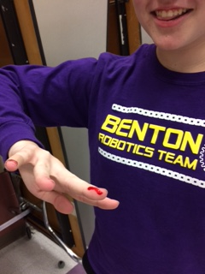Allie cut herself multiple times while trying to take off the back cover until a special pair of wire-clippers took care of it.

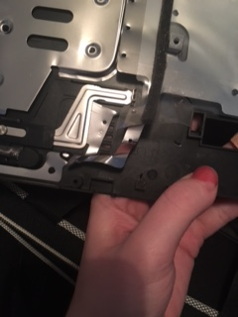

Choice parts list is as follows:

|  |  |
| --- | --- |
| Part | Summary of Role |
| CPU | Computes |
| Motherboard | Keeps everything together |
| USB | Transfer information |
| CAT5 internet connection | Fast, strong internet connection |
| Modem | Multi-task with phone lines |
| Fan | Regulate temp. |
| Trackpad | Navigate screen |
| Keyboard | Typing |

Research on ThinkPad components:

* 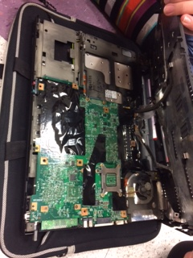CPU, or central processing unit, is the brain of the computer. It does all the calculation through lots of little switches – in binary.
* 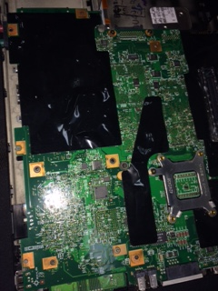The motherboard is the mother of all circuit boards! This is where all functions are mounted and communicate with each other. Circuit boards and their roles: A circuit board connects electronics through pathways of copper encased in an insulated material.

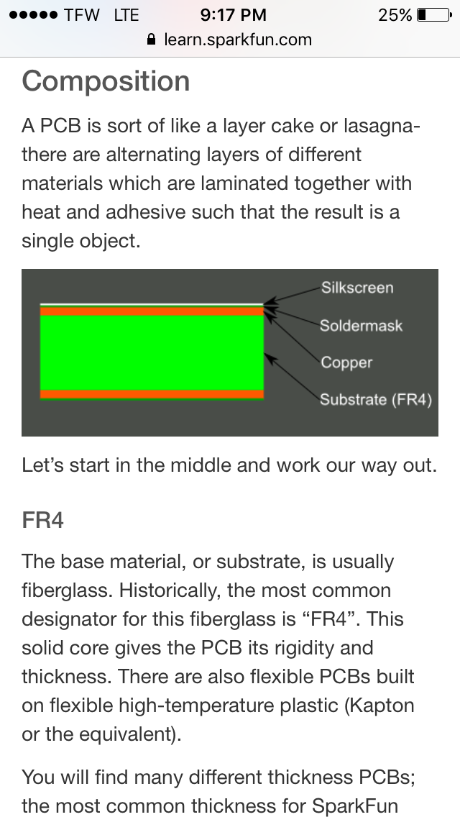The substrate is the base material and is almost always a type of fiberglass. The copper conducting layer can be on 1 side or both (top and bottom – called double-sided). The solder mask gives the component its green color, although it could be any color desired. This protects particles from conducting outward. Silkscreen adds writing for user and manufacturer use.

* 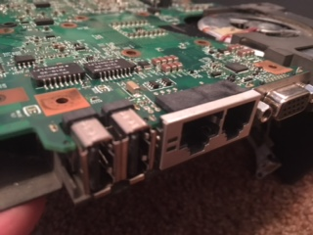A USB transfers information in a portable way. It is the most up-to-date way to share data.
* CAT5 is a faster alternative to using phone lines. It is considered hard-wired internet.
* 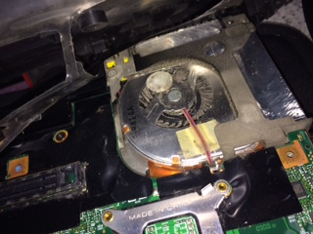Modems are means of communication, like an old phone line. This way you can use your computer and phone at the same time.
* Computers are mainly metal, and metal keeps in heat. To prevent the computer from overheating and risk crashing, the fan circulates air.
* Trackpads are used everywhere. They use a tactile sensor shown here.

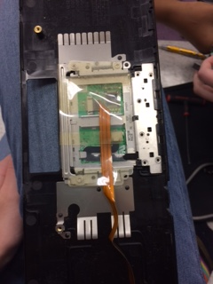

* Keyboards can use compressed air sensors. The alternative trackpad in the middle also uses tactile sensors.

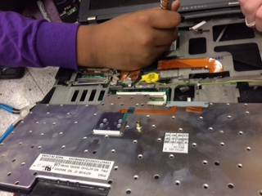

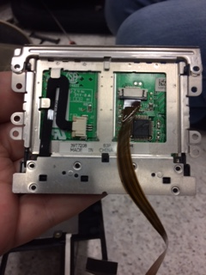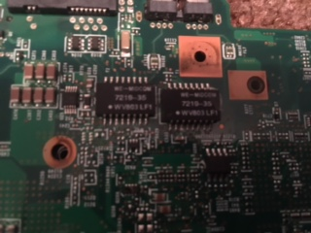

These are other picture of our dissections.

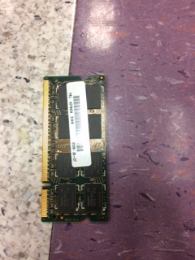

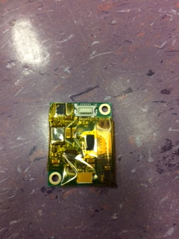

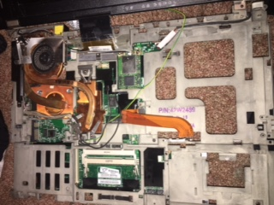

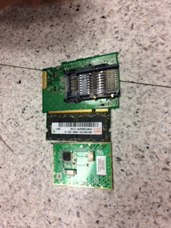

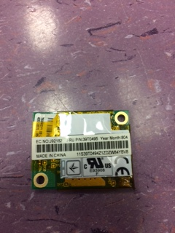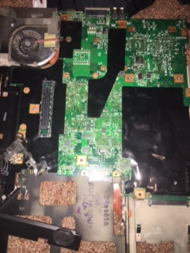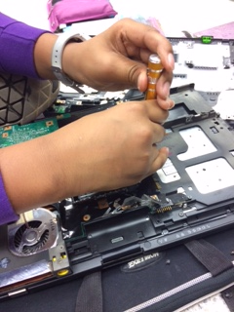

Our friends from other team are interested.