Online Challenge

Brennan Hansotia & Jake Barfield

Mr. W

11/1/17

Purpose:
We both came up witht he idea to create a linear lift. The concept came from a train design. With a linear lift, the upside would be that it would be a stronger, faster, and more efficient version of a rack gear and that the linear lift would be able to move forward and backward. When beginning to make a 3d design, we thought about switching from a linear lift to making a new and faster way to make the field perimeter. The purpose of this object is to make assembling the field do much easier. After coming up with thoughts, we came up with making a clip that would help attach to parts of the field and would still be as sturdy. We used tinkercad for making this 3D field.

How it works:
Instead of having to screw the field together, which takes for ever and is a huge pain, we thought why not use clips to put the field together. These clips are 3D printed onto a piece of plastic, they can either be glued onto the field pieces or drilled through and screwed on. We haven't come up with a way to do the corners of the field but we personally think it would be better to leave the corners with screws for extra support. In the future i am sure the field will be able to be assembled without a single screw.

Pictures:

Top View:

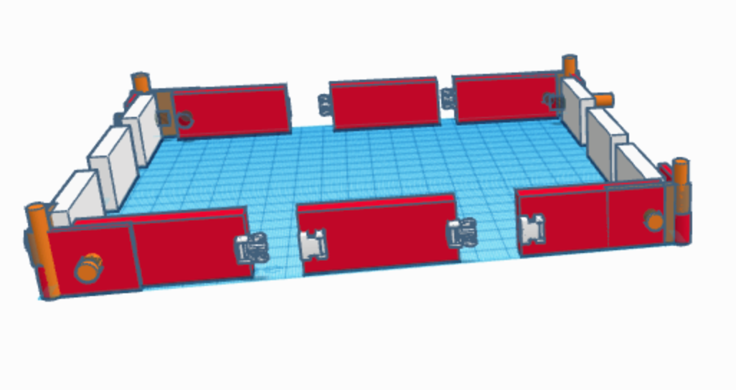

Back View:

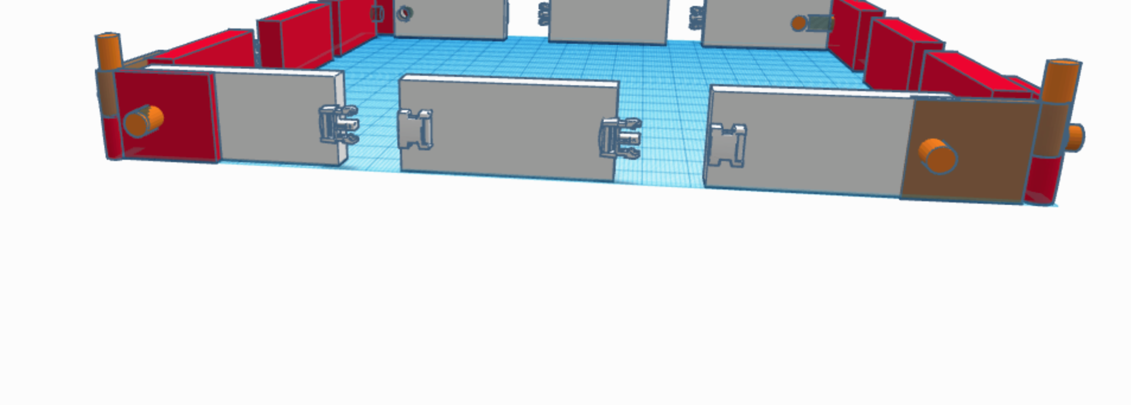

How to attach:
You can the two together by grabbing the clip on the tips and the push inwards. Once completed you slide it through the clip holder and then release pressure. This will allow the sides to interlock and to be as stable as screwing the sides together. The orange poles will just slide into the holes and allow it to be a quick lock in between each other.

Conclusion:
Creating this online project allowed us to learn how to use the Tinkercad design. We will definitely use 3D design in the future, it is a great way to bringing dreams to a reality. This program was very basic and easy to use, if we needed to create a online design of our robot we would be able to do so. We could also use the program to see how the robot would move. I believe learning 3D design will help me in the future because I would like to be a mechanical engineer.

