Jacob Levine & Ethan Redlich
November 2, 2017
Robotics CAD Challenge
The C-link
The C-link is a new vex part that will allow for c-channels to easily connect in multiple ways that can be beneficial to making a chassis, tower, arm, etc. The C-link goes over the top of a c-channel and can connect to another c-channel both perpendicularly and parallel. This can open up a whole new way to build towers and chassis because it enables us to use less materials and a simple piece to perform multiple functions. This can also be used to secure angle bars and threaded beams across a robot easily. With this piece, no more cutting base-plates and angle bars into small pieces to connect c-channels together. This piece is an all around great piece for many functions in the robot. Our piece eliminates the clutter of screws in your designs and allows for a cleaner way to design your robot.
Purpose
The purpose of the C-Link is to allow easy connections between multiple-channels. This can help with creating big structure designs instead of using excess screws and small cut c-channels/base plates. You can use the piece to connect 2 ends of a C-Channel together or the sides of up to 4 c-channels interconnected by a single piece. You can also use this piece to connect a C-Channel perpendicular to another C-Channel. Thirdly, you can use this piece to connect 2 C-Channels parallel with one another along with a perpendicular C-Channel. The side of the C-link is 2 by 3 holes side hanging off the top which allows easy connection for perpendicular c-channels and other pieces to hang off one another.

Progress
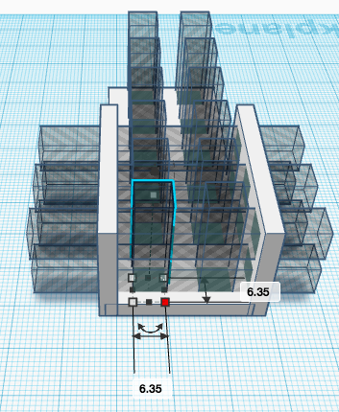

Product 1-(Oct 23)
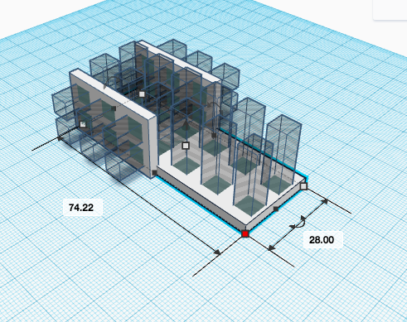

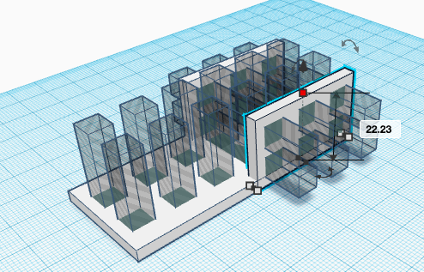

Progress Update

These original designs for the C-Link were made using measurements but we forgot to account for the fact that the C-Channel has to fit inside this C-Link and so it was too small for the C-Channel to fit in. These measurements are in millimeters to be more exact for these small and minimal lengths but after 3-D printing are testing it with C-Channels, we went back to the drawing board on tinkercad.com and expanded the C-Link with new measurements.

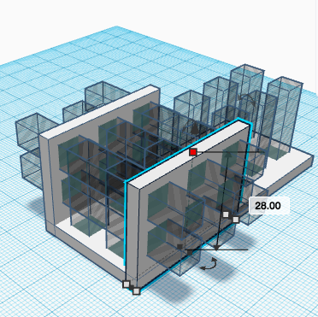
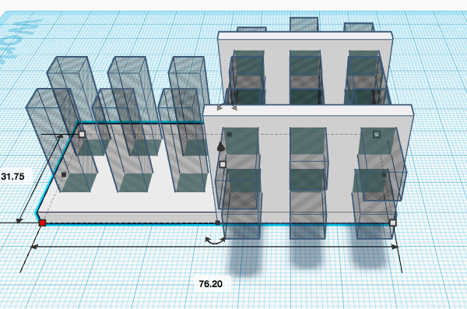
Product 2-(Nov 2)
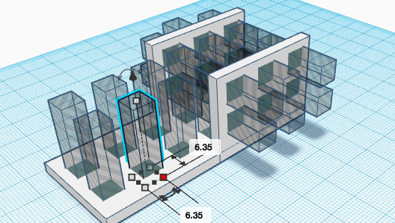

Progress Update

We have obtained new measurements to add by subtracting the height difference when the C-Channel was inside the prototype C-Link. We went back to tinkercad and changed it and we are in the process of 3-D printing it and will test it once it is printed.

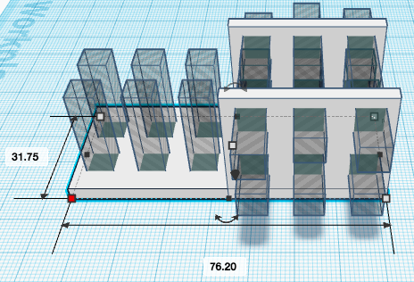
Product 3- (Nov 16)

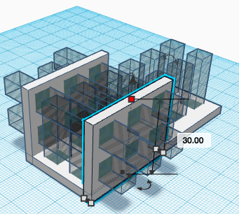
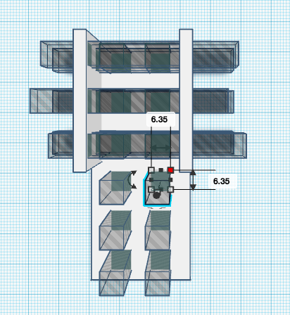

Progress Update

My partner and I realized that when attaching the C-Channels perpedincuar the 6.25 mm by 6.25 mm holes were to close to each other to correctly attach it. We then took a ruler and measure the distance we needed to cahnge, then we editted it on tinkercad and 3-D printed it.

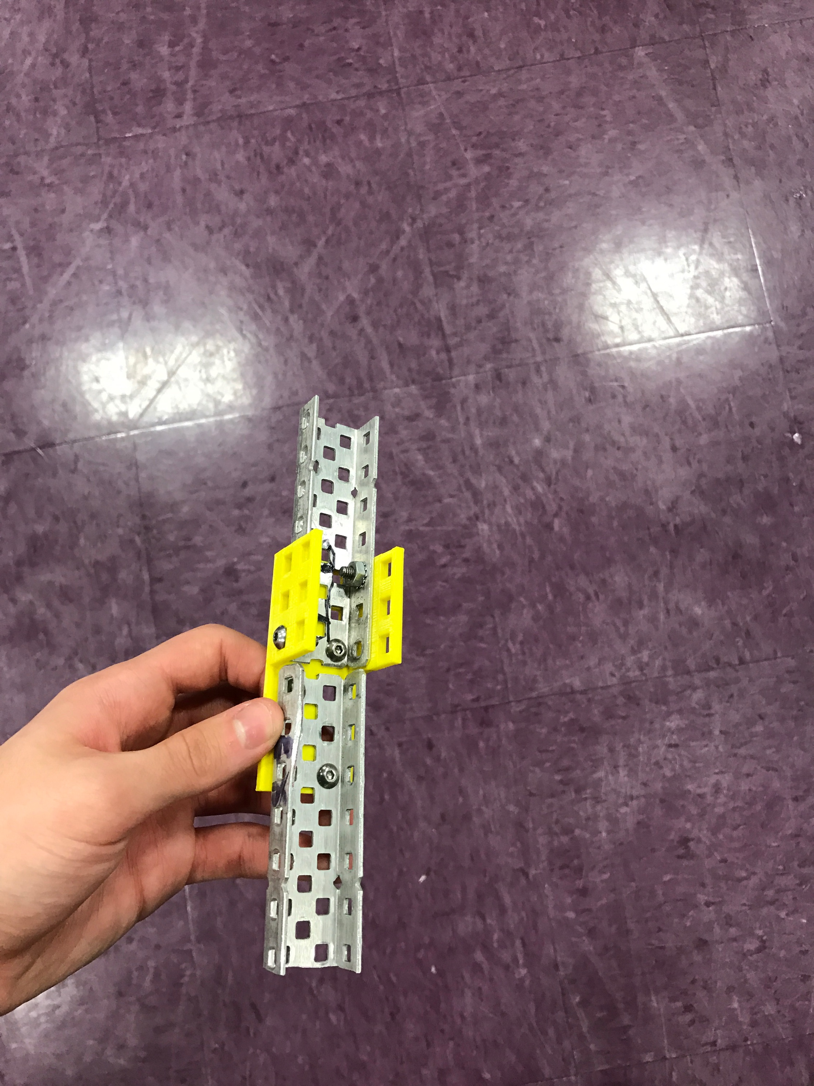
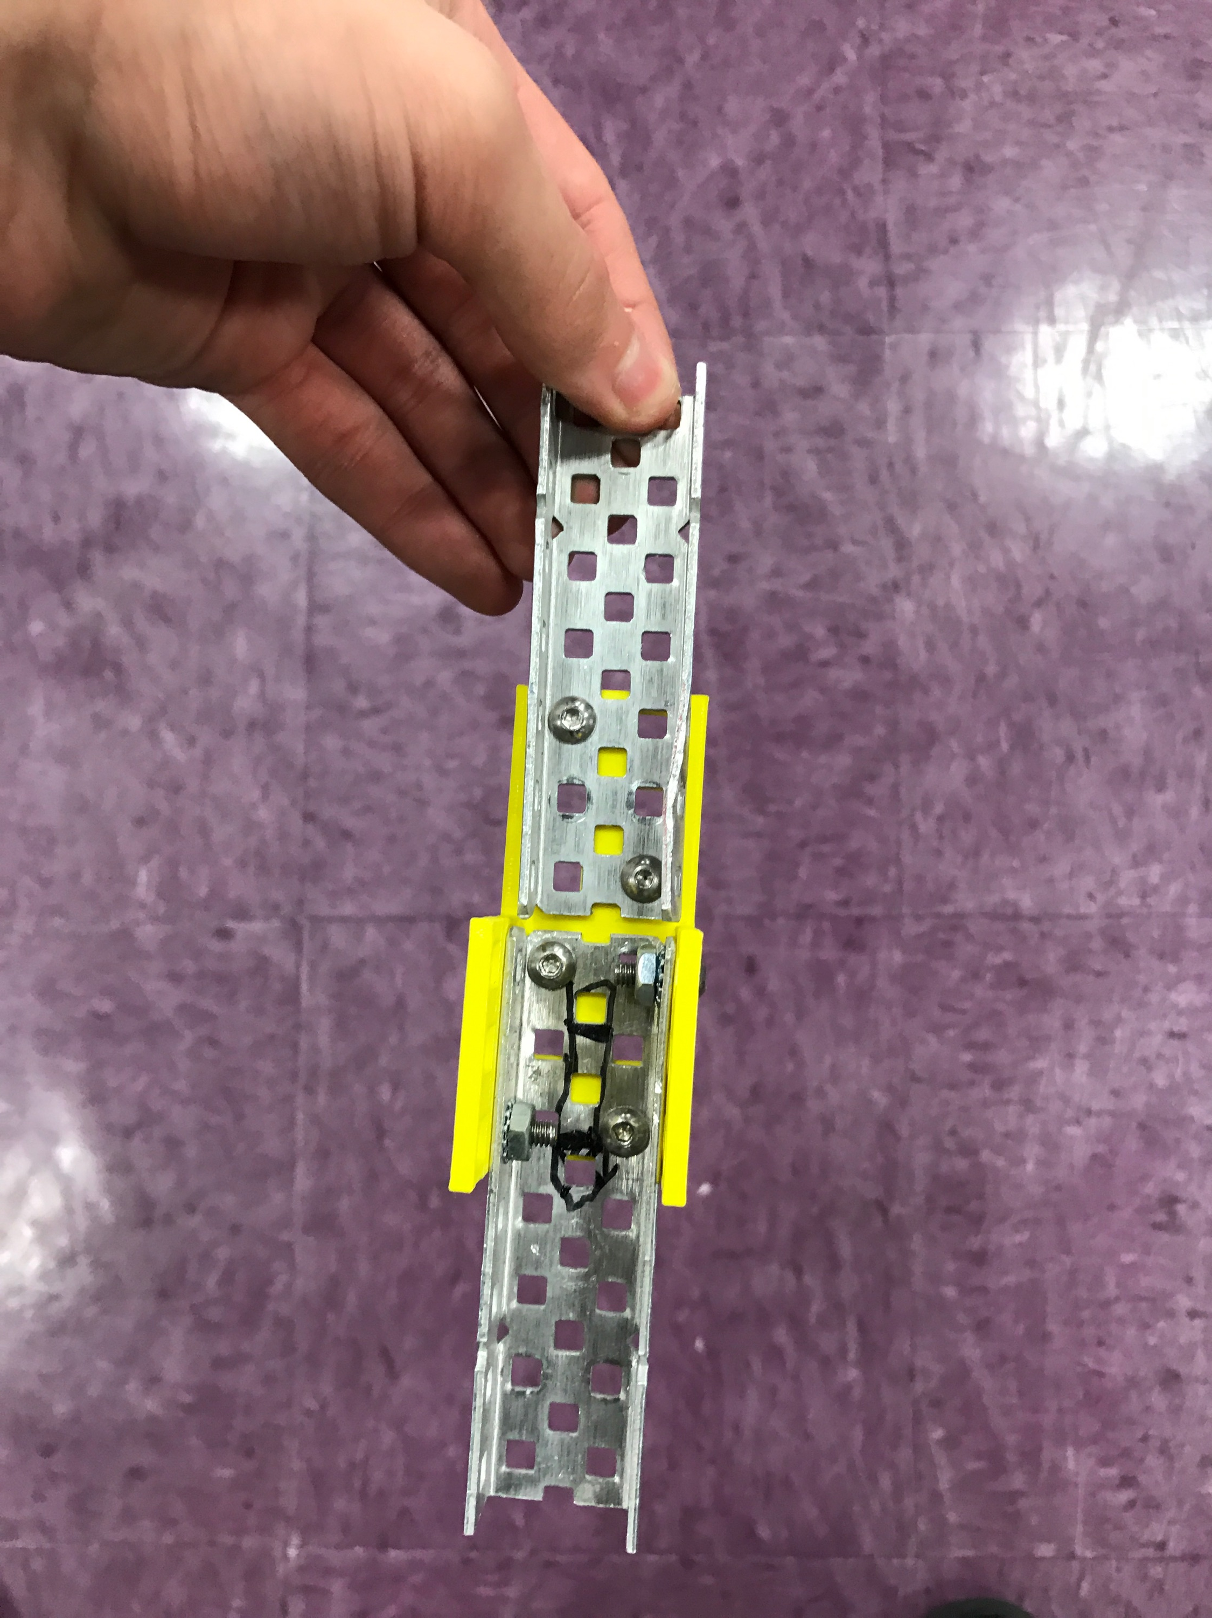
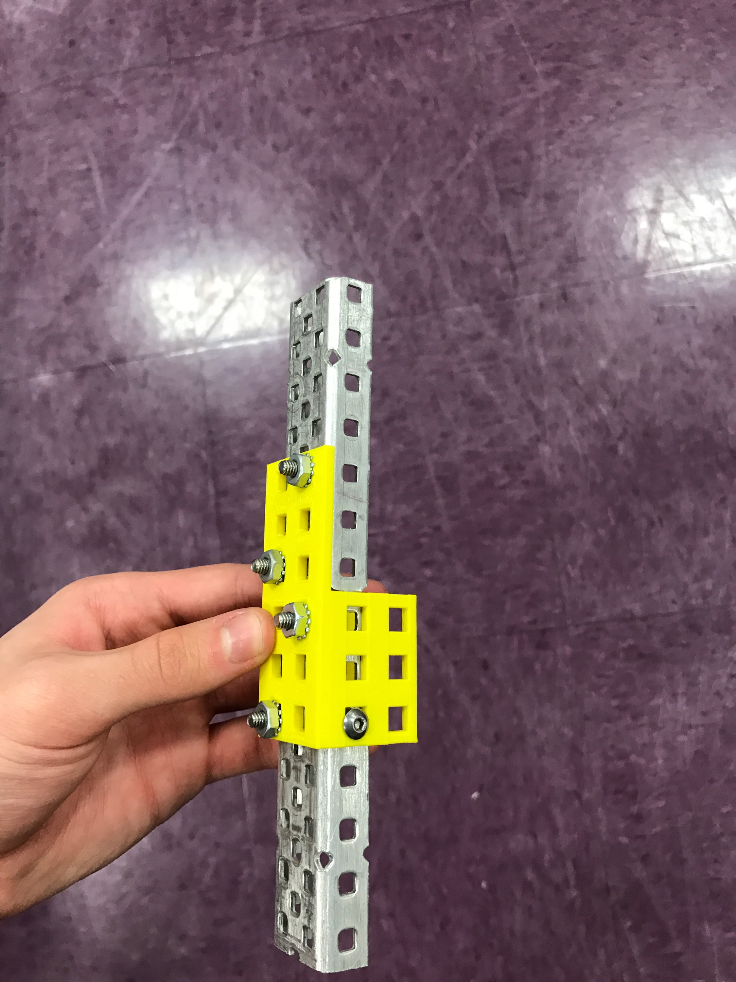
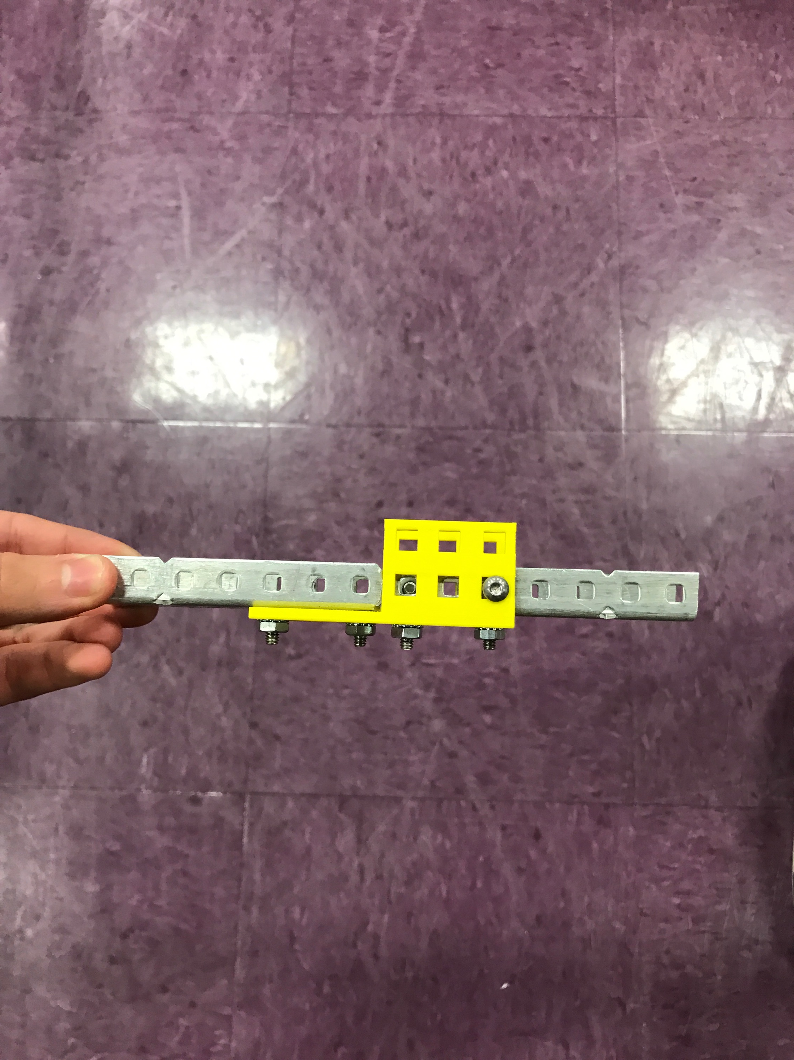
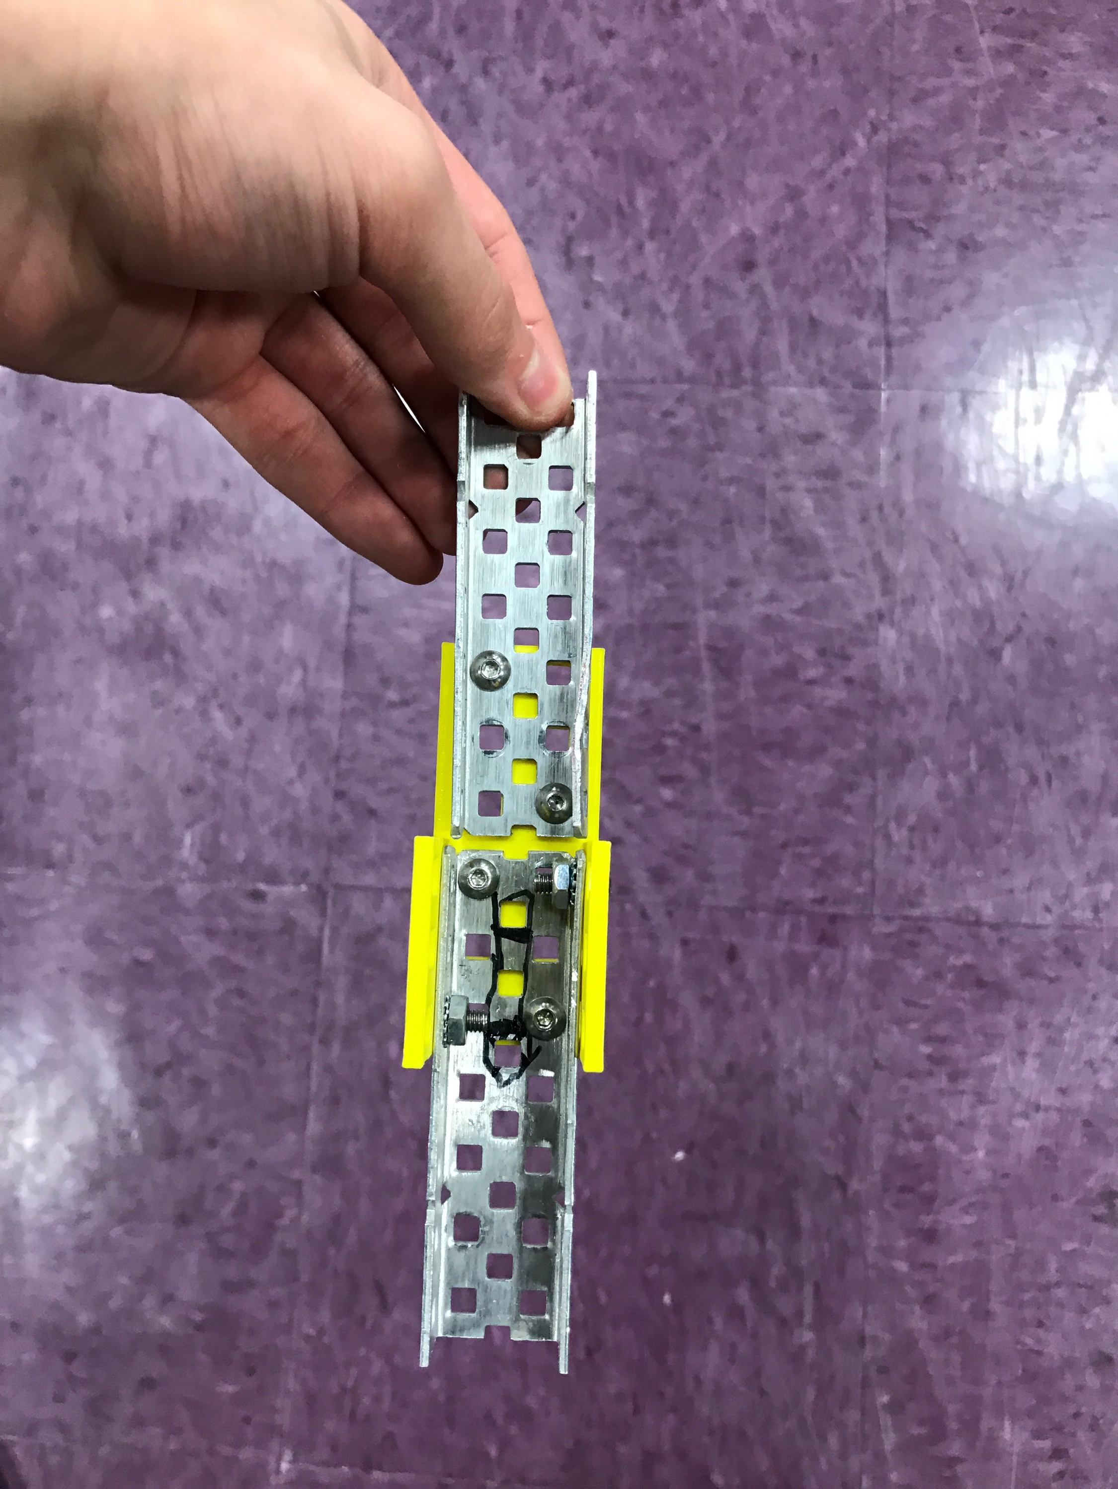
This is our final project after 3D printing it. These pictures are of an example of our C-Link in use connecting 2 C-Channels. The screws go in through the sides and the bottom to connect in and it is both sturdy and straight. We are proud to reveal this as our the final stage in creating our C-Link

