Jonathan DiPasquale
10/5/17
AutoCAD challenge
Wire Holder
For the online challenge I am going to do the AutoCAD challenge, by Autodesk. I have an idea for a part that will help prevent wires from going into gears and breaking. The part will replace the use of rubber bands or tie wraps to hold down wires. The problem with tie wraps is they are stiff, and they cannot be adjusted if tightened too far and need to be cut to move the wires if you need to. When using the rubber bands to attach wires they need to be tied in a knot and sometimes it can come loose. Also, rubber bands like tie wraps do not allow the wires to move as freely as my newly created part will. My piece will be like a bearing flat that is missing some of the middle piece. Its shape will allow you to put the wire through the hole. It will allow the wires to move with the metal but not get tangled in gears, or any other moving parts. The piece will also reusable, so you don’t waste tie wraps. This new piece is a simple solution to preventing wires from getting in the way and breaking.
I will use Tinkercad to create my project, I will create it using a box with some holes in it.

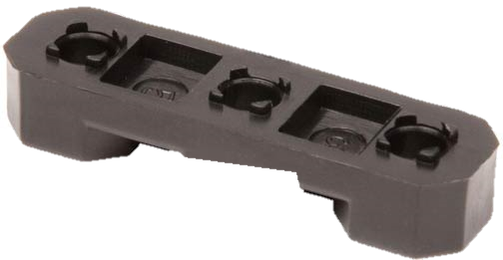

I based my design of a bearing flat so it took measurements one
Bearing flat Measurements
Length 35mm, width 10mm, height 6mm, hole diameter 5mm.
My design measurements
Length 35mm, width 10mm, height 6mm, hole diameter 5mm, new hole height 3mm, new hole length 15mm, new hole with 10mm.

Here are some pictures my first design for the wire holder on Tinkercad (it is upside down, so it would print correctly).
Bottom right corner
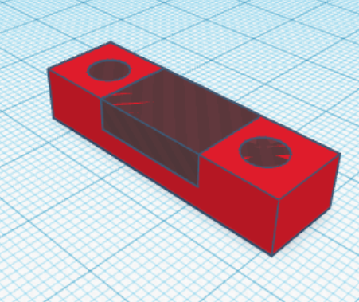
Bottom
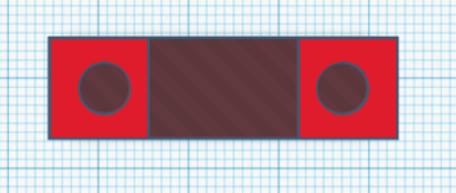

Front or back
Top
Right or left side
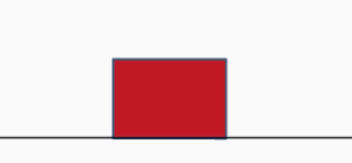

Pictures of the piece after it printed
Bottom right corner
Bottom
Front or back
Top

Right or left side

Testing the piece, to make sure it fits.
The screw holes are the right size.
The first hole lines up with metal and a keps nut
I ran in to a problem with the second hole, it does not line up with the hole in the metal

After testing out the piece I realized some changes I need to make to my piece to make it better. I need to move the holes a little, so it can easily be screwed down to the metal. I also want to add a way to prevent the wire from moving because the way the first one was created allows wires to flow easily through it. Another change that I want to make on it is to add something to prevent the wires from rubbing up against sharp edges of metal. I don’t want my piece to be the reason why wires break.
The new design will have a third hole to put a screw into and hold the wire in place and a cover over the hole for the wire to prevent it from rubbing on the metal and damaging the wire.
New design
Bottom right corner
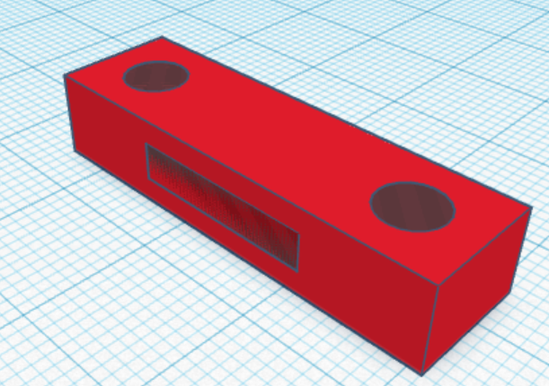

Bottom
Right or left side
Front or back
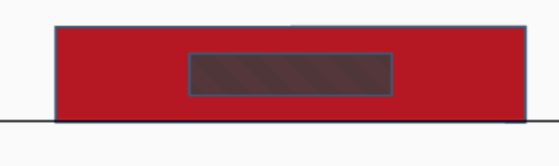
Top
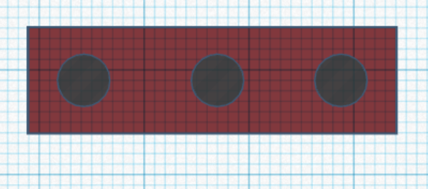
Testing out my final piece
Testing to see if the holes line up with the metal
Both holes line up perfectly
The third screw hole for holding the wire still works
I realized that there was a problem with the wire hole, where the wire does not fit.
After testing out the second version I realized that I need to fix the wire hole. I need to make it 1 mm taller and remove some of the 3d printing structure in the way. Other than that, my design works perfectly.
Conclusion
In this project I learned that it is very hard to get something correct the first time. I learned to be very careful while moving things on Tinkercad because you may change the size messing it up. I also learned that you need to measure multiple times to avoid things not lining up
Here is the link to my Tinkercad design https://tinkercad.com/things/8Wn8qfTsytF

