Vex Skyrise Cube Table/Mini-Shelf

By Lucas Fernandez and Ivan Hernandez

__________________________________________________________________

Design Process

Our design for the Vex Future Foundation Recycling Challenge was a table/shelf made from Vex Skyrise Cubes, Vex Part boxes, and Vex Mats. At first, we were thinking that we would make a shelf, but we decided we can also integrate it into a table as well, and then came our design for the Table/Shelf. Our first design wasn’t stable, and we were unsure about the final measurements, but we managed to get around it, and fixed up the measurements, our final design came through and all the measurements were shorter and in control, all we needed to do was put everything together.

__________________________________________________________________

Building Process

Our building process would take us a month to work on and we would start with the Vex Mats. The first thing we did was put the mats together, it was very simple, as it was a puzzle piece that we would just normally put together. We would then proceed to hot glue the Skyrise Cubes in a 4x1x1 leg format. After we glued on the four legs, we would let the table stand up, it turned out that the legs were not enough support for the vex mats, and since then we would have to delay the shelf part of the build.
Later, we found out an easier way to fix our problem, we would use the Skyrise tube connecting to the 2 front legs, and add an extra set of legs in the back. Fortunately, it was stable enough to hold a lot of objects like a laptop, a book, a tissue box, papers, everything necessary towards the use of a table.
Next and Last would come the most frustrating part of our building process, the shelf. We would have to take a VEX part box and cut it with exact measurements. It was pretty hard considering we would have to glue the cardboard on afterwards. However, we were successfully get the measurements to a 5x7 space, and cut it to stretch across the legs of the table. We also decided to add cardboard to the 5x5 spaces, which we thought would look cool, because we thought we could add each cardboard to say ‘V, E, X’.
Finally, we completed our Table/Mini Shelf, and are now ready to submit it.

__________________________________________________________________

Pictures
Here are pictures of the table and the sketches we took.
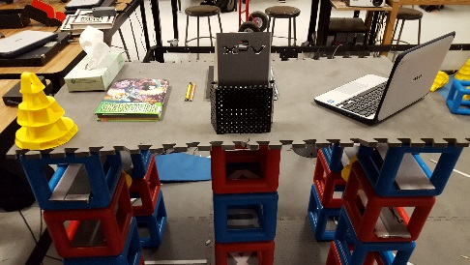
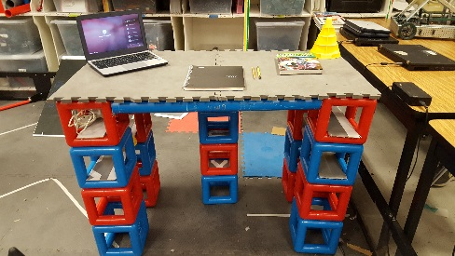

Front view with objects on it. Back view with objects on it.
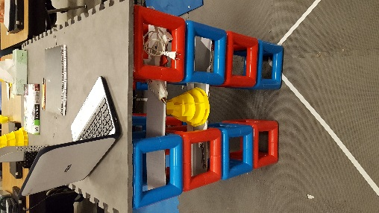
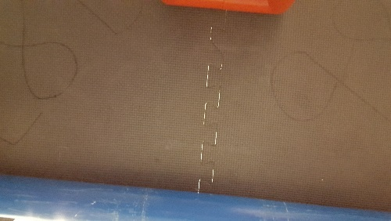

Side view with objects on it. Under view of the table.

__________________________________________________________________

Sketches

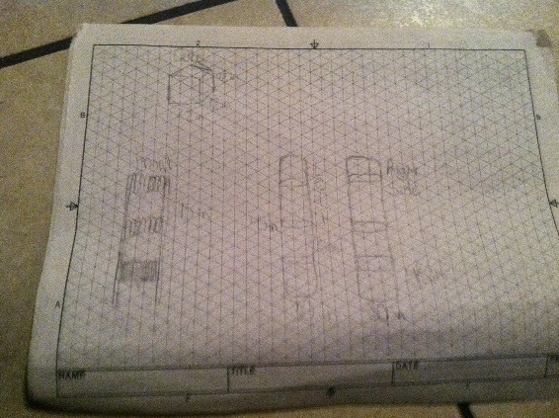
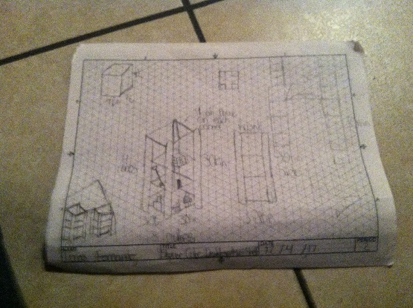

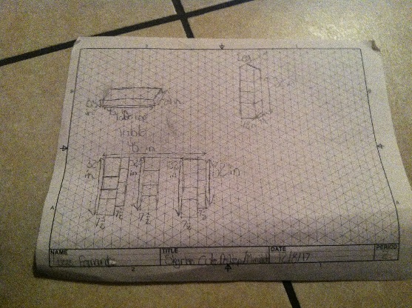
1st Sketch 2nd Sketch

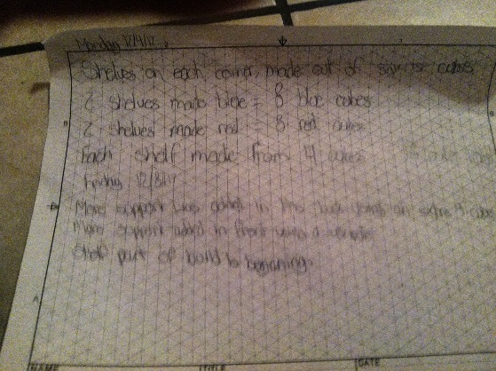

3rd Sketch Planning log on back of 2nd sketch.

