Electronics Online Challenge

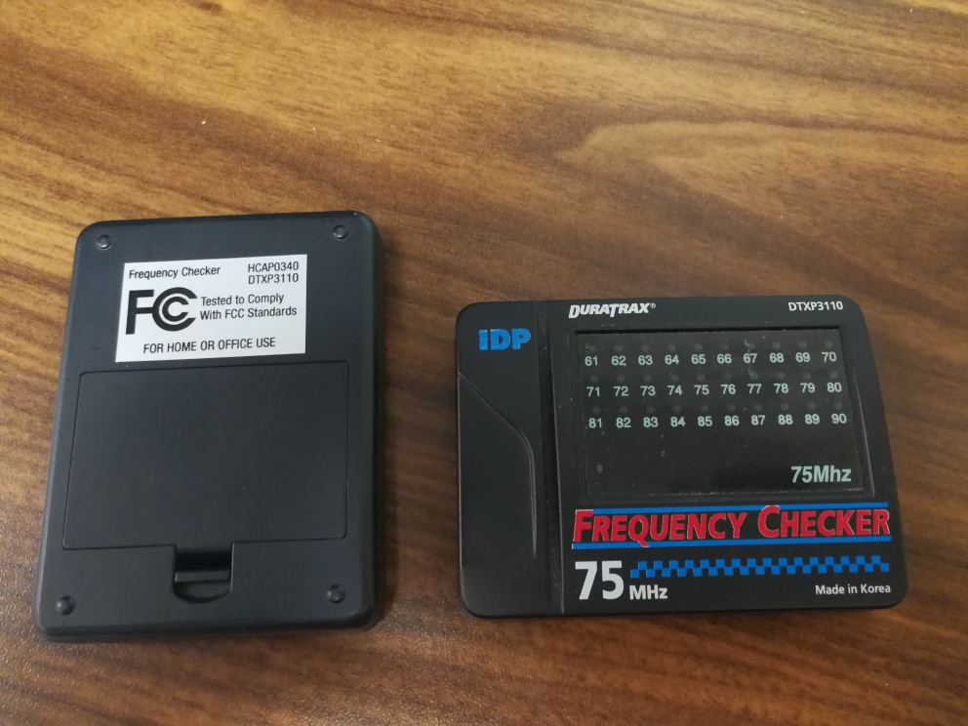Humanity is built upon innovation and evolution. From the renaissance to the information era, Humans have created many devices and contraptions to suit their need. Currently, we live in a world where connections and interactions have become wireless. In this wireless society, there is difficulty in detecting and identifying wavelengths. However, just as the ancient Chinese created calendars to record the days, scientists have created the frequency checker/detector. This device was selected due to how we all interact with each other wirelessly through the internet. The data transfer by either waves or cable is used to connect with the internet. Despite cables being able to transfer data faster than wireless, wireless devices have become a standard today.

The frequency checker from Duratrax, a utility company for RC cars, is designed to examine all 30 R/C frequencies in the 75MHz Band and to identify other transmitters using the channel to prevent two transmitters from transferring 2 sets of commands to the receiver. This instrument contains microchip processor that allows for the programming of the LEDs. The LEDs are programed to shine whenever the filtered FM detector discovers another transmitter using the frequency corresponding to the LED. This device also contains a potentiometer, K11.150 crystal, CQ relay, dual PLL frequency synthesizer, switch, and a port for an external antenna. This device does not contain any Texas instruments components.

Duratrax Frequency Checker

Starting from the potentiometer, its task to is measure voltage. Potentiometer is usually used in devices to control volume. The K11.150, a crystal, is used to create its own frequency by applying current to the crystal. This then allows for the synthesizer to generate a range of frequencies from the reference frequency created by the crystal. As the frequencies are crated, the 10.7MHz 2 pole filter will filtrate all the frequencies that are not within the 75MHz range. Finally, the frequencies within the 75MHz range will be scanned by creating the same wavelength with the dual PLL frequency synthesizer.

Overall, with the increase of wireless communication becoming apparent, people need to know how it works. By participating in the challenge, I’ve learn how to identify different parts of a circuit and their usages, such as a crystal oscillator creating its own frequency. Additionally, I have educated myself in how wireless communication works.

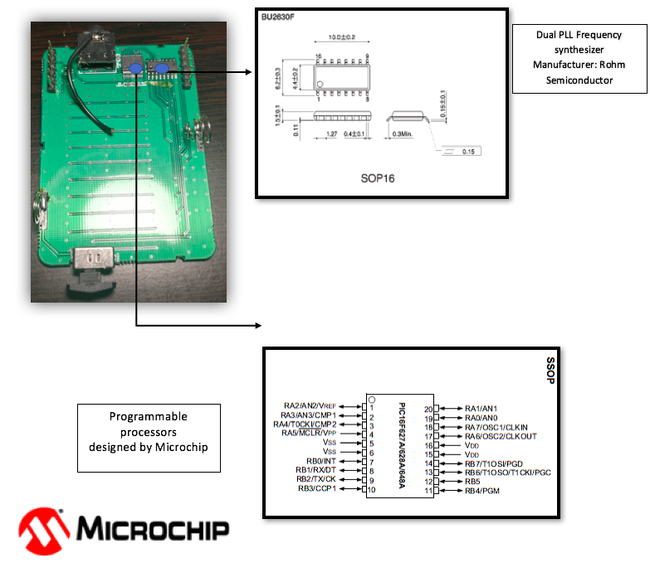

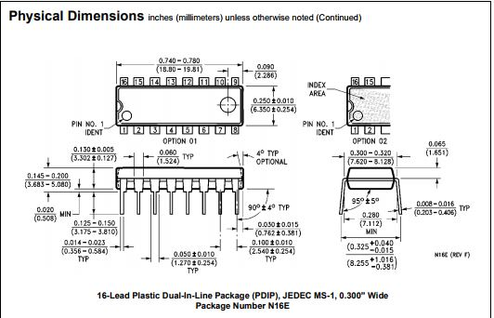

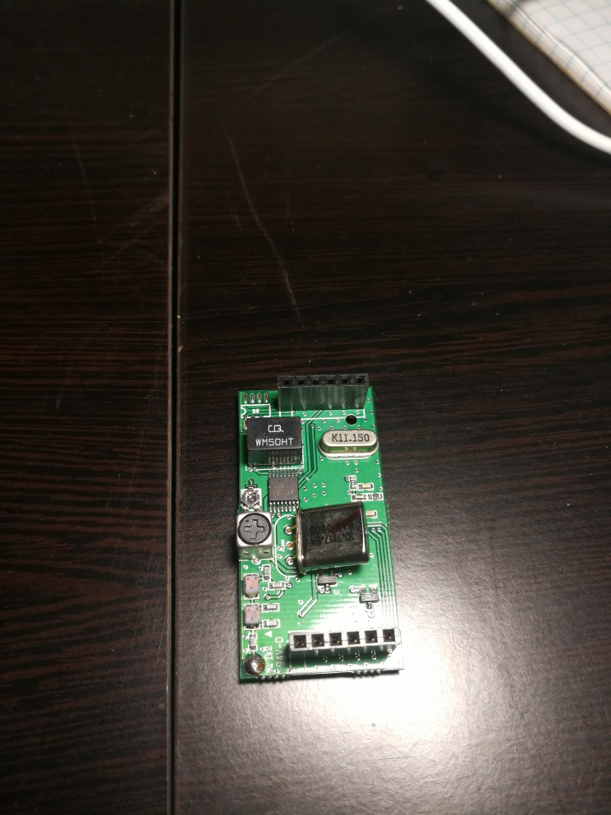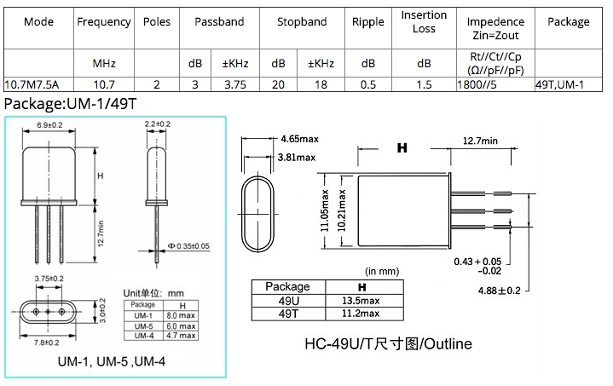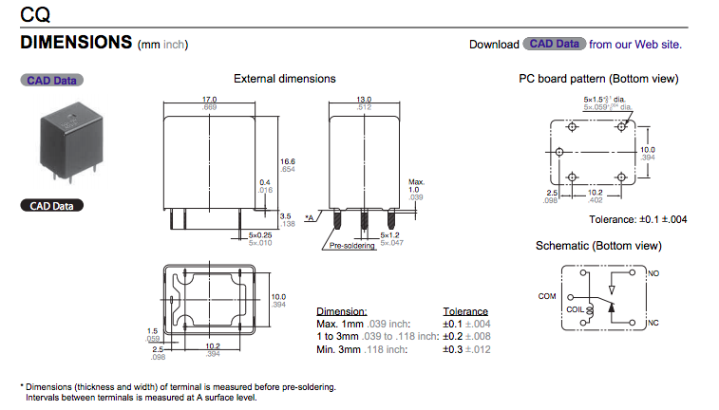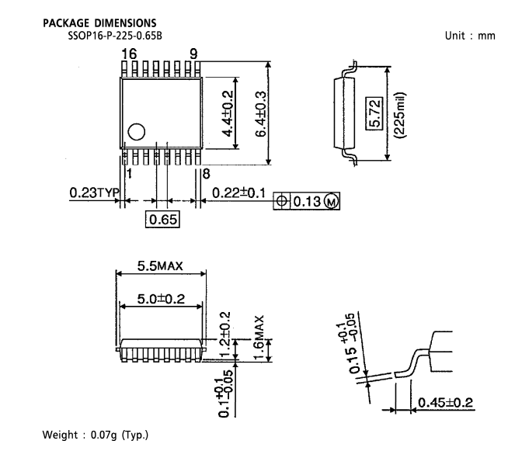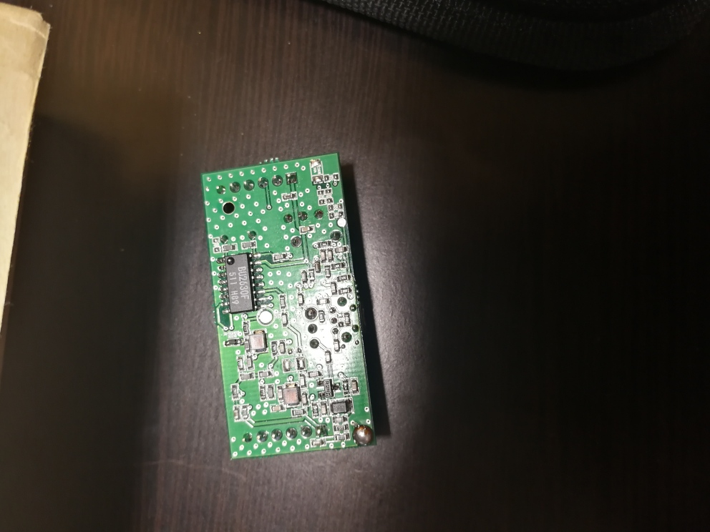

2 poles, 10.7MHz filter

Brand name: PvD

(Physical vapor deposition)

CQ Relay

Designed by: Mouser Electronics

FM Detector

Designed by: Toshiba

Counter Shift Registers Decode Ctr/Divider

Brand Name: ON semiconductor / Fairchild