Team 3249A
Recycling Online Challenge Report

We decided to create something that would work universally in almost any setting to address this challenge. In an effort to keep people from viewing old field parts as trash, we turned them into a trash can. It’s quite simple to use, just place it somewhere, and you can put whatever you would like through the open top of the freestanding container.

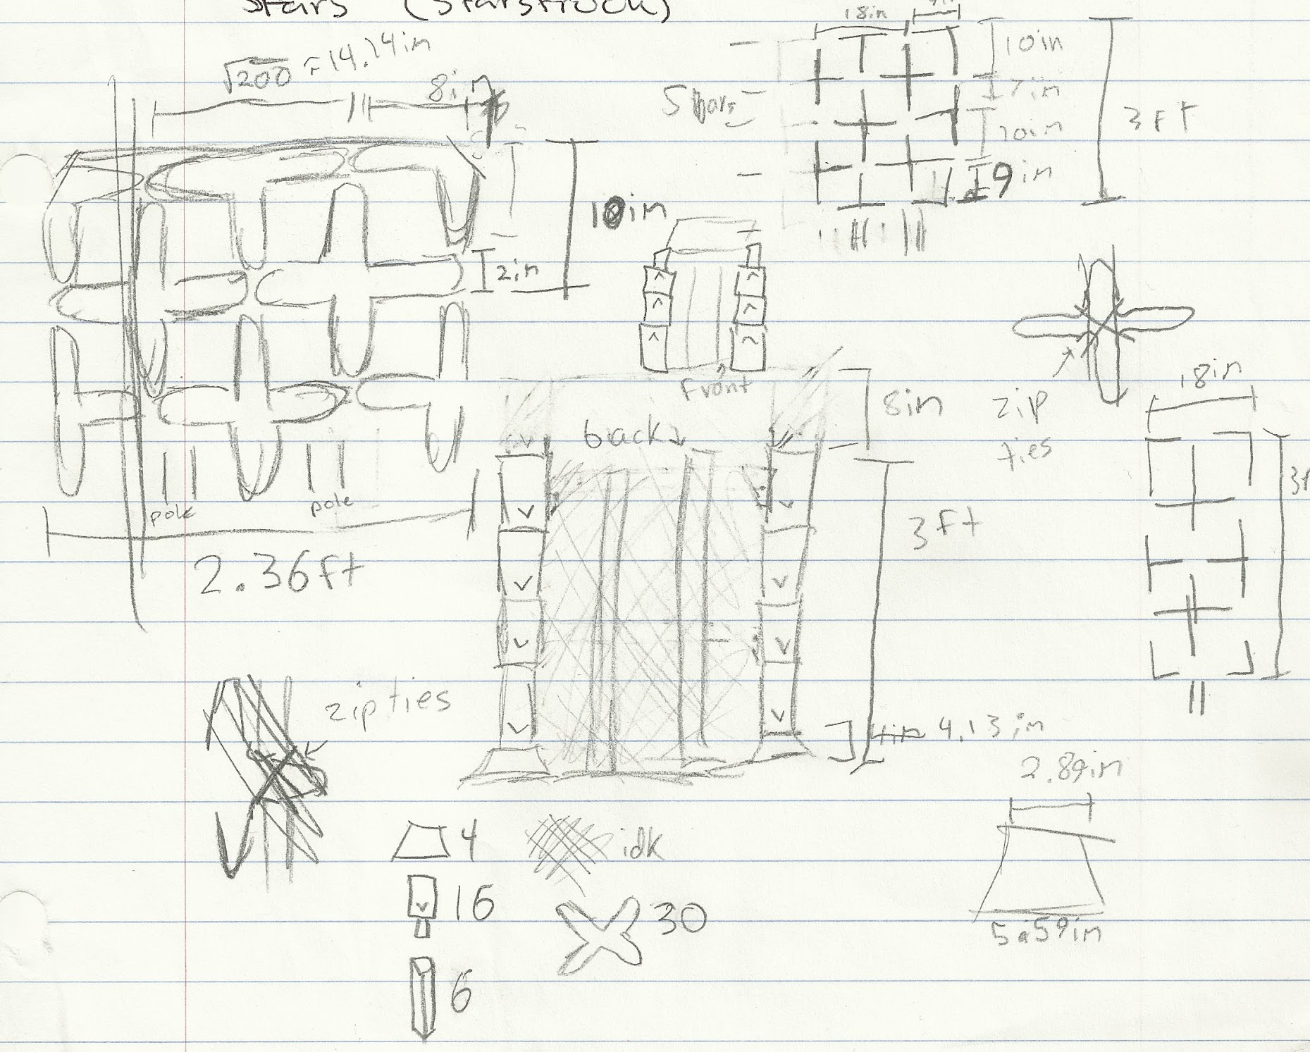
We started out by sketching out some possible designs we had ideas for.

This creation is symbolic to us. Using tower pieces from Skyrise, our first year competing, we created a solid foundation. Netting and balls from Nothing but Net join them, adding more color and variety. Finally, wall pieces and stars from Starstruck bring everything together, connecting it solidly, and making something beautiful. Our team evolved in this way too.

We wanted to create something sturdy, and strong. We knew we would need solid pieces to stand on their own, sides that won’t come apart. The sides would need to be relatively tall, and we realized that the towers from Skyrise were perfect. The fence from Starstruck was already made to connect, so we trimmed them a little to fit our size, and used them as the supports on each side.
Out of all the parts we had, the largest quantity was stars. We knew they would make a good decoration and covering, to give our product the feel of a wall, while just placing them on the outside of a framework. Pulling back out the piece that goes through the middle made them flat enough to use.
The product is a little large to put a standard garbage bag around the edges, so we solved our problem with the net poles from Nothing but Net. Attached on the inside, to each corner, they provide a strong place to wrap the bag around, or in our case, stab them through the corners of the bag, to hold it in place. A little unconventional, but the netting on the inside prevents the strain of a lot of weight in the garbage bag from pulling down and ripping the garbage bag right off the poles inside.

The great part about this product is that it can be used, anywhere, and for almost anything. A trash can is something everyone needs, and uses. But it doesn’t have to be just for trash, it can hold paper recycling, old cans to be recycled, or even for storage. After creating this, we put the rest of the stars we didn’t use back into the product, for easier transport.

