Geneva Gear
  - VRC Team: 1961N Neon
SFHS Neon | Autodesk Make It Real Challenge| January 2018

Introduction
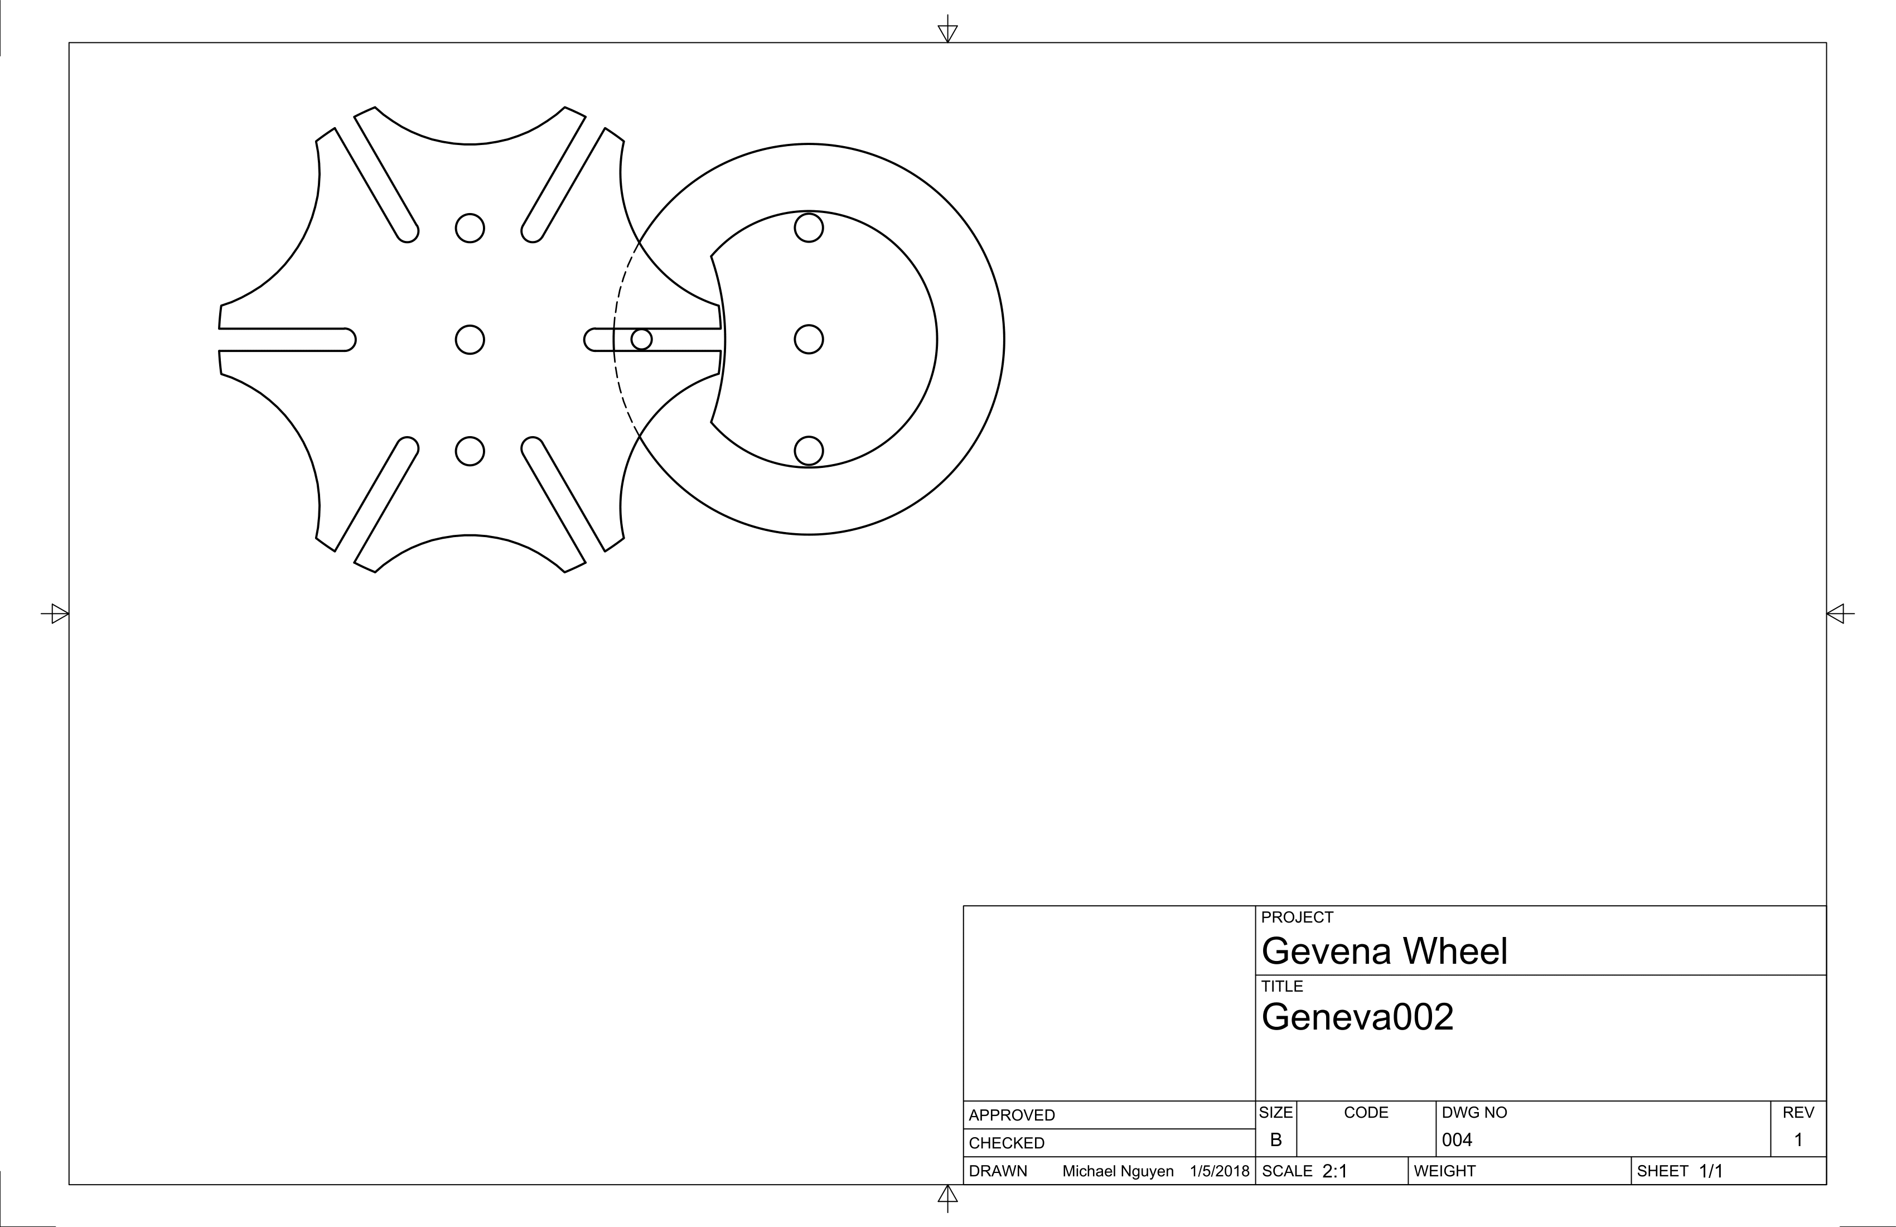
VEX parts are very flexible in nature due to their regular intervals and standardized thickness. However one thing that is sorely lacking is the ability to create what we call burst motion. This is the motion used in old film projectors where frames would be shown for a short period of time then quickly moved out and replaced by another frame.
This design is special because it allows the driving gear (Green) to move in a smooth rotational manner while the driven gear (Blue) moves intermittently – See below video. 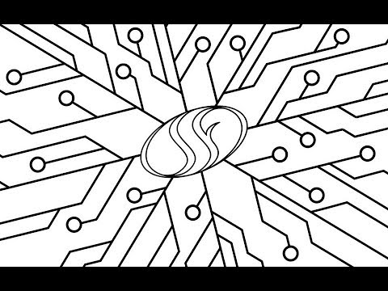
This step motion also allows for a locking function as the Driven Gear is sturdily locked in place. The slit catches the pegs as it spins around allowing it to move, but the circular cutouts also lock onto the inner “circle” as the Driving Gear spins around for a second run preventing the Driven Gear from spinning.

Explanation
This year’s game “In The Zone” introduces many novel ideas and reintroduces many old ones. The object of stacking is not a particularly new concept, but the items we are stacking are quite different then what we have dealt with before. One not so novel idea of interacting with these cones is the usage of a claw.

Heat
One of the largest drawbacks of claws is their method of grip. Many claws hold items by applying pressure. This means that as the motor turns to apply pressure it stalls. Stalling the motor can create heat, and as a result melt the thermal capacitor. This means the claw can only operate for short period of time before burning out and becoming unusable.

Back driving
Another issue with any motor driven device is possibility of the motor being turned in opposite direction that it is trying to work. For example if the motor is driving a lift upward the load might back driven the lift down. This can be circumvented through many ways. Without adding more power through spring motion or motor, there are certain things that can be done. One method is the use of a worm gear, however VEX worm gears don’t have a high strength, and cannot be used in a compact manner. In addition to that VEX worm gears only exist in a single gear ratio (1:21). This extreme gear ratio forces a high torque low speed mechanism which doesn’t work for all situations especially not for a claw where opening and closing at high speeds is important for fast stacking.
Another option is to use a ratcheting mechanism, but yet again the mechanism has low material strength. The ratchet does not use the half-inch high strength gear standard that has become standard. Instead it uses the low strength quarter-inch that was common previously. As result high load situations cannot use this system due to fear of catastrophic failure. By its nature ratchet system can only move in one direction. While this makes it very appealing for certain situations. A ratcheting system however doesn’t work for our use case as a claw needs to both open and close.
Our new part solves incorporates benefits from both solutions. The Geneva gear is stronger because it’s larger in size and has a larger surface area. This part also allows for movement in both direction at a reasonable gear ratio.

Tools
- Autodesk Fusion 360
- Version: 2.0.3800
Autodesk Fusion was an extremely helpful tool due to its ability to store data in the cloud as opposed to storing files locally. This fit our use case as our school computers have very small storage space. The cloud storage allowed us to share between users and between computers. This is my first time working with Fusion 360, I use Autodesk Inventor on my personal computer, and however I decided to use a school computer for this project. Adjusting to Fusion’s unorthodox method of handling assemblies which made it confusing to handle multiple parts without constraints and lack of an origin on individual parts. Once I understood how to properly manipulate parts – thanks to some helpful YouTube videos – Fusion 360 animations and movements were relatively easy to understand.
The part was made using the tips in the article “Make Geneva wheels of any size”
Link: https://newgottland.com/2012/01/08/make-geneva-wheels-of-any-size/

Conclusion
This year’s challenge has brought back many ideas and created some new ones with its delivery. This delivery has brought light to some of the weaker parts of the VEX Catalog. When my team sat at the drawing board we noticed that despite the open canvas that VEX provides many options, the game is also very limiting due to its constraints on parts. We hope the VEX continues to diversify its product line, and hope that many of the suggestions made by the community are considered in the years to come. The release of V5 is very exciting and shows that the company is moving forward with technology, we hope that this forward momentum is used in the mechanical side as they faze out old parts and introduce new ones.
This task has given us a new perspective on creation and design. It is said that a craftsman is only as good as his tools. In our experience, we’ve found this to be resoundingly true. We’ve always been limited by our blades, screwdrivers, materials, and method of design. With the move to Autodesk Fusion, more of our team can watch the design process unfold and interact with the program rather than simply watching a single person is slowly creating a part. When we began this challenge we saw the VEX part list as a static tool, it was and is one of the best canvases available to high schoolers yet limited in its flexibility. This challenge introduced us to custom design, where everything could be built for the task rather than selected from a rigid list. This has been an eye opening experience, and we will grow as engineers for it.

