WRITE UP
By Justin Nagovskiy & Brandon Rodriguez
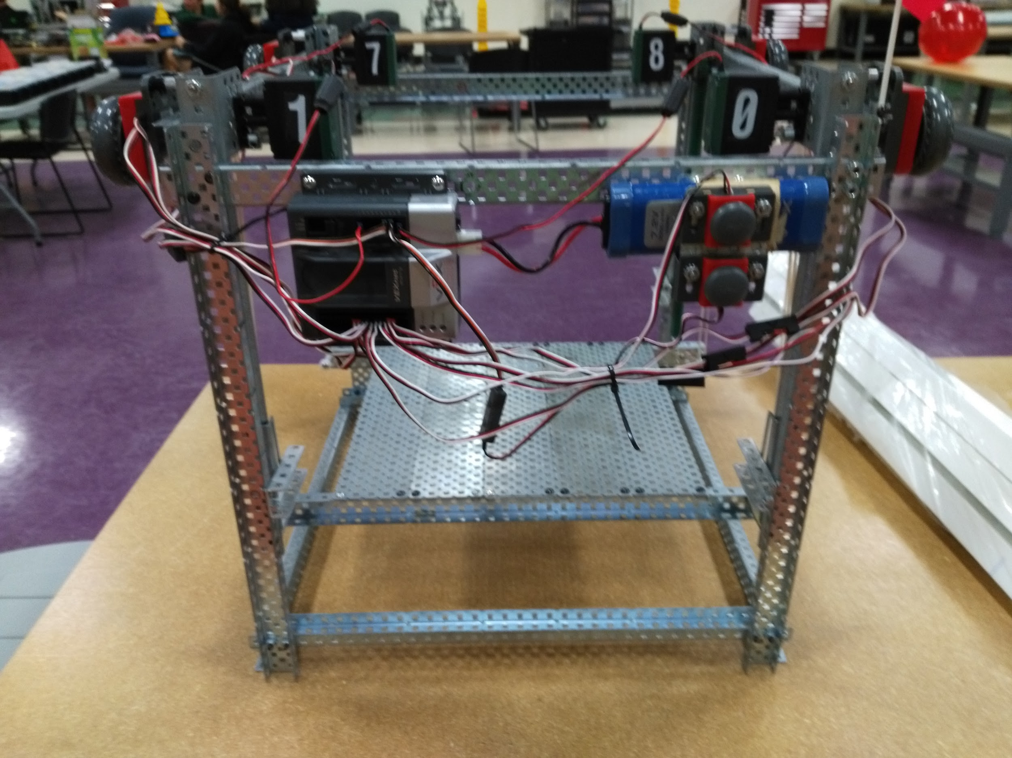
We decided to construct a portable two tier adjustable storage shelf unit composed primarily of previously used VEX EDR game components, as well as some non-competition VEX parts. Originally, we thought about building a battery holder or a flagpole out of VEX competition parts, but we that a portable two tier adjustable shelf storage unit was more useful due to all the beneficial functionality it can achieve within a school, work, or home setting. An adjustable shelf would be able to accomodate items of different proportions and allow the storage of a variety of materials, containers, or products to fit within the parameters of the shelves. For example, the top shelf can hold books or a small robot, while the bottom shelf can hold toys, containers, larger robots, or tools with each tier having a label on it for identification and organizational purposes. Initially, to test out the feasibility of this innovative idea, we built a prototype of the adjustable shelf unit with only VEX non-competition parts, which was able to hold up to 15 pounds or an equivalent small robot. In order to make each of the rack gears be at the same position when the shelf is lifted a certain height, we thought of using optical shaft encoders, but could not find a way to make it efficient. Optical shaft encoders can still be seen on the prototype, but they have no function.

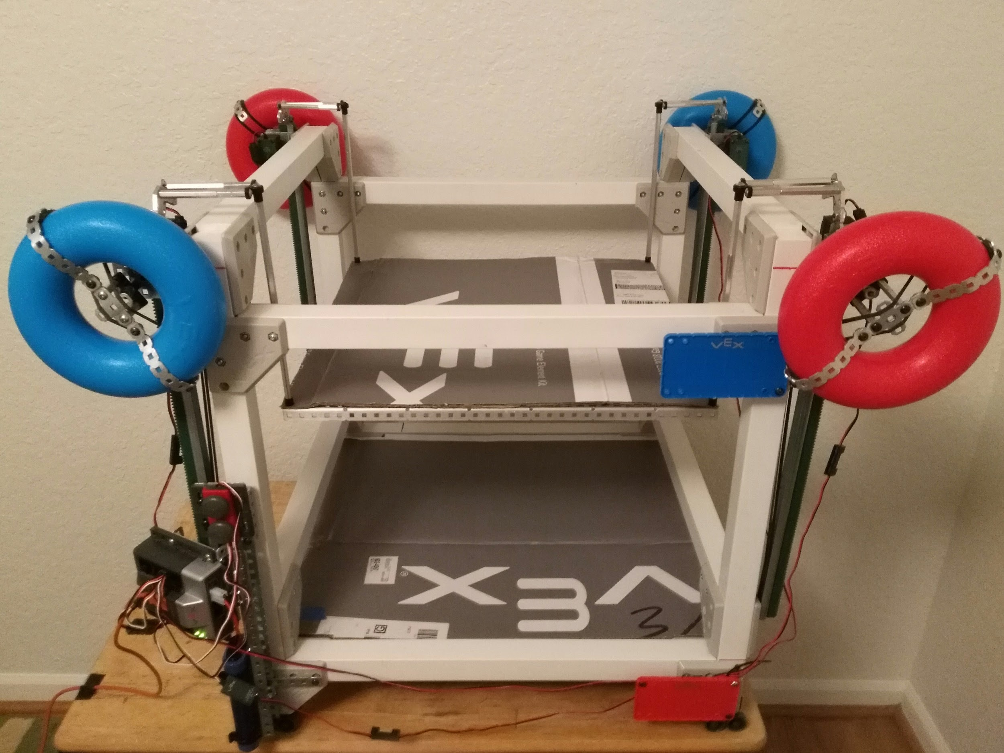
For our final build of the adjustable shelf unit, we decided to use the fence parts from the Starstruck tournament for the frame and the cardboard from old VEX boxes that contained previously used VEX game pieces. We first planned on using the Skyrise cubes for the shelves, but realized it would not work well since they took up much more space than cardboard and had large gaps in them. We developed a code that would vertically move the top shelf up and down by utilizing VEX motors, rack gears, and two bumper switches that when pressed would move the shelves in an upward or downward motion in order to maximize the utilization of space and adapt the shelves to accommodate an array of different sized items for a customized storage unit. Moreover, the top shelf could also be manually moved up and down using the circular tubes from the Round Up, which are connected to each of the 4 motors. We also decided to make the shelf portable for easier access and transportation to different locations by incorporating wheels on the front and back of the adjustable shelf unit. Hence, we created a multipurpose portable and adjustable shelf unit mostly from reusable VEX parts that allows the user to customize the configuration in order to accommodate and transport a variety of items, which is useful for home, school, or office storage and organization as well as important in protecting natural resources by reusing old materials.

