The Description of Shelter holder
When exercising with our robot, we found that when our robot was completely folded, the fame will hit the rear wheel, which will damage the rear wheel. By using the shelter holder, the fame would hit the shelter holder first instead of hitting the rear wheel. In this way, we can protect our robot.
We design our own shelter holder by using Autodesk Inventor 2015. During the design period, we designed the size, shape and distance of the first hole (①) and the second hole (②) to be the same as those of VEX C-Channel. Besides, using fillets (③) to strengthen the strength of the designed part.
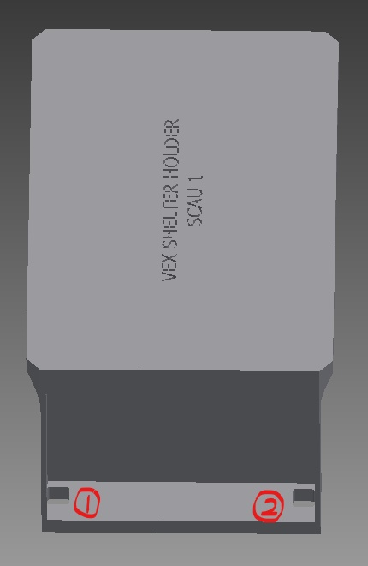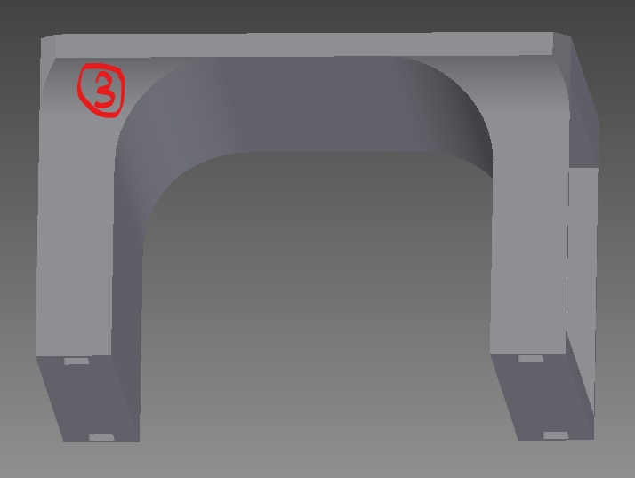
The design will make it easier for us to connect the designed part with the rear wheel frame directly with SCREW-832-0375 and NUT-832-KEPS.
Through designing our own shelter holder, we acquire the ability of three-dimensional observation. Therefore, we stick to using 3D design software in the future because of its powerful. We find out 3D design software could design accelerator, stress analysis, motion simulation and so on.
Each of us believe it could be very useful in our future works. Thanks to its multifunctional, we could make our own robot parts to let our robot more functional. We also sure it may allow us save more time to finding incredible ideas in our future career.

