VEX Motor Case
Vedruna – Epsilon
52521E
Make It Real CAD Engineering Challenge

- Introduction
Motors are probably the second most important equipment for a Robot, only behind the VEX ARM® Cortex®-based Microcontroller. However, when we took up this challenge, we realized that they were in a defenceless state, not only because the cable could easily be pulled out, but also because it could easily get a hit. Our last year’s Robot (when we were playing Starstruck) had its picking system designed in a way that when it had to collect stars or cubes it collided with the front wheels Motors. Because of that, some of our motors currently have the marks of it.
Knowing all of that, we decided that we should make something to protect them and we eventually came up with the idea of making a full case to prevent hits and to reinforce the cable.

- Motor Case
When we were designing this component, we realized that we had two options available. The motor case could be 3D printed with a solid material (in that case, however, the design should be cut in half before printing, or the motor would not be able to fit) or it could be made of a flexible material (such as nylon), and then the motor would be able to enter perfectly. Either of these options would consist of a 54 x 29 x 44 mm (2.126 x 1.142 x 1.732 in) rectangular capsule with a 2 mm (0.079 in) thickness, leaving a total space of 50 x 25 x 40 mm (1.969 x 0.984 x 1.575 in) to be occupied by the motor (the motor is not an exact prism, so it is not touching the walls completely, but it does not have enough space to move).
The component we have designed covers completely four of the 6 faces the motor has, leaving the faces with the cable exit and the shaft entrance partially opened.

- Design
To design our new component we used Autodesk Inventor Professional 2016 with a Student license. Since the object we had to design was all around the motor, we decided to work on the motor CAD file available at the VEX Robotics website and cover the motor with our case.

- Conclusion
The VEX Motor Case allows all motors to be safer while competing with your Robot. It could be made of an elastic material or it could be a rigid box. Not only does it prevent the Motor from getting hit, but also ensures the cable end is more protected.
By doing this project we learned the basics of Autodesk Inventor and we have seen how useful it is when thinking about prototypes. We are currently building our Competition Robot, which we did not design it using any CAD software, which would probably have saved us some valuable time.

- Images
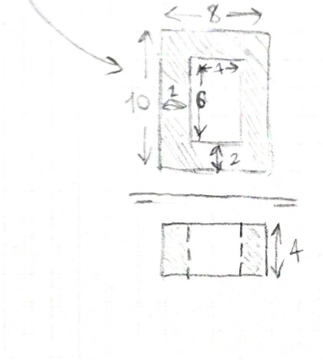
Scans of this project’s first drafts
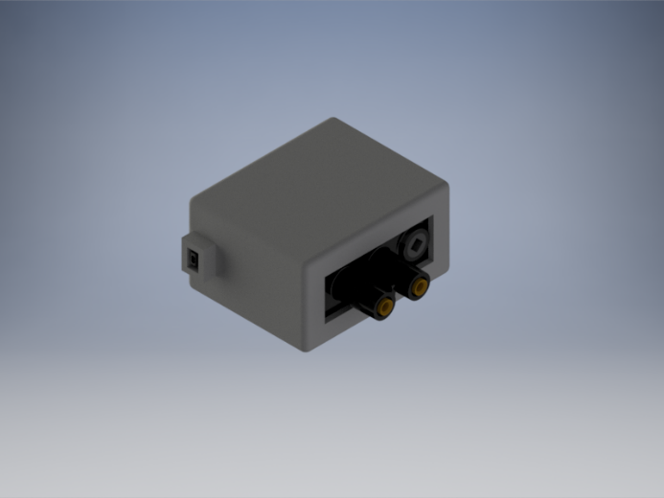
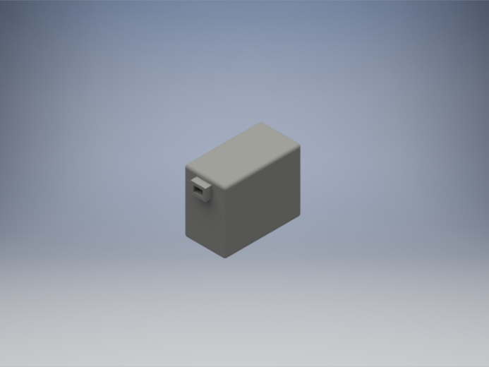
Rendered images of Autodesk Invetor’s case design. On the left, without any Motor and on the right, with a Motor inserted

