Robotics 2018/2019

Goal: to have a taller tower than your opponent to score more points than the opposing alliance
VEX Robotics Competition Building Blocks is played on a 12 x 12 foot square field. Two alliances – one red and one blue – composed of two teams each, compete in matches consisting of a fifteen second autonomous period followed by one minute and forty-five seconds of driver controlled time.

Vex Robotics Building Blocks is the new game for 2018 and 2019, the game consists of 20 yellow cubes that are 5.5 x 5.5 x 5.5 and 20 red rectangles that are 5.5 x 11 x 5.5 and 10 cubes that are from the star struck game 11 x 11 x 11 as Seen Below.
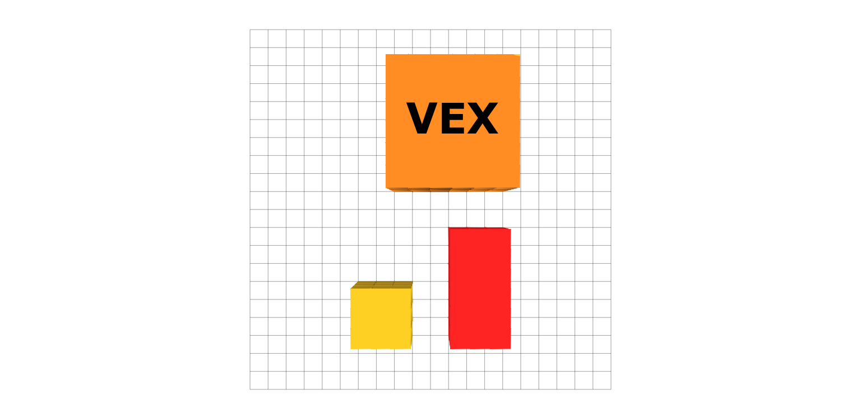
If the tower is 2, 3 blocks high it is 3 points
4, 5 is 5 points
6, 7 is 8 points
Anything higher is 8 points

The points will be added up after the match and whoever has the most points will win the match.
Parking robots at the end of the match will give your team an extra 5 points

Matches are played on a field setup as illustrated in the figures throughout. Two Alliances – one “red” and one “blue” – composed of two Teams each, compete in each Match. The object of the game is to attain a higher score than the opposing Alliance by Stacking cubes on other cubes and making their tower taller than the opposing alliance.
Rules:

Robot Size And Parts : Robot must and only be made of vex robotics 2018 and 2019 and nothing else. They must also be 18 x 18 x 18 and no bigger, if the robot is not the appropriate size it will be disqualified or will not be in the competition.

Matches : you must attend every match at the appropriate time are you can not attend the match. Your robot must be inspected to attend the match (inspection starts when you get there).

Building : Only your team can build a robot there shall be no help from the other teams they can give you advice but they can not help you build. Your alliance can not even help you they can give you strategies advice and help but they can not help you build.

Pit rules : you must wear goggles when you are in the pit at all times. There are also a driver and an assistant driver in case something happens to the driver. If the battery dies in the pit you are not allowed to take the robot back and get another battery.
There are no toys items are small objects in the pit at any times including keychains, small toys, or action figures etc.

Drug Form : At the beginning of the robotics season you will be given a drug form. You must turn in this drug for in order to go to competitions and participate. If you do not turn in the drug form you also can not participate in competitions. If you must take a prescription for health reasons that is fine.

Teams : Team names must not be inappropriate or offensive in any way.

Field rules : Drive Team Member – Any of the three (3) Students allowed in the Alliance Station during a Match for each Team. Only Drive Team Members are allowed to touch the controls at any time during the Match, interact with the Robot as per , and interact with Scoring Objects as per . Adults are not allowed to be Drive Team Members. Driver Controlled Period – The one minute and forty-five second (1:45) time period during which the Student Drive Team Members operate the Robots. Entanglement – A Robot is considered to have Entangled an opposing Robot if it has grabbed or hooked the opponent Robot.
Parked : A Robot is considered to be Parked if it is touching one of its Alliance’s Parking Tiles at the end of the Match. Only one Robot can earn Parking points on a single Parking Tile. A robot has to be more than half way in a Parking Tile for it to count as points.
Preload : The preload is when at the start of a match the robot gets to use one yellow cube on there robot. Whenever the match starts you can use the cube to stack and make points. At the 30 second mark both of the alliances are forced to put in the orange vex cube in order to score more points if they have already put the cube in they will not have to.

This is what the final rounds bracket will look like when doing the matches.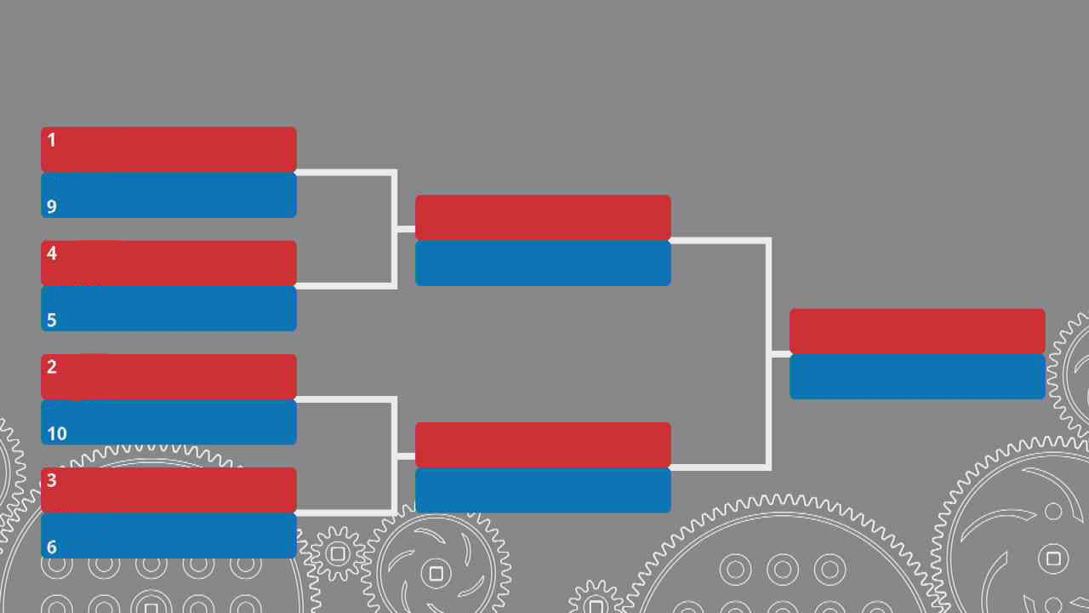

Match Scoring Points
In match scoring, some points will not be counted. These are some example of shapes being stacked properly.

Figure A
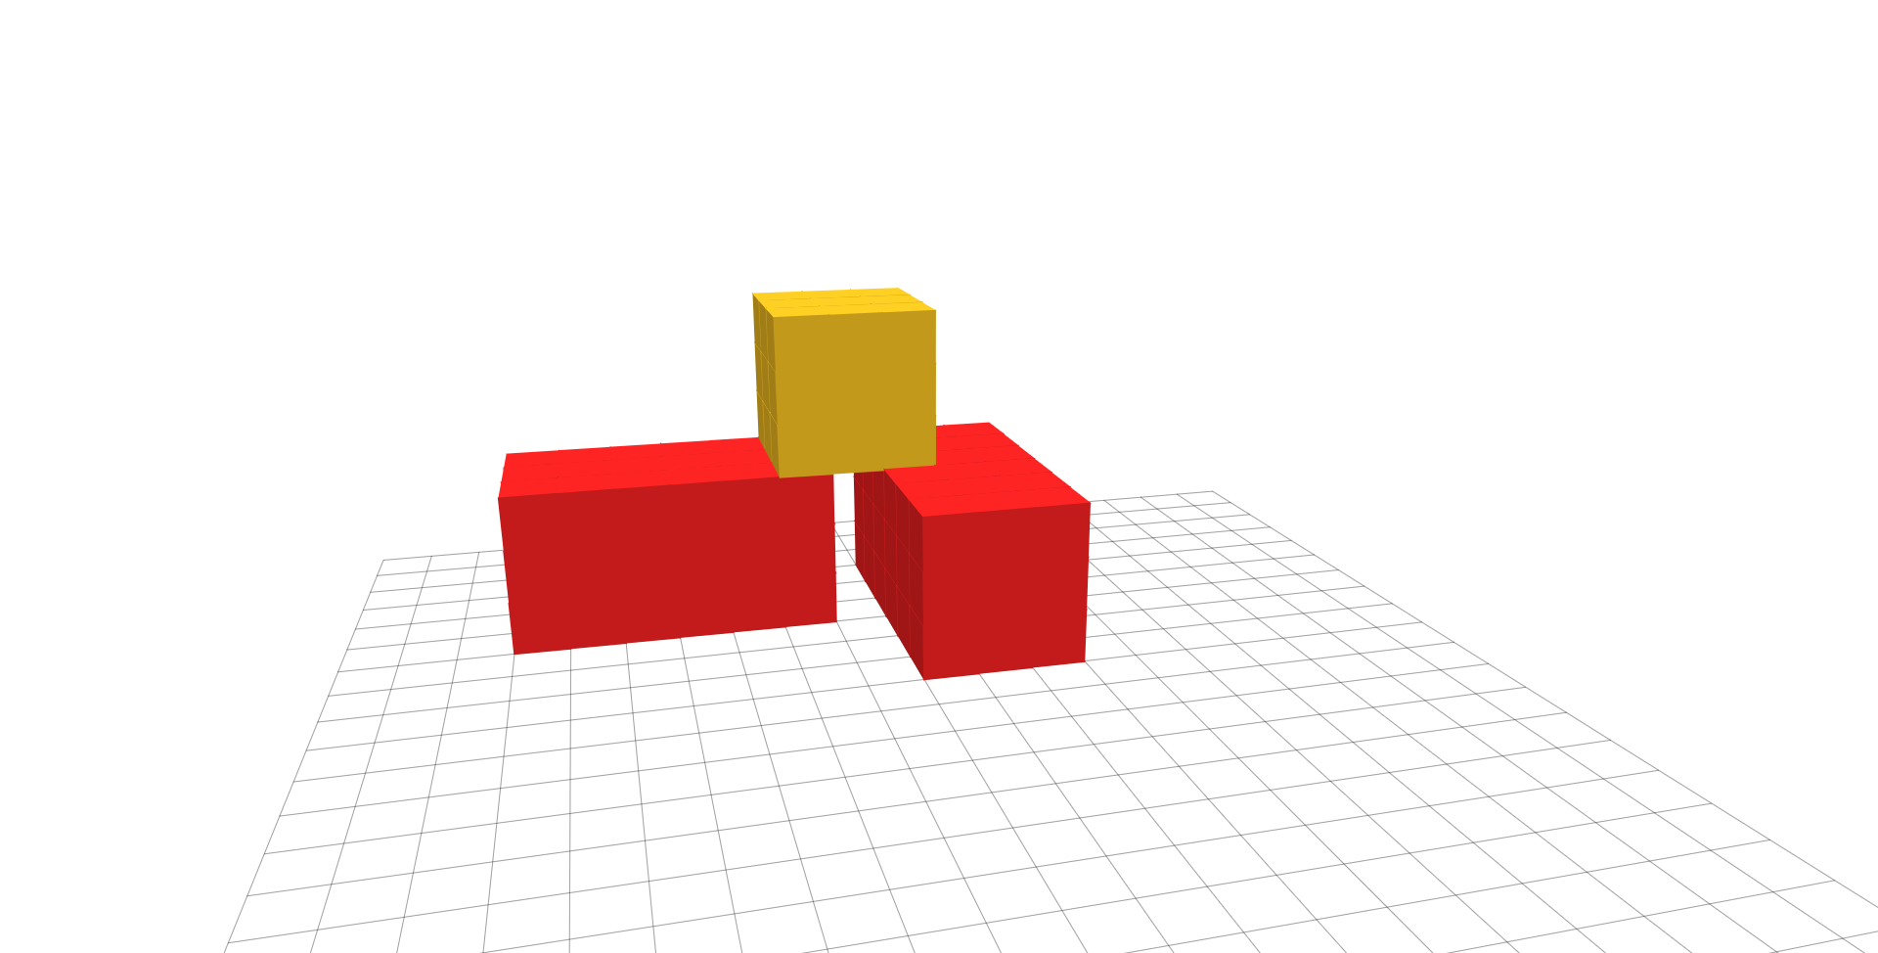

Mountains
Each side of the field will have a mountain that you can score points on the point bracket is shown below.

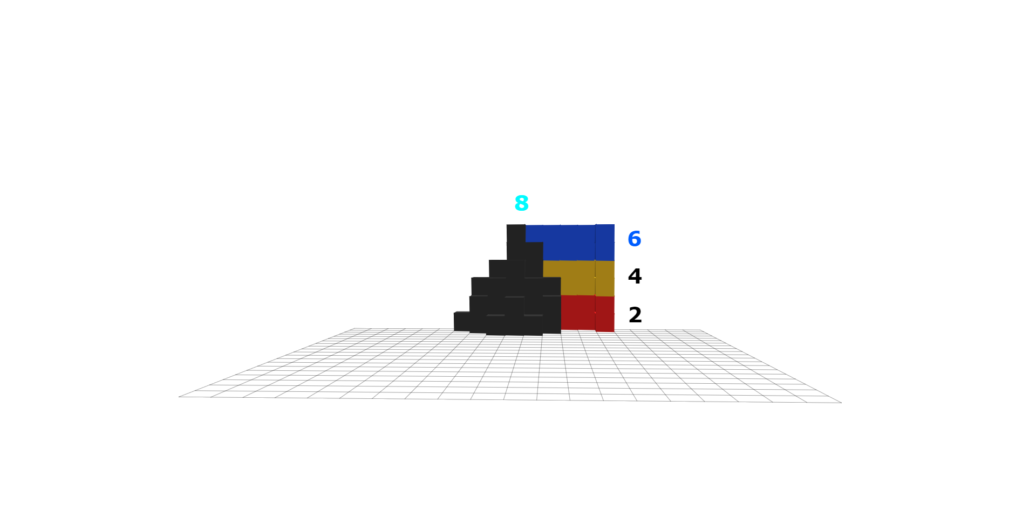
If a point is to be scored it must be touching the mountain it can not be touching a block that is touching the mountain.
Here is what the field will look like with the mountains.
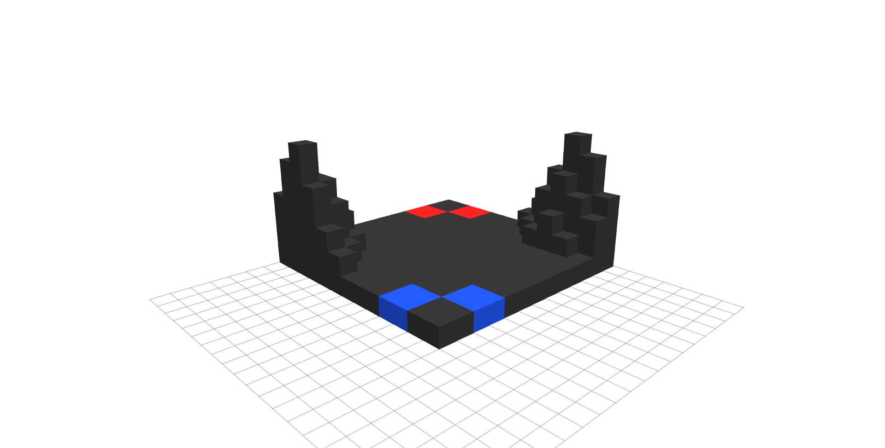
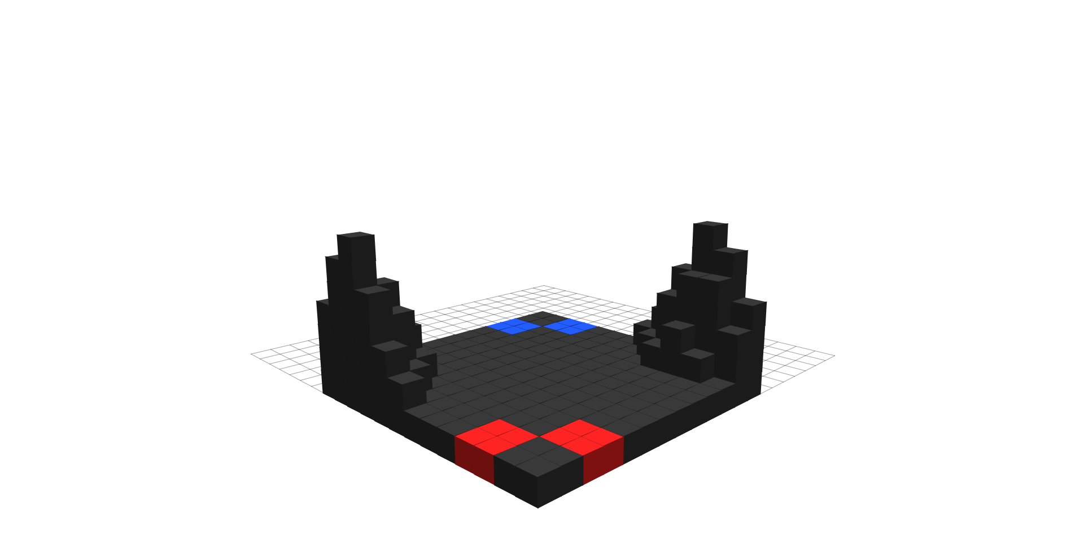
All pictures were made possible by Voxels Mr Doob

