Vex Recycling Challenge Report
The thought process of our recycled game components is to produce an object that will brighten up our balcony, because the only purpose the balcony serves is pictures and storage for previous game elements. This resulted in our creation of a garden using game elements from several seasons. We undertook the vex online recycling challenge, in which you use game elements from previous seasons and give them a new purpose. What we decided to do is make a garden using game elements from three different seasons.
First, we have the through from the 2012-2013 sack attack season in which it serves as the as the beginning water channel. We outlined circles in which the water pipes will attach to by using a can to outline a perfect circle. After we outlined the circle, we cut out the circle using a Dremel, by first cutting out a “X” and then cut triangles out one by one so we cut out a square from the circle, then we shaved off the rest to make the shape circular.
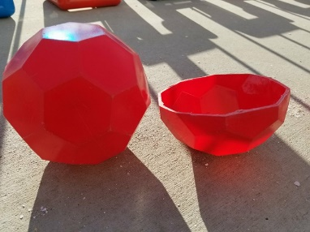
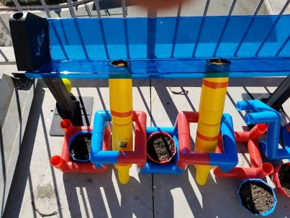
Continuing down, we have the skyrise cone from the 2014 2015 skyrise season which serve as the water pipes. This is attached to the through by using sealant as a glue and to allow water to flow without a leak nor the risk of the seal falling apart. The cones go directly to the pots which are made from the Bucky balls in the 2013-2014 toss-up season. We did this by cutting the Bucky balls in half which make two pots in total so we only had to cut 2 balls since that made four pots. Along with cutting the Bucky balls in half, we drilled holes in the bottom to allow the water to drain, once the plant is watered; This will prevent the seeds from drowning and overflowing.
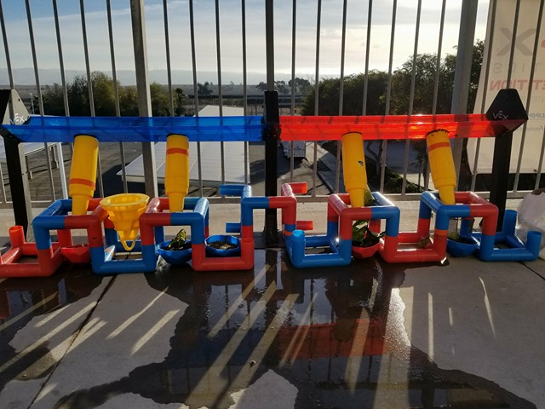
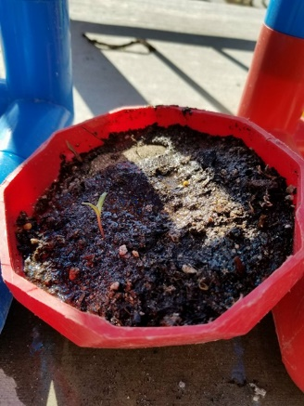
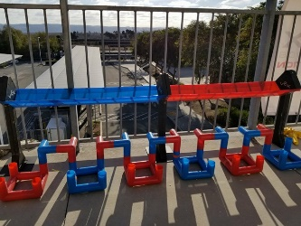
Finally, from the same skyrise season, we used the cubes as structure to keep the pots still and align the pots with the water pipes. So how it works is we put water in the middle of the through, it is at the middle so the water can go into both skyrise cones, which flow down the skyrise cone and directly onto the plants, the pots themselves. Since the skyrise cones have a tiny hole at the bottom, this reduces the strength of the water when it hits the plants to not cause any harm to them. What we planted were; cosmos flowers in the first pot, bougainvillea in the second pot, as an experiment, a lime tree in the third pot, and roses for the fourth pot.

