Team PUJ1
Javex Robotics, Pontificia Universidad Javeriana
The IMB
Entry for:
Make It Real CAD Engineering Challenge Sponsored by Autodesk ®

Problem to solve
Attaching a bearing block to a motor sometimes isn’t as simple as it should be, there are several scenarios that must be evaluated such as spacing and accessibility, also there are other factors that affect the correct behavior of a bearing block such as friction, when attaching a bearing block on a motor as seen in figure 1 if the screws are over tightened the bearing block´s holes get damaged and will not be able to correctly operate in a future because of friction on the damaged hole, also if the screws are under tightened, then the motor have the risk of fall from its position and damage the bearing and the metal bar, another option is to place the bearing block individually but it means using more screws and nuts that is reflected on adding weight to the robot.
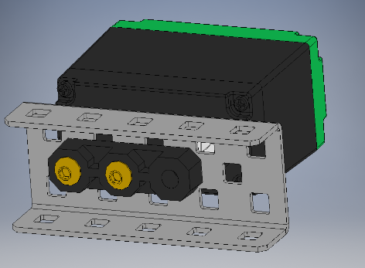
Figure 1

Solution
The solution proposed by team PUJ1 is the Integrated Motor Bearing (IMB), the IMB is a screw less bearing block that is attached to the motor at the moment of screwing the motor to a bar, it is custom-made part that perfectly fits into the bottom tubes of the motor case such that it is supported internally by the outer edges of the motor case´s tubes to avoid slop on the bearing, also the thickness of the bearing is defined by the space that stands between the metal bar and the bottom nerve that links both of the tubes.

Design
The idea of ​​the design came from facilitate the placement of the bearing blocks, the shape of the motor was used for this purpose, without the requirement to use additional screws, only the screws of the motors were needed, to decrease weight on robots. Since the tubes of the motor are not perfect cylinders, on the other hand these are cones with a very low degree of opening then, the angle of the motor tube was used so that the piece was made to measure, that angle was measured taking the upper and lower diameter of the tube and by trigonometry it is possible to determine it. This piece is designed to be printed on nylon, thus preventing the friction.
Once we have a proposal for the design of the piece and the conditions for it to be tailored to the motor, a design is made that consumes little material, so it is a small design, with the aim of remaining adjusted with play up and down. The thickness of the piece is the distance from the sheet screwed to the membrane that joins the tubes.

Benefits
The main benefit of the piece designed is the non-use of screws, which for a robot with 12 motors represents a decrease of 100 g of the total weight, something considerable. In the same way, the design allows to place a shaft collar between the bearing block and the motor, so there is no disadvantage compared to the conventional bearing block.
On the other hand, the part does not present wear since it is not necessary to screw the bearing block, for which its useful life will be greater.
Finally, when assembling, you can take more space in the robot, it is possible to assemble sets with a smaller distance of axis, which prevents the axes from bending by torque and enables the design of more compact systems.

Results
Isometric view

On the following pictures is show the final product designed on the left and its equivalent real-world picture showing that the desired behavior of the piece is achieved.
IMB mounted on motor Top view
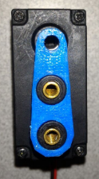
IMB mounted on motor Top view
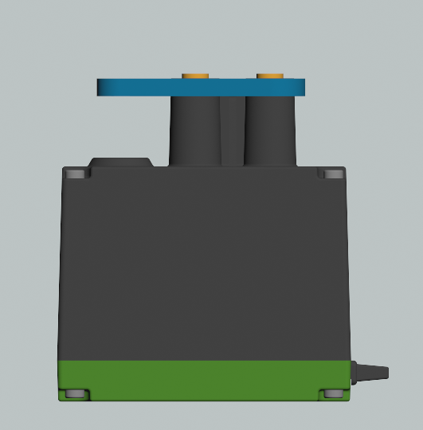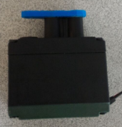

IMB mounted on motor Isometric view
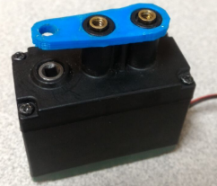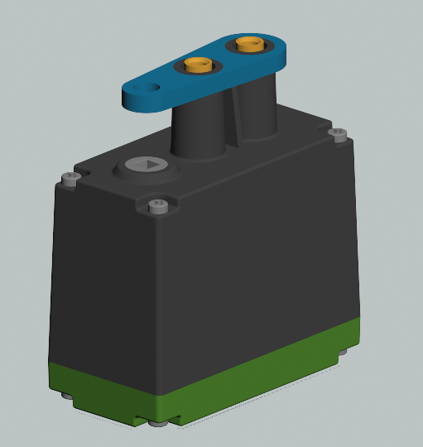

IMB mounted on motor attached to a chassis rail Side view
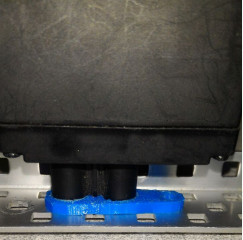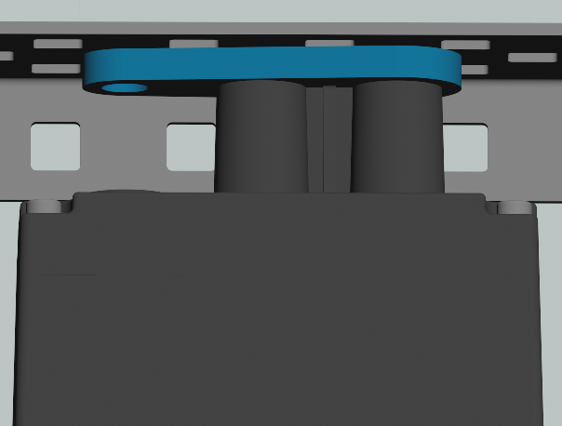

IMB used on a robot assembly
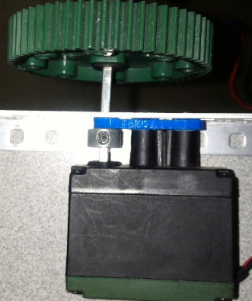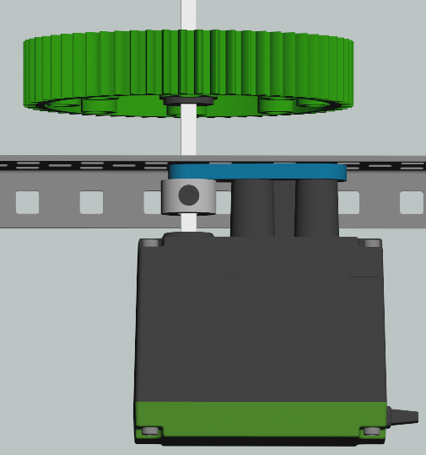

Design Software

3D Printing

Conclusion
While developing this current project our team learnt about the advantages of 3d printing and design such as robot improvement by avoiding additional weight on robots and spacing usage, so if it is possible our team decided to improve our robot by 3D designing so that will ensure the usage of 3D designing software.
The usage of Autodesk Inventor as 3D designing software will let our team to improve our robot during this season so we can achieve to build a lighter and more efficient robot with custom-made parts for developing specific tasks in a better way than metal assemble systems.
As our team is composed a 100% of Electronics Engineering students, learning a 3D design software will be a useful ability for our career, because it offers several applications for Electronics Engineers such as designing complex electro-mechanic systems for specific tasks, designing cases for Printed Board Circuits (PCB) that protects the electronic components and the board itself, so it can be implemented on real-world applications and be protected for real-world environments. Coordinator

Team Members
ING. Jairo Alberto Hurtado Londoño PhD-Coach
ING. Camilo Andrés Otalora Sánchez MsC-Coach
ING. Juan Francisco Jurado Páez-Coordinator
David Orlando Rodríguez Ojeda- Electronics Engineering student, team Member
Daniel Felipe Orozco Lopez- Electronics Engineering student, team Member
Daniela Maria Perdomo Garavito- Electronics Engineering student, team Member
Nestor Eduardo Ribero Vargas Electronics Engineering student, team Founder

