Recycling Online Challenge 2017-18

Ten Ton Robotics 1010A
By Katherine How and Stephanie Chow

http://www.facebook.com/TenTonRobotics/

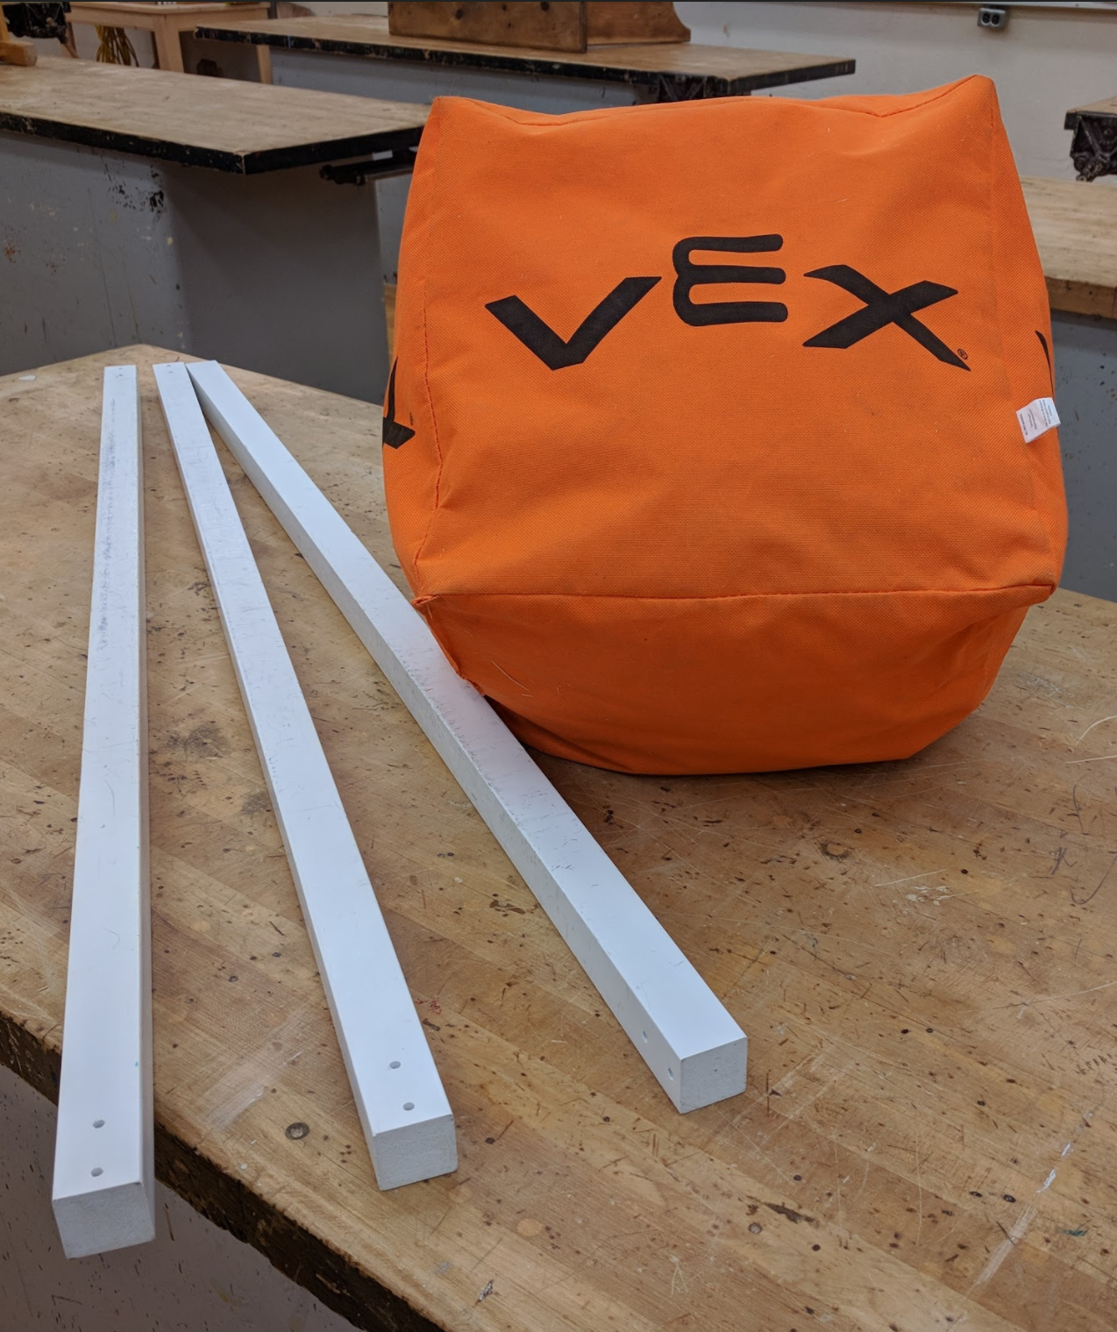
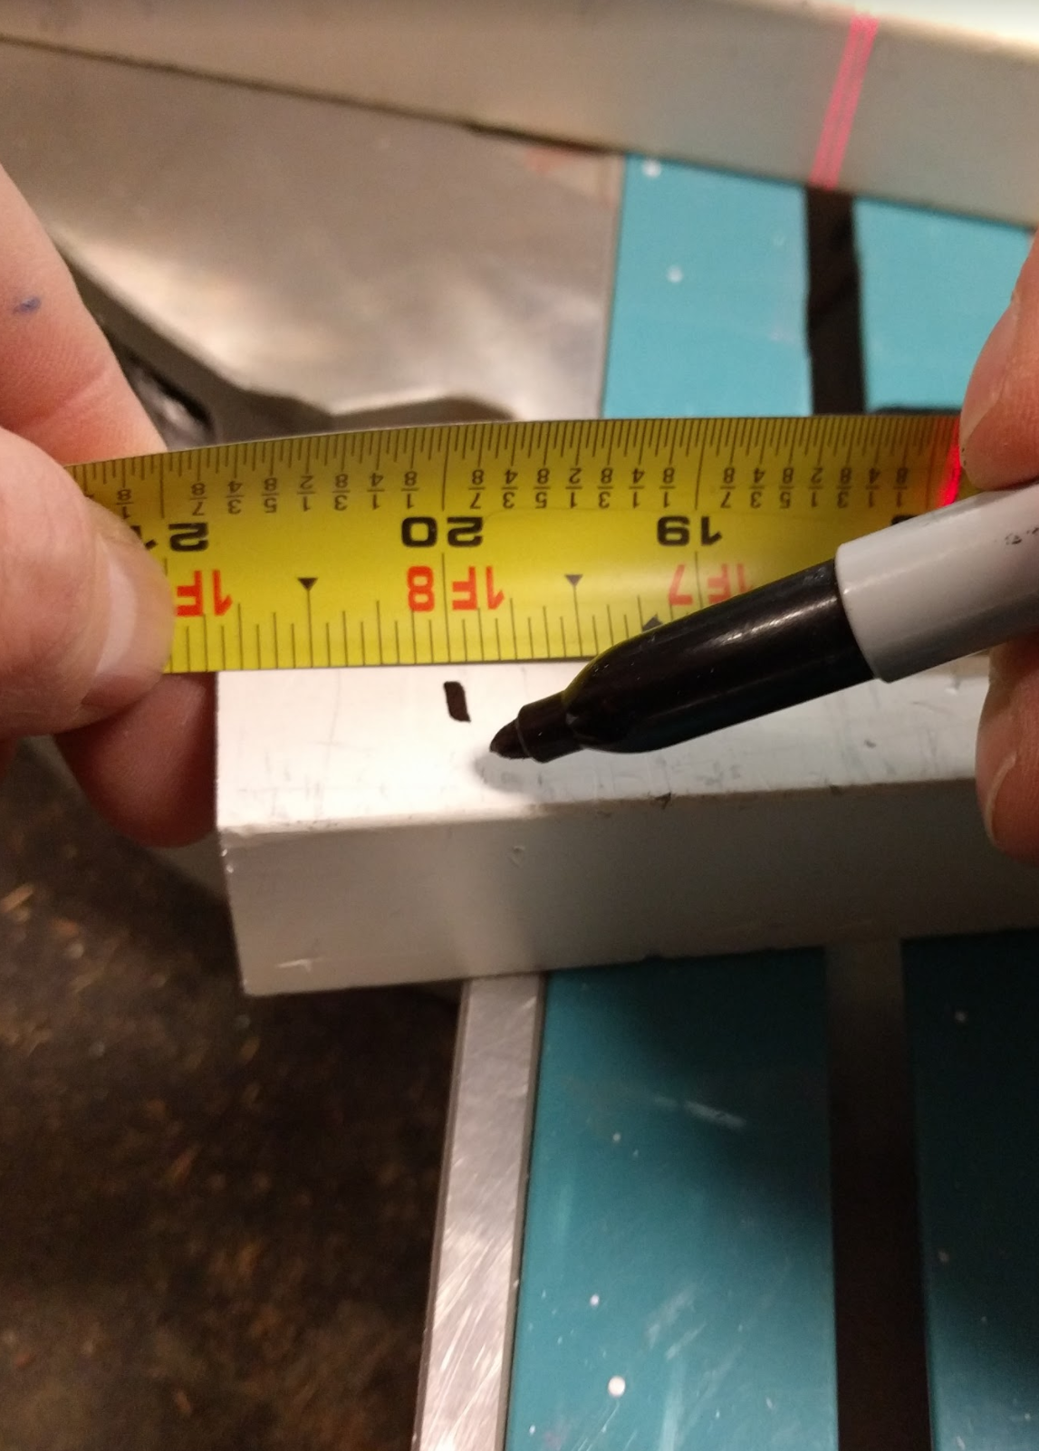
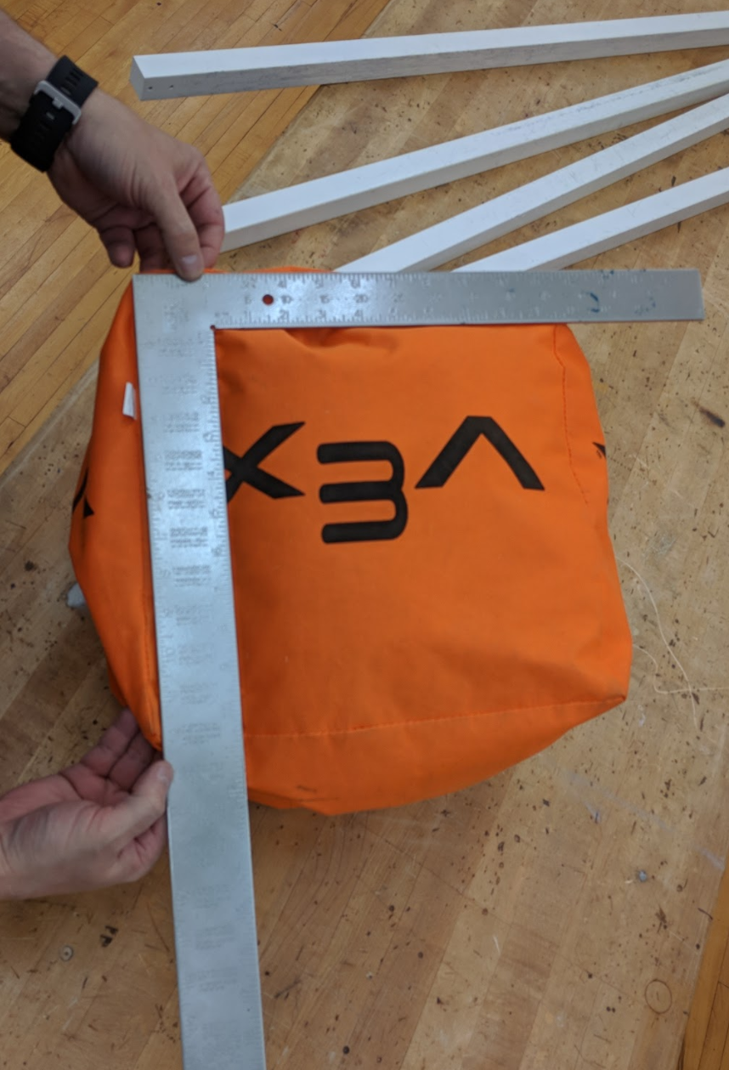
To tackle this year’s new Recycling Challenge, our team decided to repurpose game pieces from last year’s Starstruck game. We looked at the various materials the game pieces offered, including the irregularly shaped stars, the pillow cubes and the plastic fence. We decided to use the cubes and the fence to create a stool by using the cube as a cushion and the fence as legs. With the help of our mentor, Mr Ablett we used tools from our school’s woodshop to build what we envisioned.

First, we measured the cube. (approximately 12” by 12”) This measurement helped us plan how wide and long to build it.

Next, we decided to make the legs and the supports for our stool. We measured the fence to find the required lengths of the legs and the crossbars. Then, we cut the plastic into 4 20” for the legs, 4 12” long for the supports, and 3 smaller pieces for sizing later.
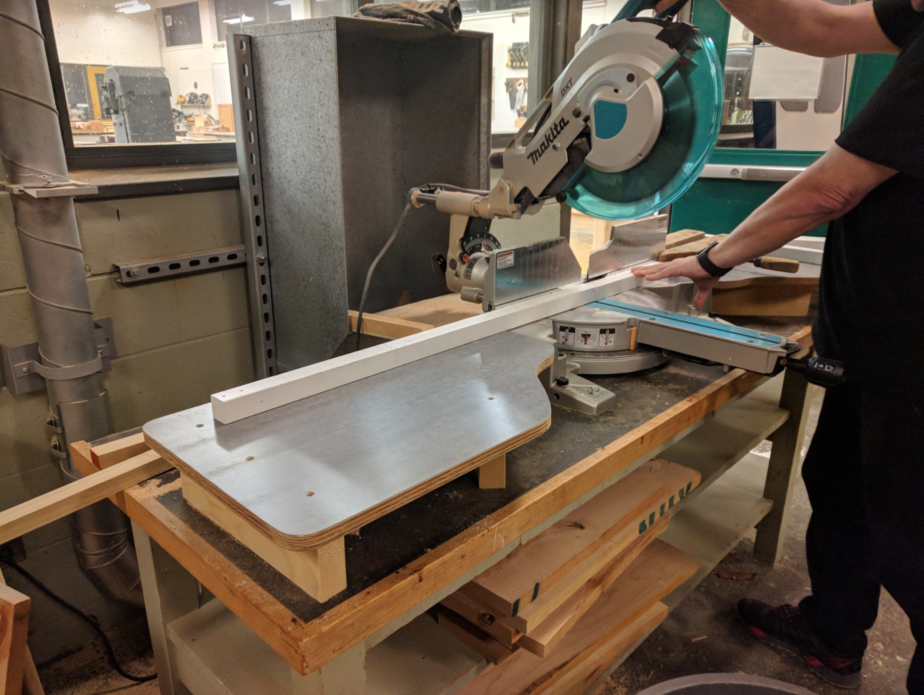
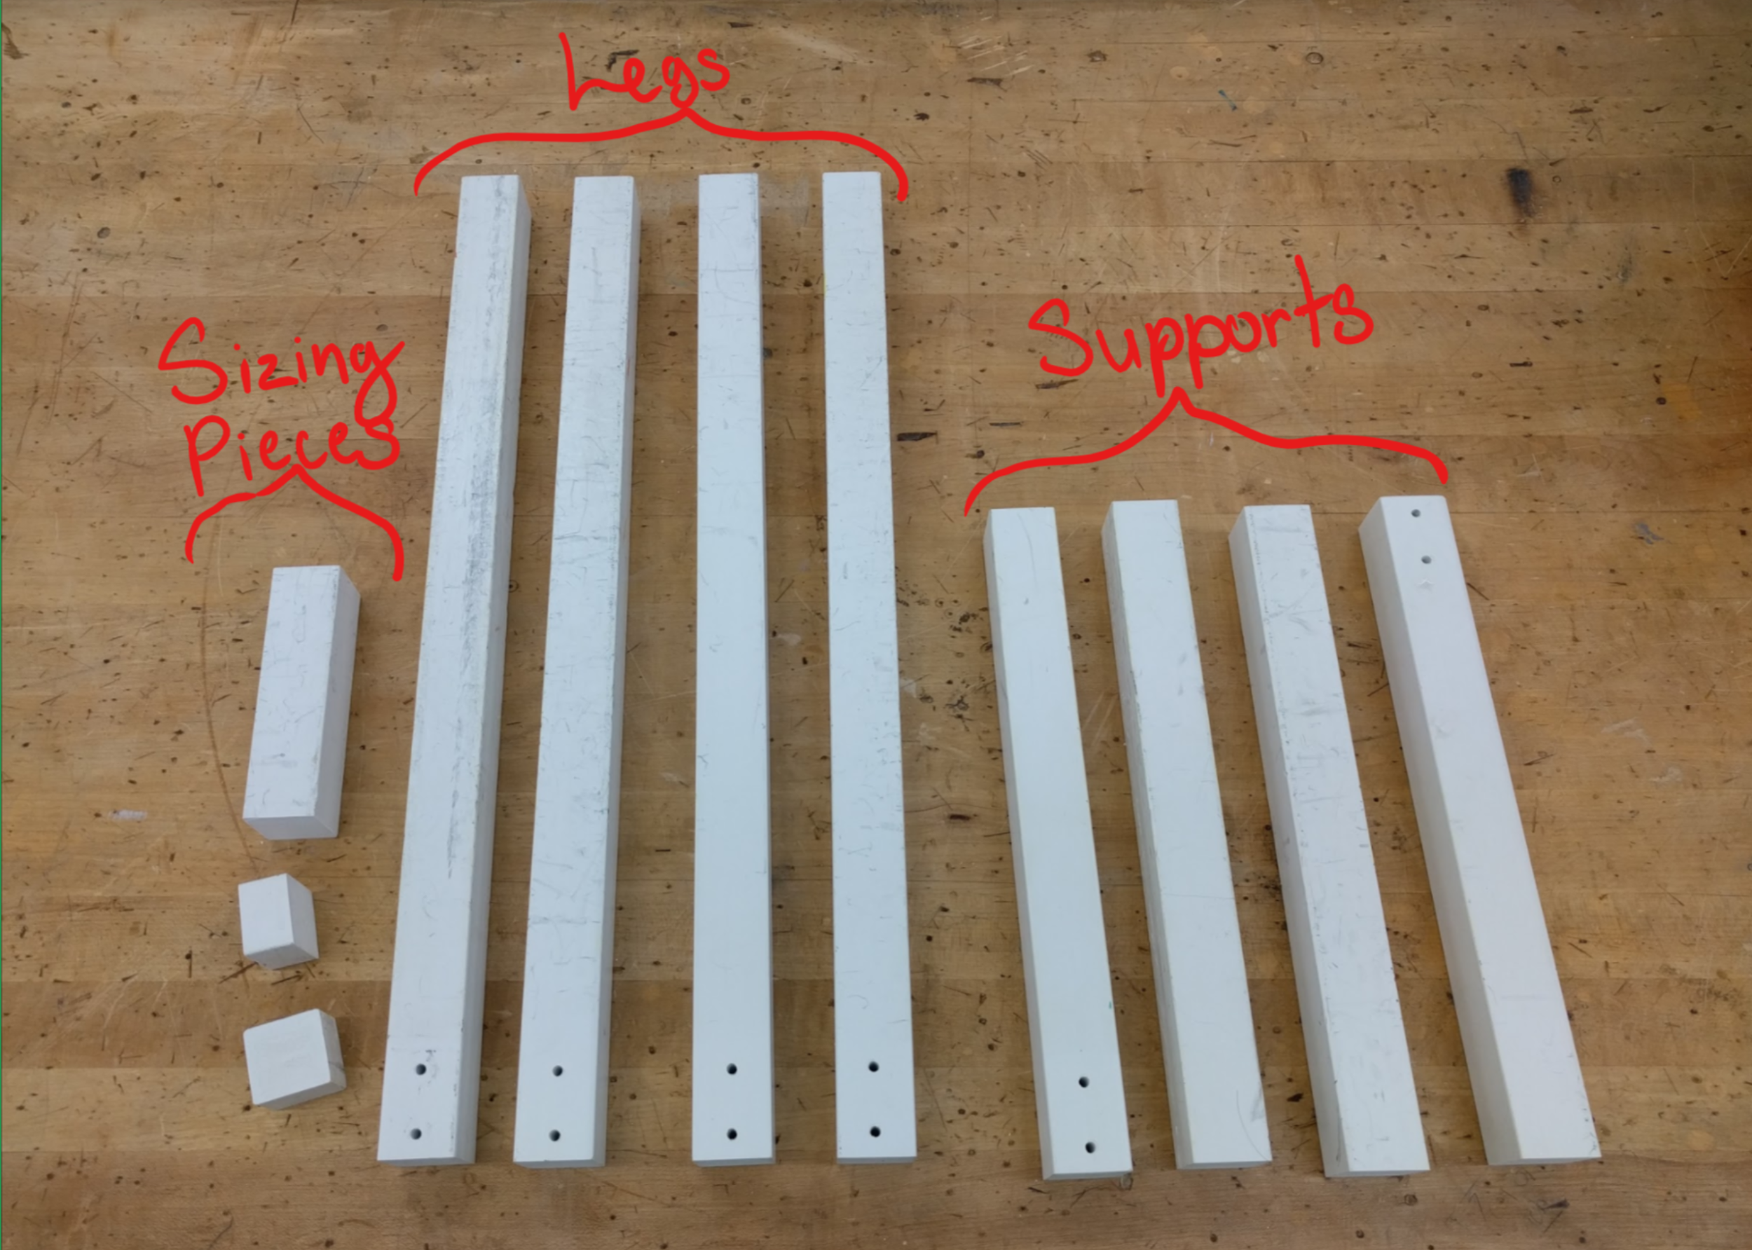

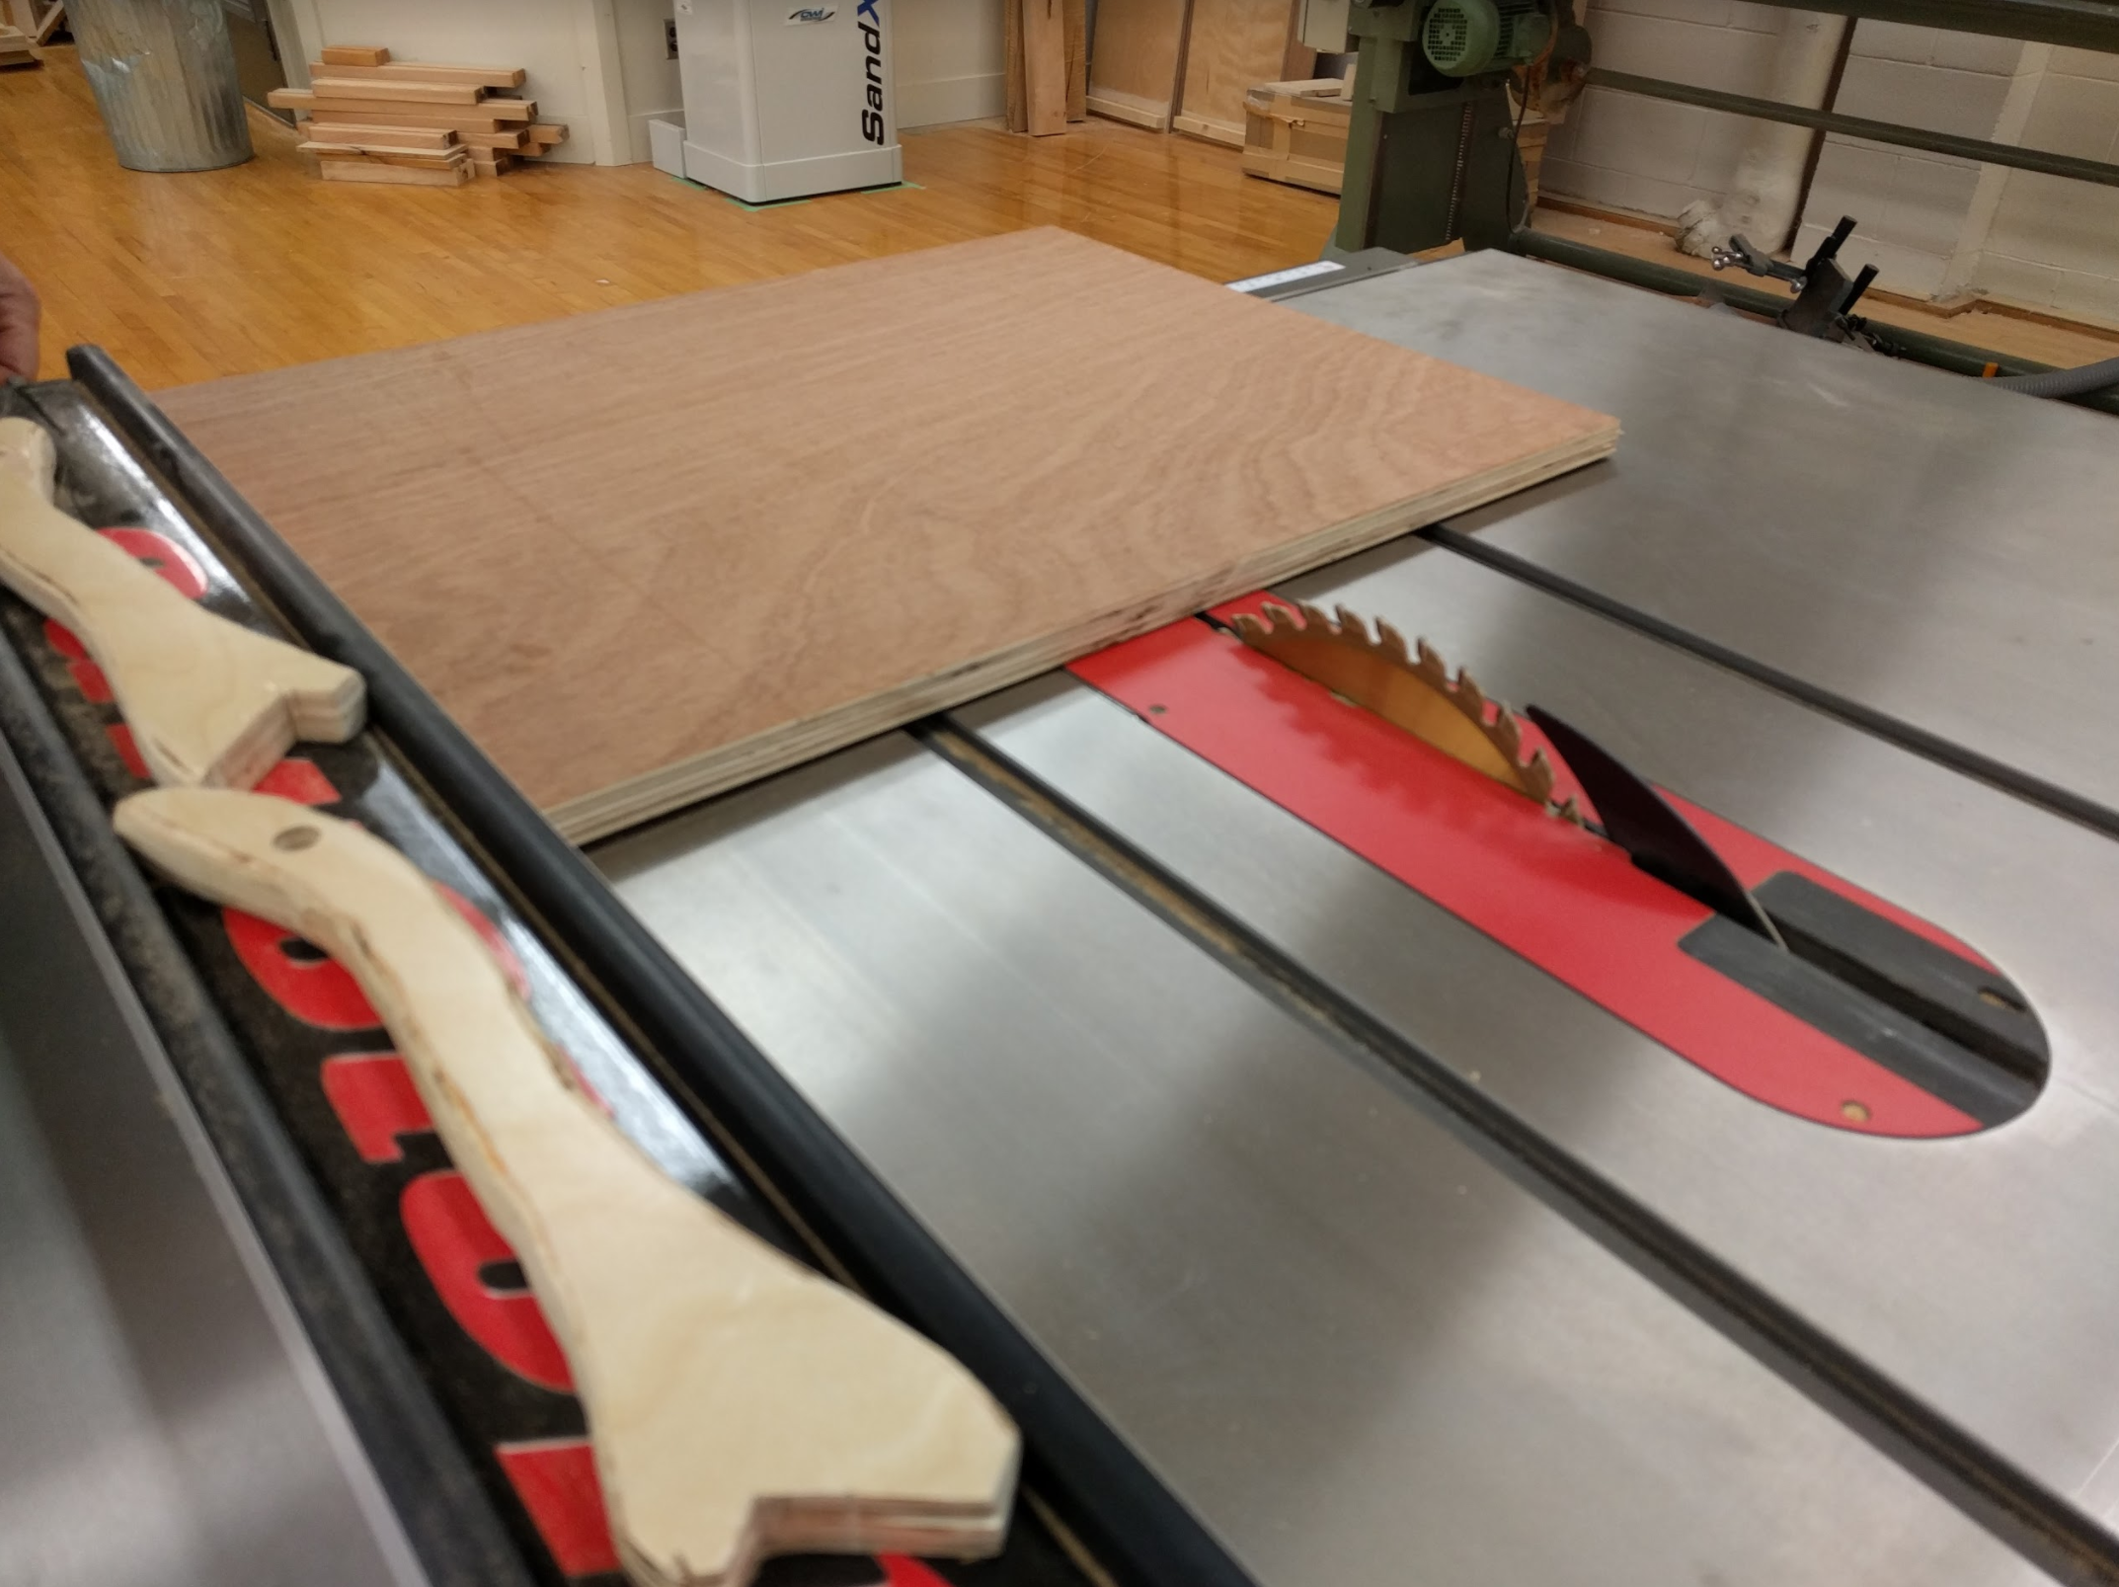
Next, we needed to create a stronger top for the stool to support a person's the weight and to hold the legs together. To do so, we used 3/4” plywood to reinforce the top. We first cut a 12” by 12” square plate. We then cut two 4” by 12” and using the sizing pieces, we fixed them to the plate, parallel to each other and offset from the sides by the width of the bars. Next, we cut two 10.5” by 4” plates of plywood to fit in between. Finally, we added the four 20” legs in each corner.

Next, we worked on supporting the base of the stool. Using a 6” sizing piece we added the four 12” supports we cut out of the fence. We fixed them to the base of our stool in a square, to stabilize the legs and strengthen it.
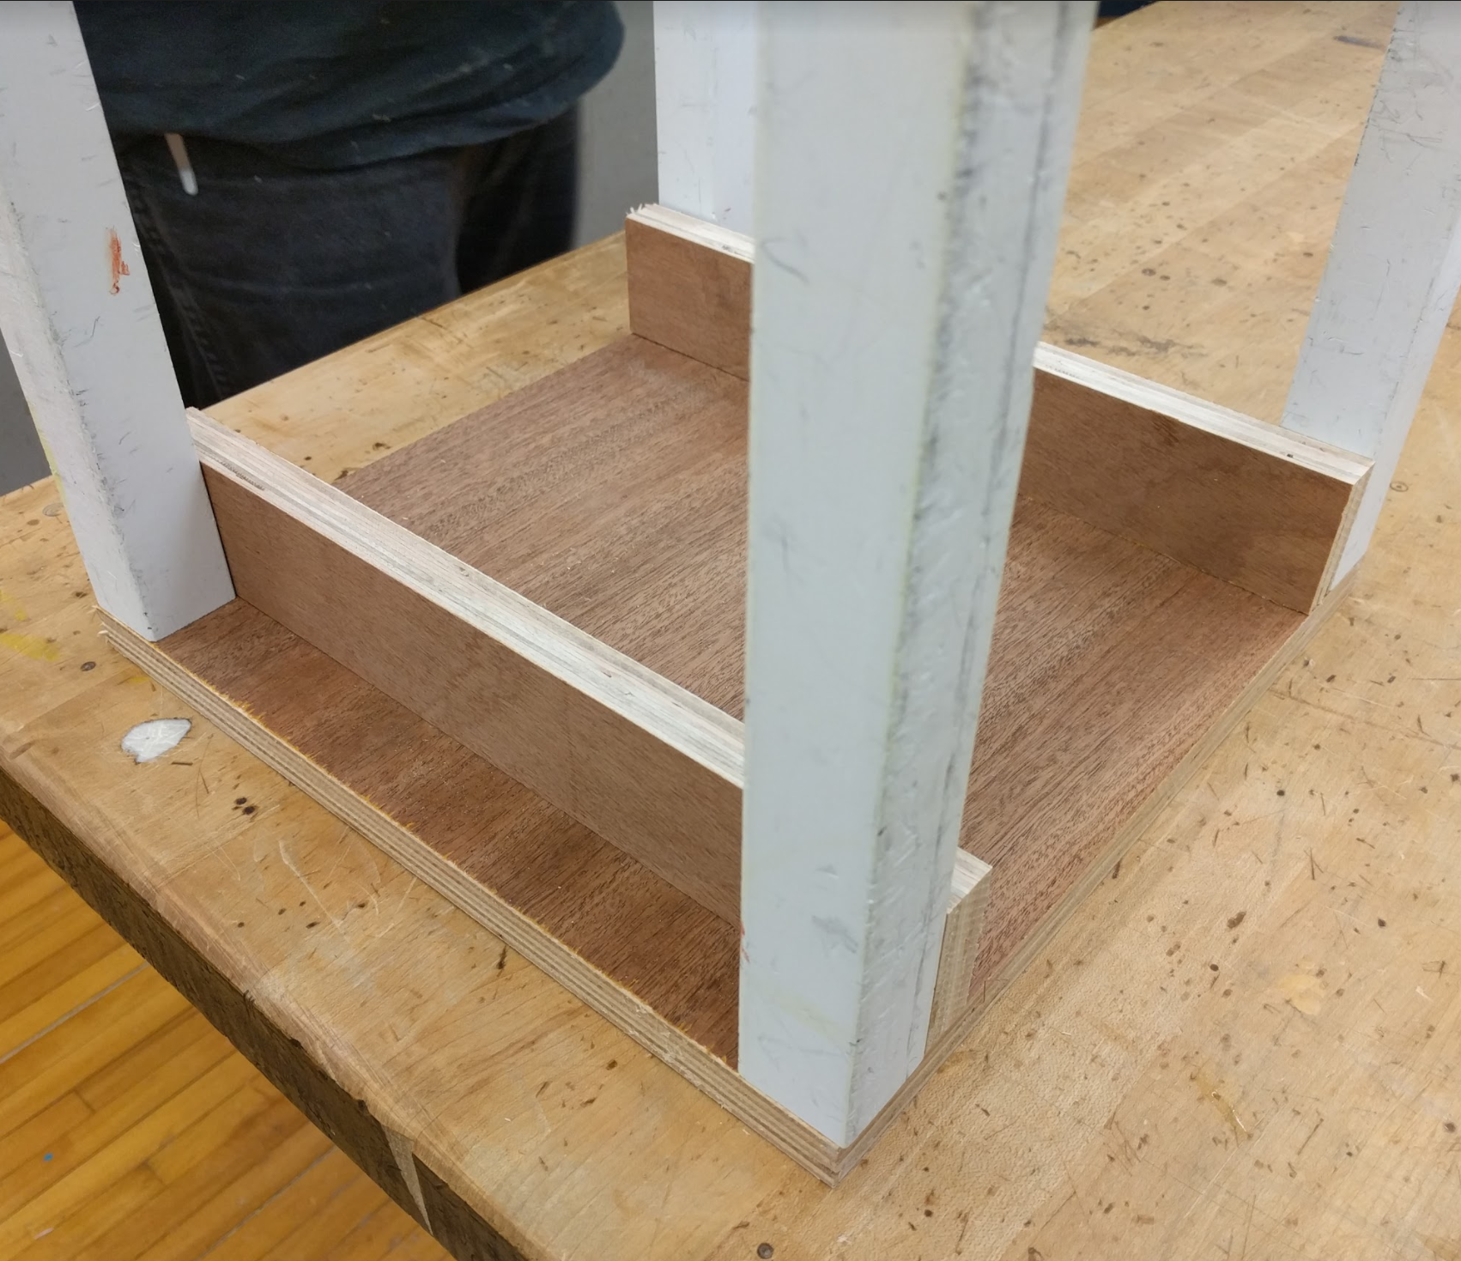
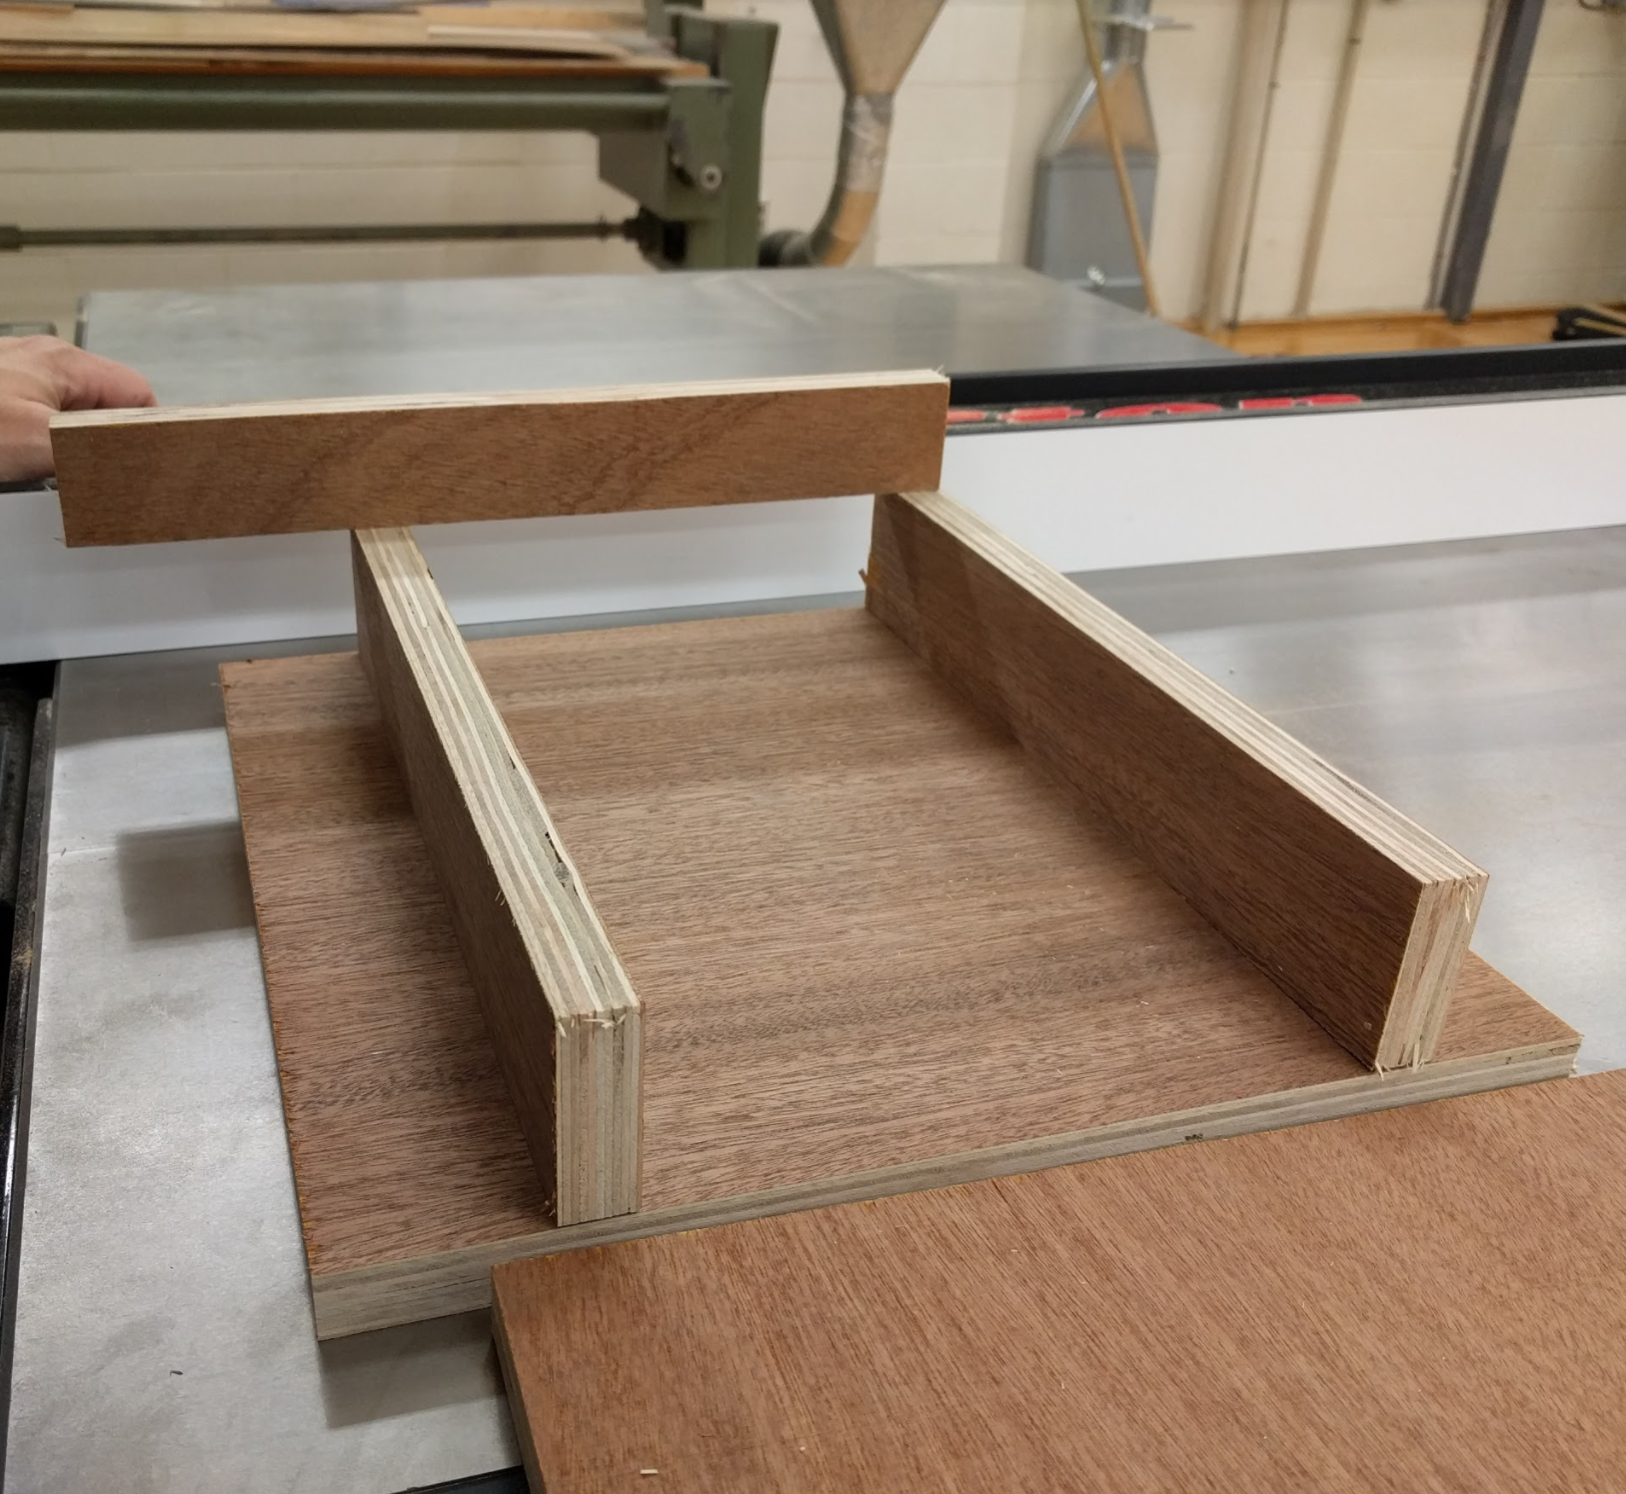

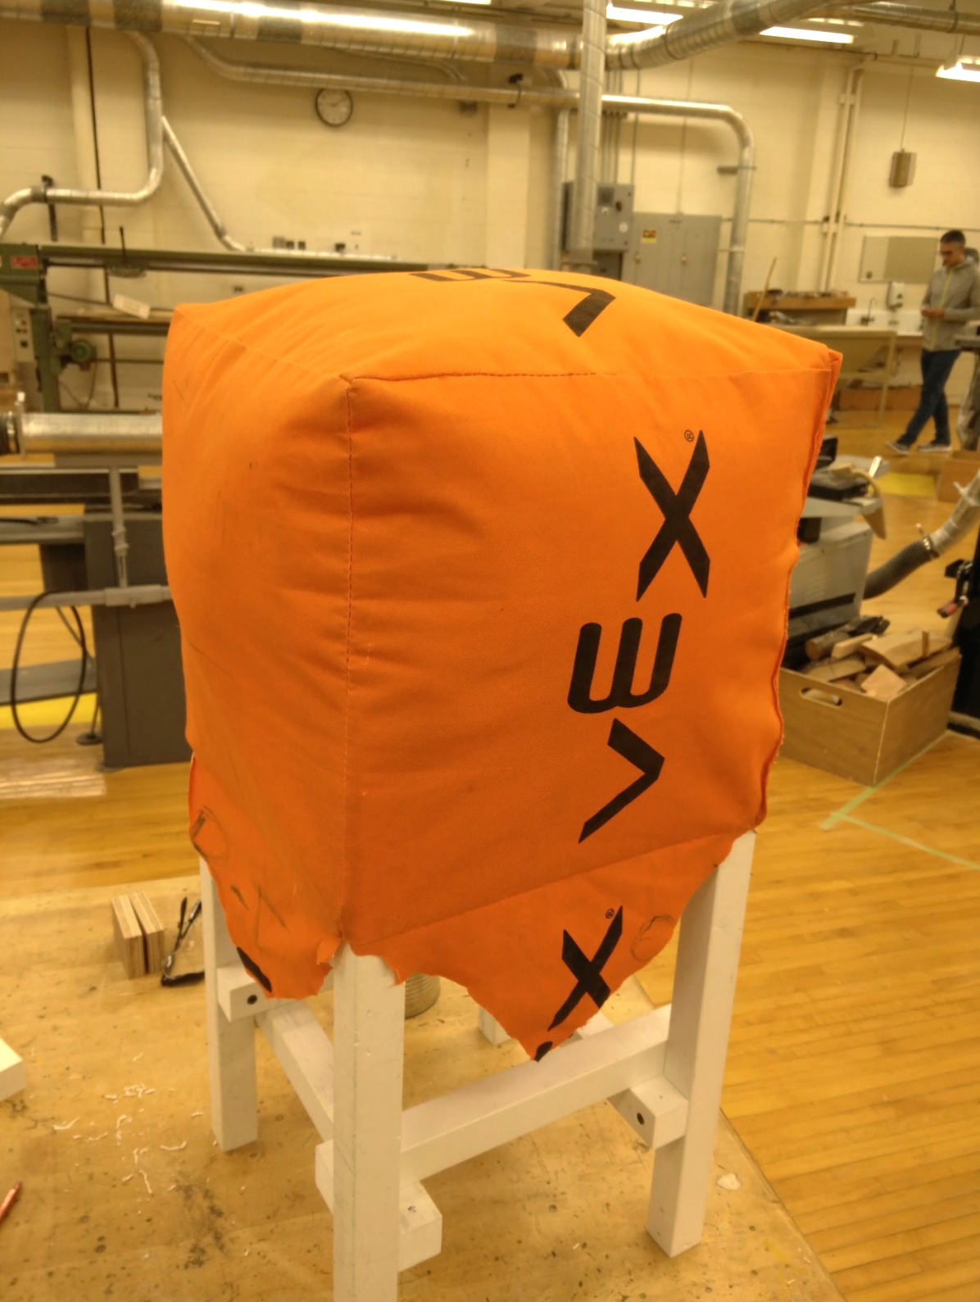
Finally, we began to work on the cushion of our stool. To fix the cube to the stool, we started by cutting the fabric in the base of the cube into four triangular pieces, this way, we could wrap them around the top of the stool and staple them to the 12” plate.

After trimming the excess fabric off, our stool was complete! It is now frequently used in our class, as it is a perfect height for our tables and the cushion makes it much more comfortable than the classroom standard chairs.

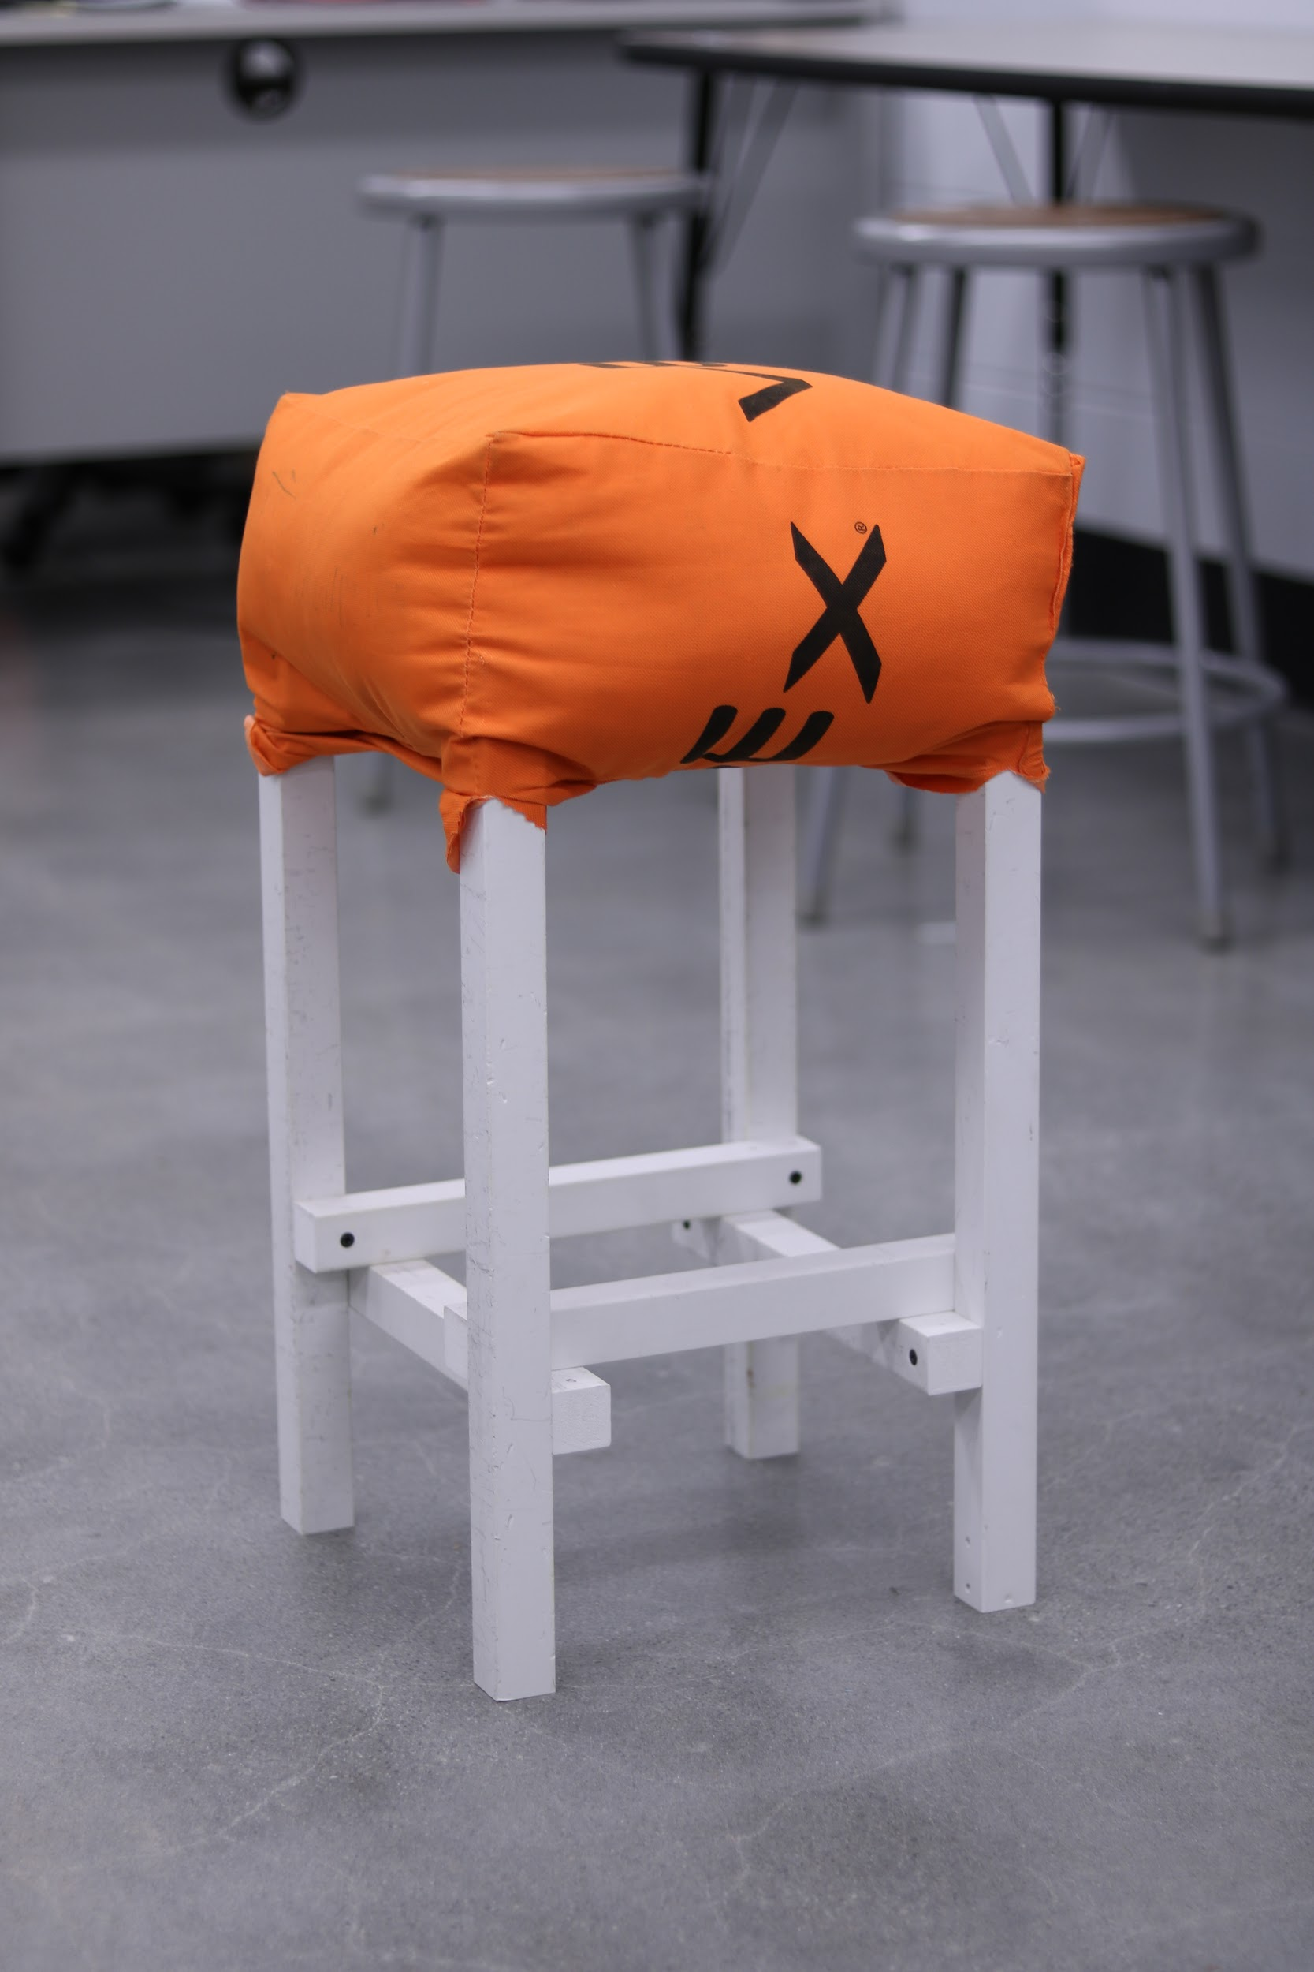
Click here to watch our video!

