Deconstructing a Slide Phone

Introduction:

Emily and Tiffany, along with help from the rest of team 1575D, chose to disassemble a Samsung Flight 2 slide phone that was patented in 2010. This device was readily available and, as a phone, has everyday use. Although what we chose to analyze is an older model, Samsung is still a major phone manufacturing company and the device is something that most people use on a daily basis. We wanted to take apart something with that sort of functionality, as it will be most relevant in jobs we will soon be partaking in.

Summary and major component roles:

Some major components we found inside included semiconductor chips (or integrated circuits), the display, the speakers, the motherboard, the keypad, the batteries, and the communication ribbon. The ribbon was damaged prior to the dissection and therefore did not operate due to the lack of communication between the motherboard and the display.

Semiconductors chips switch and transfer signals throughout the motherboard (a printed circuit board off which more circuit boards can branch) to accomplish its given task. In this particular phone, we found some made by Fairchild, Qualcomm, and MagnaChip, along with one wafer specializing in Wifi use and manufactured by Skyworks. None of the chips we were able to read were produced by Texas Instruments. Many of them, however, had the abbreviations SOQ etched into them along with the part numbers. This stands for ‘silicon on quartz’, meaning they were made up of a semiconductor covering (silicon) layered on a quartz base.

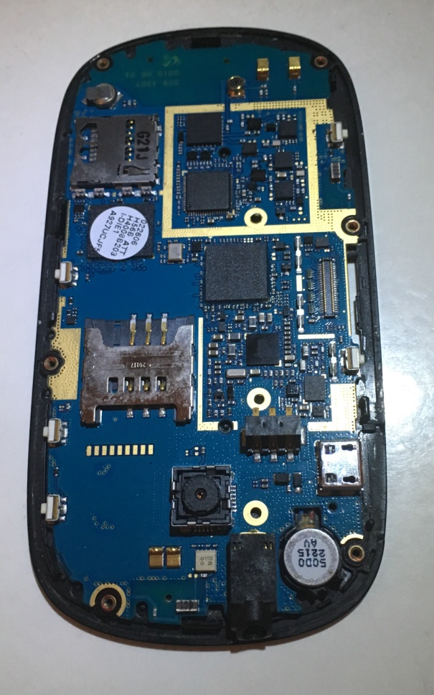

Notable components on the motherboard

1. Charging port
2. Headphone jack
3. Memory backup battery – this retains data that your phone stores, like text messages, contacts, and pictures, while it is off or out of charge. It is also the reason that your phone reads the correct time even after it has died.

**5.**

1. Camera
2. Intel smart phone chip (like a microprocessor like found in computers that integrate functions of a CPU on a semiconductor chip)

*semiconductor chips are not labeled since there are so many appearing in so many different ways*

**1.**

Another significant part of this phone is the sliding mechanism. It does not require and electricity and is yet similar to the 4-bar on our robot.

**4.**

**3.**

Conclusion:

**2.**

Taking apart this phone was much more fun than we expected. We found ourselves excited to take apart the next stage, and disappointed when we were unable to detach them. More than that, this challenge was educational, causing us to appreciate mobile phones and their seemingly expensive price. Once you see the internal workings of any phone, you fully appreciate the work that is put into making such a complex thing on such a small scale and how that intricate object could be worth only $12. All in all, we learned there is a very interesting journey ahead to fully understand this phone and other systems.

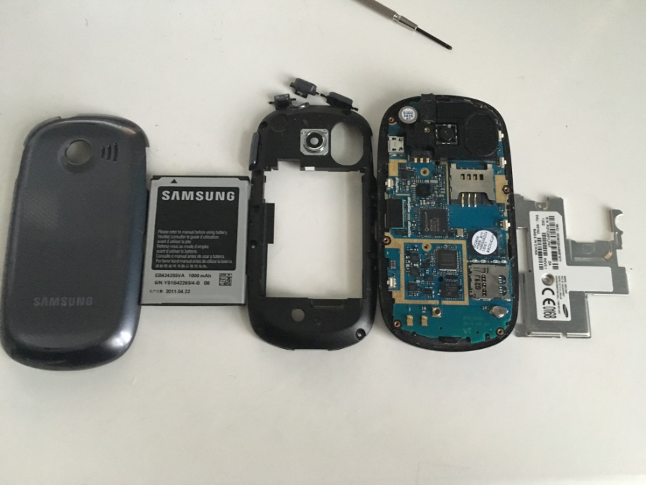

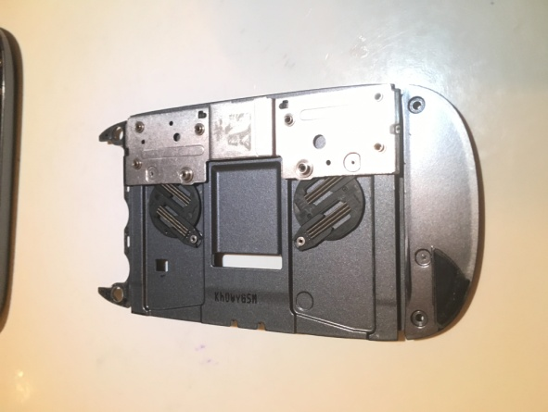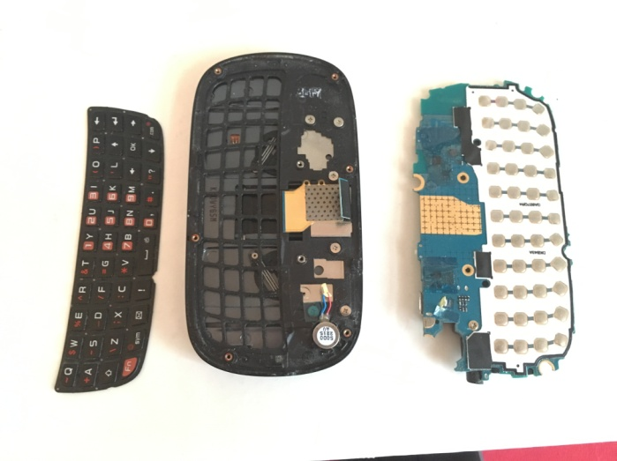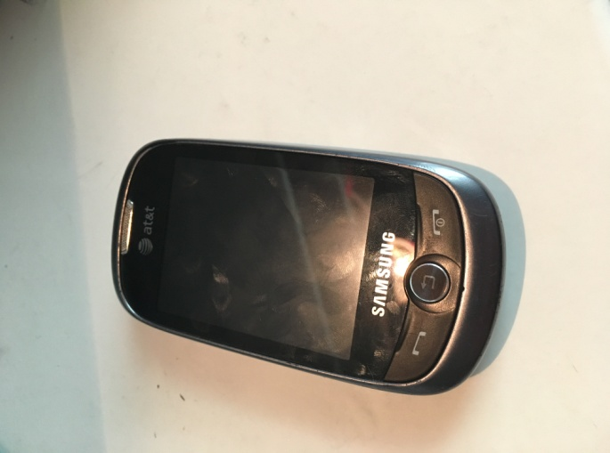

Slide mechanism with springs.

This photo depicts the rubber keyboard (keyboard GUI, if you will), and circuit board that sends a signal indicating which character to display on-screen.

The first step to dissecting the phone was to discard the back covers and remove the battery, as it is a major safety hazard.

This is the Flight 2 phone still intact.

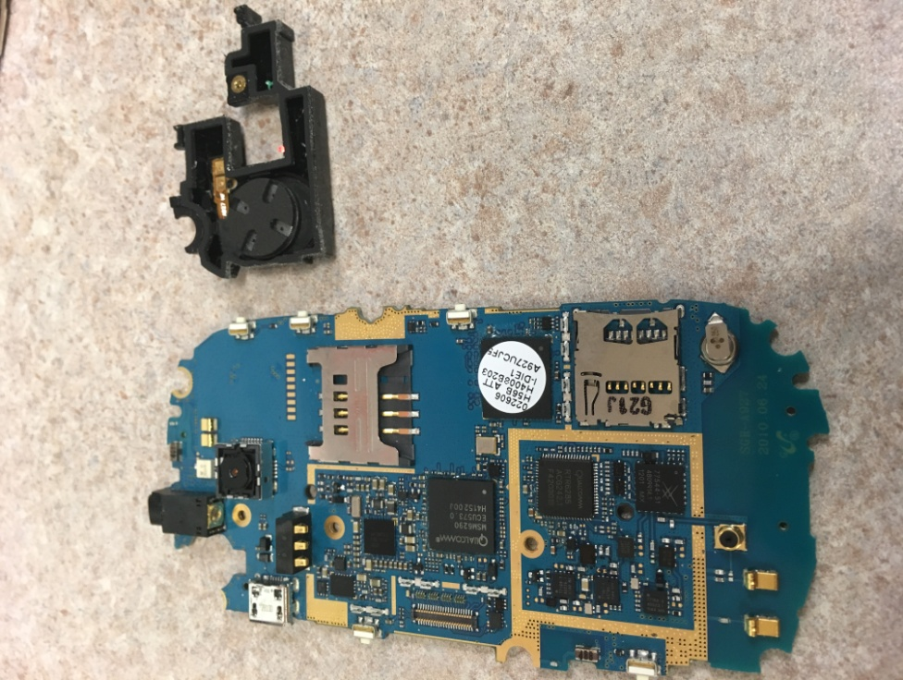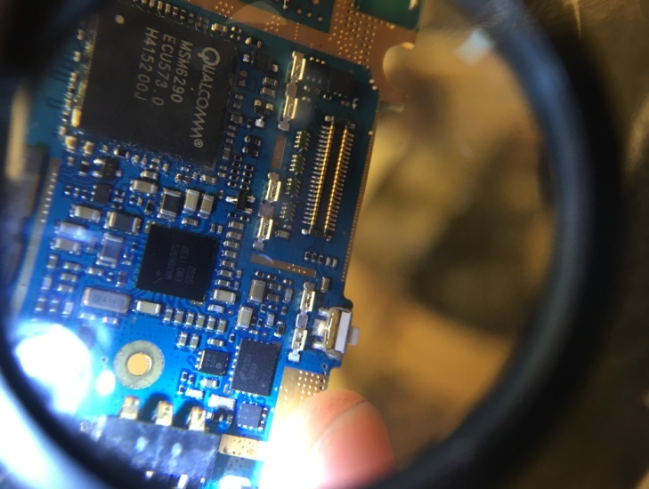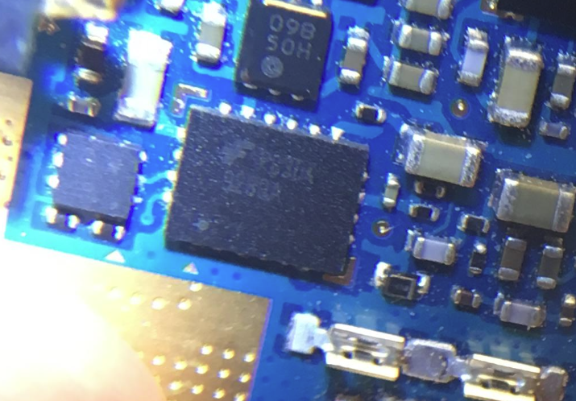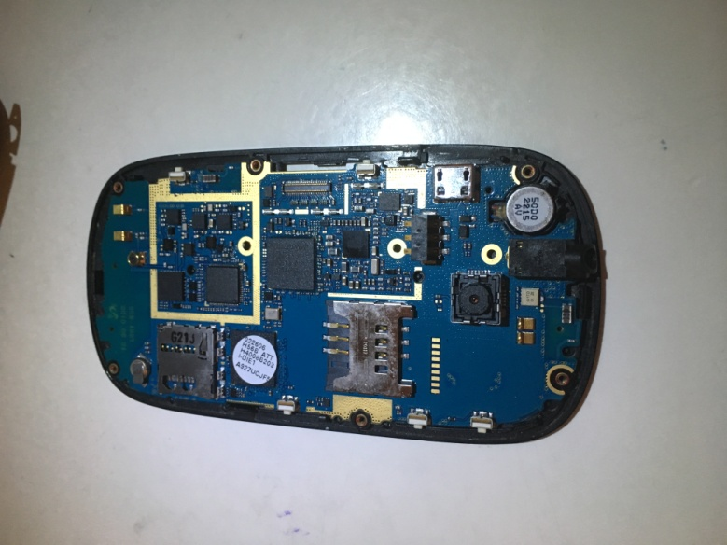

This is the speaker detached from the motherboard.

To decipher the logos, names, or numbers on some semiconductor chips, we had to use Mr. Castro’s (our coach’s) headband magnifier.

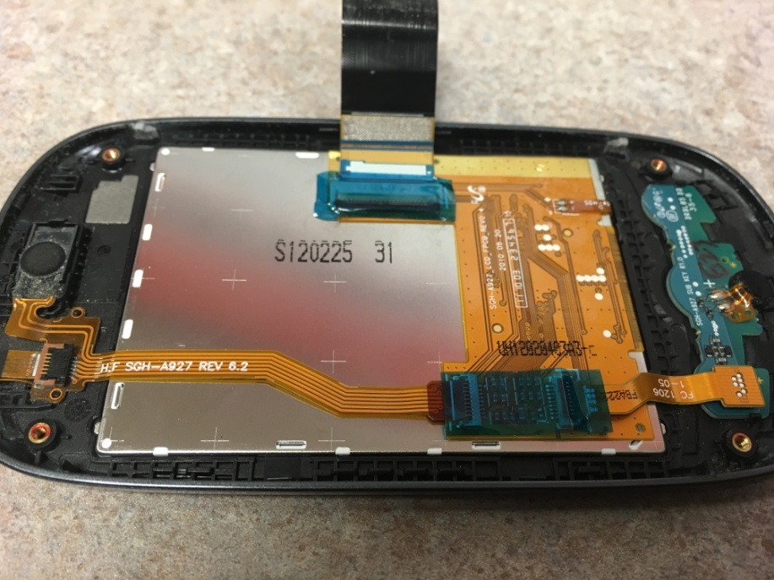

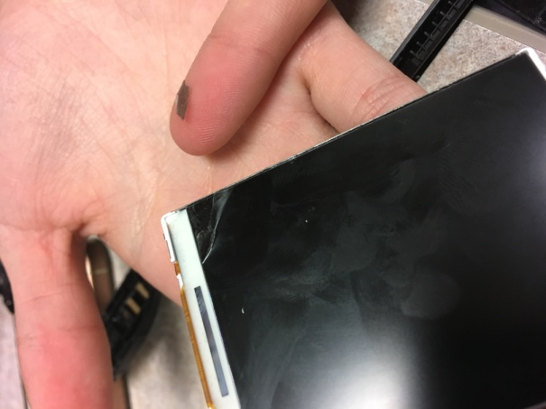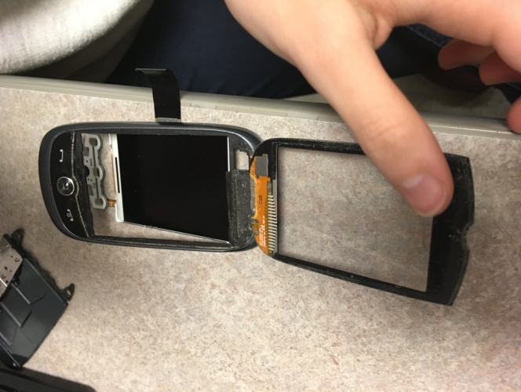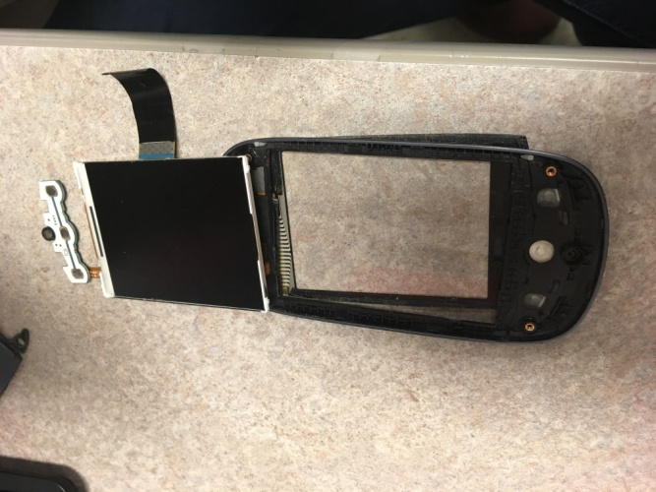

We tried peeling this sheet off the display to see if there were different layers, but it ended up ripping and we couldn’t peel farther.

**Lil tini speaker**

The top potion of the phone included the display, screen, another button pad, and the microphone.