My robotics experience started out in seventh grade when I first walked into the room. I could see that my new team members took this seriously. Of course I was nervous because I was the only girl on the team. Ever since I have been on the robotics team I have learned so many things that some kids don’t know. I have learned to build a robot, but my favorite thing that I have learned is how to code. I know that not very many people like to code but I love it. So far being on the robotics team we have had quite an experience, we have had an opportunity to go to competitions with our robot, which we named Vlad. This is my story about what it means to me to be Girl Powered and girl who loves robots and everything about them! My team and I, we all have prefer a certain job, if we break off and work independently. Even if we struggle we all, work together to find a solution. Teamwork is what this overall experience has meant to me. Even though this is my first year on the team I still have a lot of work to do. I also have a lot to learn. Being girl powered means that you don’t let anything discourage you and it sends the message to other girls to not be afraid to ask a question; always ask your teammates or your coach for help. That has helped me tremendously this year! The best thing is that if you really love robotics like me and many other girls do, you will work outside of practice. This girl powered online challenge is a big opportunity for me and for the rest of my teammates. Perfect isn’t a thing in robotics you will make mistakes and probably many of them. It is good to make a mistake so that way you can learn and move on. What this all means to me is that I am a strong independent girl who does robotics. Some may not like robotics like some of us do but this opportunity and many more experiences like it will be what I remember when I am looking back on everything. When I think about what Girl Powered means to me or what it means to my teammates, it means being me and not changing for anything or anyone!

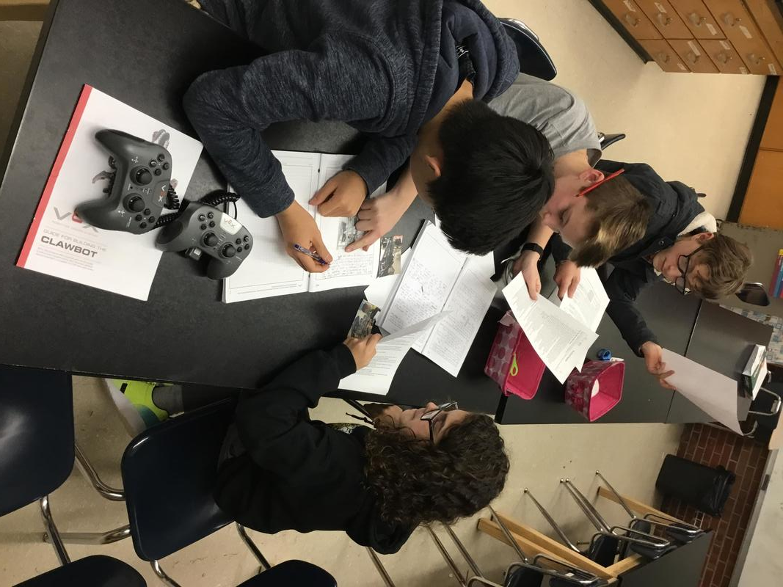

My team and I are very good at problem solving. We always try to find solutions as a team or even individually. In the picture above we are working on some more corrections for Vlad. (Our Robot)I aggree with working as a team because we are working much more productive.

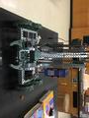
This is a picture of our robot Vlad. We have done a whole lot of work to him to make him more amazing. It is hard to believe how far we have come along. We first started with a standard claw bot and here we are with a bigger much more productive Vlad.

Credits
This entire entry was written and created by
Delaina Fleming

