Rotational Stabilizer
Why I created this part:
I created this part to make rotating with fewer motors possible. You can create a similar part like this using parts. But it is less efficient and uses a lot of parts. You have to keep constant maintenance of the makeshift rotational stabilizer because of how many parts you use and the load it takes will increase if you don’t have a rotational stabilizer. If you use the makeshift rotational stabilizer it will come apart after constant use because the parts that are attached are being constantly rotated which the excess energy is dispersed which some goes into the screws. This will slowly take apart your makeshift item. You can use this if you need to use less motors and you have parts that rotate because this supports the load on your rotating part which makes the load less strenuous on the motor and the current draw isn’t as large. This gives you more space instead of the motor and makes it more stable. Because without this if you want to use less motors, it will hurt your motors and won’t be as stable. In addition for this competition, Vex In the Zone, most people have mobile goal intakes which has a lot of load. With this they can limit how many motors they use and add it to be more efficient over all.
How it works:
These rotational stabilizers are meant to be attached on a c-channel onto the rotating part which it add support to the rotating part. When you add a mass on the end of the rotating part (ex. If you want to move something) the load can be too great which either it won’t move or it will burn out the motor and during a competition this is bad. If you add this rotational support the load affects the end of the rotating part so the weight of the mass affects the rotating part (ex. C-channel) less which makes the motor’s current draw less. With this when it rotates the torque applied to the rotating part is less because of the extra support.
How I used Autodesk:
I used Autodesk Inventor Professional 2017 – English to design my rotational stabilizer. Using my previous knowledge of Autodesk. I already knew the basics of it and more. With this I used basic geometric shapes and extruded them to make it 3d. Then adding different work planes to get cut a hole inside of the curved top. Then I threaded both holes for the use of screws then I was done.
Conclusion:
I learned more skills on Autodesk and I learned why Autodesk is great for creating parts that we could use and for simulations. I will be using Autodesk in my future as a student and hopefully in my future career as an engineer. If I ever need to design anything or simulate anything I can use this. Autodesk can help you in this competition if you have a weight distribution you can simulate where the weight is going and how much tension is each section is taking to make it more efficient. This will definitely help my future career. My dream job is engineer and if I ever want to create a part this software is great for doing this. For designing the assembly of your part. This can do everything. Then it can test how good your part is by simulations. This is a full package. Which I hope to use in my future.
Extra: Autodesk Inventor Professional 2017 – English (all)
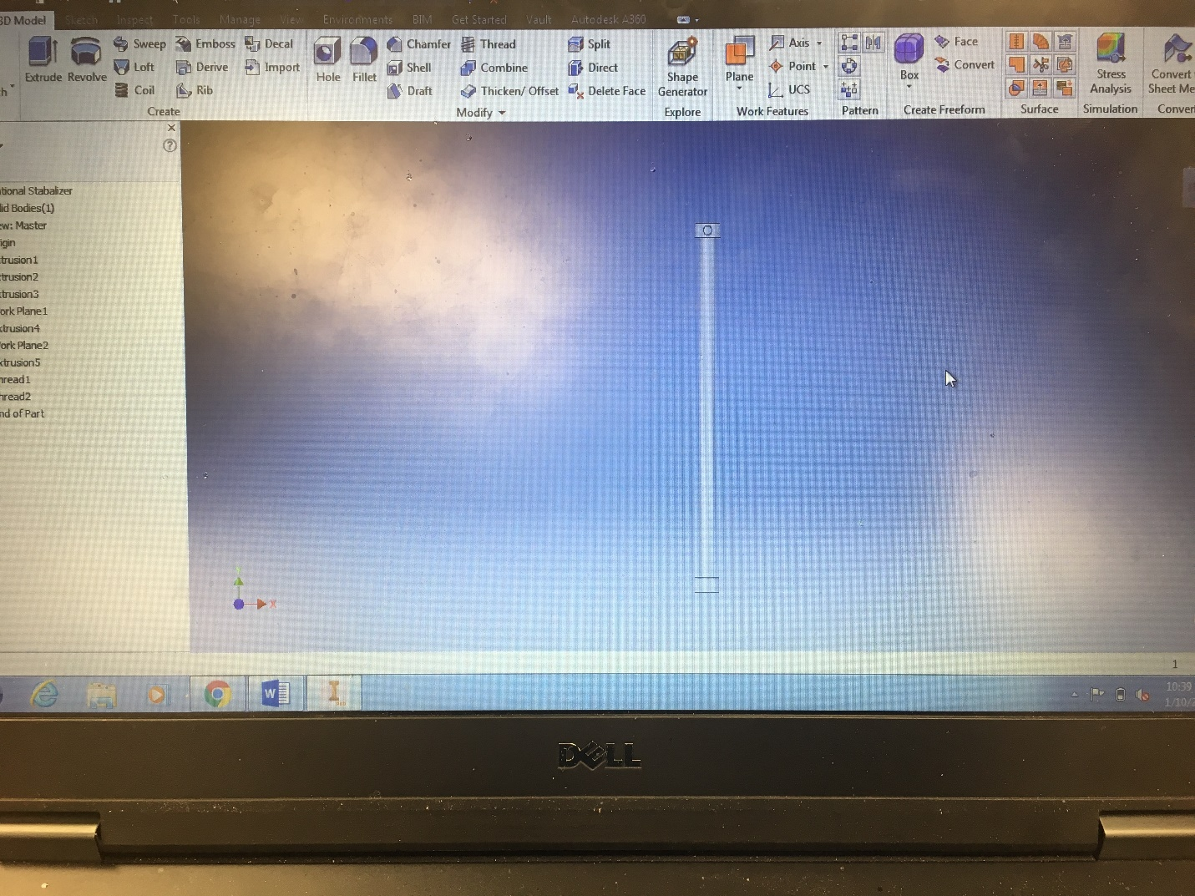
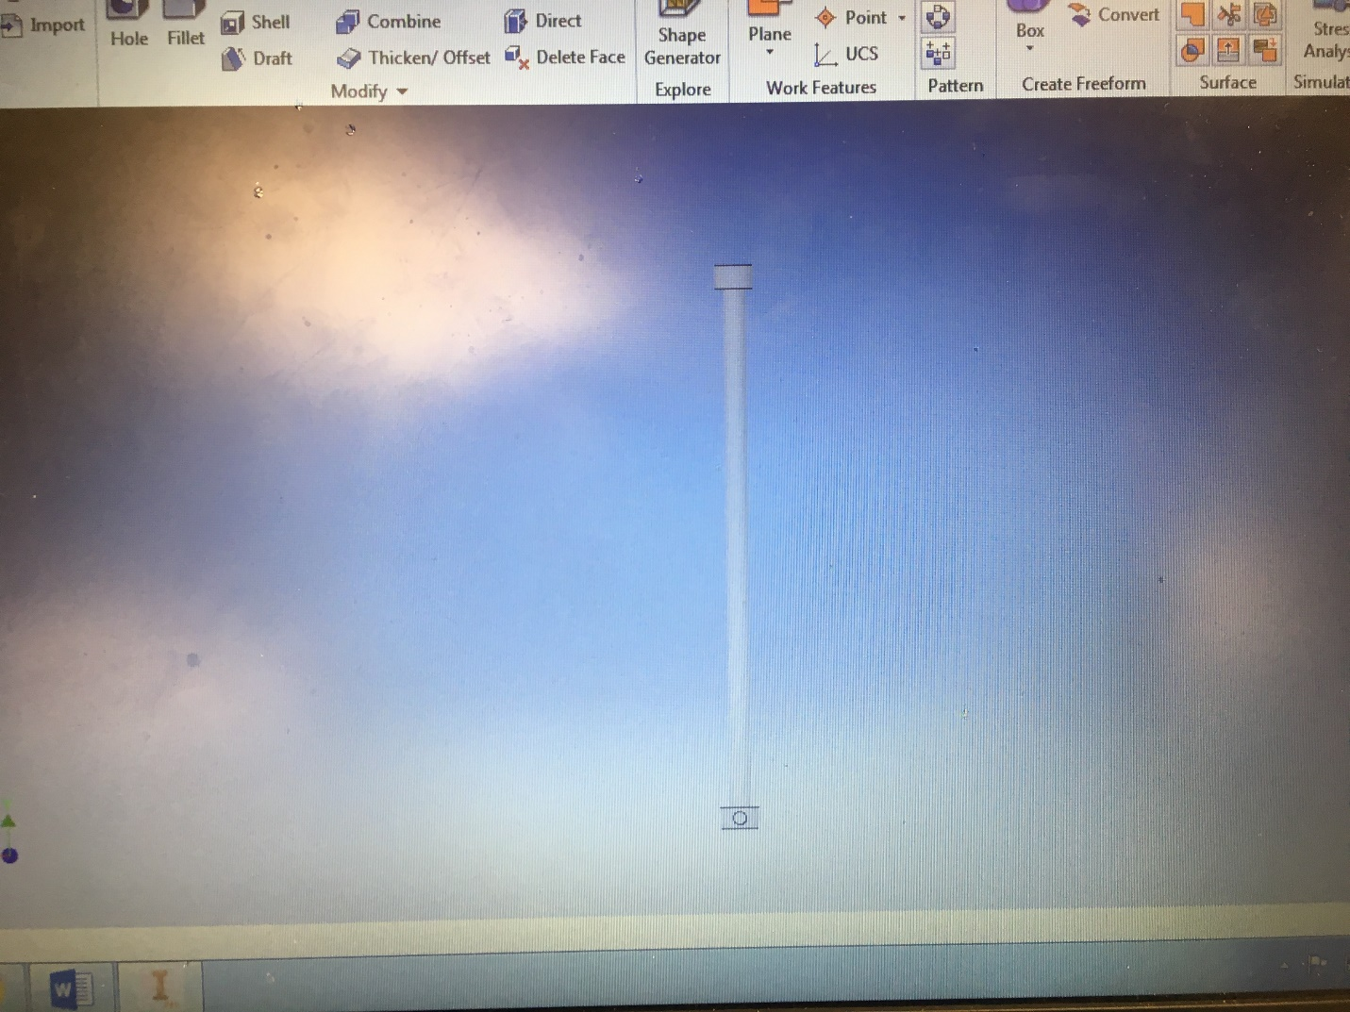
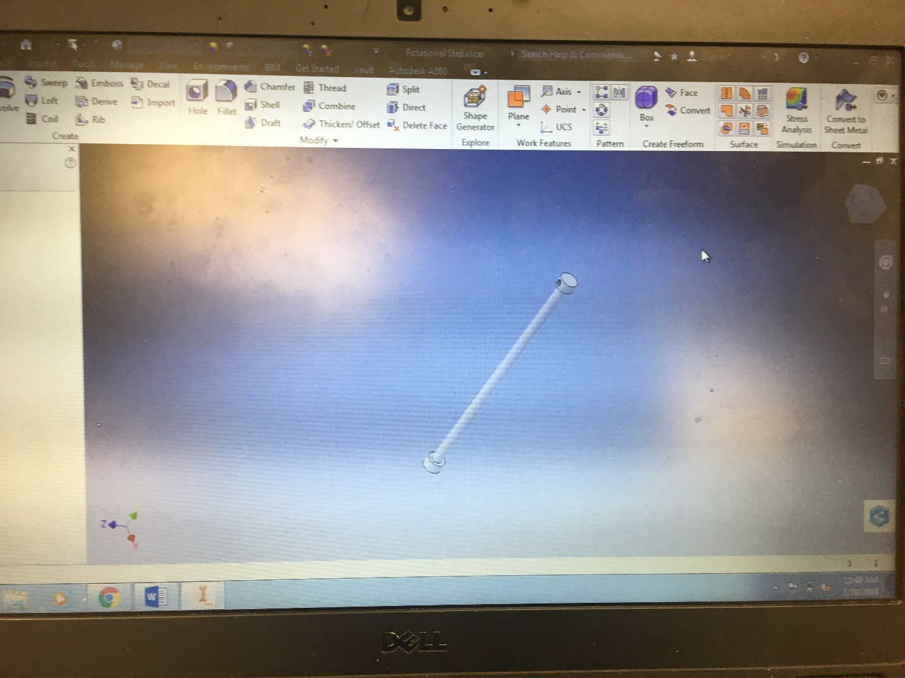
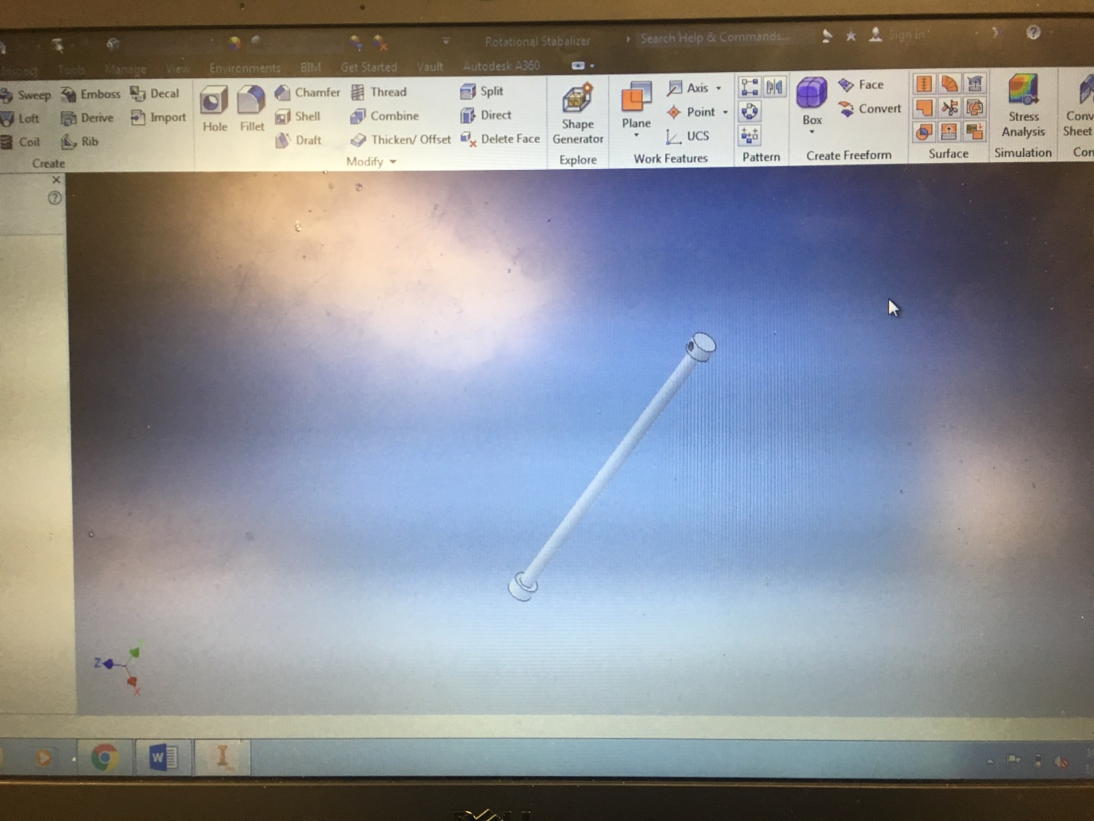
Bonus: