VRC Girl Powered Online Challenge
Titanious Robotics
The first thing that comes to our minds when we hear girl power is girls having the strength to be able to do whatever anyone else can do. They should have strength, be positive, and believe in whatever they want to accomplish in life. We think girls are strong and capable of doing whatever they want as long as they put their mind to it. Our team has done everything they can to include girl power to whatever we do. On our team we have twp girls how are included in everything that's done on the team. They build, they program, they put their whole heart into the engineering notebook to make sure it's as perfect as it can be. With these girls working like this they have, the team has now qualified into the VEX Robotics States competition. They qualified with overall the design of the robot but also the engineering notebook. This really made them proud of all the hard work they have been putting into the engineering notebook. Each of our team members all have a part in the designing, building, programming, and the engineering notebook. The two girls have really found a passion in writing in the engineering notebook. They really enjoy writing what they see and hear, this makes the engineering notebook the girls strength. But, the two girls also enjoy building and learning more and more about programming as the season goes by. Now the guys on the other hand don't enjoy writing as much but, the team knows that it's important that every team member is included in every strength. Each team member needs to really know the robot and understand everything that incorporated into the engineering notebook. They also have to understand all the complications in the programs our team has created. Our team feels that we are very strong on understanding the engineering notebook, our robot, and our programs. We feel that every team member needs to have in opinion in every design or change on the robot. Each opinion really helps us out because their are some creative ideas one team member might have thought of that the another team member might have not. We need each opinion because one team member may not want to make a change and the other might want to. Then we would discuss the pros and the cons and why one thinks one way and one thinks the other. We believe that both of our coaches are our STEM role models. WE think this because they both put all their heart into making sure that this robotics season will be fun, enjoyable, and educational. They always help us and inform us. They don't always keep it easy they like to challenge us to keep our minds thinking. Just as important, our two coaches are both women! They are smart and very inspiring. All in all, this Girl Powered was written by the two smart, strong, and creative girls on team Titanious , Karen Gallegos (7th grade) and Jada McCall (7th grade).
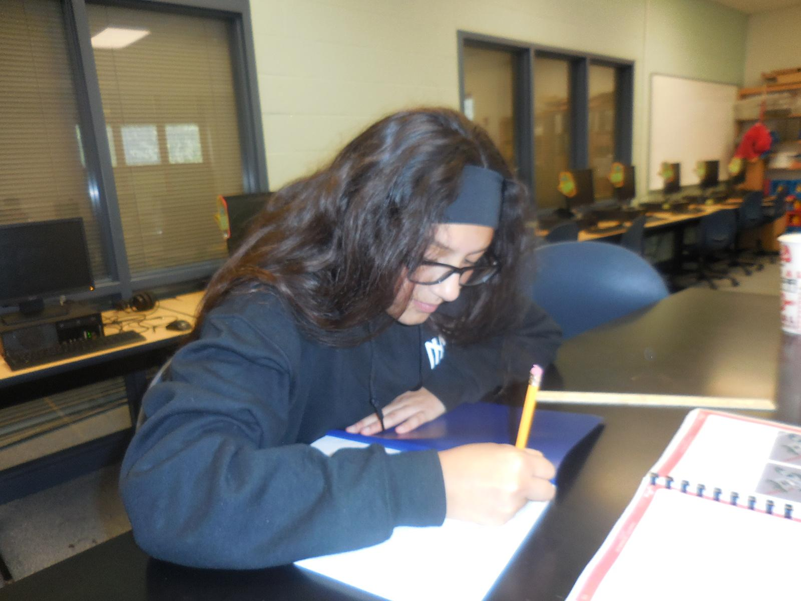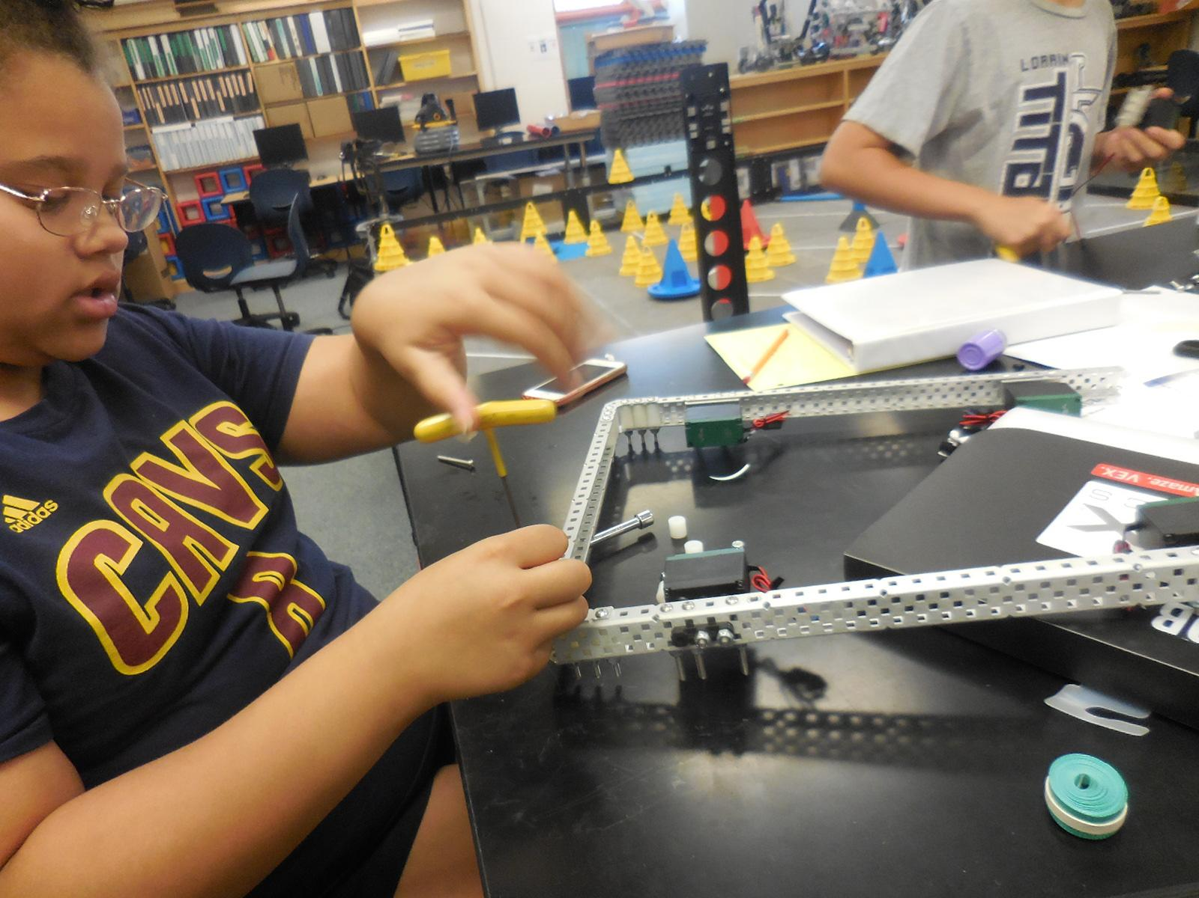
On the left there's Karen working in the engineering notebook and on the left there is Jada working on our robots base. We are both very happy and proud to be on this robotics team and we both hope to inspire other girls to do what they want!

