Bangarang 5956G
Shannon Zoltek, Morgan Nelson, Rose Moskowitz, Sam Ashby, and Shelby Constant
Online Challenge: Recycling
For our recycling challenge, we decided to reuse the cloth VEX cubes form the last year’s competition, Starstruck. We deconstructed and reused the cloth and the stuffing. We created a backpack, so students can carry supplies with them around school.
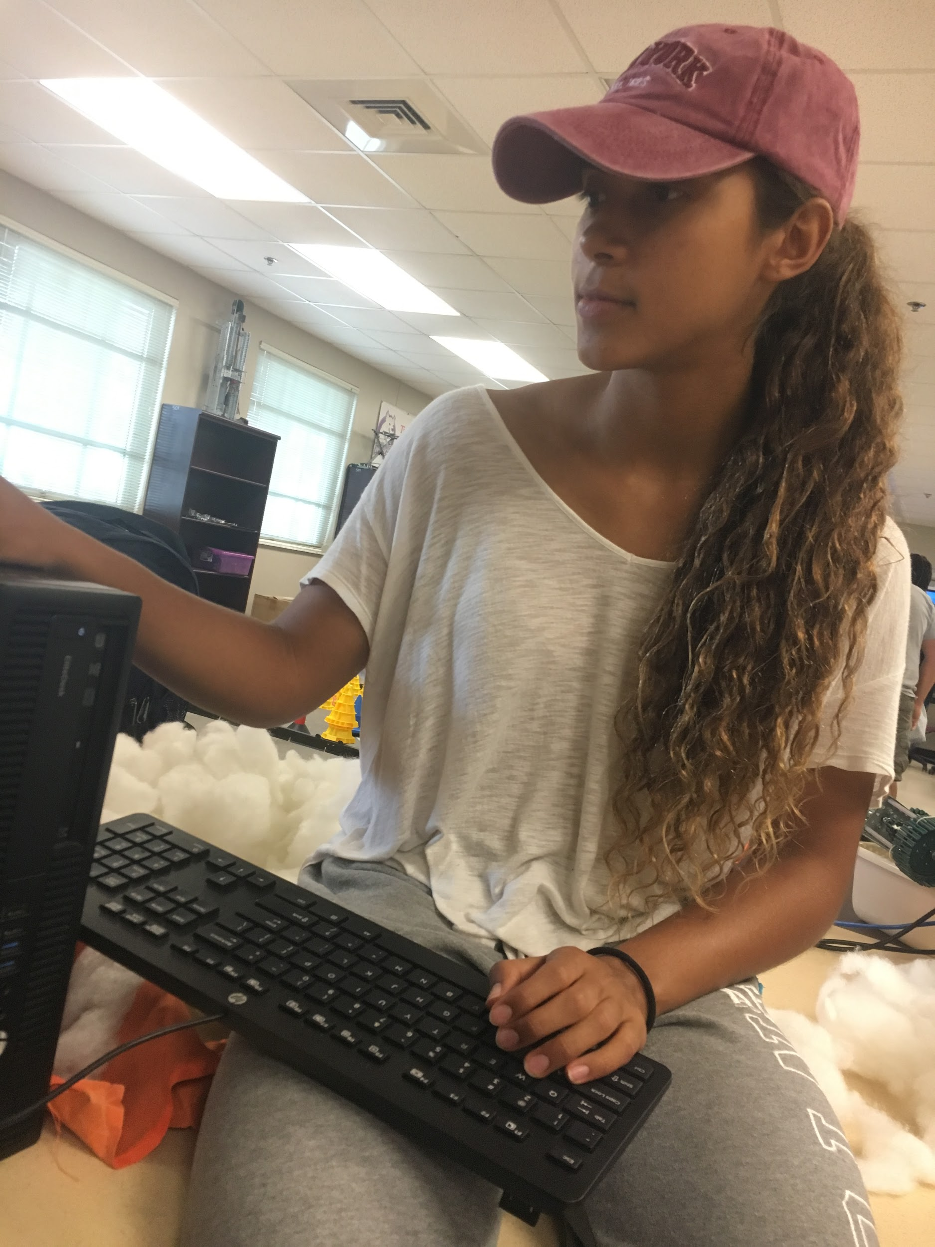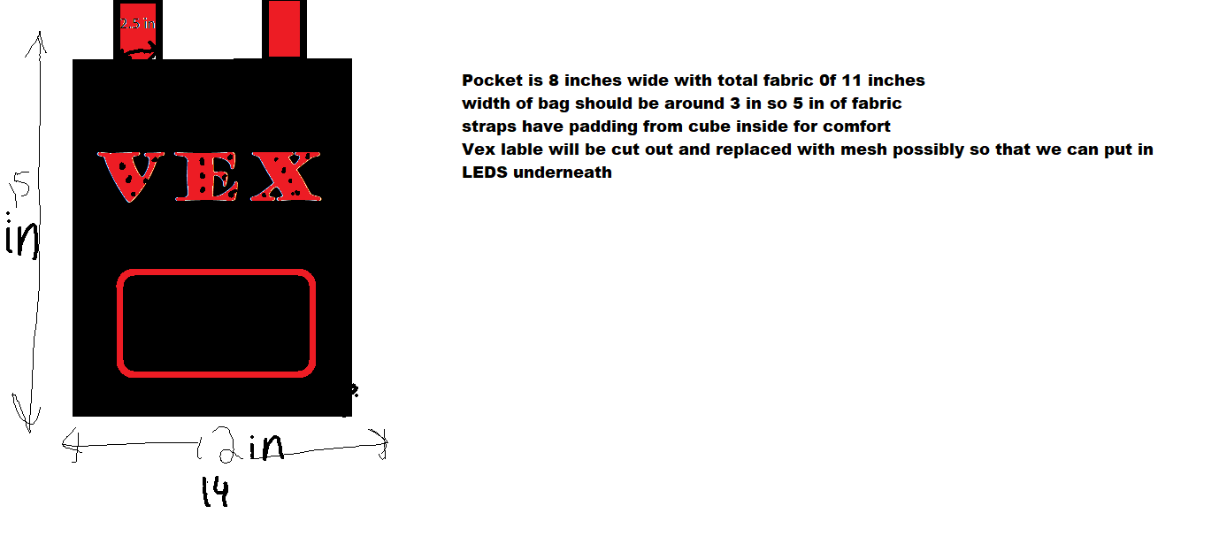
We started the process in the beginning of the year by unstuffing VEX cubes and researching backpack designs. We decided to use a rounded design with one big pocket that can be zipped shut and a smaller front pocket for pencils and pens.
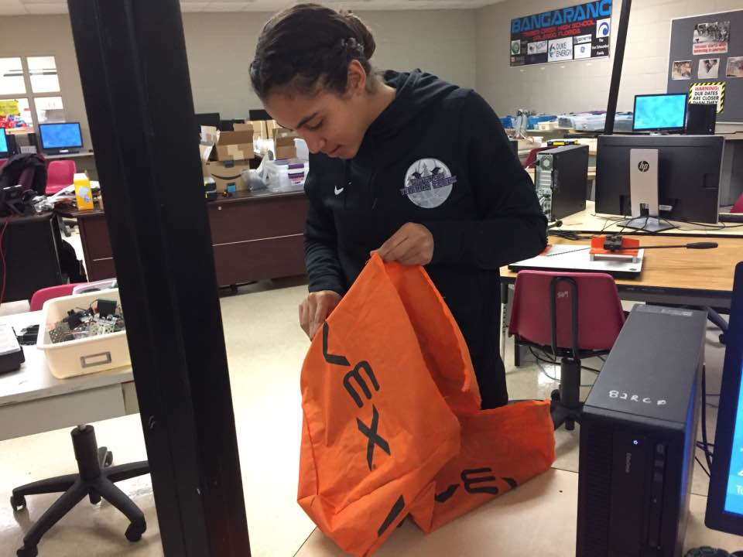
After designing the bag we began gathering and shaping fabric so that we could build the bag. We planned on sewing the basic shape and then adding extra decorations and pockets.
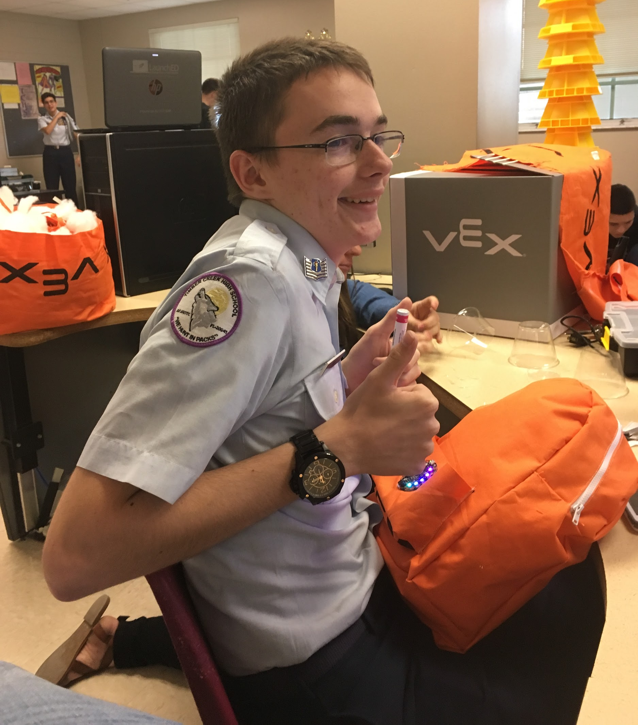
Once the basic shape was sewed together we began adding decorations, such as the LEDs on the front pocket. These decorations make the bag unique and fashionable as well as functional.
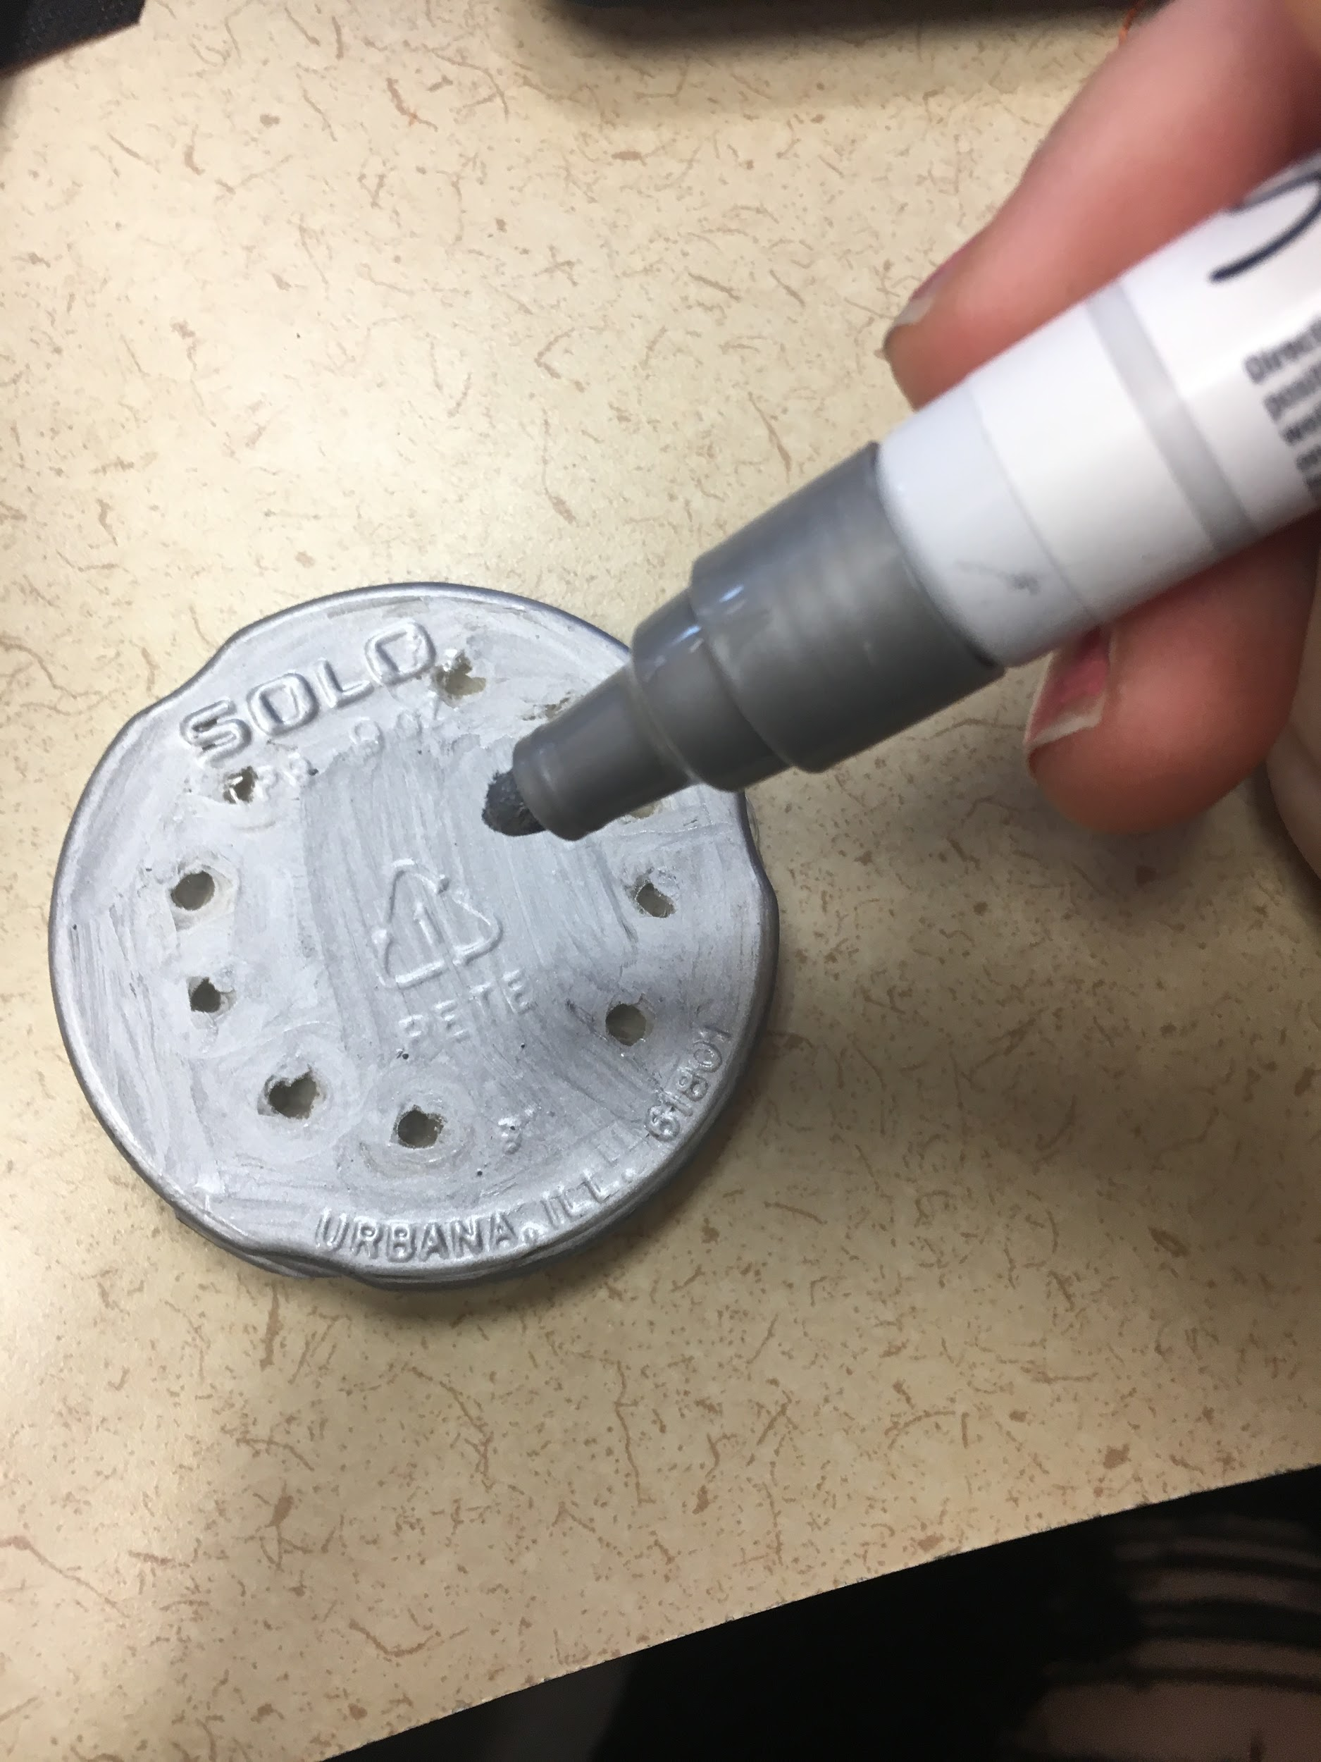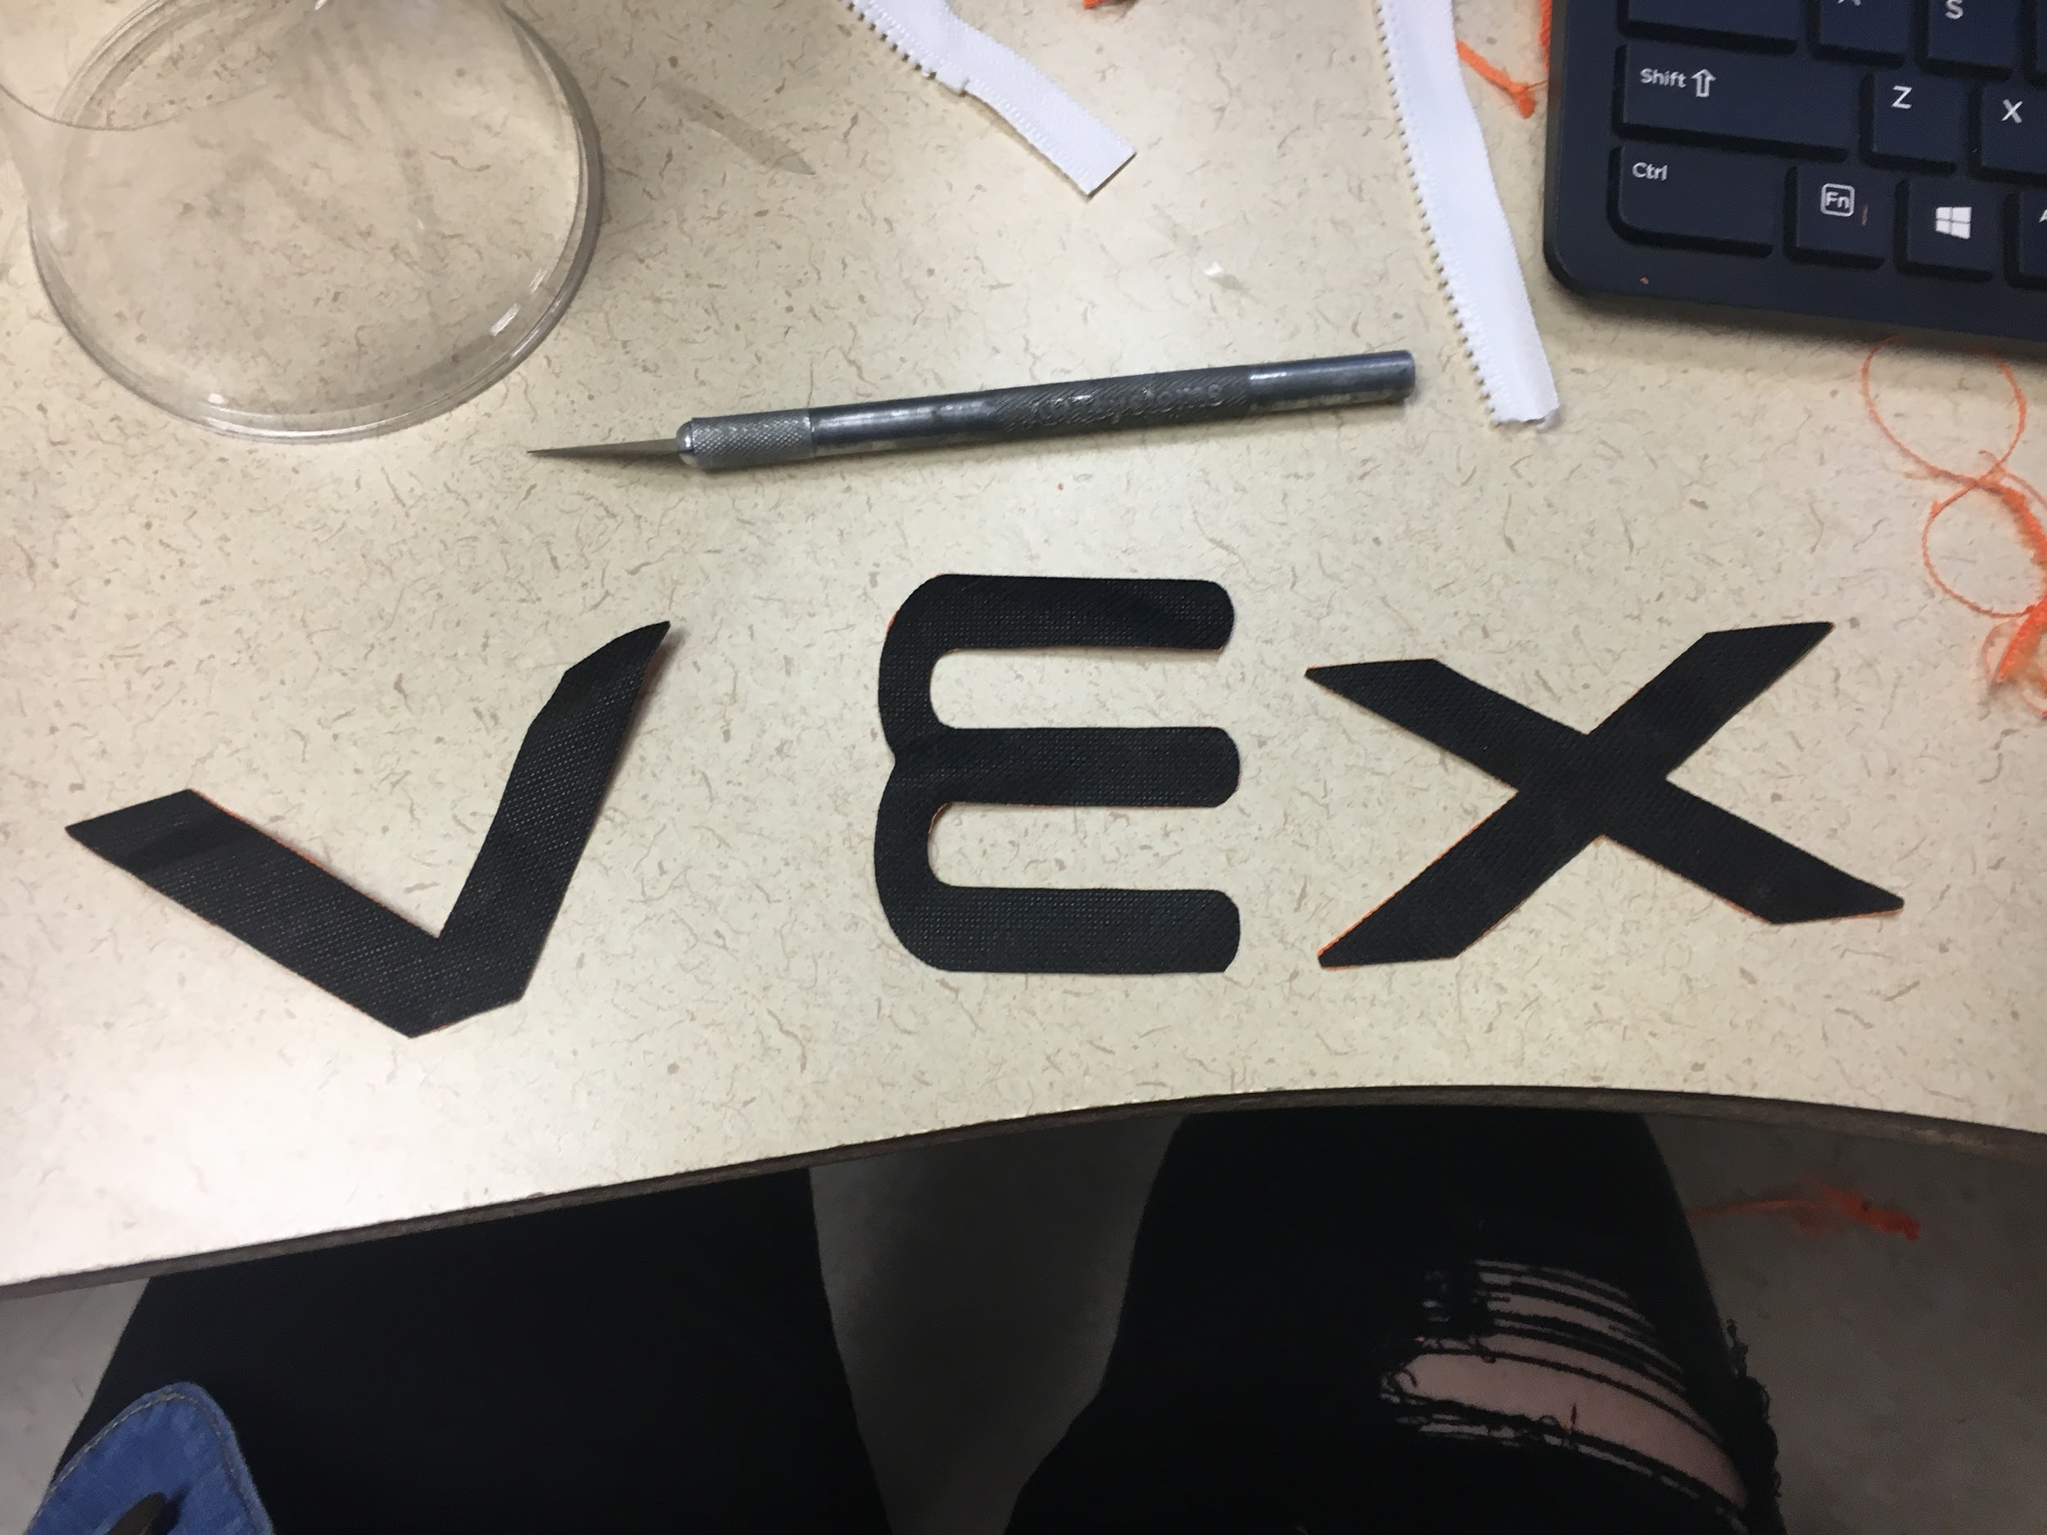
To continue the theme of recycling we took the bottom of the cup to cover the LEDs. We also cut out the logo from the VEX bag to decorate our backpack. The logo on the backpack will allow others to know the company that was responsible for the bag, as well show our pride as a VEX robotics team!
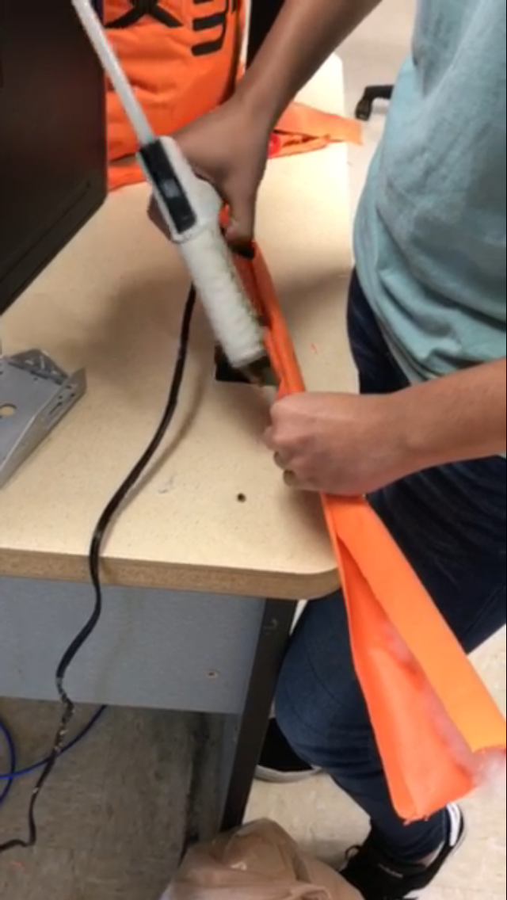
When the bag was mostly completed we began working on the straps that will be used to carry the bag. The straps are made from long strips of the cube that we restuffed in order to make them more comfortable for the wearer.
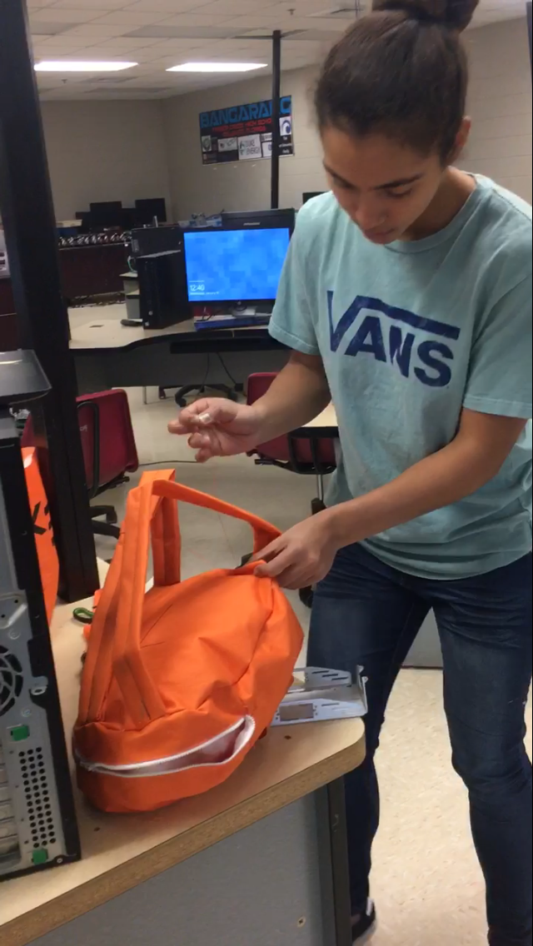
After finishing the straps we attached them to the bag itself. We decided to sew them to the bag to provide extra support so that they will not break off of the bag. Now it could be easily carried around on someone’s back.
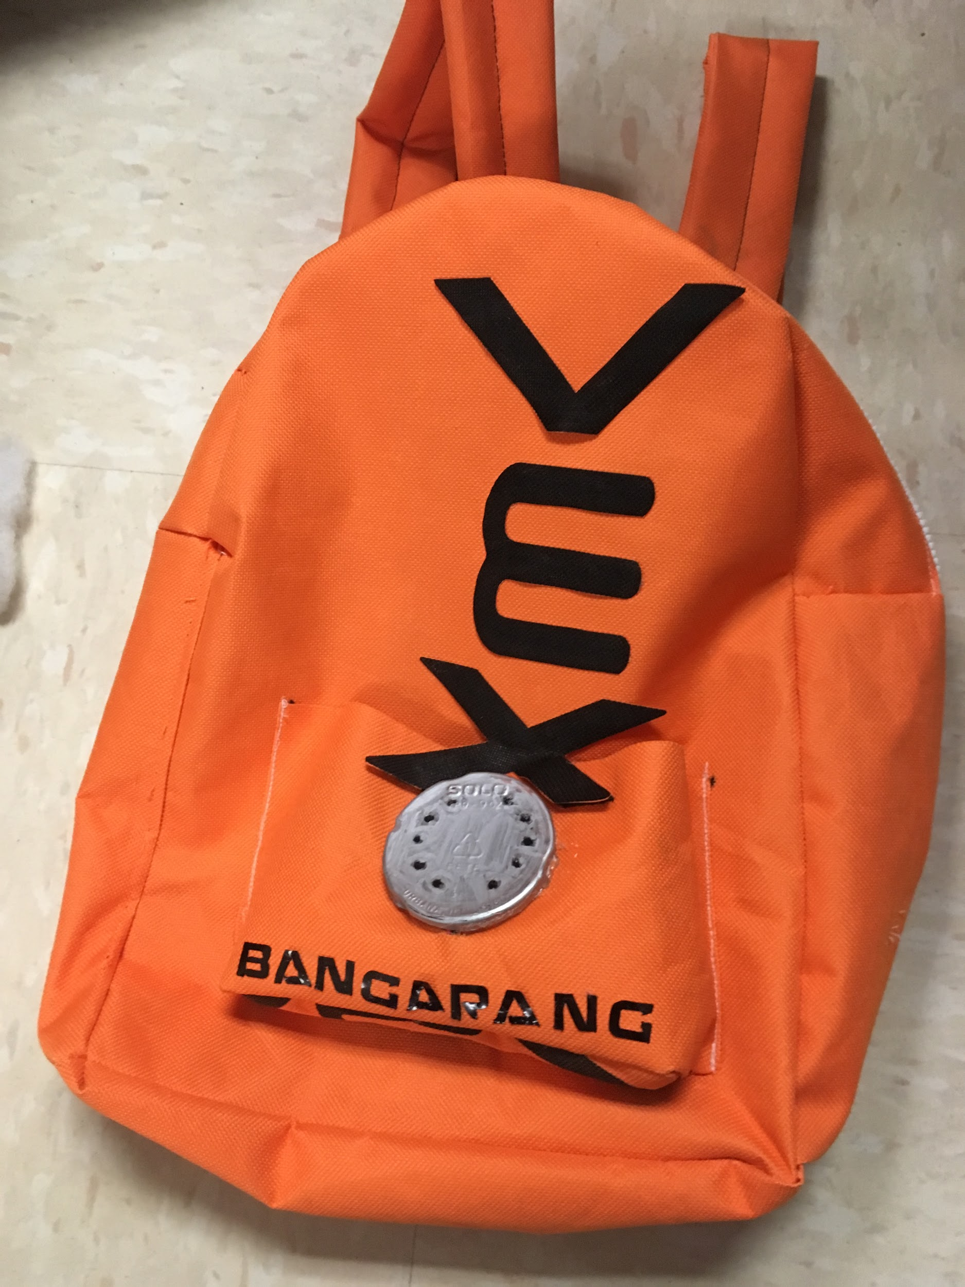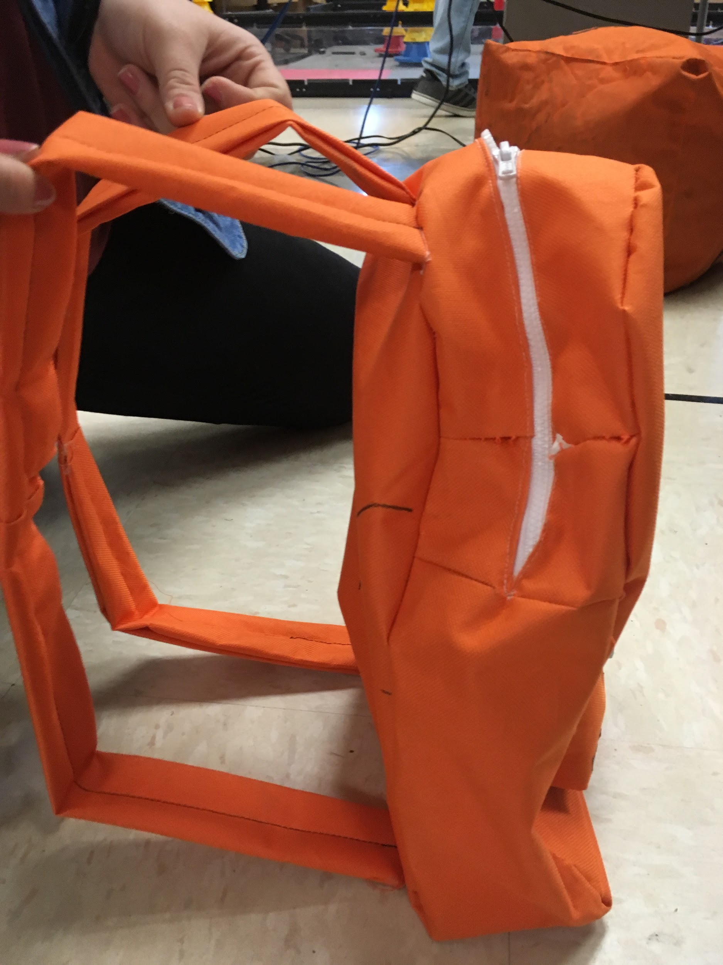
The finished product looks great and functions well! The logo and team name demonstrate team pride, and we will now be able to use this bag to carry engineering tools at robotics competitions, or just everyday to carry books, papers, and pencils!

