Girl Powered

Citi Gals is an all girls high school robotics team located around Jacksonville, Florida. The team provides an inclusive environment that allows girls from different backgrounds to share similar interests and provide a variety of different skills. All members are involved with different areas within the team and assume roles such as programming, engineering and, marketing. The members come from multiple schools that have different “Career Academies” that have allowed us to specialize in many different fields like engineering and information technology.

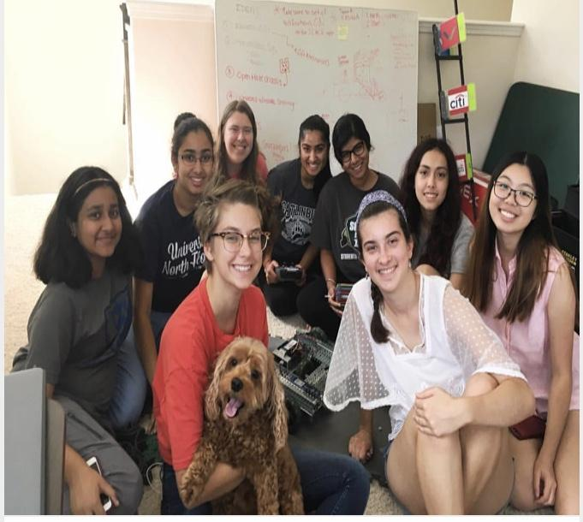

Many girls on the team were inspired to join through participating in technology internships at Citi. These experiences inspired us and gave us a place to

strengthen our STEM and teamwork skills. We were empowered by Citi who provided us with all of the materials for the competition and graciously gave us mentors to give us assistance when we ran into some problems. Some members introduced their younger siblings who were completely new to the STEM field and team dynamics. It was a little difficult for them at first but we pushed them to try it and continue with the team. Our team tries to encourage more girls to pursue a career in the field of STEM. This is because we want future generations to be inspired to take part in the future where STEM will be used in everyday life.

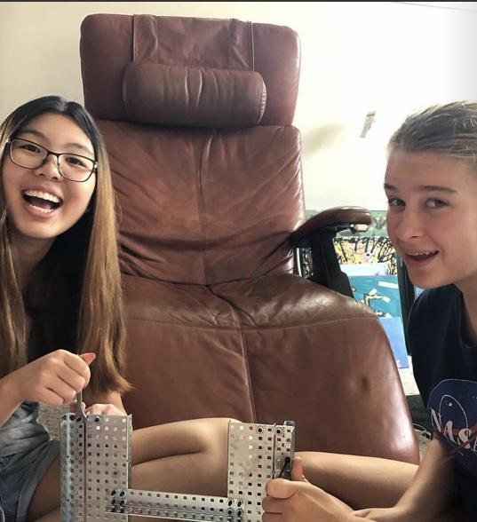

The team is divided into three groups; marketing, programming and, engineering. Each member is encouraged to try out all the different roles to see where they fit in best. Even if a member does not have previous experience, they are welcome on the team as long as they are motivated to learn. We believe that our teamwork and positive attitude is our biggest strength. Each person has a background which helps them incorporate new things into the robot and its design. Instead of letting our differences divide us, we let them unite us.

Team captain Emily Hannon believes that our team is girl powered because through our love of robotics “we give girls opportunities in STEM that they wouldn’t have otherwise.” Many STEM related classes are male-dominated, which cause some girls to shy away from them and lack confidence in their abilities.Citi Gals aims to combat this by providing an energizing environment for girls to learn more about the field.When we make mistakes, we make sure they are fixed and that we learn from them. However, we believe that gender does not define us or hold us back in any way. Another senior member of the team, Maanasi, said that “girl powered enables us to be equals in the field”. Robotics is very male-dominated and girls may not have the opportunity to speak up. Our unique team changes women's outlooks on technology and pushes them to break these barriers.

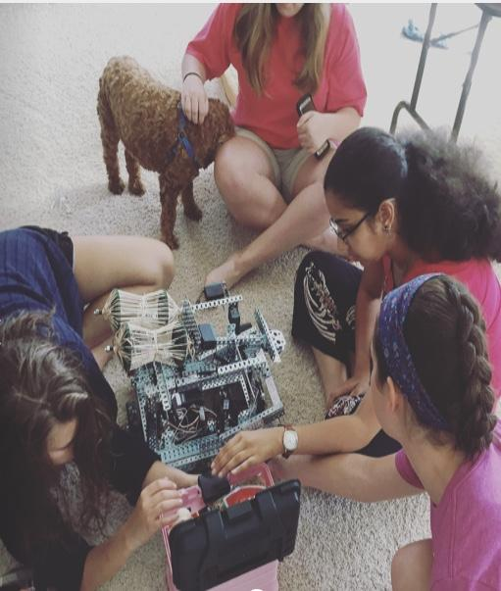

Many of our members come from academies at different schools and have spent years learning different skills relating to engineering and information technology. Each of our prior experiences with internships and academies have made each of us unique and able to bring something new to the table. We have been able to form a bond as a team with our shared interests.

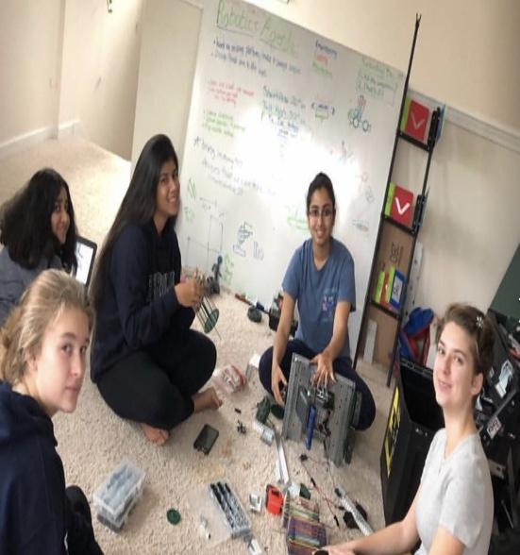

Being one of the only all-girls robotics team at many competitions has given us a completely different view of the field. It has improved our team spirit tremendously. We let our pride in involving more girls in robotics help us strive to do better and prove that we are not inferior to other teams. Many people have inspired us in our journey through STEM. Grace Hopper is a very influential woman we look up to. She was a pioneer in developing computer technology that is still used today. Maanasi was inspired by her own grandfather who would share his designs for satellites with her. As a result, she is pursuing a career in engineering and computer science and is a lead engineer on our team. Overall, Citi gals is not a team, but a family who strives to empower girls and make sure their voices are heard through robotics.

Team Number: 53346A

Entrants: Citi Gals Robotics Team. Written by: Kshama Shetty, Yashika Vadlamani, and the other members.

Title: Girl Powered