Single hole fixed column

Introduction.
In the construction of the robot, we used the rubber band to assist the mechanical structure and the motor to carry out the lifting action many times. However, when the rubber band is fixed, we often encounter the problem of how to fix the rubber band. Now it is fixed by the structure of the long screw or nut column (Fig. 1).
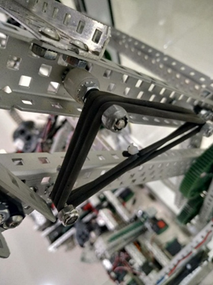
Fig. 1
When the rubber band is encountered, the screw thread and the nut column edge rub, causing the loss of the rubber band, reducing the life and tension of the rubber band. We think about this problem and design a fixed column with a single hole (Figure 2).
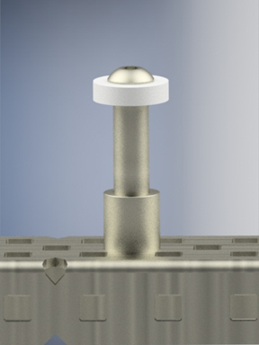
Figure 2
The surface forms a smooth cylinder, which reduces friction with the rubber band and improves machine performance.

2. Design inspiration.
Observe the ribs of the screw thread and the nut column. We have considered that the rubber band fixing column can avoid the damage of the rubber band if it can be made into a smooth surface. Observe the size of the nut column and the gasket, and set the design direction. The nut with the lower end is 0.5 to be fixed on the aluminum C channel. The upper end is a threaded hole, which is convenient for fixing the different size gaskets.

3. Design process.
We use the Inventor2016 version to make and assemble parts (Figure 3). By observing the size of the nut column and the spacer, we set the diameter of the rod to be larger than the inner diameter of the hexagonal surface of the nut column, so to facilitate the fixing of the rubber band. Draw the part and assemble the part with the existing EDR part.
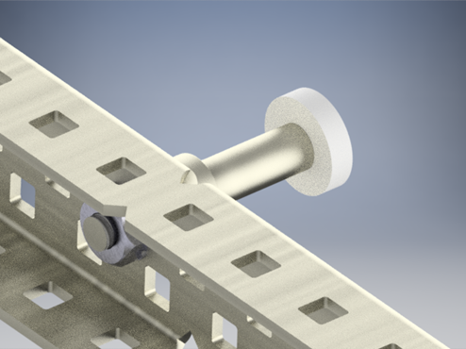
Figure 3

4. Conclusion.
In this design project, we learned that designing parts needs to think about different factors, and should also consider the function and size of the parts from the perspective of the user. 3D design software allows us to better realize our own ideas and make inspirations come true. In the early days of the actual team design of the machine, we will use 3D software to design and verify the new structure. Through the use of 3D software, it is very helpful for our three-dimensional space and structure. Let us have a reference when building the machine and have a new direction of thinking. 3D design software may not be the main body of work, but I firmly believe that 3D design software is our best auxiliary tool.

