Stronger United

We, 39W, The Avengers, started our journey in 8th grade. We came into VEX with a passion for robotics. Maryam, Nikita, and Ishu have been doing robotics since 6th grade. Alysa joined in 8th grade when we transitioned from VEX IQ to VEX. Although we had knowledge in robotics from VEX IQ, we were still overwhelmed by the change. There were many different roles and responsibilities as well as new building processes. It had taken us a while to qualify for regionals and despite our hard work we were not able to make it to States. In this new season we strive to make it farther as well as promote the idea of women in STEM.

Maryam, one of our captains, functions as a driver, programmer, and builder as well. In addition to occasionally screwing pieces in the wrong place and then whining when fixing it, Maryam is adept at driving Dummy, a skill she comes by naturally, and building. She also is the assistant programmer. Last year and throughout Vex IQ, Robot C was used for programming. This year because of the new V5 software, the language has changed to C++. It’s more complicated but she has learned how it works. She’s been doing robotics at Cranbrook for four years now, since sixth grade, along with Nikita and Ishu, back in the good ole VEX IQ days. Through robotics, she’s added these practical skills to her ever-growing repertoire.

Alysa, our other captain, programs as well as builds our robots. Programming is one of her passions, along with drinking excessive amounts of tea and soda, but hey! The new C++ she had to learn this year threw her a bit of a curveball but she learned fast. She started robotics last year, but has already become an old soul.

Ishu (: eye-shoe), our scout, builds as well, developing our strategy for matches. She notes the strengths and weaknesses of each team and based on their performance in multiple matches, determines who we should form alliances with and how we could best form a winning game plan. She’s also been in robotics since sixth grade and expects to stay as long as she can.

The last, but definitely not least, member of our team is Nikita. This year has marked Nikita becoming one of our best drivers. She’s fast and picks it up quickly, important qualities to have when you’re in an ever-changing game. She has learned a lot about building and has improved at driving throughout the years.

Throughout the building process we kept in mind how we could improve our team chemistry. In past years, we primarily only had one person as a driver but this year we wanted to expand in this area and now have two *main* drivers out of four. Most of our team members also attended the summer sessions our school held, where we built robots and programmed extensively before the competitive season began. Having more time to brainstorm and interacting more extensively with other teams allowed us to develop new ideas in regards to our perspective on how we built and programmed. Expanding our knowledge and broadening our horizons in this manner created a more inclusive environment in which everyone felt like they had a voice that could be heard. Everyone provided useful input when building our robot and we all benefited from the expansion of ideas. This new approach encouraged us to spend more time in terms of building, hesitant to rush as we had in the years prior. We also encouraged many girls from school to join. We want to share this wonderful learning experience with every girl we can.

We chose to maintain an all-girls team this year because while some of the guys we know would make great addition to the team, nobody else can quite fit together like the four of us. We’ve known each other for years and that in itself lends to a bond that others wouldn’t understand. Last year, an upperclassman offhandedly remarked that nobody cared about an all-girls eighth grade team and that we wouldn’t win anything anyways. We proved him wrong then and we’ll prove that ignorant remark wrong again and again until it sticks. *That* remark is what “Girl Powered” means to us. It means others doubting your ability because of your gender. Because we excel in a field dominated by men. Because we’re better than a lot of those men. Because we succeed. We don’t know the name of that upperclassman, but whether he intended to make us doubt ourselves or thought nobody would hear him, it’s only made us strive to be the best we can be. We don’t need the skeptical to drag us down. Thank you, next.

Ahh, wise words. Thank you, next. Well said, Ariana Grande. But long before she sang that spectacular subtle diss track, three brilliant women represented those words through their actions. Katherine Johnson, Dorothy Vaughan, and Mary Johnson proved all the skeptics wrong when they showed them that they, three African-American women struggling with the limitations enforced upon them in the Jim Crow era, were the architects of one of the most monumental operations in space history, when John Glenn was launched into orbit. This single feat turned the tide of the Space Race and created history, and it all happened because of the women behind it all. The resilience and inner strength of these women to persevere when everything acted against them, things as simple as the color of their skin and the gender they identified as, is a constant inspiration to us that failure is not final. As Orison Swett Marden says best, “There can be no failure to a man who has not lost his courage, his character, his self respect, or his self-confidence. He is still a King.” They didn't. And that’s a lesson we can all learn from.

And that’s us! The Avengers. We’re a little annoying and loud, whine a lot, and generally spent twenty percent of our time complaining about various topics, but at the end of the day we are all doing robotics because we love *creating* and we are determined to go to Worlds for another year and the many more to come. Although we are freshman, we will continue to promote Girl Power in our school and encourage other females to find a passion in STEM with us.

**\*Insert picture of extremely motivated children. Preferably us. But understandable if its not.\***

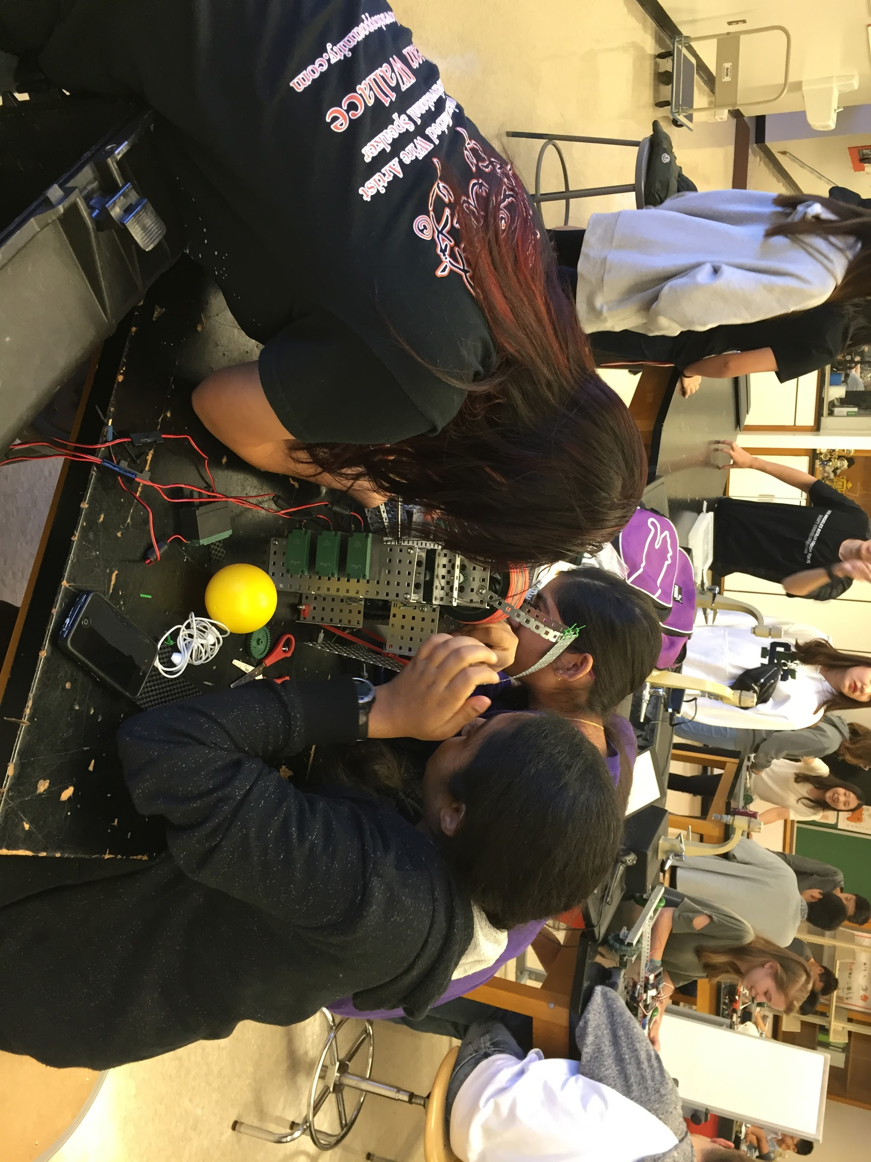

**\*Wow! It’s us!**

Credits

**Entrants:**

Maryam Khan: Co-captain, Builder, Driver, Programmer

Alysa Shi: Co-captain, Builder, Programmer

Ishu Kudapa: Builder, Scout

Nikita Shishu: Builder, Driver

**Team #:** 39W

**Title of Submission:** “Stronger United”