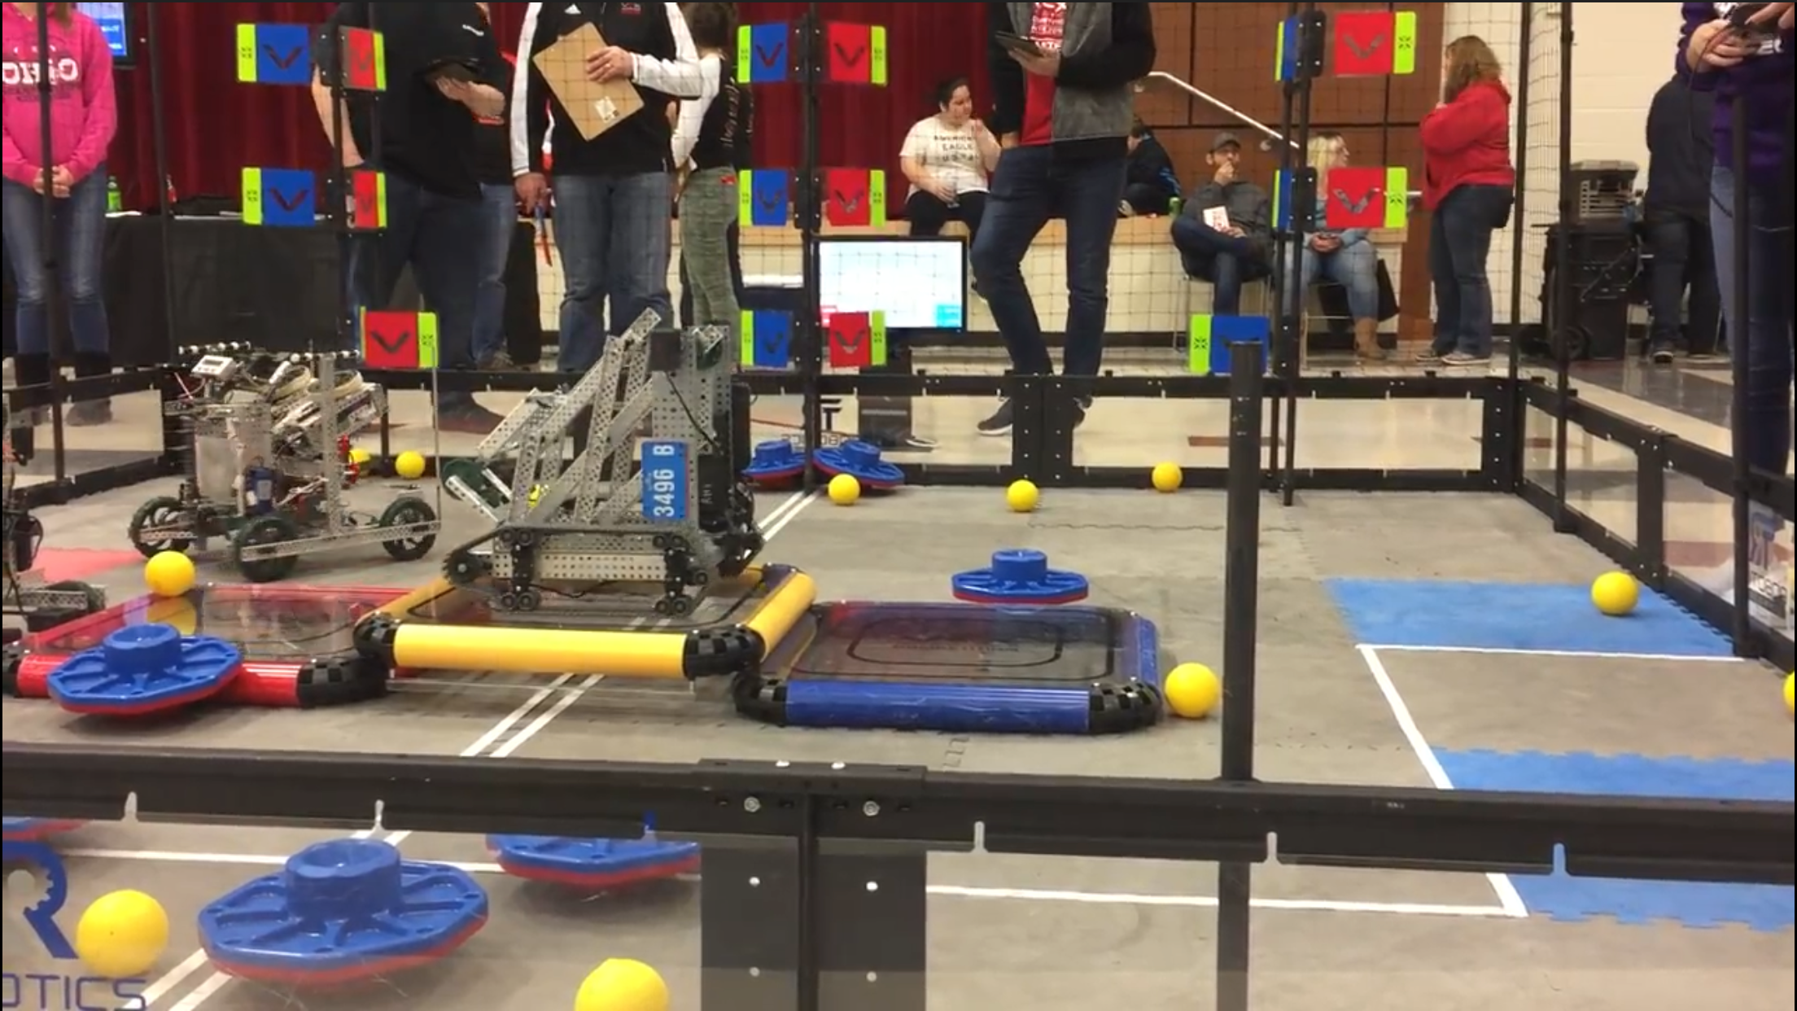

This picture is meaningful because it was our second competition in which our robot was fully functional and we were able to get on the top platform during an actual tournament. This was definitely a significant moment for myself and the team because we experienced a lot of struggles in building our robot and getting it to perform all the tasks that we had in mind. And designing a robot that could get up on the platforms (while still being able to flip caps and stack them on poles) was definitely one of the major challenges that we faced, and were thrilled to overcome. This picture certainly a symbolizes our efforts in this class and how our perseverance helped us become the king of the hill. helped us overcome obstacles

