Girl Powered
By: 6008C; C U Later
The phrase “girl powered” has been encouragement for girls everywhere and our team is no exception. The phrase is used to express the strength for women to rise above the majority and any hardships that stand in the way. For us, girl powered means to be your own hero, in everything you do. May that be in your career, personal life, or simply just robotics club. Girl power is strength. Girl power is independence. Girl power is confidence. Girl power is inspiration.

Our story begins back in the sixth grade with Logan Suiter and Jessica Valentine. Logan took on the stereotypical male driven role as the builder of the robot and the driver. He naturally took to the ingenuity aspect. Jessica, being one of the very few women in the club at that time, says she remembers feeling awkward and out-of-place. She felt as if she had no place on her team of two. She convinced me, Hailee Miller, to join after a long period of persuasion and contemplating. I didn’t think I would have any place on a robotics team either. What place does a girl have on a robotics team? We soon found out.
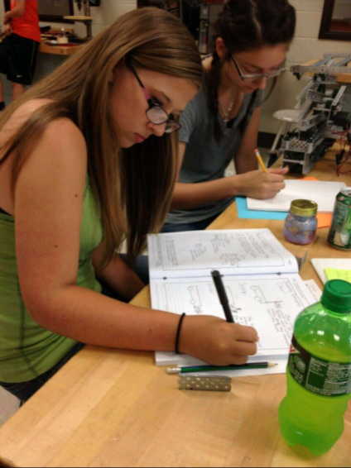
I got placed doing a job that people generally thought only a female could do well. It was simply the only job a girl could do well by the standards of the club, although that wasn’t far from the truth. I did notebook documentation about what the builder does. I didn’t necessarily enjoy my job, but I did it and I did it extremely well. Jessica assisted me throughout the season and we had found our place on the team.
By high school, not much changed. We added Ethan Kavanagh to our team and he took on the role as builder. Jessica and I were eager to explore more. We felt as if we had more potential than what we were bringing to the table. But we had no clue how to go about doing these things. The boys tended to be very unintentionally controlling when it came to the robot and the way things got done. In my free time, I taught myself how to program with RobotC, the programming software we use for Vex, and proved that I could program for our team. Although I got to now help with the programming aspect of our team, I still felt as if the boys were being restrictive. I never thought I’d ever earn the title of “programmer” for our team.
Jessica took a various amount of engineering classes in high school and knew she had great potential. I also saw the potential in her that the boys in robotics didn’t. She always had great ideas and was always there to help when the boys needed her, but she never got the recognition she deserved. She also didn’t get taken seriously as an engineer on the team. This is how the dynamic of our team was for a few years.
Without much notice, Logan and Ethan quit our team. We were very distraught and didn’t know what this meant for us. We didn’t know what our next moves were going to be. Everyone else in the club counted us out, except for our robotics coach, Jodi Kavanagh. Jessica and I considered quitting for a while too. We didn’t think we were capable of filling the shoes that the boys left for us. After a few weeks of consideration, and the countless heart to hearts with Mrs. Kavanagh, we knew we had to stay. Mrs. Kavanagh introduced us to the dedication, fire, and girl power that we didn’t even know we had. She showed us that we can do anything. She was our biggest inspiration.
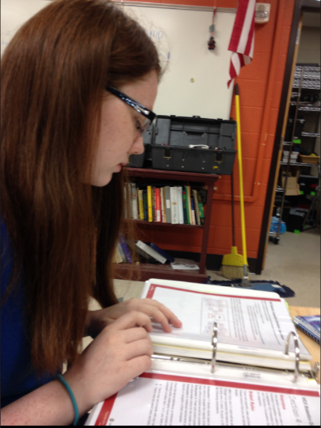
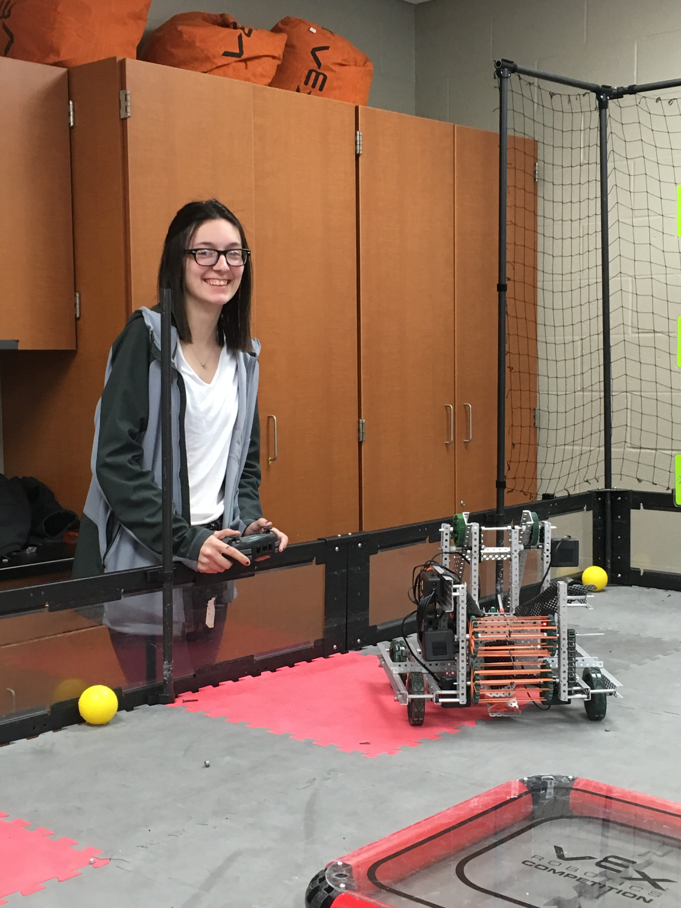
What a lot of people don’t know is that Jessica and I don’t have a lot in our lives besides each other and the things we put our heart and soul into. Robotics is one of those things. Over the five years we’ve spent in Vex, we’ve found a family that we could always turn to. We found a coach that cares for us like a mother, and we’ve found an undeniable sense of girl power that nobody can take from us.
Jessica stepped up and took on the role as our team builder and driver. She completely stepped out of her comfort zone to go above and beyond, and she found her place. Jessica found her girl power. Within this time, I became the team captain and help Jessica with everything she needs, as a real team should. We added two new members, Libby Caldwell and Julien Gorman. They are both observing and learning from Jessica and I.
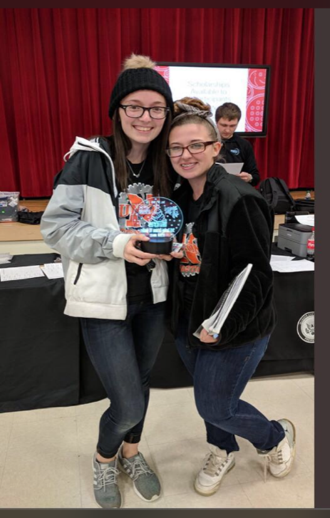
Although we quite literally have been told that we can’t have a team without the boys, we proved everyone wrong. And that’s what girl power really is. Being fearless. Being strong enough to not listen to the criticism or sexist comments. To not let others belittle you because you are a woman. To not let anyone tell you that you are less than a man. Now that our team is 75% female, we can show everyone what girl power is really about.
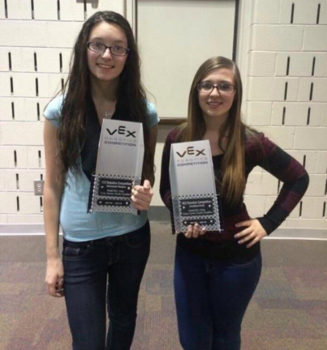
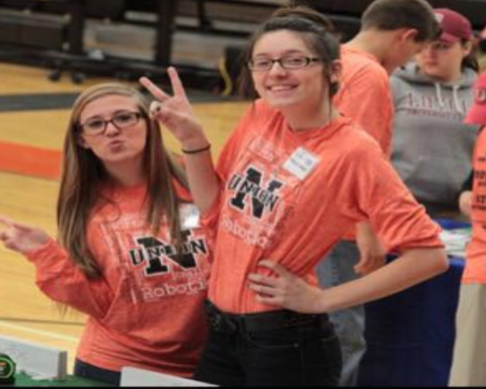
We continue to grow from the experience of being a female-powered team in such positive ways. We volunteer at our local library to introduce kids to what we do and open a new door for them. We also helped at a summer camp for foster kids, and we taught them all about robotics and how they can do these things as well. Everything we do now and in the future will be done with girl power, because girl power is inspiration. We want to inspire any little girl that will listen so they know they can be just like us. We want to give the gift of girl power that Mrs. Kavanagh gave to us. We want every female we meet to know that they can be their own hero.

