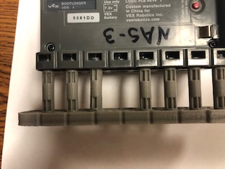

The standoffs are attached to middle holes in a 2x9. This gives us enough room to be able to easily attached the brain to other beams on the robot.

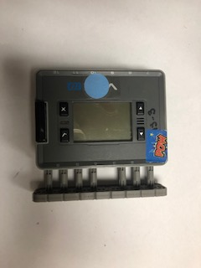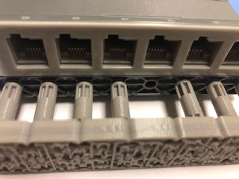

The standoffs and beam are one piece. This makes it easier to attached to the brain and take off and put back on. It also makes it stronger.

These are standoffs that are 3 long.

We are missing a standoff, it broke and we lost it.

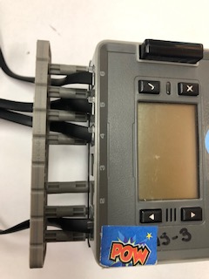

3 long standoffs give us more room to make changes when plugging in smart cables. If we need to take a smart cable out or change it there enough room for us to get it out.

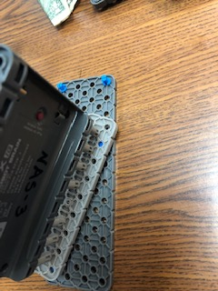

The 3 long standoffs and 2x9 beam connected as one piece makes it easier to attach the brain to other pieces at an angle.