Inertia Gears – Make It Real Cad Challenge

Each year, the VEX Challenges get more and more interesting, and its constant game change makes way for thorough thinking and designing. This year’s ball objects must be launched, so being a university team, our restrictions were less of motor quantity and more spatial in many ways. How many motors will it need? How many layers of metal for structure as well as protection once the practical uses are completed. How do we make it more compact and less heavy? Those and many other questions arose from team brainstorming, and while many great ideas were brought to the table, the mechanism itself seemed to be troublesome in its surroundings. Motors could not be tightened at maximum compact states, and our structure and weight kept suffering to compensate it. it only our gears could take less space…

A few months later it came to fruition. Our new design for gears would solve all our problems. Thanks to the Inertia gears, as we’ve eloquently branded them, not only have we gained our desired space, but a great strength in gear as well, and a minute portion of resistance in Inertia multiplied by our vast motor power has seen great increases in success rate. Our flywheel designs consist of great rpms ranging from 1200 to 2700 rpms and after placing our ratchet mechanisms on each end to pursue efficiency and safety, our Inertia gears have lengthened the spin of the flywheel. Less energy is lost with each motor stop, but what would seem small and indifferent in a mass change has greatly helped our efficiency in design and practice. Its pillar like shapes also provide the support which non-high strength geometries and widths would fail to provide, and even betters it in term of structural design.

This has happened to everyone in one way or another. We’re in search of something and find other things we had looked for before but could not find it. In engineering, those surprises found are not something trivial, but a new vision towards projects, a new approach, a transformational concept which redirects the journey of thought and design. We proudly present our, first surprising, but now designed, the Inertia gears.
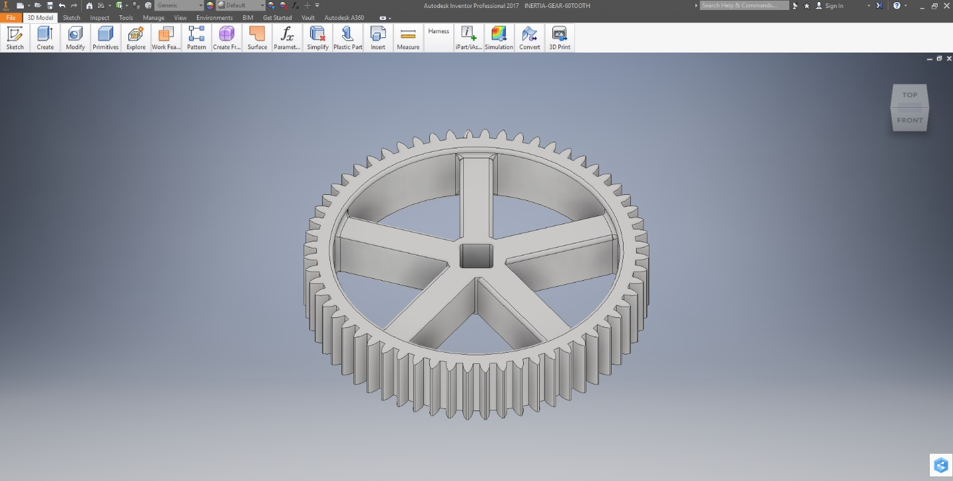
-60 Tooth Inertia Gear on Autodesk 2017

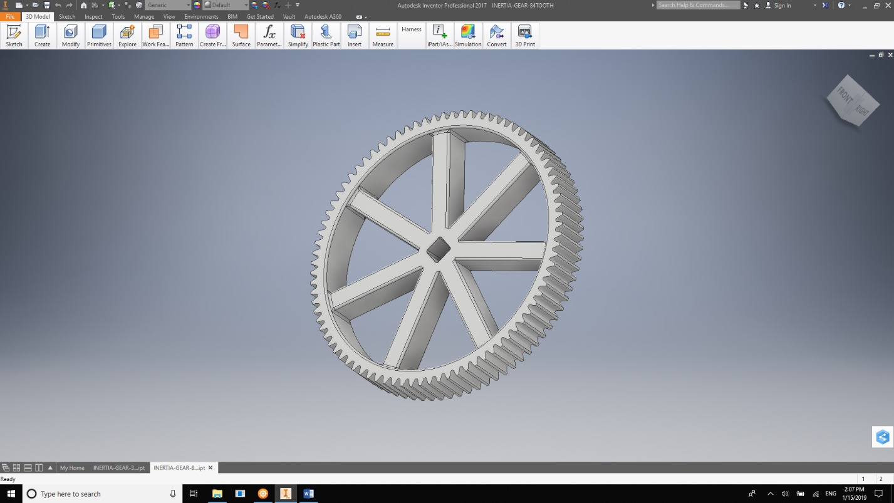
-84 Tooth Inertia Gear on Autodesk 2017
-32 Tooth Inertia Gear on Autodesk 2017
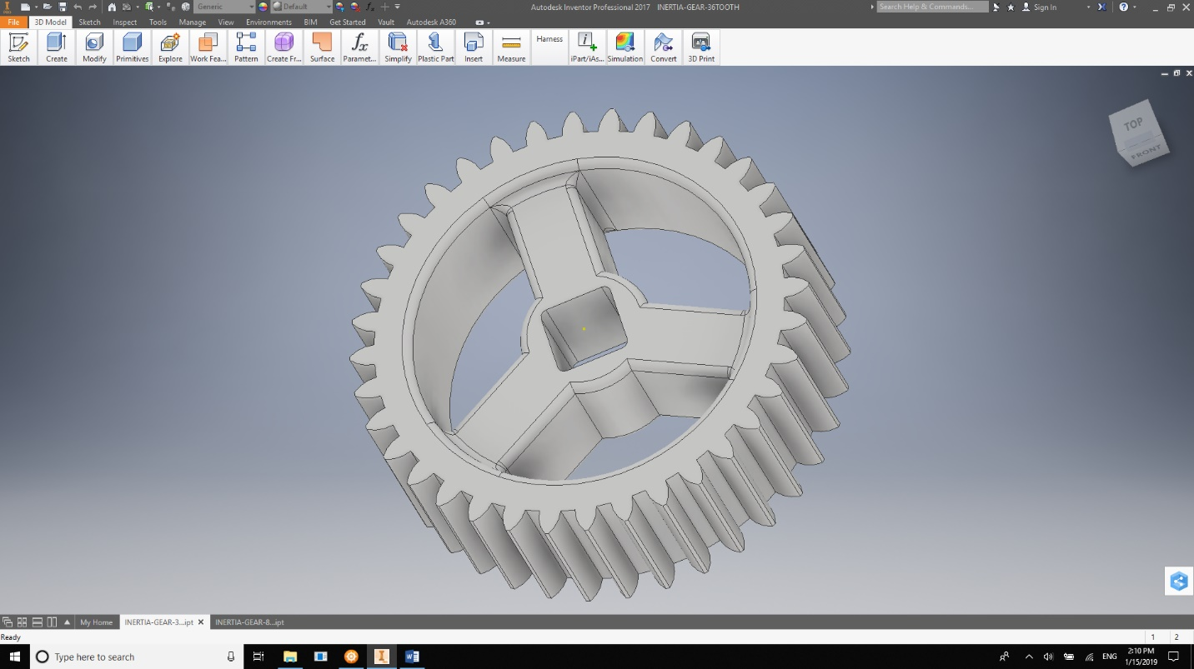

-32 Tooth Inertia Slip Gear – 3/4 on Autodesk 2017
