VEX IQ GIRL POWERED ONLINE CHALLENGE
What Girl Powered Means To Me
From my point of view, the word “Girl Powered” means equality for girls. Whenever I think of equality, I think about how boys are picked for certain tasks often because they are the strongest. I think girls are just as strong. The strength of girls reflects in our team because we are a team made up of all strong girls. Girl power is not just about girls thinking they are in more control than boys are. Girl power motivates girls to go into different professions that are mostly associated with boys, like robotics.
Our team reflects Girl Power because some people probably think that we cannot do the same jobs as boys, but we strive to succeed anyway. We have a more inclusive environment because we are including all types of girls. We are all different and bring something special to the group. Communicating with different people helps you learn how other people think, and how to collaborate. Our team learned how to think creatively and innovate together.
When we first started, each person wanted to drive, and when we practiced driving, a lot of our team members changed their minds. We learned that everything cannot be done perfectly the first try. The builders quickly learned safety is important, and that if one thing goes wrong, everything crashes down. Having all these different people work together caused some conflict between us. Everyone had so many ideas, sometimes it was hard to make a decision for the project, but we learned Girl Power collaboration was needed to succeed. Then we found we each fit in a certain online challenge which helped us decide what we wanted to do in the whole competition project. Our atmosphere also affected our ability to succeed. We tried to finish our robot project in a noisy room, but we could not concentrate. We tried a building room, but yet again, we could not concentrate. We were finally able to get each team member to find a quiet spot for us to work productively.
However, our ability to succeed came from our diversity. We all had different ideas but the same purpose, to have our robot succeed. When I first received the STEM Academy induction letter, I’m going to be honest, I thought it was junk mail. I could not believe it. So, I went to the meeting and I could not believe I was chosen for this academy out of some really smart students at Goshen and other surrounding schools. I did my Snoopy happy dance for the rest of the day! And here I am building Robots for VEX IQ and going to VEX ROBOTICS competitions that could lead the nationals! I never in my whole 11 years of life could have imagined I would have this chance. I am so grateful I was chosen, and I have learned a lot about taking initiative and admitting when I am wrong. Most of all, I learned that as a girl, I still have power to do great things.
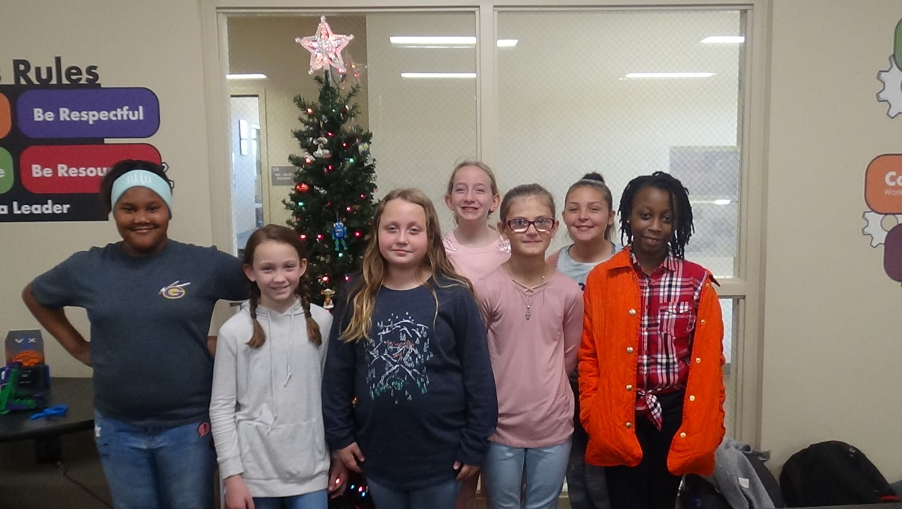
My STEM role model is my teacher Mrs. Amy Garrett. She is my role model because she always stays positive even if our team wins or loses. Also, she makes me have a more inclusive team attitude because she said everyone should be doing something, and she was right. I have been inspired by Mrs. Garrett and my team members to be the strongest girl and team member I could possibly be.

Merry Christmas Girls ‘n Boys!

