Make It Real CAD Engineering Challenge
Team 56445J
We have made a piece to help the robot pick up balls so we can take extra balls with us in our game, Squared Away. We named this piece, The Tray! This piece is supposed to help us score extra points during the game. We will tell you how The Tray was built and can help us win in a short description.

The girl powered group 56445J and I decided to go on Tinkercad and make a part that can pick up 3 inch by 3 inch diameter balls. Also, we used the software Tinkercad to make our custom part and then exported the file. We imported the part onto Ultimaker Cura so we could make sure the size was right for printing. We downloaded the design onto a USB and then used a NWA3D printer to print out the part. Tinkercad teaches a lot because you can learn how to make different shapes, angles, and sizes. The Tray functions as an attachment to the front of the robot and it scoops up balls. When you use Tinkercad you can picture a part in 3D in your mind, and turn it into an actual design!
Amaiah
What I learned from this Tinkercad project
I learned in the Tinkercad project that you should use your creativity and it can take you a long way. Using your creativity also means that you are not afraid to show yourself to the world and think outside of the box.

Ashlyn
What I learned from this Tinkercad project

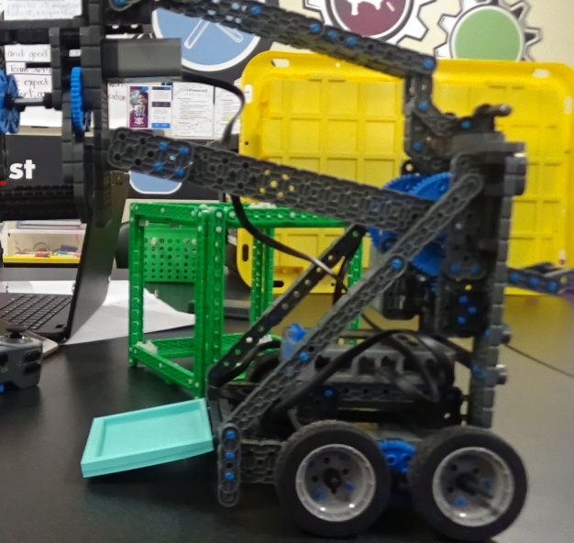
What I learned from this project is that you have to take your time. Time management is a bit of a struggle. Also, I learned to use creativity because everybody is going to think of something different so creativity is a big deal.

