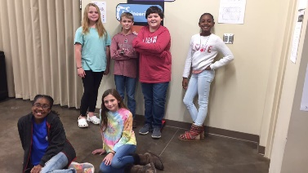
PROLOGUE

By: Khadasia and Chloe

Team 56445A, The Brainy Bunch, has a robot named T.U.R.T.L.E. T.U.R.T.L.E. means Tirelessly Using Robotics To Learn Engineering. With this robot, they plan to win the VEX IQ challenge. They also received the Girl Powered grant along with the fifth grade team, Team 56445J who also goes by S.T.E.M. S.T.E.M. means Super Teamworking Eager Members. The Brainy Bunch has decided to participate in the Girl Powered Online Challenge.

CHAPTER ONE

Girl Powered Phrase

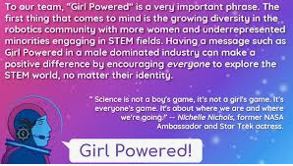
By: Khadasia and Gracie

When I hear the phrase “Girl Powered” equal rights comes to my mind. It reflects my team’s approach as everyone has equal chances on the team. We all know that people deserve equal chances because they could surprise you by being better at something than you would expect them to be. We influence people of all diversities, nationalities, and races to become part of a STEM centered program.

CHAPTER TWO

A More Inclusive Environment

By: Chloe and Gracie

My team took initiative to create a more inclusive environment that attracts a more diverse group of students by helping others to learn about robotics and other STEM centered activities. We believe that everyone, no matter what your race, nationality, or ethnicity, deserves equal chances, especially where robotics is concerned.

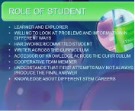
CHAPTER THREE

Various Roles We’ve Tried

By: Khadasia and Chloe

Each team member has tried new things or things they weren’t familiar with. For example, Chloe has built, worked on notebook, did an interview for the promotional video, and helped with the Girl Powered story.

Gracie has tried doing notebook and uploading pictures. She has also helped with the Girl Powered story.

Jakiyah has done notebooking, helped with the promotional video, and uploaded pictures. She had to learn how to write better descriptions. She has very good ideas for most of the things she does.

Weston has been doing the website, tried building, and did the voiceover for the promotional video. He is a good worker and stays on task mostly.

These are just a few examples of our team’s various roles.

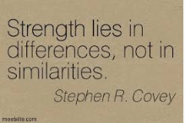
CHAPTER FOUR

Diversity of Perspective

By: Khadasia and Chloe

We believe that a diversity of perspective changes our robot design, our team chemistry, and our ability to succeed for the better.

It changes our robot design because if there were only one type of gender, race, or nationality on a team, they would probably all have pretty much the same idea. If everyone had the same idea and it failed, the team would continue failing and may end up giving up.

It changes our team chemistry because, with us having different mindsets and being different people, we learn about other people’s strengths and weaknesses. We also learn that there should be no bullying anyone because of their race, nationality, gender, strengths, or weaknesses because we are all leaders.

It changes our ability to succeed because we learn how to work together and value each other’s ideas and thoughts. One example of us learning how to work together include Khadasia and Carson learning to be more patient with the new STEM kids which took a lot of work, especially with Khadasia. If we learn how to work together and figure out who is better at some things than others, we have a better chance of winning.

CHAPTER FIVE

STEM Role Model

By: Chloe, Khadasia, and Gracie
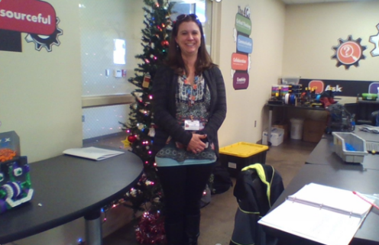

Our STEM role model is Mrs. Garrett.

Why? Mrs. Garrett is our STEM role model because she helps us to become better as a team. She also inspires us to become better students by telling us we can do anything someday as long as we believe in ourselves. Overall, she teaches us how to be a better person. This person does inspire me to have a better team and program.

How? She inspires me to have a better team by teaching us leadership skills, communication, collaboration, critical thinking, and creativity.

These are just some of the things she teaches us in our STEM classroom. She is a good role model because she cares about her students or any kid she comes in contact with.

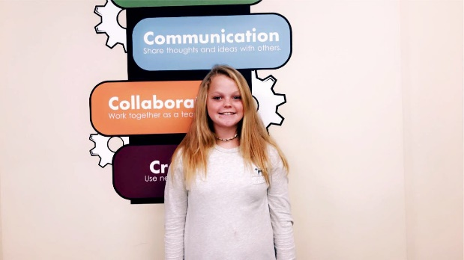
CHAPTER SIX

Chloe Lanham

By: Khadasia and Chloe

Chloe Lanham is a new member. She supports the Girl Powered program because she believes no matter what gender, race, diversity, or nationality everyone should have equal rights. Her favorite subjects are Engineering and Science in both STEM and school. Some things she enjoys doing includes playing softball, hanging out with friends, and talking with teammates. This sometimes gets her off task. Her favorite color is yellow. These are some of the things she likes.

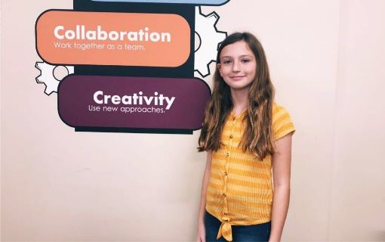
Chapter SEVEN

Emily Grace Smith

By: Khadasia and Chloe

Emily Grace Smith, Gracie as everyone calls her, is a new member. She supports the Girl Powered program because she believes everyone should have equal rights not just girls. Her favorite subject is Engineering in STEM and Math in school. Some things she enjoys doing includes playing soccer, read books, and playing softball. Her favorite color is dark red.

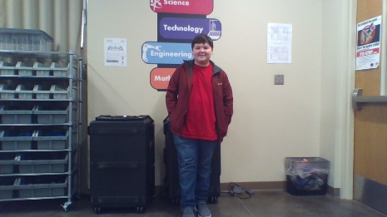
CHAPTER EIGHT

Carson King

By: Khadasia and Chloe

Carson is an old member. He supports the Girl Powered program because he believes that equality is important in a work environment to balance each other’s strengths and weaknesses so we can be productive to the best of our ability. His favorite subjects are Technology and Social Studies in both STEM and school. Some things he enjoy are eating good food, hanging out with his friends and family, and coming to STEM class. His favorite color is teal. These are some of the things he likes.

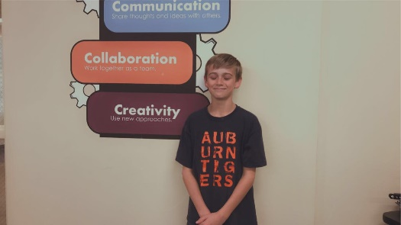
CHAPTER NINE

Weston Garrett

By: Khadasia

Weston is a new member. He supports the Girl Powered Program because he believes that everyone should be able to do something they want to do in robotics because robotics should be fun. His favorite subjects are Engineering in STEM and Math in school. Some things he enjoy are playing baseball, playing the guitar, and going to STEM. His favorite color is blue. These are some of the things he likes.

CHAPTER TEN

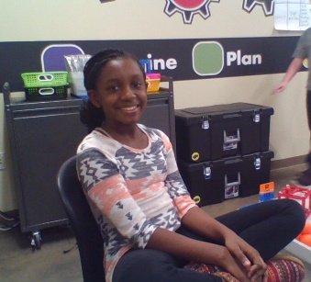
Jakiyah Hyman

By: Khadasia, Chloe, and Gracie

Jakiyah Hyman is a new member. She supports the Girl Powered Program because she believes that it gives everyone a fair chance. Her favorite subjects are Math in both school and STEM. Some things she enjoy doing include dancing, traveling, and painting. Her favorite color is purple. These are somethings she likes.

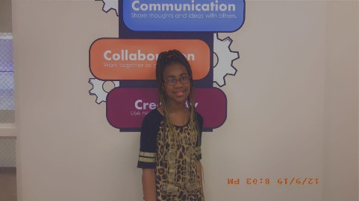
CHAPTER ELEVEN

Khadasia Harris

By: Khadasia

Khadasia Harris is an old member. She supports the Girl Powered Program because she believes that everyone deserves to be equal and treated fairly because you never know what someone can do. Her favorite subject is Math in school and Engineering in STEM. Some things she enjoys doing includes reading different varieties of books and articles, making up her own stories, and playing with friends. She sometimes plays a little too much. Her favorite color is lavender.
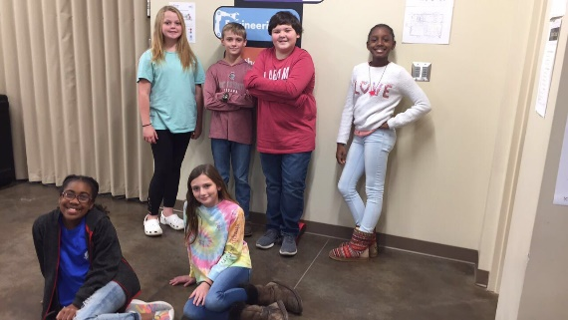

EPILOGUE

By: Khadasia and Chloe

Now that you know a little more about our feelings about the Girl Powered program and the members on our team, we will now tell you about how we are working to support the Girl Powered program.

Our team includes diverse people. We get along well even though we all have very different personalities. We barely argue. We have only had small disagreements. The two biggest arguments we have had was between Khadasia and Jakiyah, and Carson and Jakiyah. But they communicated together to work out their differences.

We all value each other’s ideas. When we stay on task, we can accomplish a lot together!

