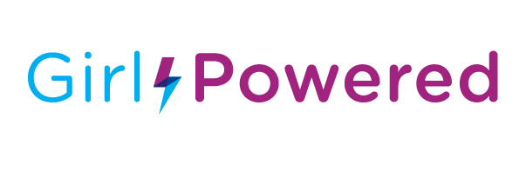VEX IQ Girl Powered: 10173C HBS Vortex
Girl Power has advanced abundantly over the years and even now it is continuously getting stronger. We, as the future generation, are confident in taking a stand to prove that girls can do anything of the same calibre (if not better) as the opposite gender. The Girl Powered initiative encourages the equal participation and recognition of both girls and boys in robotics and supports the empowerment of women, therefore improving the STEM community as a whole. We strongly believe that our VEX IQ team: HBS Vortex 2.0, completely embraces the Girl Powered initiative and reflects it in our approach to robotics.
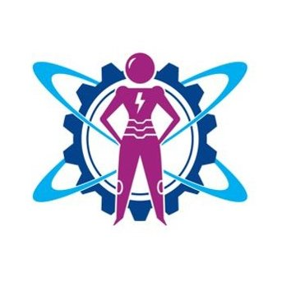
To us, the Girl Powered Initiative represents the belief that girls are just as capable of doing robotics and STEM as boys and should be recognised worldwide. We believe that girls are: highly analytical, incredibly innovative, exceedingly adaptable, resourceful, focused and determined. We think that Girl Powered is an amazing initiative and will create awareness of our capabilities. We are extremely grateful that it has been introduced as it has helped us grow, not only as individuals but also as a team.
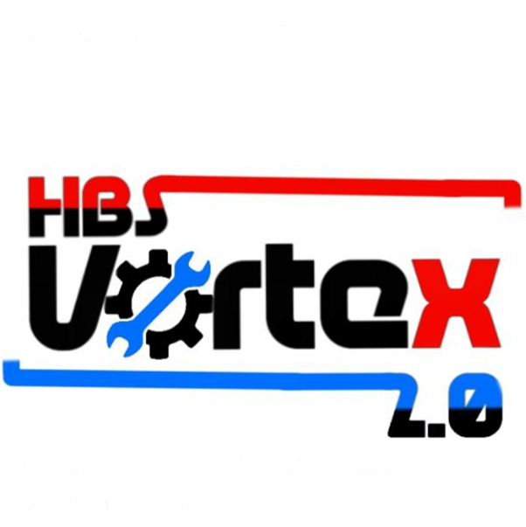
The year began as a new chapter in our robotics careers and we wanted to begin it with a positive mindset. 4 passionate team members. 3 stages to pass. 2 new teachers and 1 solid robot. Going to an all girls school, we see the creativity and drive of girls everyday so we know what it takes to be successful. Although we are all girls, each of us is unique and we have a diverse range of talents that contribute to the variety of roles in our team. Our team is made up of Prisha, Sriya, Rayna and Twisha. Prisha is the CAD specialist, sketchbook logger, STEM researcher and builder. Rayna is the photography and logs specialist, 2nd half driver, sketchbook developer, STEM app designer and builder. Sriya is the Team portfolio specialist, STEM specialist, Sketchbook and builder. Twisha is the team promoter, first half driver, sketchbook, STEM compiler, coding specialist and builder. We all work together to design, build and improve our robot and also support each other with everything else that robotics entails like sketchbook and STEM. This year we had an advantage because one of our team members, Twisha, bought a new robotics kit, which gave us more resources to work with to develop and enhance our robot. We were very enthusiastic about the new challenge: Squared Away, and were all in complete agreement of the designated roles so were prepared to work together very hard to succeed.
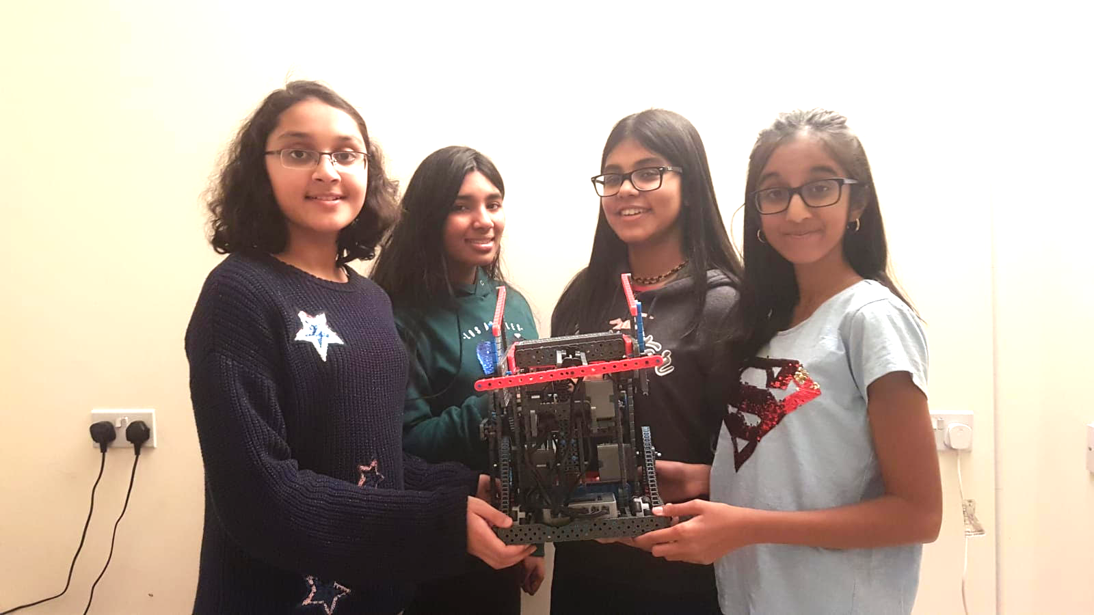

The first stage in our journey this year was the preparation for regionals where we could compete for a chance to qualify for nationals. We had a team meeting as soon as school reopened to discuss our ideas and strategies for the new game. We agreed to meet up to drive code and keep logs regularly. On October the 5th, we attended our first regional, at Greig City. Recognising that we also needed time to practise driving we decided to finish building 10 days before the competition. We diligently met up every weekend to develop our robot and sketchbook for the first competition. Our first robot was quite straightforward with a conveyor claw, a back grabber and a simple, effective base. We had many ideas for possible ball mechanisms such as ball intakes. However, we decided to keep it simple at first so that we could practice proficiently and score well.

On the day of the GCA regional, we were thrilled to begin the competition. 20 teams were competing and we were looking forward to showing what we could do. We whizzed past the size limit check and practice matches, completely prepared for the matches to begin. Our alliances were a mix of both great and unprepared teams but we made the most of them. We always discussed strategies and practised with our team-works prior to our match, based on both their abilities and ours to ensure we had the best chance in the real game. Throughout the day, we went up and down the leaderboard but consistently managed to stay in the top 5. Even after particularly bad matches, when something went wrong, we moved on with our heads held high and maintained our team spirit. This is something we pride in our team as no matter what obstacles we face, we never fall down or give up. In the finals, we came 3rd but by a small difference, the 1st place score being merely 3 points more. As the competition ended, we were disheartened, but resolved to do better next time.

After the GCA regional, we had a better idea of the range of robots competing in this years’ challenge and decided to try and incorporate the best ideas from others as well as our own ones. Our next competition was at Nottingham University Academy on 23rd November so we had plenty of time to prepare. We changed our robot to enhance its efficiency, by altering the conveyor belt claw to an arm, made the grabber sturdier and improve our driving strategy, which really improved our scoring, contributing to both Teamwork and Skills.

On the day of the Nottingham regional, we were extremely enthusiastic to achieve our goal of qualifying for nationals. We started with skills and managed to rank 3rd place. It wasn’t the ideal rank but we were satisfied due to their being many great teams there. We then began our practice matches where we scored very well, making us feel absolutely prepared for the competition. Most of our matches went well as we even managed to score 100 points twice. However, as in all competitions, we were paired with teams whose robots malfunctioned so we had to do a skills run instead on multiple occasions. This held us back to being the 2nd finalist match. In our finals match we came second but qualified for nationals through skills rollover. We were delighted that we had qualified but concluded that we could definitely do better in the future.
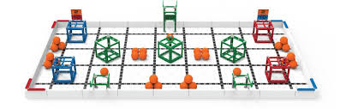

After we qualified, not only did we refine our robot and add new mechanisms, but we also decided to start focusing more on other aspects such as the STEM project, coding for autonomous and the online challenges. We decided that overall the use of a claw at the back rather than a grabber was better as the use of a grabber meant that the cubes were sometimes stopped by the orange pins. We also created ball intake and retainer mechanisms. Then, we incorporated this in a new strategy.
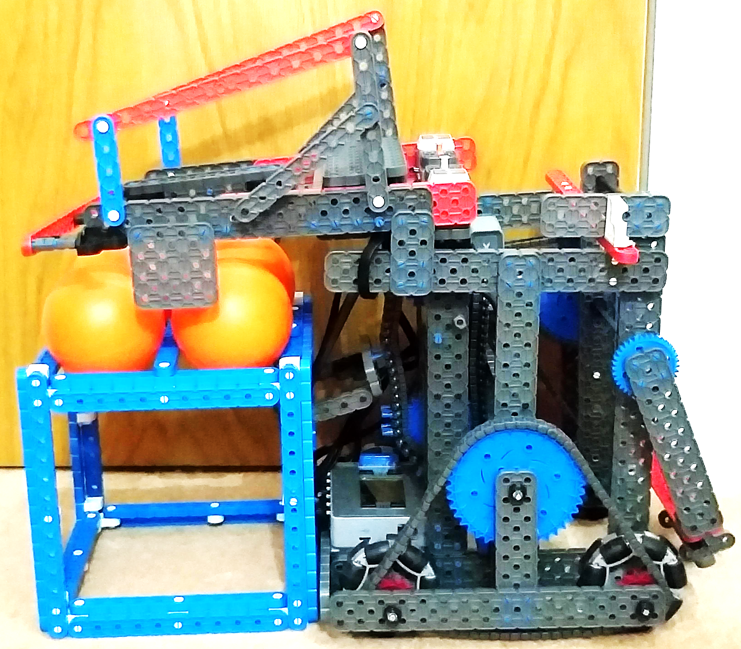

For autonomous, we started coding the program for the cubes first as they are worth more points. We started with the code to drag the red cubes to the opposite corners and the blue cubes to the other. We also developed a code to lift and place the 2 side green cubes on the lower platforms as well as the middle green on the higher platform. These codes are quite reliable so we aim to get 80 points for autonomous in our next competition. For our STEM project, we decided to focus on the topic of carbon emissions and are making an app to help people reduce their overall carbon footprint. We made a video detailing the current statistics of carbon emissions and introduced our app, Carbon Free, which can help people do their part in saving the world. It includes several complex features such as statistical data analysis. We strongly believe that our app can be instrumental in saving the planet and become greater than just a STEM project.
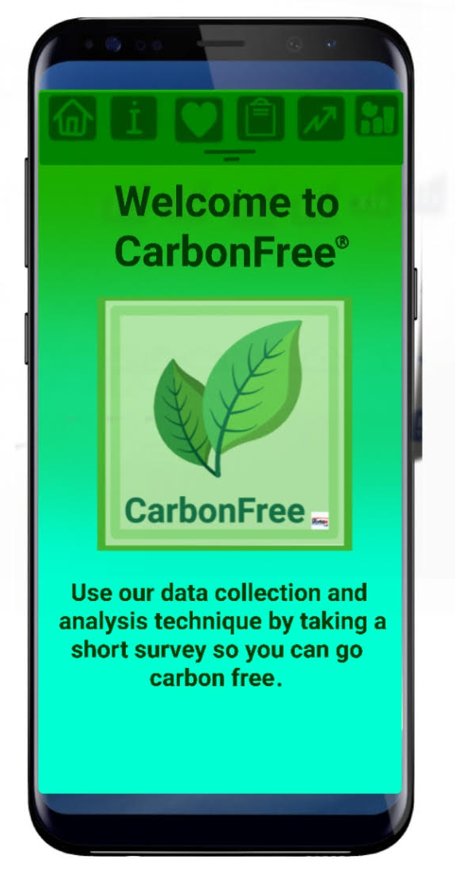
For the online challenges, we started with the team promote video as we thought it was a great opportunity to show the robotics world who we are and what we plan to do this year. In this video we have incorporated elements that show everyone our team, why we love VEX and how robotics has helped us by teaching us numerous new skills. This girl-powered essay was one that we found very enjoyable doing as we were able to display our qualities and voice our opinions about the empowerment of girls specifically in terms of robotics and technology. The main theme we want to present in this essay is the fact that girls are as capable as boys in this field and that the talents of both genders should be recognised.
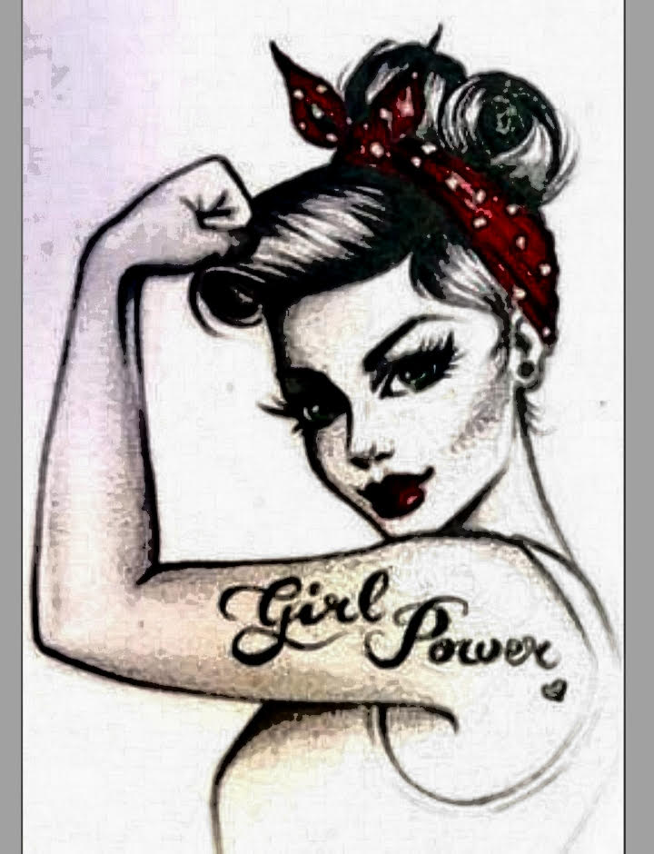

Now, we are working towards doing well at nationals and getting awards. We believe that we have done exceedingly well so far and have the potential to qualify for the World Championships. Our team constantly strives to do our best and have progressed so much together. Qualifying for Worlds would make our dreams come true. We hope that our story and our dedication to robotics will give us the chance to succeed in this online challenge, go to Worlds and prove to everyone that we girls can achieve anything.
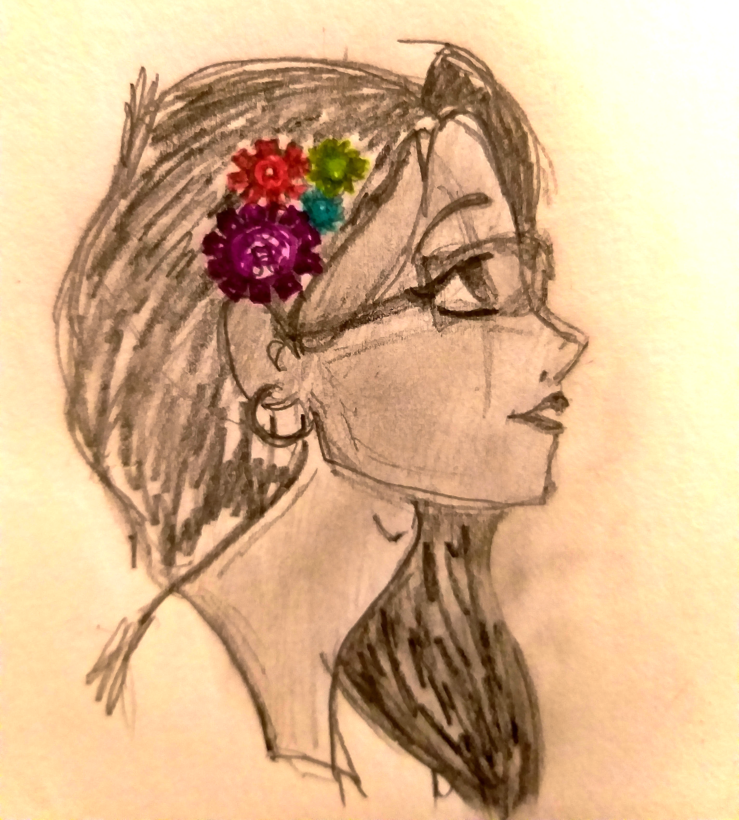
Thank you
¬HBS Vortex 2.0

