Synapse 20785b- Final Submission
Many people need to lock omni-wheels in order to prevent the spokes from spinning preventing them from getting pushed around by other teams. Many people use screws to do this, this makes it hard to take on and off and causes damage to the overall omni wheel design.
Design Specification
Must | Should | Could
Not impair the mobility | Be one piece | Be a new piece all together
Not cause long term damage | Be minimalistic
Be cheap

We began ideating design and found out the best solution was a single piece. We wanted to find out how many spokes need to be locked, to finalise this we tested it to see how many we need to be locked:
Initial Testing
Number of Spokes | Fully locked or not
1 | Not locked
2 | Not locked
3 | Not locked
4 | Not locked
5 | Not locked
6 | Not locked
7 | Not locked
8 | Locked
Prototyping
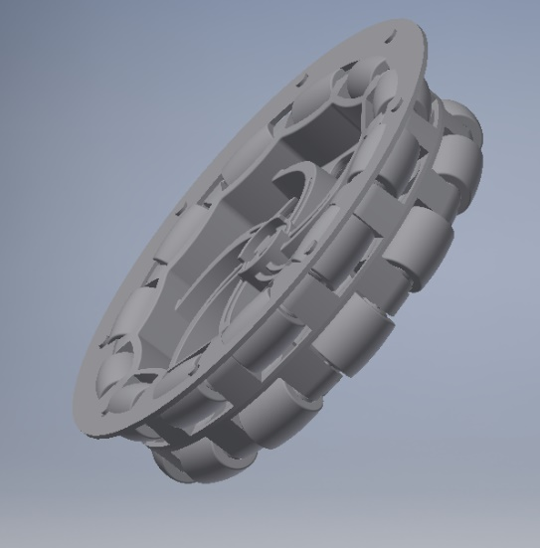
We then began to design the piece in Autodesk Inventor Pro 2018. Originally, we made the design too big and found out the diameter must be smaller than 4 inches to ensure full mobility. On the left shows a prototype which didn’t work.
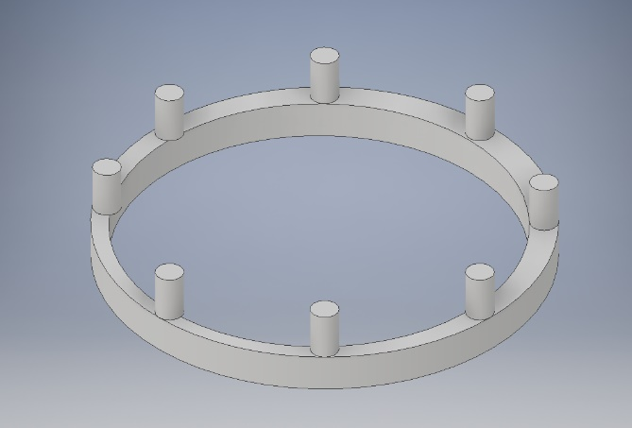

We then developed the solution on the left, which was perfect when being fitted with the omni wheel. We compared this with our specification and most factors were considered. We then proceeded with the testing period:

Testing
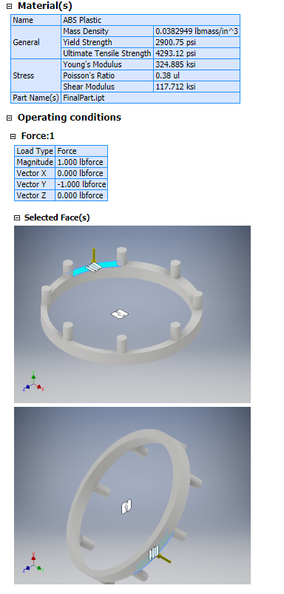
We used Inventor’s stress analysis to see how functional and feasible our design was. We defined our constraints and ran the stress analysis with ABS plastic as our material of choice.
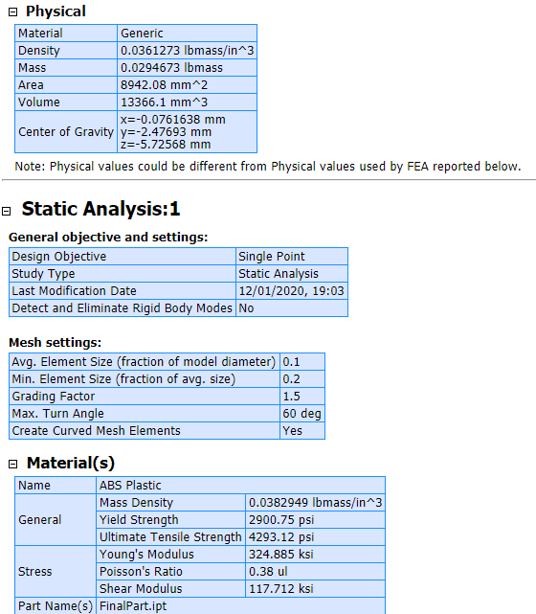

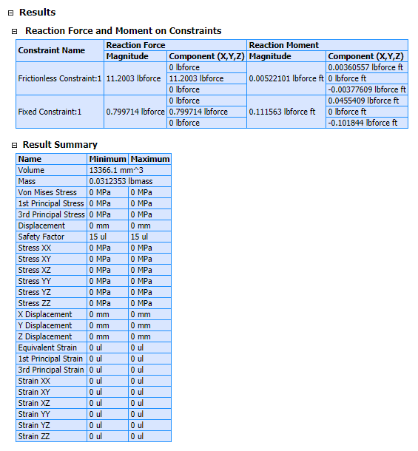

Testing Conclusion

The data shows our product will be able to withstand some stress based on the simulations run in Inventor. This will enable us to finalise the prototype and render it.

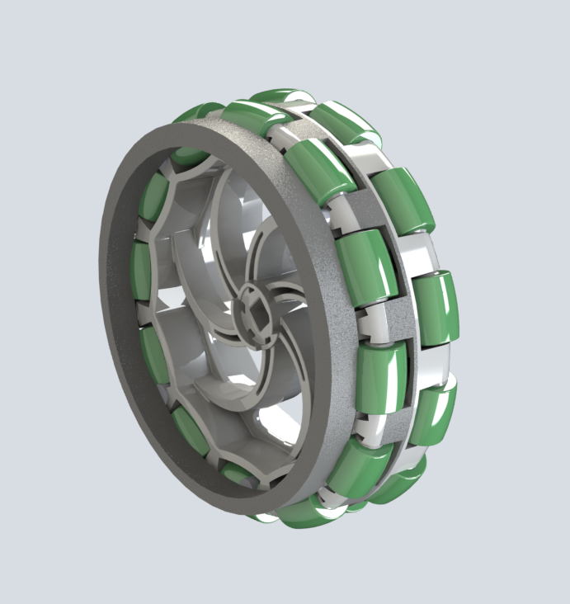
The Final Render (with Omni)

Here is the final render of our product use on a 4-inch omni wheel. This was successful and we finalised the design.
Steps to create the design
Here are the steps for creating the design:
- Open a new part in inventor
- Enter 2D Sketch and click circular pattern, this will create the extrusions to lock the wheels
- Draw another circle around the extrusions
- Extrude the entire design
- Save it and place it in a new assembly and add an omni wheel
- Move freely and rotate until it comes into place and mate accordingly
- Export and open in Fusion 360 and use an in canvas render
Conclusion
From this project, we have learnt how to develop solutions to problems using CAD skills and how it can be used in the industry to develop solutions for problems. Moreover, we have developed basic CAD skills which we will hone throughout the season and we have now seen how CAD can completely change the design process. Additionally, this is the first time we have encountered the stress stimulations and are fascinated in simulated testing. We will use these capabilities in future products and even on our robot to see how stable it can be. We have enjoyed taking part in this competition and are satisfied with the new skills we have learnt which we can utilise in everyday life as well as in the future in jobs. The overall competition has allowed us to see a new side of engineering which has encouraged some of our members to follow engineering in the future and learn all of inventor’s capabilities.

